Four Seasons Hotel London at Park Lane Welcomes Back the Secret Garden for Summer 2017

June 12, 2017, London at Park Lane, England

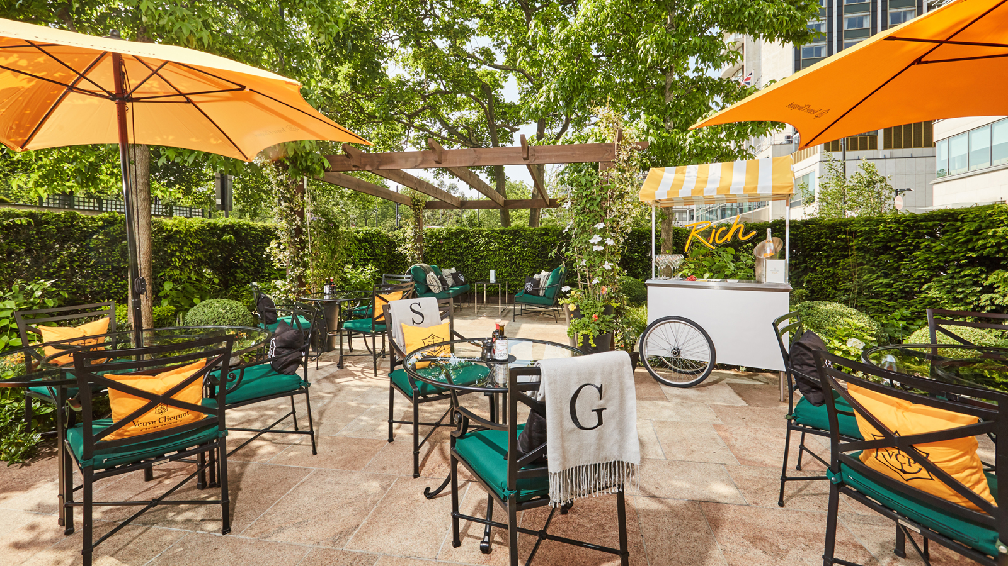
iPhones at the ready, Mayfair’s most Instagrammable hidden terrace is back for summer at
Four Seasons
Hotel London at Park Lane, complete with a new laid back ground floor Hennessy Lounge, a concept menu featuring street food from around the world, and signature Secret Garden Veuve Clicquot Champagne Terrace.
Guests can escape the hustle and bustle of the city in this residence-style garden, designed with a new Hennessy Lounge on its ground floor for those looking to sit back, relax and take in the sunshine on the cosy Hennessy sofas complemented by white begonia flowers, blue salvia and agapanthus. Following its success last summer, Hotel guests and Londoners alike will be thrilled to welcome back the Veuve Clicquot Champagne Terrace on the Secret Garden’s first floor, surrounded by hydrangea, canna lily and more begonias offering warm apricot, bronze, cool green and white tones designed by Four Seasons very own Floral Designer Rosalind Ackerley. Guests can sip on signature Champagne and enjoy a range of new delicious cocktails while listening to the cool summer beats.
Chef de Cuisine Eliano Crespi has devised a delectable tapas style menu featuring street food from around the world bursting with Mediterranean, Italian and Indian flavours. Perfect as an aperitif and for sharing with friends, signature tapas dishes include chicken or beef skewers served with a Malaysian peanut sauce and grilled pineapple; or paneer tikka with an Indian cottage cheese, capsicum and onion skewers with a mango and passion fruit salsa; as well as calamari alla Romana served with a homemade wasabi mayonnaise.
Raise a glass to the social season with the Secret Garden Spritz,
Four Seasons
take on a traditional Aperol Spritz made with Veuve Clicquot Champagne and grapefruit. For those looking to give their champagne a summer fruity twist, try a peach, strawberry or raspberry Veuve Clicquot Bellini. A curated Hennessy drinks menu will also be available to punters featuring the likes of Hennessy Fine, XO and Paradis Imperial as well as a Hennessy Fine Champagne cocktail with homemade bitters.
With its Veuve Clicquot Umbrellas, cushions and smartly dressed staff with 1920s flat caps offering
Four Seasons
signature service, complete with the glamorous backdrop of
Four Seasons
Hotel London at Park Lane, this green space is the ultimate high-end summer hang out in the heart of Mayfair.
The Secret Garden is open daily from 12:00 noon until 11:00 pm and operates a no-booking policy.

RELATED

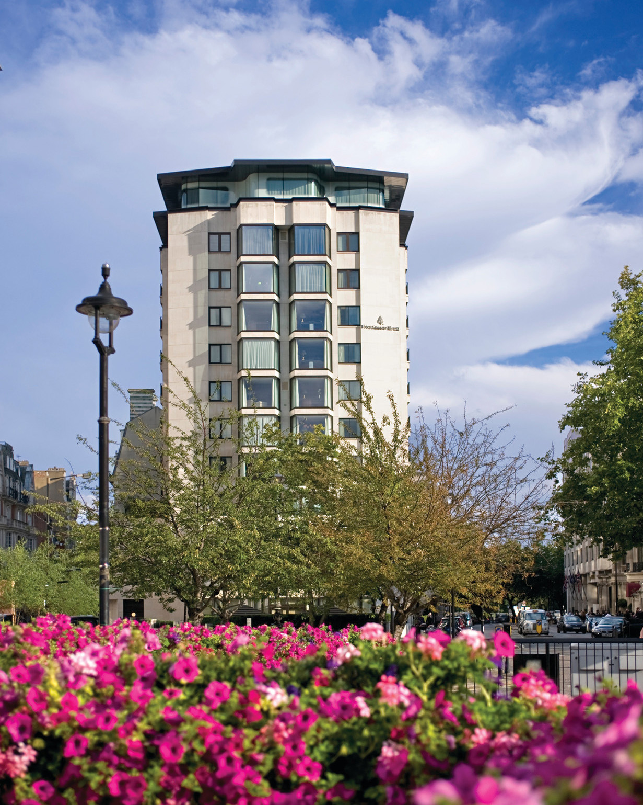 | June 8, 2017, London at Park Lane, England  Four Seasons Hotel London at Park Lane Launches a "Summer Exhibition," First in a New Series  http://publish.url/london/hotel-news/2017/summer-art-exhibition.html
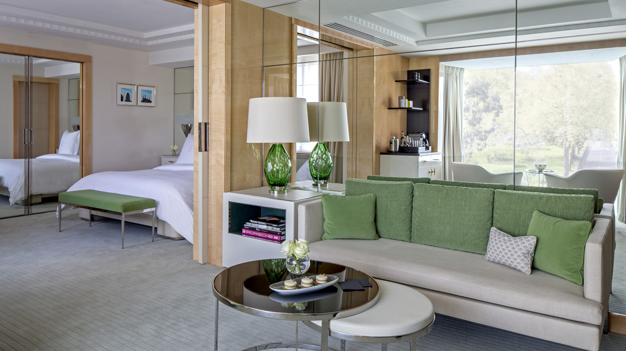 | May 23, 2017, London at Park Lane, England  Four Seasons Hotel London at Park Lane Offers an Oasis of Calm in the Heart of the Capital with Newly Designed Mayfair Suites  http://publish.url/london/hotel-news/2017/new-mayfair-suites.html

PRESS CONTACTS

Georgie Herdman
Public Relations Manager
Hamilton Place, Park Lane
London
UK
georgie.herdman@fourseasons.com

+44 (20) 74990888

