FOUR SEASONS Guangzhou
Tel: 86 20 8883 3888 Email: contactus.guangzhou@fourseasons.com

OPENING DATE: July 2012
GENERAL MANAGER: David Macklin

Physical Features
Total Number of Rooms: 344
- Guest Rooms: 302
- Suites: 42
Number of Stories: 103 (Four Seasons occupies top third of building)
Design Aesthetic:
- Features 34-floor central atrium rising from 70th floor lobby
Architect: Wilkinson Eyre
Interior Designer(s):
- HBA / Hirsch Bedner Associates
- Steve Leung Designers Limited (100th floor restaurant)
Location:
- Occupies the top third of the 103-story IFC Guangzhou, one of the world's ten tallest skyscrapers
- In the heart of Pearl River New City, next door the Zaha Hadid-designed Guangzhou Opera House

Spa
Size: 1,866 sq m / 20,000 sq ft
Interior Designer: HBA / Hirsch Bedner Associates
Design Aesthetic:
- Natural light in all treatment rooms with views from the 69th floor
Number of Treatment Rooms: 8
Special Facilities:
- Two VIP double suites with oversized vitality tub and rain shower
- Extensive water-based treatment area with crystal steam room, laconium and ice fountain in the women’s area, plus herbal steam bath, Finnish sauna and ice fountain in the men’s area

Dining
Executive Chef: Giancarlo Di Francesco
Restaurant: Kumoi
- Cuisine: Japanese

Recreation
Off-site Activities:
Pools:
- Number of Pools: 1
Fitness Facilities:

- Special Features:
- Cardio equipment and weight-training facilities with machines and free weights
- 25 metre (82 foot) lap pool

Meeting Rooms
Total Size: 3,585 sq m / 38,585 sq ft
Largest Ballroom: 896 sq m (9,645 sq ft) with adjacent VIP room ideal as a bride's room, green room or VIP waiting area
Second Ballroom: 534 sq m (5,750 sq ft) with adjacent VIP room ideal as a bride's room, green room or VIP waiting area
Third Ballroom: 758 sq m (8,160 sq ft) with adjacent VIP room ideal as a bride's room, green room or VIP waiting area
Meet and Feed Capacity: 540
Banquet Capacity: 720
Breakout Spaces: 8

Special Features
Executive Club on the 99th floor
Extensive collection of contemporary art by Chinese and international artists, with an emphasis on sculpture

PRESS CONTACTS
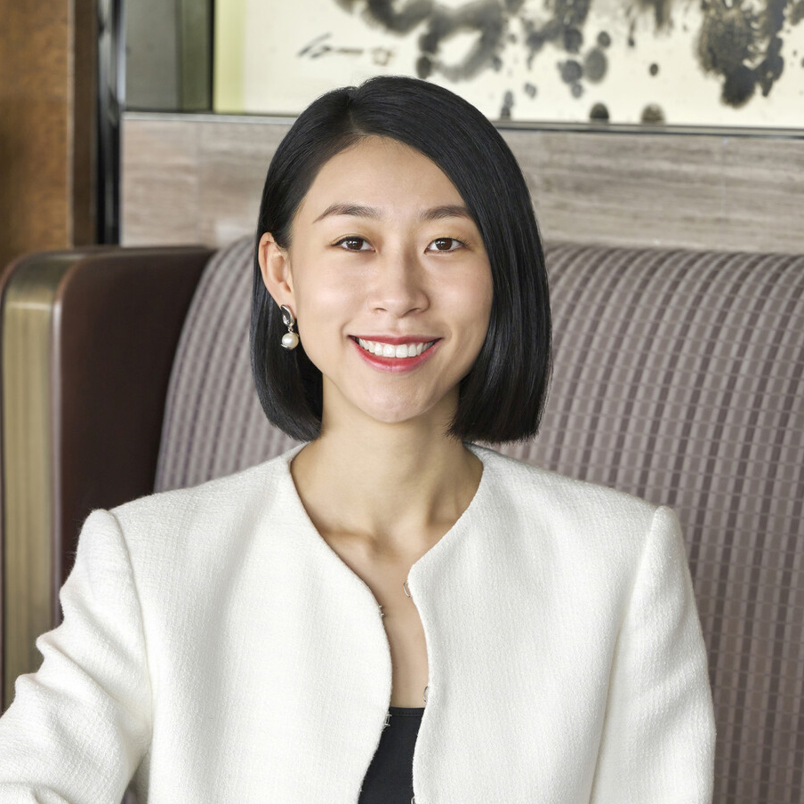 | Yvonne Ye  Director of Public Relations and Communications  5 Zhujiang West Road, Pearl River New City, Tianhe District  Guangzhou  China  yvonne.ye@fourseasons.com  86 (20) 8883-3901

