Texan Tapped for Four Seasons Hotel Austin Meeting Space Redesign

Austin’s unique spirit reflected in summer enhancement
April 19, 2016, Austin, U.S.A

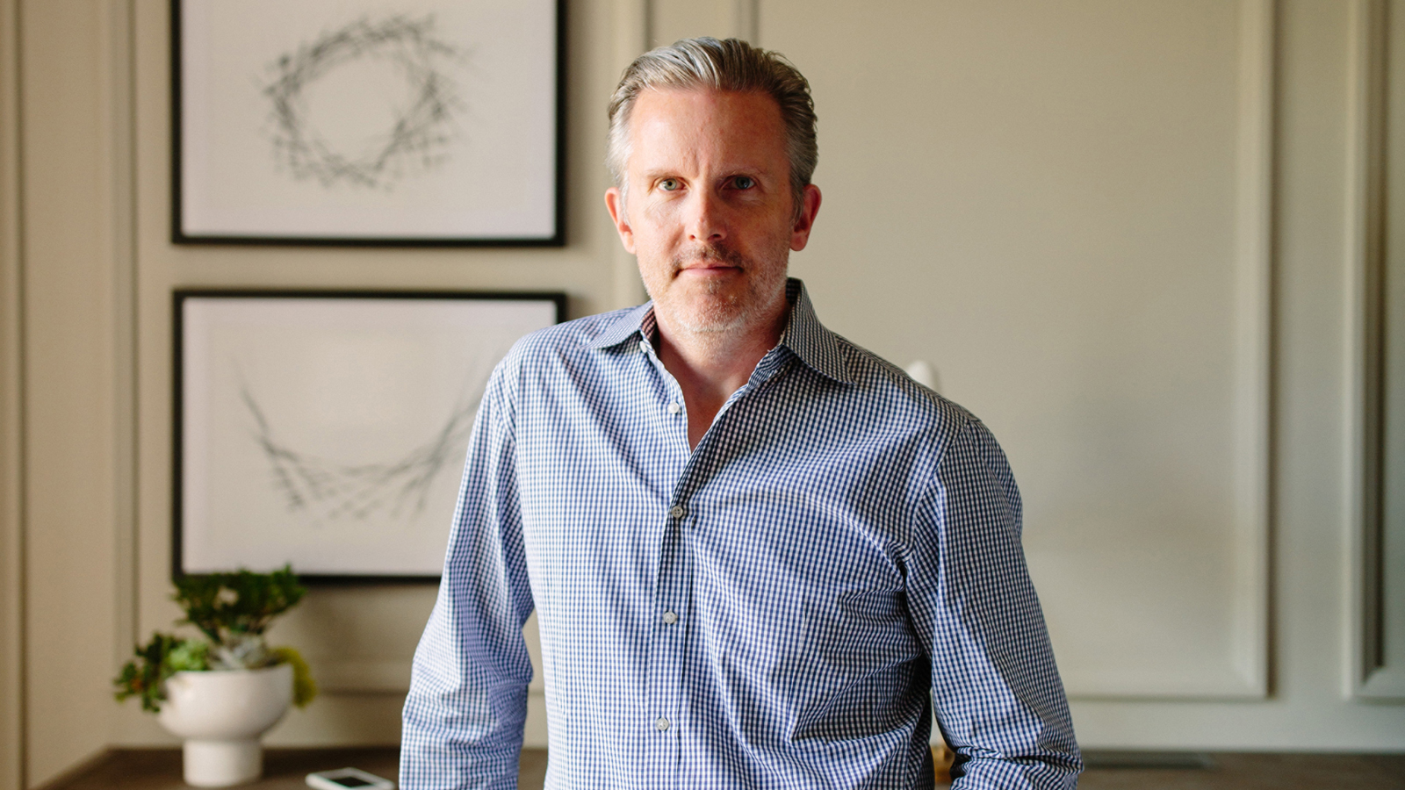
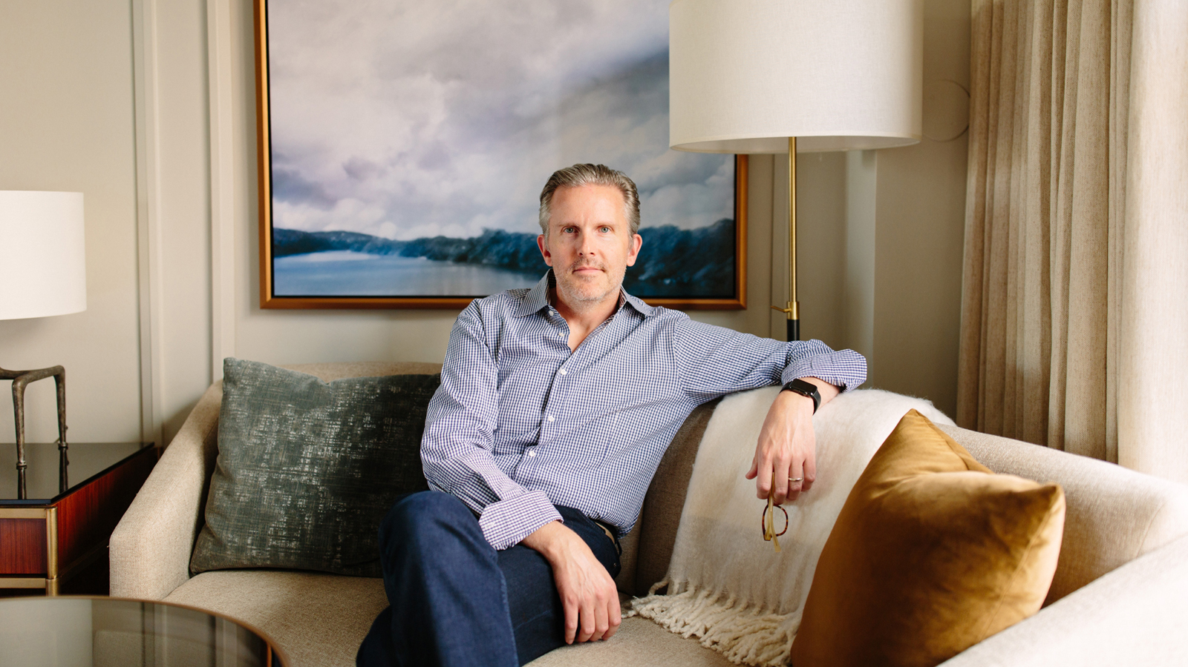 | 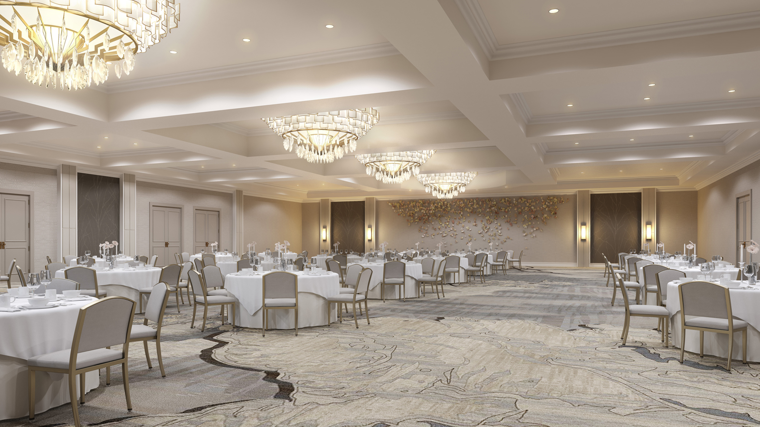 | 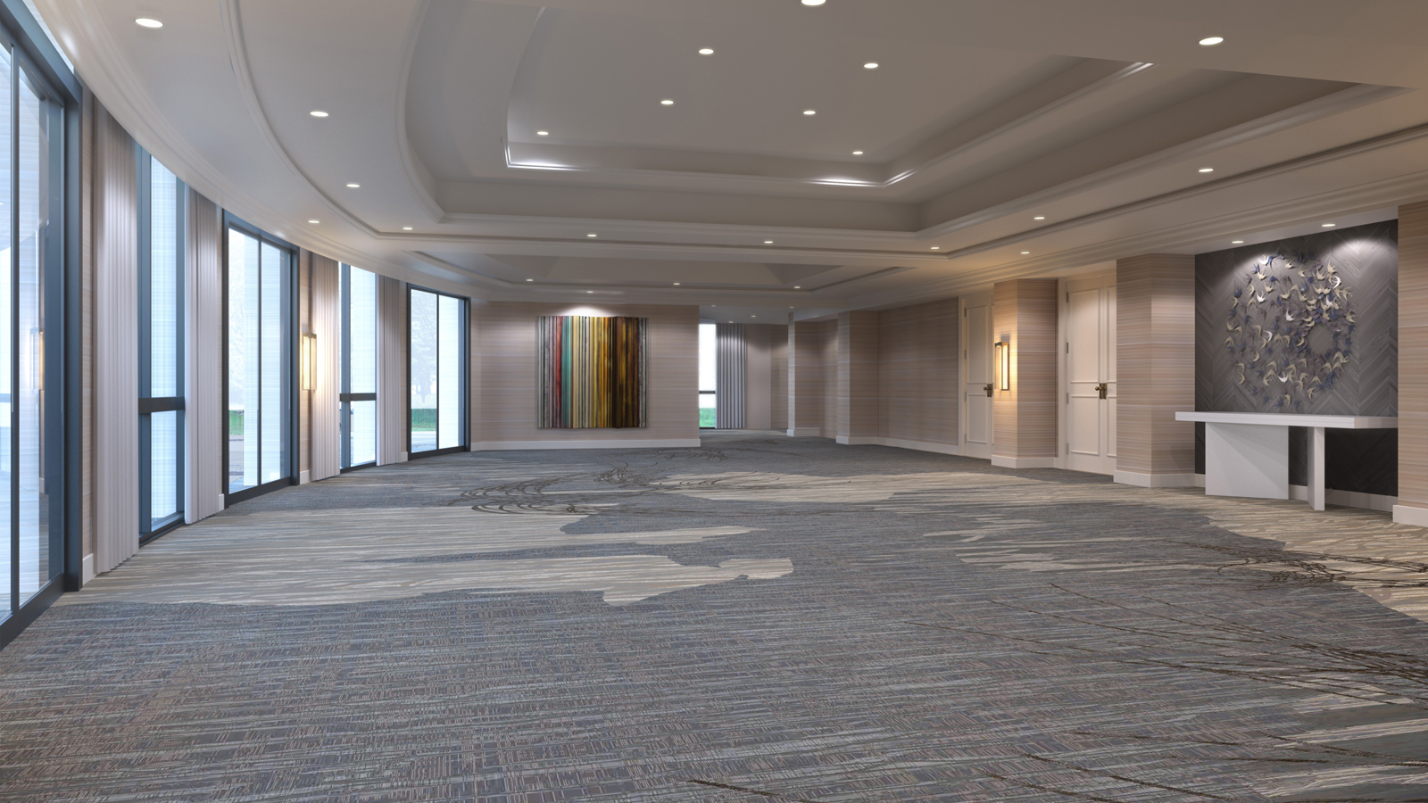
Stepping into the soon-to-be-refurbished ballroom at
Four Seasons
Hotel Austin is like a homecoming of sorts for Michael Dalton, principal of Whitespace Interiors and the designer hand-selected to lead the downtown Austin Hotel’s upcoming meeting space enhancements.
A Texan and University of Texas alumnus, Dalton has a special affinity for Texas, and Austin in particular, that makes this project – currently slated for completion in July 2016 – more personal than other luxury efforts he’s worked on in the past.
Collaborating side-by-side with partner Heather O’Sullivan, Dalton credits these deep Texas roots with enriching their design approach, bringing an authenticity to the space that blends the attitude of the Lone Star state with the unique beauty and character of Austin and the Hill Country.
“There’s really no better stimulus for design than the vibrant, youthful and ever-changing city of Austin,” says Dalton, who’s quick to point out that, while Austin may be the “Live Music Capital of the World,” it’s far more than music venues and leading-edge tech spaces. “The true mystique of Austin lies in the marriage of nature and the burgeoning cityscape that spawns its diverse, one-of-a-kind ethos; some still call it ‘weirdness’ and we love that.”
“Everywhere you go in Austin, nature is present and integral to your experience,” he continues. “From craggy live oaks to purple martins and the broad blue sky, you can’t escape the natural charm of the city. We tried hard to capture that essence in our plans, to respect what makes this place so wonderful and then share that sensation through design.”
Located alongside Austin’s famed Lady Bird Lake, the idyllic setting of
Four Seasons
also provided Dalton and O’Sullivan with ample inspiration. With its immediate proximity to the energy of downtown and its inviting surroundings – enhanced by “heritage” live oaks, mature pecan trees, a lush landscape and hills that slope dramatically to the riverbank – many locals would agree the luxury Hotel enjoys perhaps the best setting in the city, one that embodies all that makes Austin’s outdoor lifestyle so appealing.
As such, each of these elements is cleverly woven into the design palette, smartly painting a story that pays homage to the natural beauty of the location. From trees to birds and clouds reflected on still water, the true spirit of Austin is thoughtfully presented in the refreshed 7,029-square-foot (653 square metre)
Four Seasons
Ballroom and its adjacent foyer.
Described as “discreet luxury at its finest,” the overall aesthetic uses a medley of lush yet authentic materials and motifs, elegantly layered together to reflect Austin’s refined ruggedness. For example, as part of the neutral and sophisticated palette, Whitespace Interiors utilised supple leather and textural finishes to provide warmth and an approachable attitude. Meanwhile, rich bronze, copper and platinum tones add strength and radiance to artwork and lighting fixtures.
“From floor to ceiling, every aspect of the function spaces works together to provide a refined, luxurious and welcoming atmosphere, one that is never pretentious,” Dalton emphasises. At its core, the room is anchored by the ornately patterned carpet, ingeniously derived from the glistening and reflective waters of Lady Bird Lake. Other components, from the furnishings to art, also share the same undercurrent, artfully blending strong natural influences with a modern viewpoint.
As Dalton puts it, “It’s really a study in honesty and subtlety, an approach we hope to continue lending to the rest of the Hotel very soon.”

RELATED

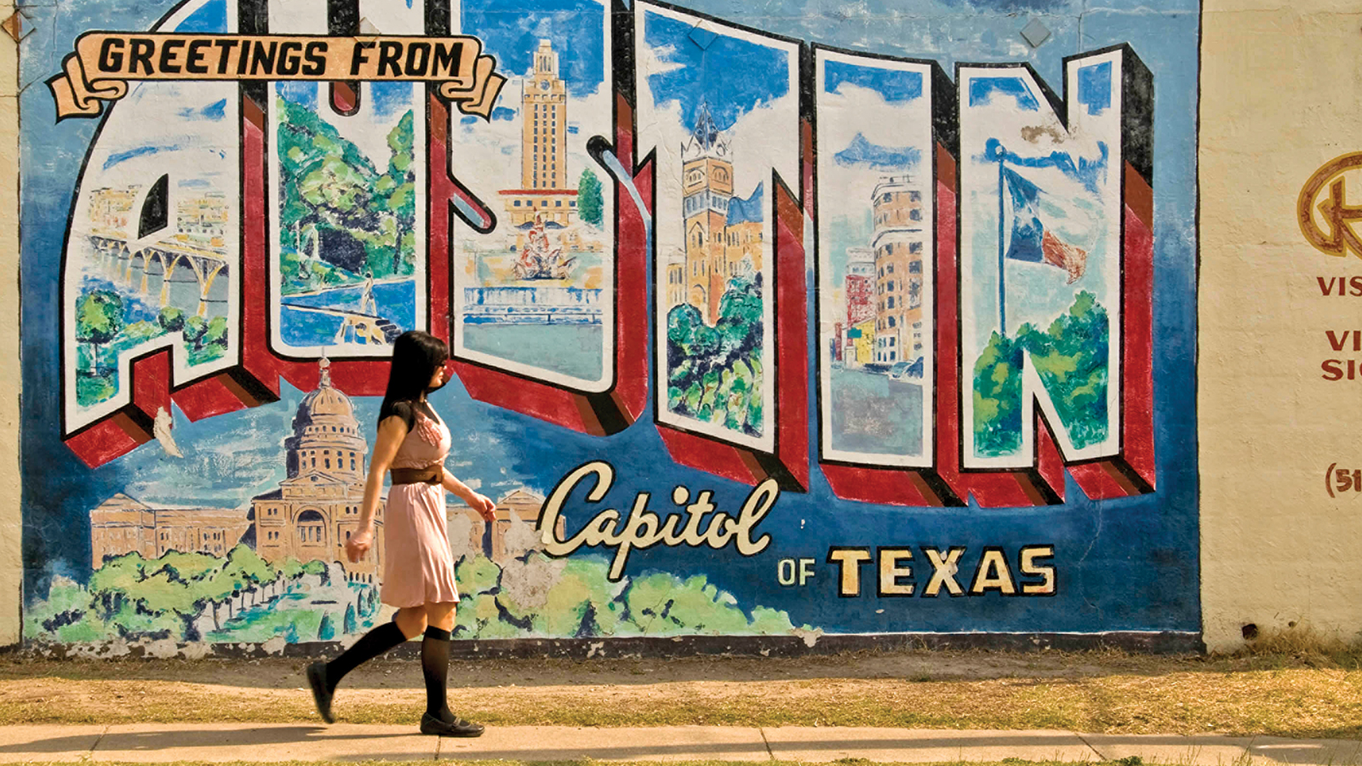 | April 12, 2017, Austin, U.S.A  Summer Offers Announced at Four Seasons Hotel Austin  http://publish.url/austin/hotel-news/2017/summer-promotions.html
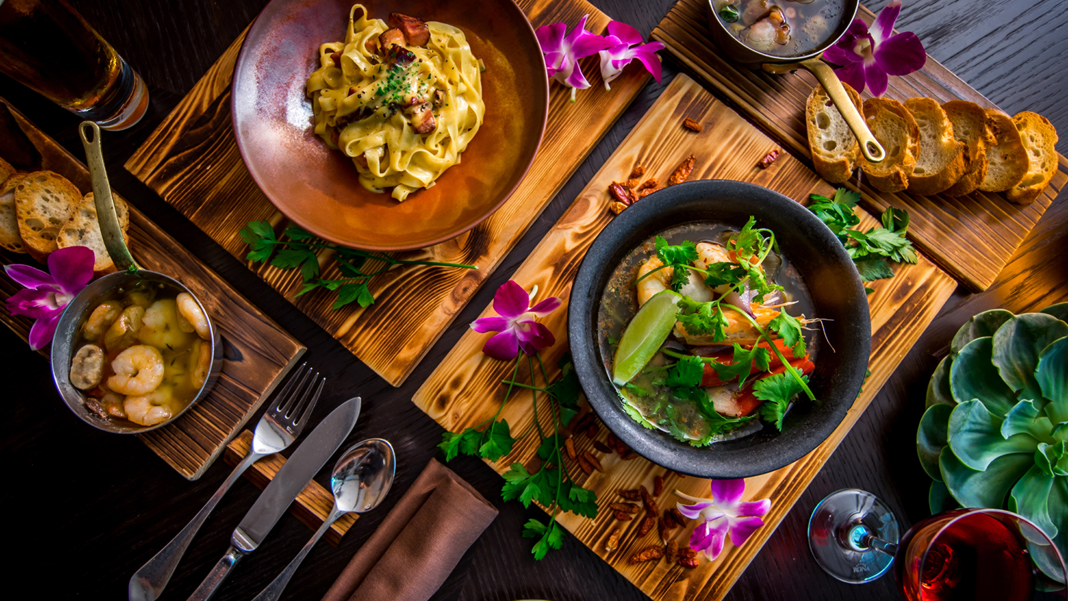 | March 22, 2017, Austin, U.S.A  One-of-a-Kind Dining Experience Returns to Four Seasons Hotel Austin  http://publish.url/austin/hotel-news/2017/one-of-a-kind-dining-experience.html

PRESS CONTACTS

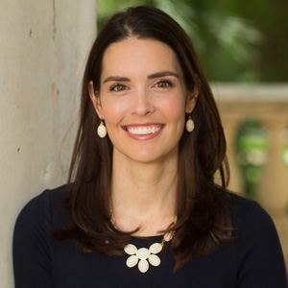 | Kerri Sholly  Senior Director of Public Relations - Americas  98 San Jacinto Boulevard  Austin  U.S.A.  kerri.sholly@fourseasons.com  1 (512) 685-8048

