Four Seasons Resort Punta Mita is a Teen Traveller’s Dream

April 19, 2017, Punta Mita, México

The prospect of spending a family vacation far from friends back home might not be top of a teen’s wish list – except of course when the destination is
Four Seasons
Resort Punta Mita.
Recognising that teens want the freedom to do their own thing, the Resort offers a variety of opportunities for older children and young adults to explore on their own, meet new friends or just chill out while also enjoying time with the rest of the family.
The fun starts on the Resort’s beaches, where teens can hit the waves on a kayak, join impromptu volleyball or Frisbee games, or laze in the swinging basket chairs and daybeds around The Shack beach bar while their younger siblings spend time at the complimentary Kids for All Seasons facility. Tropicsurf also offers surf coaching and excursions for teens.
For many teens, The Container is a favoured hang out. The complex is filled with PlayStation consoles, Wii, Xbox, and more, as well as ping pong, air hockey and foosball. Really into the game? Complimentary healthy snacks are at the ready all day, along with refreshing non-alcoholic drinks.
For active kids, there are tennis clinics and golf lessons, with the opportunity to play the Resort’s two Jack Nicklaus-designed courses. And who doesn’t want to be pampered? Younger guests over the age of 12 can indulge in treatments, including special mani-pedis for teens, at the Apuane Spa, as long as those under 18 are accompanied by an adult.
And for those who simply cannot survive without regular contact with the outside world,
Four Seasons
Resort Punta Mita offers free Wi-Fi for up to four devices. This basic service is enough to keep up with email and social media accounts in most areas of the Resort, and premium service is also available at a fee to play games and watch movies.
With all this and more, the biggest challenge for parents might be getting them back to the airport to go home!

RELATED

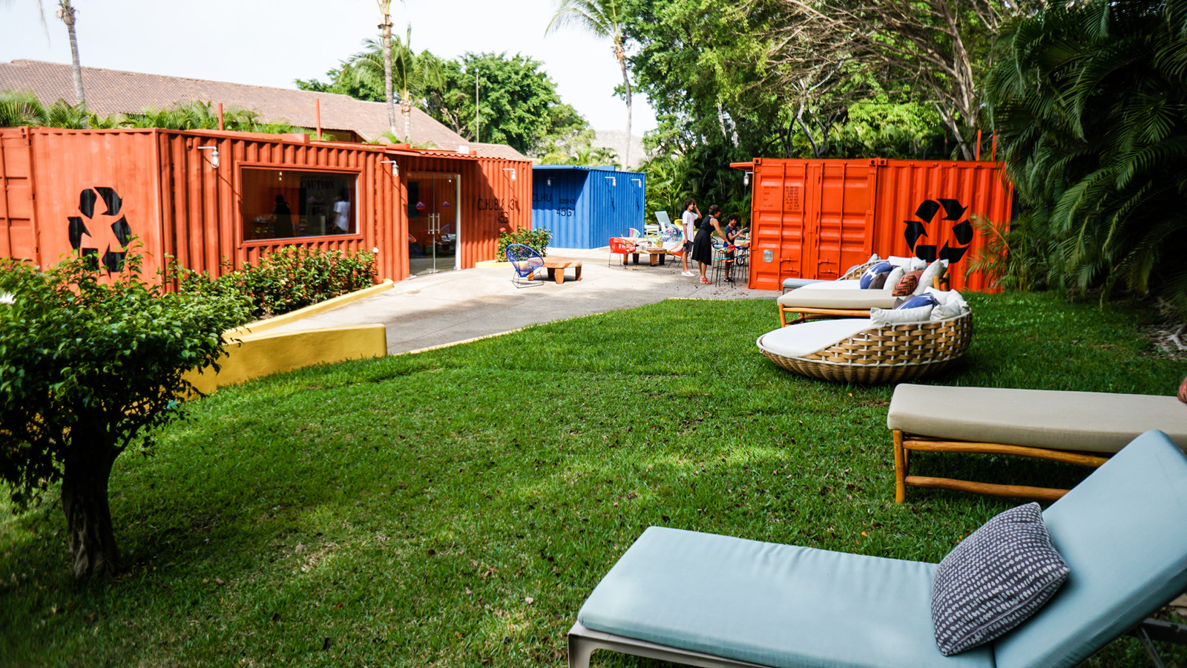 | February 16, 2018, Punta Mita, México  Four Seasons Resort Punta Mita Unveils Innovative Teen Space  https://publish.url/puntamita/hotel-news/2018/the-container-teen-centre.html
August 29, 2017, Punta Mita, México
Four Seasons Resort Punta Mita se Asocia con la Celebrity Chef Leslie Durso en la Creación de Innovadoras Opciones Veganas
https://publish.url/es/puntamita/hotel-news/2017/new-vegan-menus-2.html

PRESS CONTACTS

Ane Echeverria
Public Relations Manager
Punta Mita, Bahia de Banderas
Nayarit
Mexico
ane.echeverria@fourseasons.com

+52 329 2916000

Kimi Ozawa
Murphy O'Brien PR
11444 Olympic Boulevard, Suite 600
Los Angeles
U.S.A.
fspuntamita@murphyobrien.com

+1 (310) 586-7138

