Hot Chocolate Meets Haute Cuisine

April 17, 2017, Vail, U.S.A.

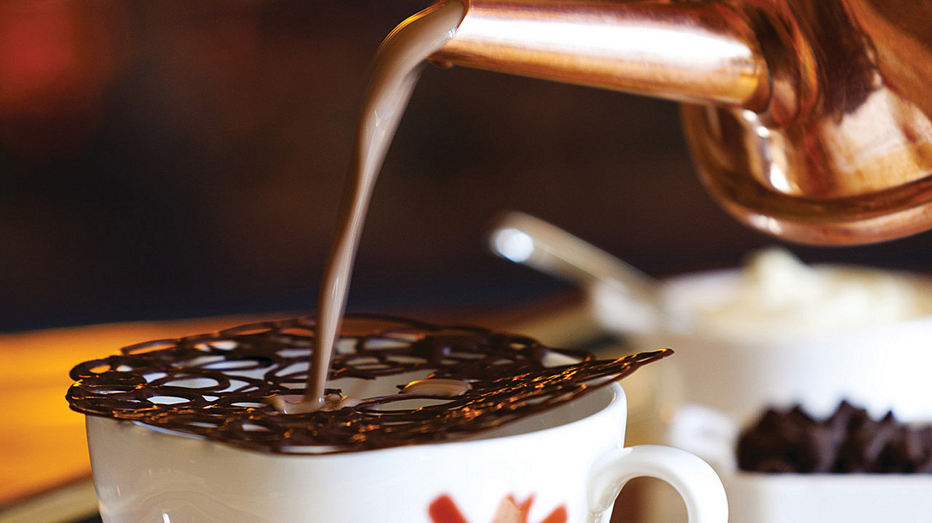
The drink menus of Flame, The Remedy Bar and In Room Dining offer many ways to warm up after a day on the slopes, with options ranging from a cup of mulled apple cider to a snifter of cognac. Another choice, found exclusively at
Four Seasons
Resort and Residences Vail, is the Resort's decadent take on hot chocolate, known as “Haute Chocolate.”
Deep mahogany in colour and piping hot, a cup of Haute Chocolate stands in stark contrast to Vail’s vast stretches of cold, white powder. Yet it is equally as memorable. The Haute Chocolate arrives in a traditional French hot chocolate pot, presented on a silver tray. Made with Valrhona chocolate and steamed milk, it is churned tableside, allowing you to enjoy the drink at its richest and thickest.
Watch as it’s poured into a cup topped with a dark chocolate lattice and homemade marshmallow. As it all melts, the smooth and elastic texture of the Haute Chocolate becomes creamier. Intensify the experience further with a spoonful or two of chocolate shavings. A snowcap of fresh whipped cream completes the recipe.
Your journey, however, is just beginning, as you breathe in deeply the aromatic delights of the Haute Chocolate. A first sip is followed by contemplation, relaxation and ultimately, pure warmth.

RELATED

October 28, 2019, Toronto, Canada
Experience North America’s Premier Ski Destinations with the Four Seasons Mountain Collection
https://publish.url/news-releases/2019/mountain-collection-winter-2019-2020.html

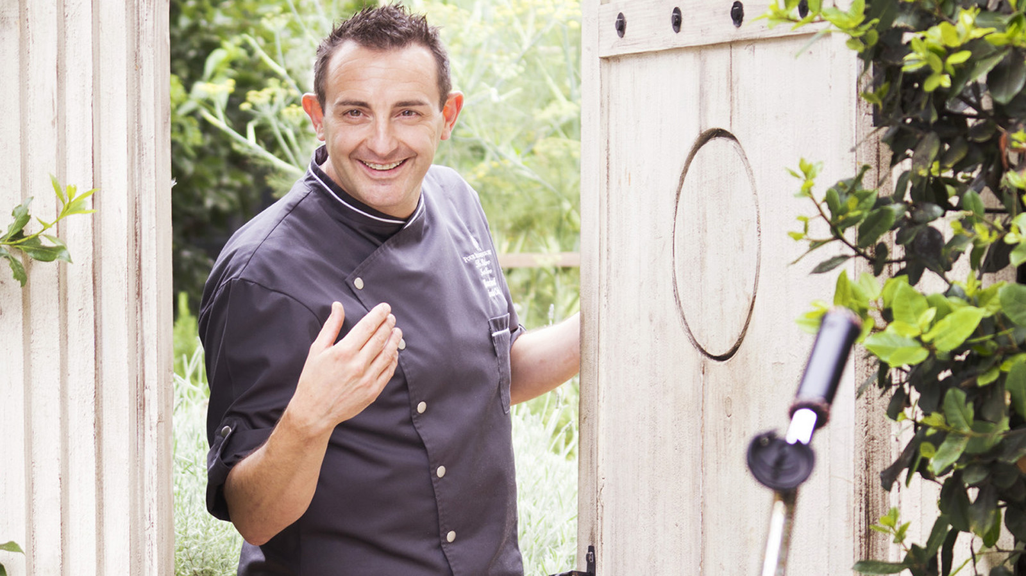 | July 30, 2019, Vail, U.S.A.  Four Seasons Resort and Residences Vail Announces New Executive Chef Marco Fossati  https://publish.url/vail/hotel-news/2019/new-executive-chef-marco-fossati.html

PRESS CONTACTS

Jonathan Reap
Director of Public Relations
One Vail Road
Vail
USA
jonathan.reap@fourseasons.com

+1 970 477 8687

