Four Seasons Hotel Washington, DC Transforms Back into a “Hotel on Ice” This Winter, Bringing the Cool Back to the Capital

This sensational seasonal event returns bigger and better to top winter travel bucket Lists, with dining in Champagne Bubbles at BOURBON STEAK, après ski at ENO Wine Bar, winter spa treatments, and so much more
November 6, 2019, Washington, DC, U.S.A.

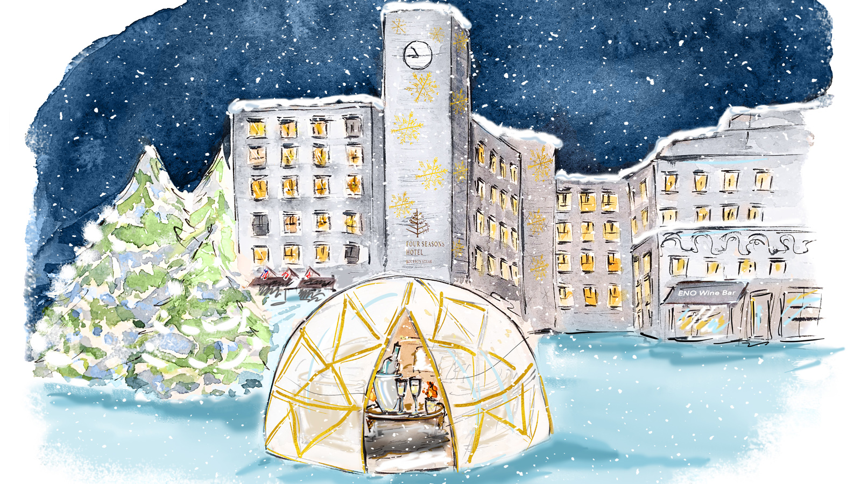
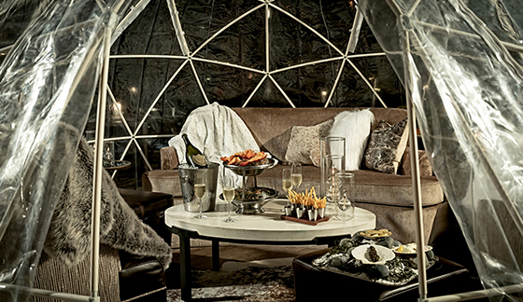 | 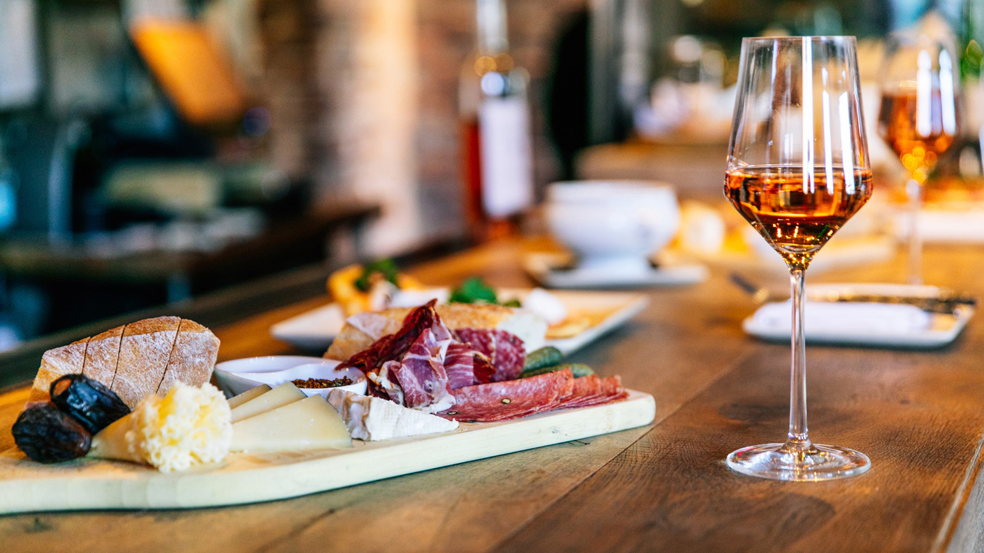 | 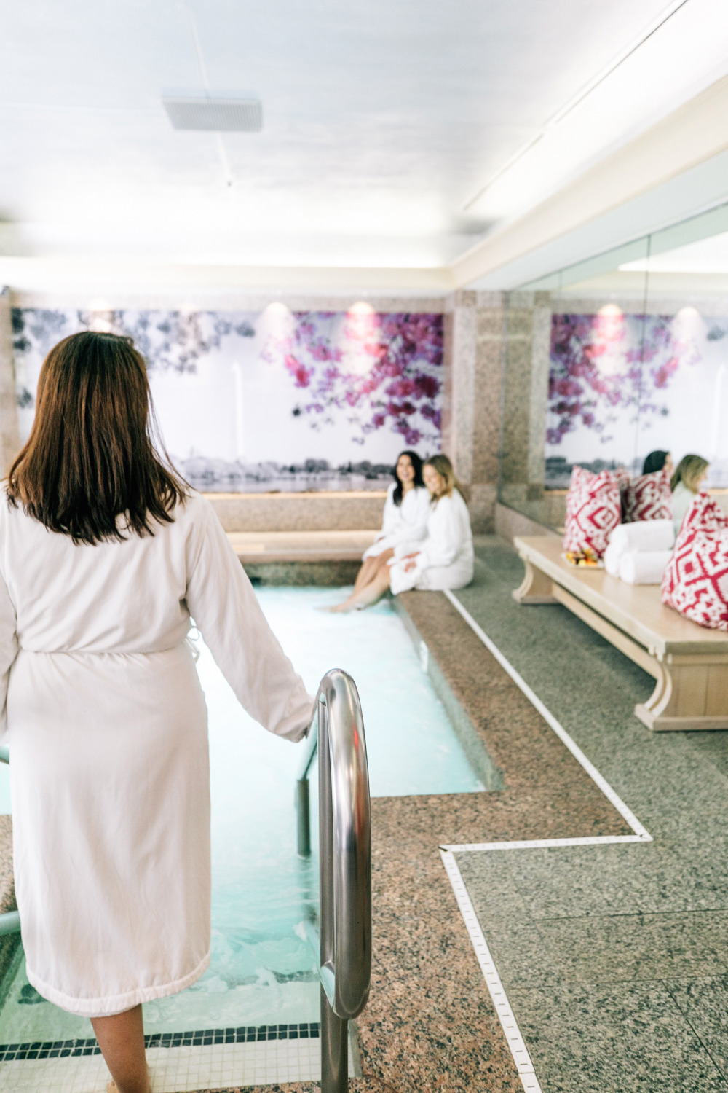
Four Seasons Hotel Washington, DC brings back the coolest winter experience to be had without leaving the city. Get away for a weekend, or even just a few hours with a winter wonderland experience that no one will forget. From dining in Champagne Bubbles on the BOURBON STEAK patio or enjoying a festive après-ski at ENO Wine Bar and chilling at The Winter Spa, create indelible memories this winter at Four Seasons Hotel Washington, DC.
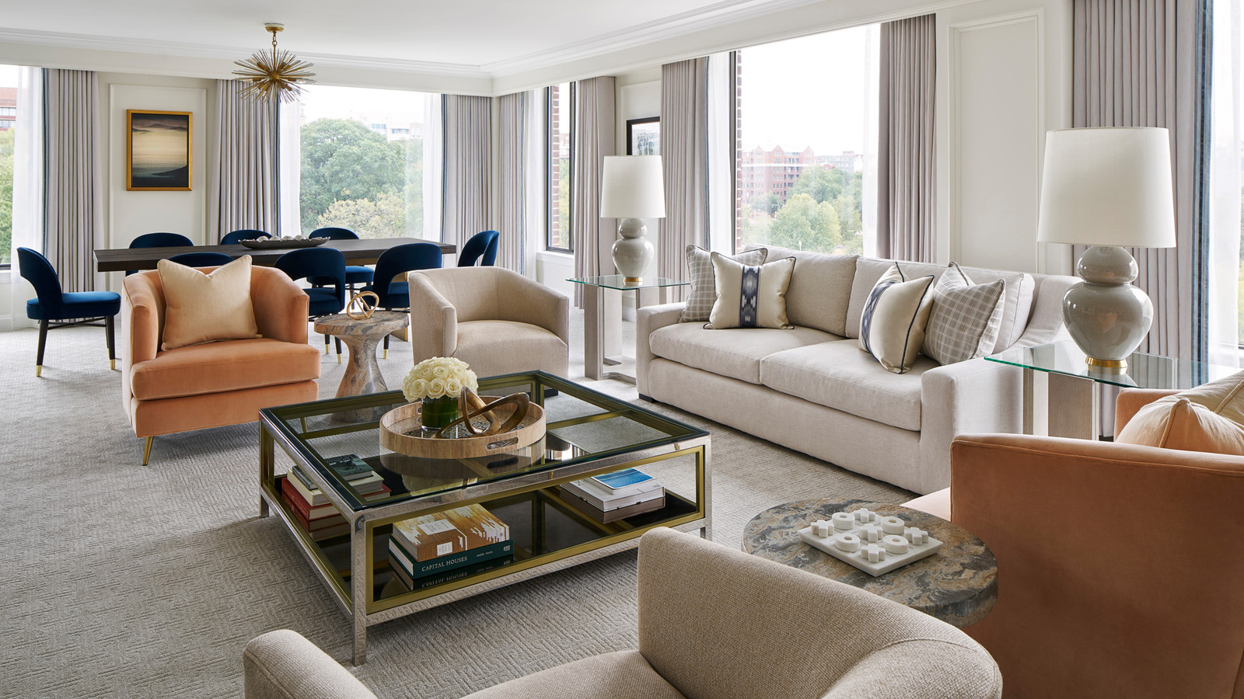 | 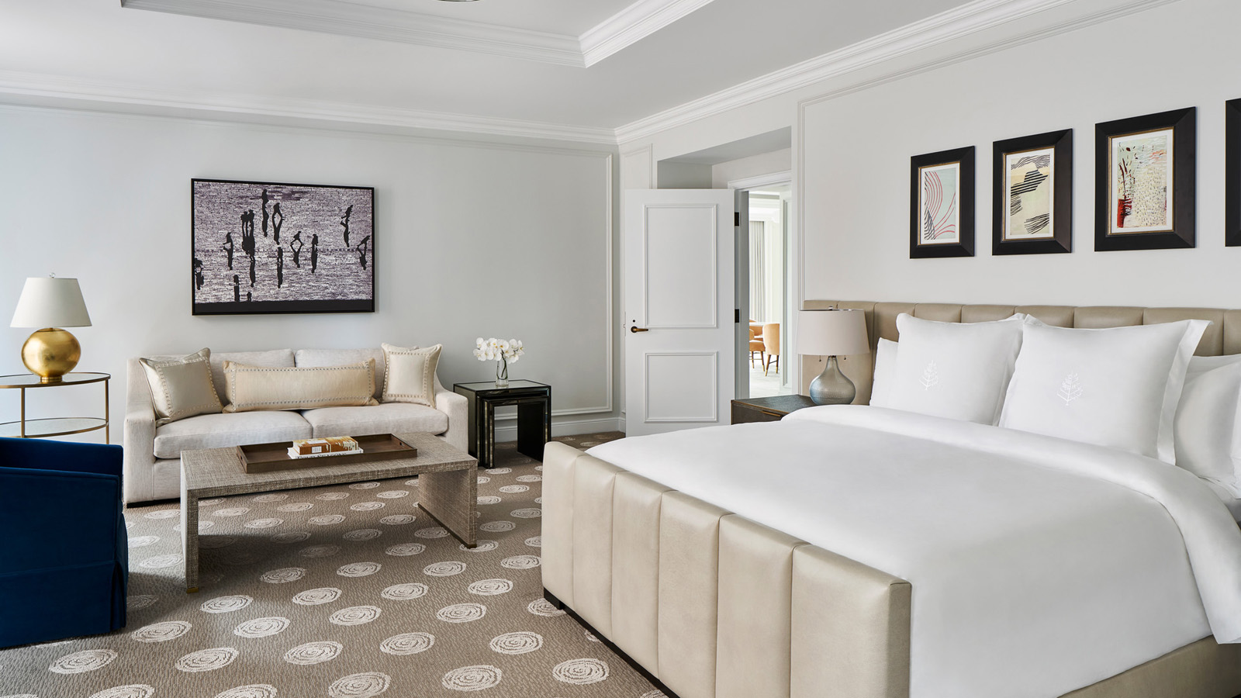 | 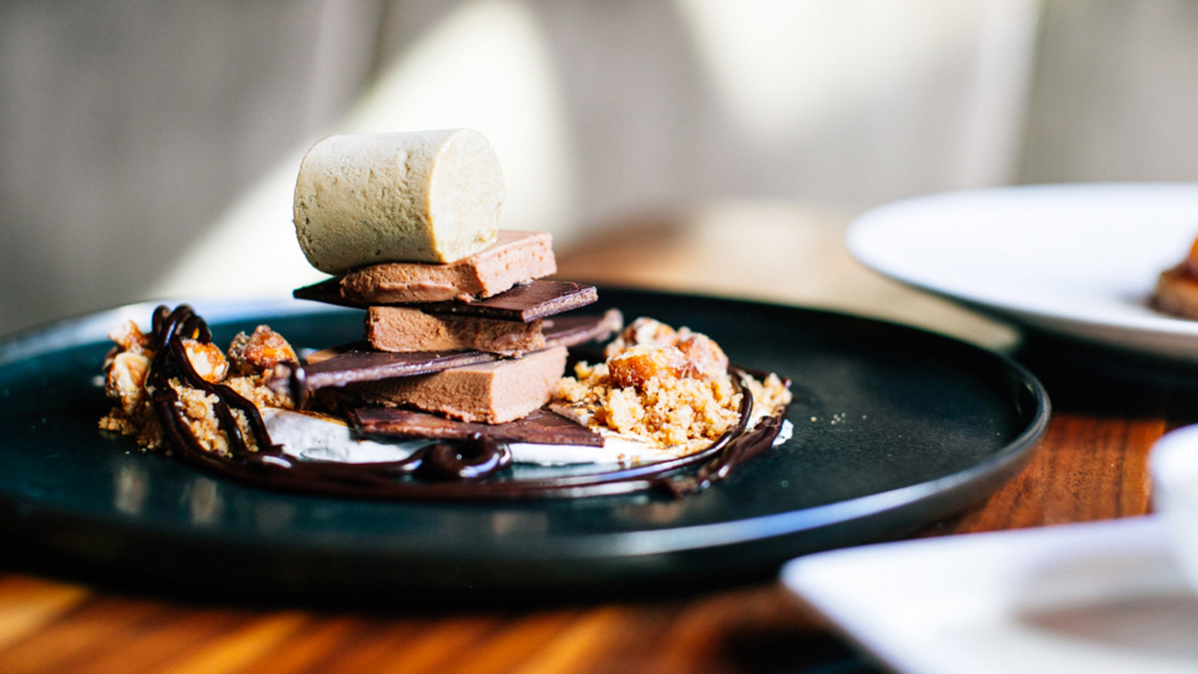
At BOURBON STEAK, the award-winning restaurant's patio returns to “BOURBON on Ice” all season long. This outdoor dining experience features three heated “Champagne Bubbles” in collaboration with the most exclusive Champagne houses by Mo&euml;t Hennessy. Each Champagne Bubble is decorated to embody the personality of its namesake Champagne.
The Ruinart Bubble pairs art and Champagne in a creative blend. Enjoy a full BOURBON STEAK menu - with specials such as a show-stopping baked Alaska dessert - in a private dining room under the stars. The Krug Bubble celebrates music and invites guests to play vinyl records while enjoying the vitality of Krug Champagne. Lastly, the Dom Pérignon Bubble is the ultimate celebration of the finer things in life. Experience elegance and harmony while relaxing in the luxurious lounge setting. Soft blankets, twinkle lights and Champagne only enhance the backdrop of a wintery night.
For family fun, stay local and reserve a Bubble experience for lunch. Enjoy smoked s’mores and hot chocolate while playing snowy lawn games such as light-up bean bag and ring toss.
ENO Wine Bar becomes a classic “après-ski,” without the “ski” all season long. Whether it is “après-shop” or “après-work,” ENO offers drink specials and an Alpine menu featuring fondue, raclette and charcuterie to warm up even the chilliest evening. For the ultimate cool experience, visitors to Georgetown are welcome to stop by the pop-up, underground “Winter Garden” for mulled wine and hot candied almonds. Stay awhile and get comfortable: the curated wine list features magnums and double magnums.
The ultimate in relaxation can be found at the Forbes 4-Star Winter Spa, with a Rock Creek Forest Massage. With hints of balsam fir and white pine, locall- inspired deep forest and mint body oils smooth the skin from head to toe during this full-body experience. A mug of piping hot spiced cider awaits spa patrons after their time in the steam room, sauna and whirlpool.
For guests traveling with children, the magic continues in-room with icy amenities and glow-in-the-dark sleeping igloos, creating a fun and wondrous experience. There’s truly something for everyone at the urban wonderland of Four Seasons Hotel Washington, DC this winter, with romantic activities for two, group attractions galore, and boundless family offerings. It’s a winter destination beyond compare, for all ages and stages.
Within just a few steps from the Hotel, from December 6, 2019 through January 5, 2020, glowing modern art installations (part of Georgetown GLOW) will act as shining beacons welcoming visitors to the city’s charming Georgetown neighbourhood. Inside the Hotel, the art exploration continues with a winter-inspired exhibition of evocative metal couture sculptures by renowned French artist Stephane Koerwyn.
Over the holidays, this cool transformation continues with Light Up the Season, a holiday event throughout the month of December showcasing festive decorations fashioned by the city's top local designers, all for a worthy cause (proceeds benefit the Children's National Hospital). Post-holiday, themed florals by Helen and Olivia Flowers will be an equally enchanting must-see display.
Visit pre-Christmas to take-in holiday sites such as National Christmas Tree, or arrive post winter holidays for a skate on Washington Harbor, just a short walk away. And that’s just the start of the many extraordinary adventures to be had citywide, and within the walls of Four Seasons Hotel Washington, DC. Plan a winter getaway to Four Seasons Hotel Washington, DC and call +1 202 342 0444 to benefit from a Stay Longer - Third Night Free offer.

RELATED

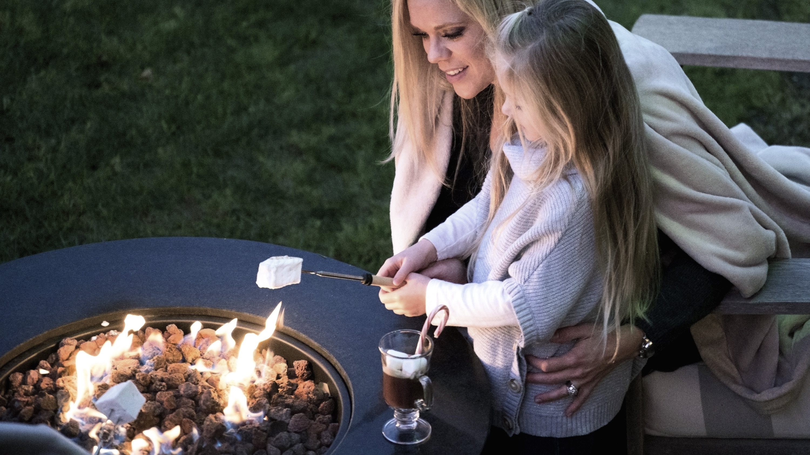 | November 4, 2019, Toronto, Canada  Let It Snow! Even in Warmer Climates, Four Seasons Offers Fresh Reasons to Get Cosy This Winter  https://publish.url/news-releases/2019/unique-winter-activities-at-four-seasons.html
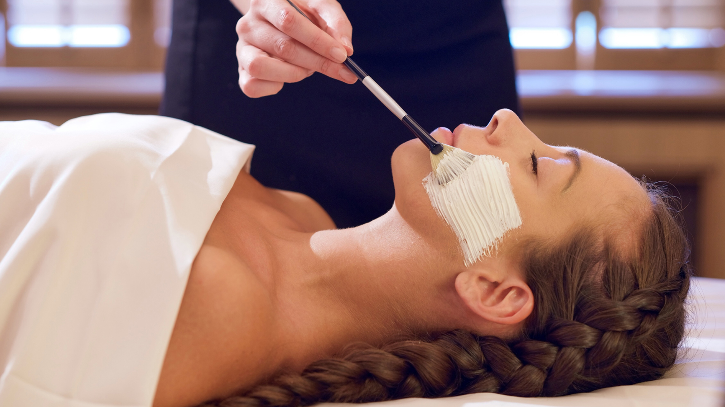 | October 3, 2019, Washington, DC, U.S.A.  Four Seasons Hotel Washington, DC Welcomes High Performance French Skincare Line CODAGE Paris to The Spa for the First Time in Washington, DC  https://publish.url/washington/hotel-news/2019/codage-at-the-spa.html

PRESS CONTACTS

Anina Belle Giannini
Director of Public Relations
2800 Pennsylvania Avenue N.W.
Washington
U.S.A.
aninabelle.giannini@fourseasons.com

+1 202 944 2074

