Florence with Kids: 5 Best Family Experiences

June 14, 2018, Florence, Italy

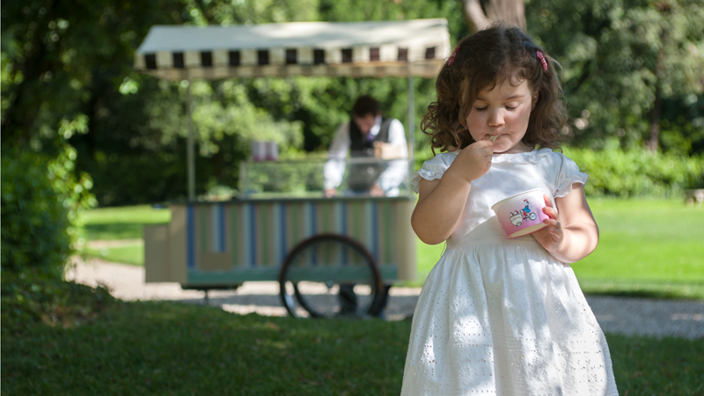
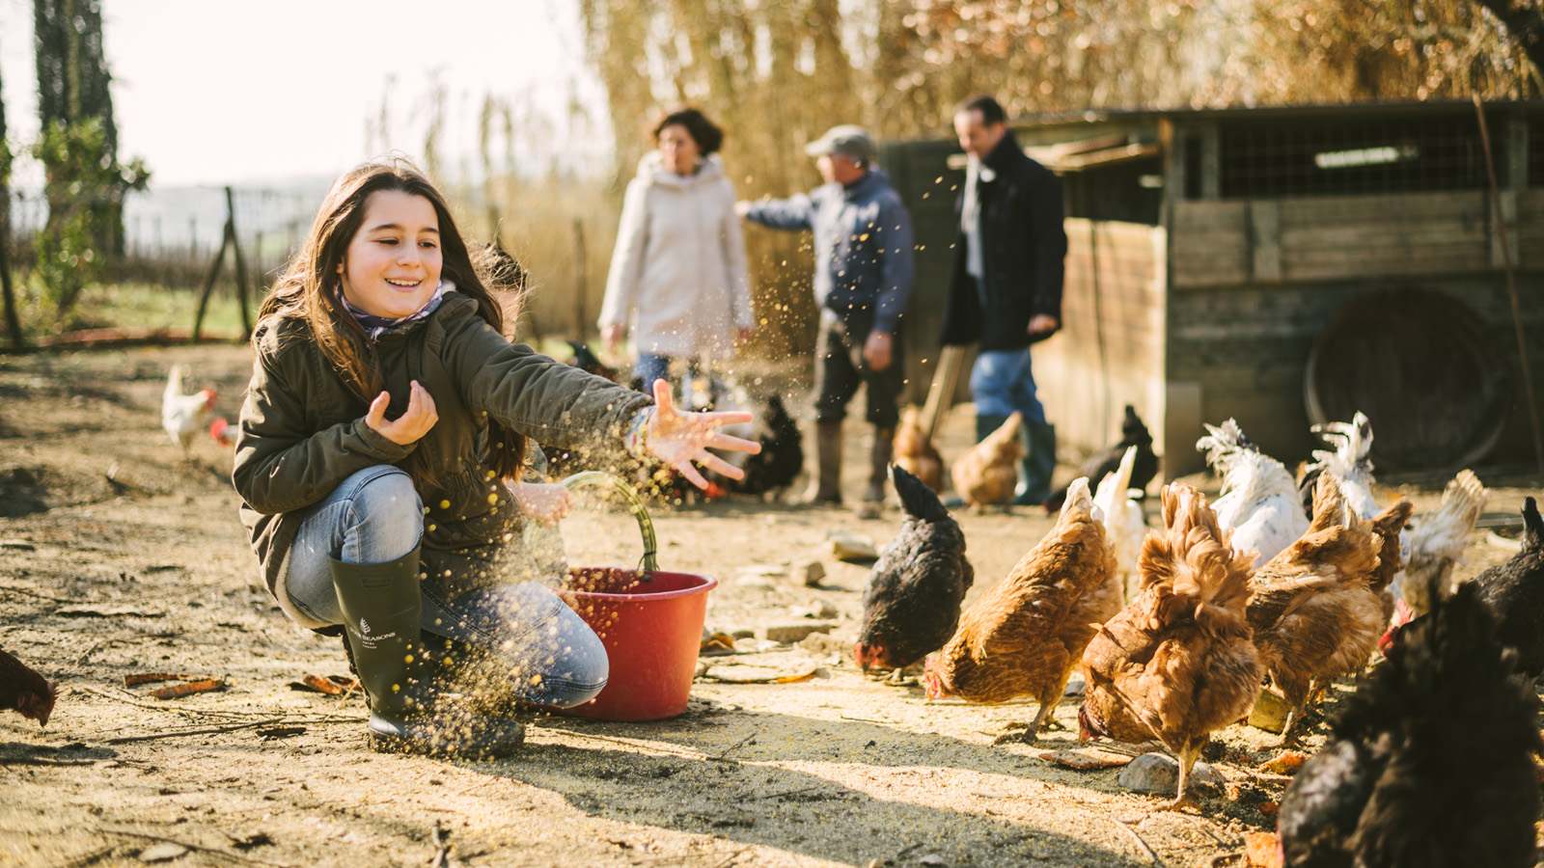 | 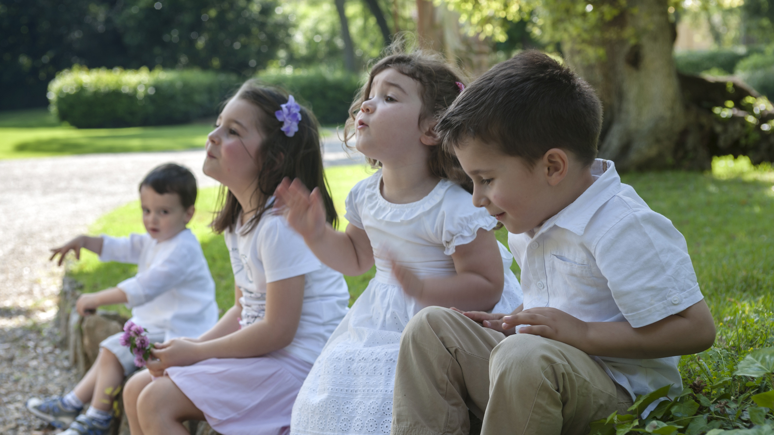 | 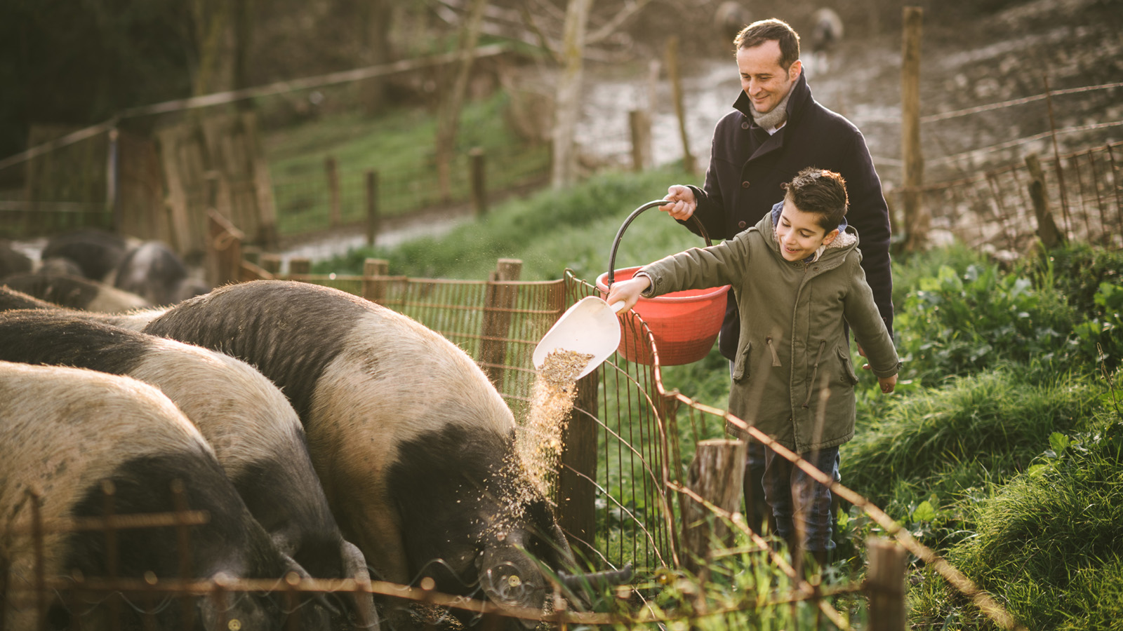
Florence is the cradle of Renaissance, famous for its magnificent art and architecture, but it also offers unique and fun activities for families and children of all ages. Paul Lydka, Head of Concierge of Four Seasons Hotel Firenze, suggests the best experiences to spend an afternoon or a day together with all the family.
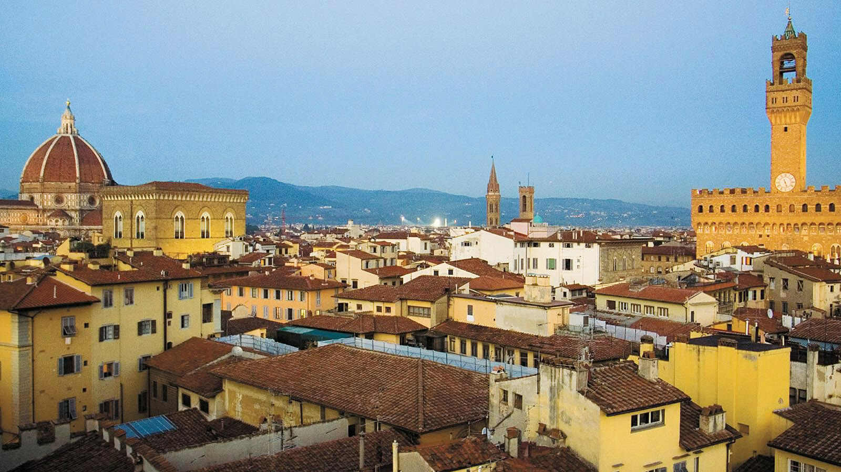 | 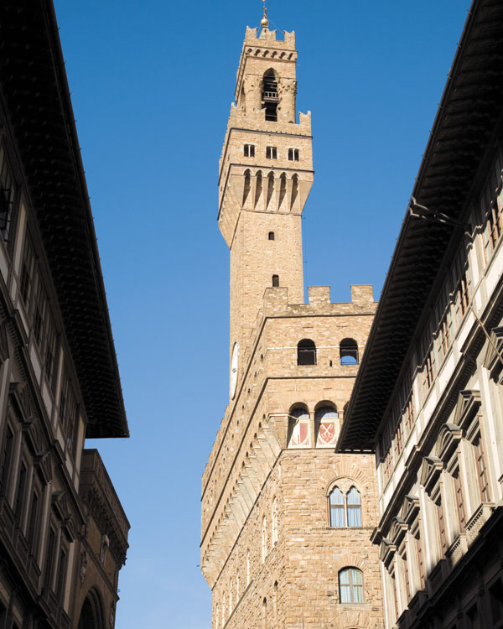 | 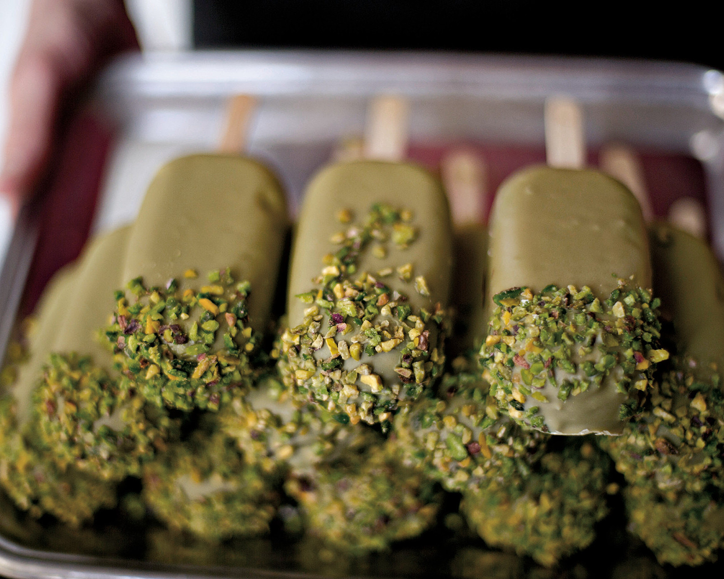
Visit one of the Kids-friendly museums
Thinking about Florence, art and culture are the first things that come to our minds. But who says that museums are for adults only? In Florence there are several museums perfect for kids that offer engaging and fun activities for families. First of all, Palazzo Vecchio, in Piazza della Signoria, offers daily activities for children from four years old and families, together with interactive visits discovering all the secrets of the Medici family, who built the building ages ago. The stunning Villa Montughi hosts the Stibbert Museum,a kids’ favourite because of its huge and amazing armour room, hosting a spectacular collection of armours, horses and riders in real size. For kids who prefer science and animals, there is the Leonardo da Vinci museum, famous for its interactive and fun inventions that kids can actually try and touch, or the National History Museum, with a huge collection of skeletons and fossils.
Have a safari in the Fattoria di Maiano
Not everyone knows that in the Florentine hills there is the possibility of having a real safari, discovering different animals in their natural habitat. The location is the Fattoria di Maiano, a wonderful estate dating back to 1400, immersed in the Fiesole hills, just 15 minutes from Florence. There, kids will have the possibility to see cows, bulls, and amiata donkeys, during a tour discovering also the most beautiful corners of the area, such as the Laghetto delle Colonne: legend has it that Queen Victoria, while staying at the Temple Leader’s Villa, has sketched it. The same tour can be done during the night, admiring the wildlife: foxes, deer, porcupines, pheasants and many other odd animals.
Have a walking tour discovering the secrets of the city centre
Our Concierge can organize a fun and engaging walking tour of the city centre, discovering the best hidden spots and city’s secrets that all children will love. The tour can start with a ride on the antique carousel in Piazza della Repubblica, and continue with a visit to Bartolucci, the historical wooden toy store and artisan producing typical and traditional toys, such as the famous Pinocchio. Families can then discover Il Porcellino (“the little pig”) fountain, located in Piazza del Mercato Nuovo. This unique and loved by Florentines statue is a wild boar, and supposedly brings good luck when visitors rub his snout and put a coin in his mouth. Another nice place for families is the Central Market: kids will have the chance to see – and taste! – all the best Florentine delicacies in a real, historical market, just like real Florentines do every morning. And don’t miss to taste a gelato!
Live a day as a farmer
Wonder how the best Italian products are grown? The secrets behind the “farm to table” process, or simply curious to see what a typical day is like on a Tuscan farm? The Table to Farm experience allows guests to live the Tuscan country life, spending a day as guest estate farmhands in the Fattoria San Michele, a barn estate in the Chianti region, located in a medieval building. Children will have the possibility to feed chickens, pick eggs, plant vegetables, feed pigs, and learn how the best oil and wines are produced. The morning will end with a delicious lunch, with all the local and biological products produced in the farm.
Get lost in Boboli Gardens
Boboli Gardens is one of the most ancient and famous parks in Italy. It was built by the Medici family as their private garden, when they used to live in Palazzo Pitti, and was designed by the famous Bernardo Buontalenti. Here, families can wander around by themselves discovering all the fountains, statues, grottos, lush lawns and fish ponds decorating this huge garden, one of the most important examples of Italian gardens of all over the world. Families can also take part to one of the tours dedicated to families and kids, and climb up reaching Forte di Belvedere, a 16th century fort with huge lawns and space to run and have fun.

RELATED

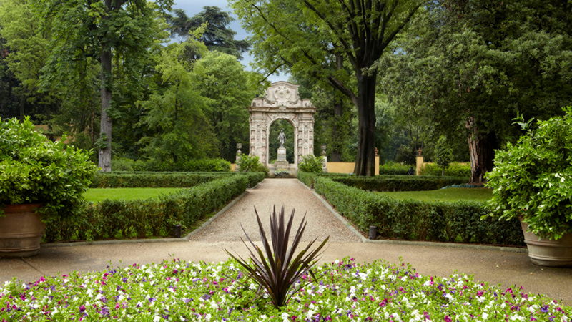 | June 2, 2018, Florence, Italy  Four Seasons Hotel Firenze compie 10 anni e organizza tre giorni di scintillanti festeggiamenti  https://publish.url/it/florence/hotel-news/2018/10th-birthday-2.html
June 2, 2018, Florence, Italy
Four Seasons Hotel Firenze Marks 10 Years with Three-Day Anniversary Celebration
https://publish.url/florence/hotel-news/2018/10th-birthday.html

PRESS CONTACTS

Caroline Mennetrier
Director of PR and Marketing Communication
Borgo Pinti, 99
Firenze
Italy
caroline.mennetrier@fourseasons.com

+39 02 7708 1795

Martina Nesti
Public Relations and Marketing Communications Coordinator
Borgo Pinti, 99
Firenze
Italy
martina.nesti@fourseasons.com

+39 055 2626222

