City of St. Louis is Muse for New Room Art and Design at Four Seasons

May 11, 2022, St. Louis, U.S.A.

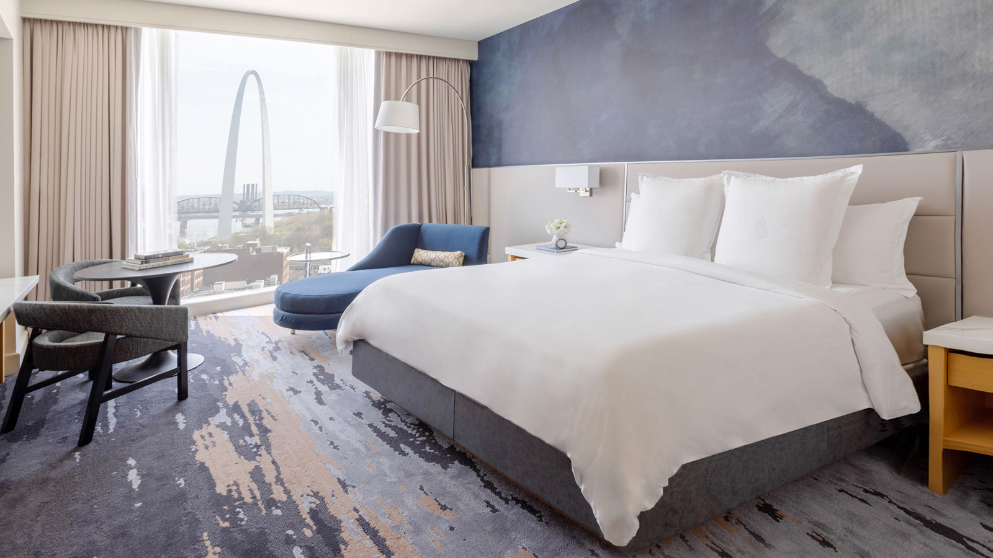
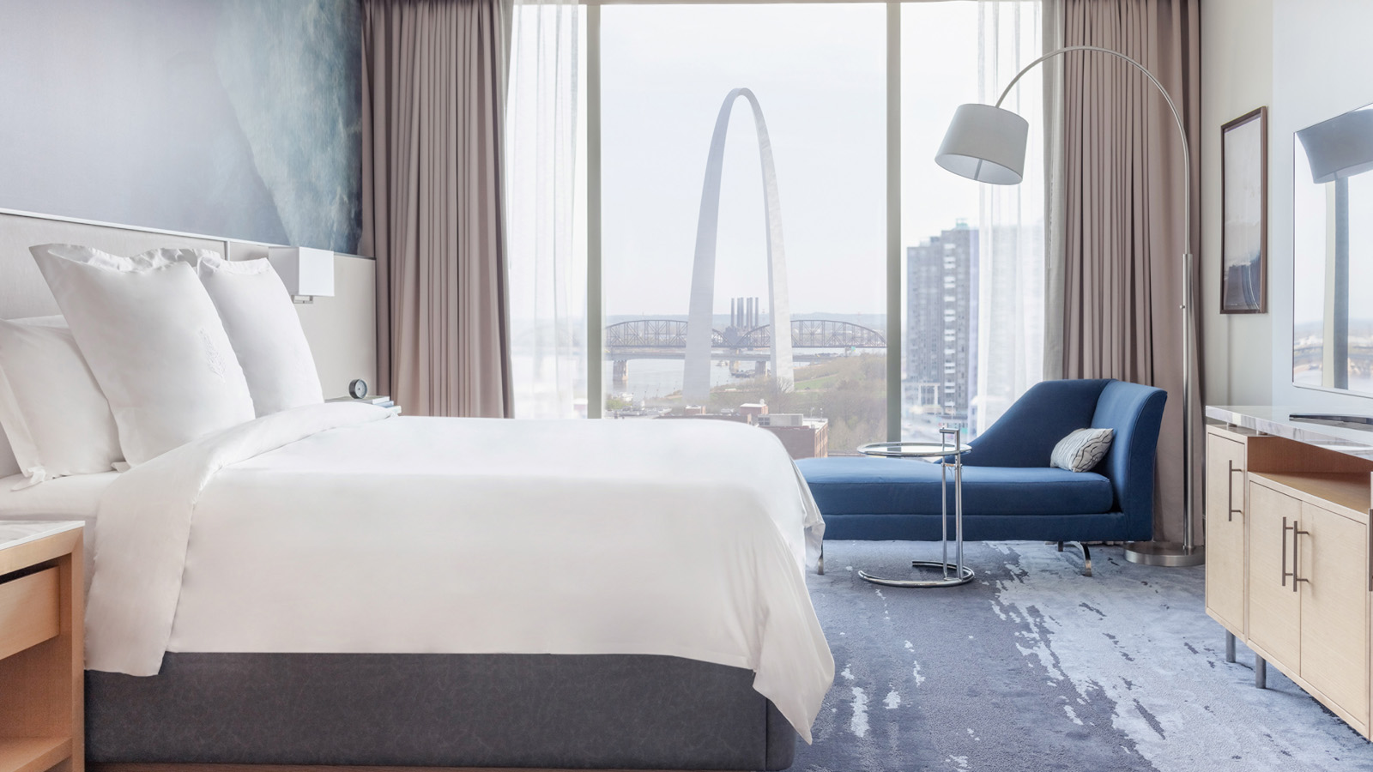 | 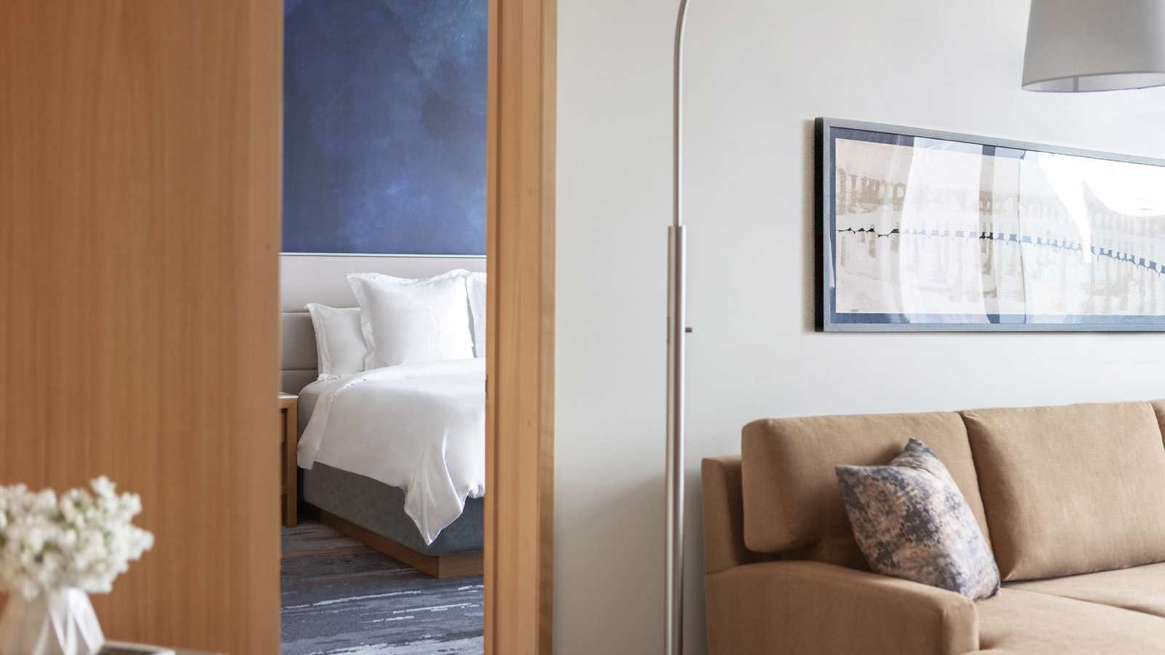 | 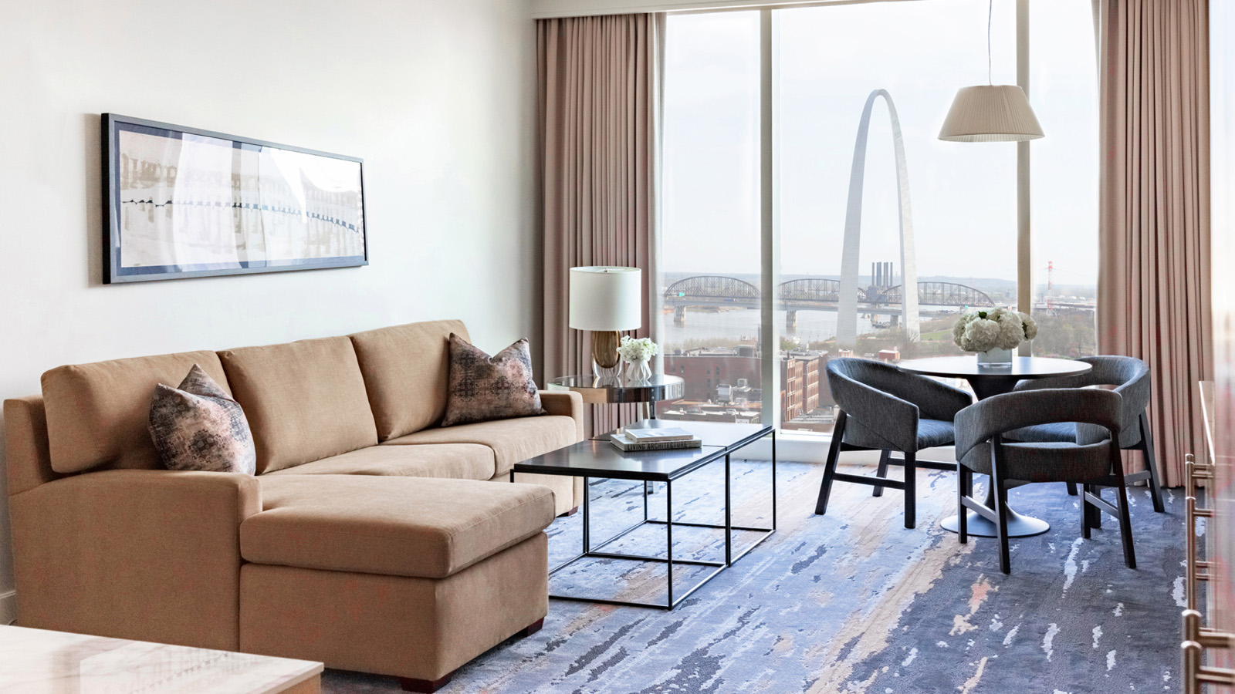
Led by St. Louis-based R|5 Design Agency, the idea behind the guest room redesign of Four Seasons Hotel St. Louis was to create the ultimate in-room relaxation environment while infusing the spirit of St. Louis and providing a strong sense of place. Inspiration came while looking out the Hotel’s windows, which frame magnificent views of the majestic Mississippi River and the Eads Bridge, and, of course, the iconic Gateway Arch.
According to acclaimed designer Manuela Macias, Design Manager of R|5 DESIGN AGENCY, “The design goal was to achieve a cohesive guest experience from the first step into the lobby through to the guest room. There, we sought to create a superlative wind down zone with soft and plush textures where guests can relax and enjoy the one-of-a-kind view. We integrated many local design aspects to connect guests to the city and enjoy a truly memorable stay.”
Soft carpeting with a mottled blue, grey and taupe abstract pattern lays the canvas for the other design elements to shine. Furniture and cabinetry in pale wood tones are topped with crisp white marble for a clean and airy aesthetic. Anchoring the room is a bold custom-designed wallcovering in undulating shades of blue alluding to the river outside and highlighting the jewel tones present elsewhere. Balancing this moody element is a bespoke crafted headboard in taupe leather with up lighting to gently illuminate the wallcovering and showcase its rich texture. With lighting and outlets incorporated directly into the headboard, the result is a clean feel and visual.
A lounger lushly upholstered in navy blue velvet beckons guests to relax and take in the stunning views from the floor-to-ceiling windows. Glass accent tables and light fixtures, graceful floor lamps, and textured accent pillows complete the serene, sophisticated look.
Perched on the Hotel’s 19th floor, the redesign of the impressive 2661 square foot (247 square metre) Presidential Suite incorporates custom-designed furniture and carpeting to match the grandeur of its sweeping views. This includes a stunning hand-crafted étagère in the main bedroom that was specifically designed to not only artfully divide the space but echo elements visible throughout the Hotel. The living and dining rooms have bespoke hand-tufted area plush rugs that give the feeling of walking on clouds. Soft and luxurious leather living room furniture is the epitome of comfort while a feature chandelier over the dining table adds a touch of glamour.
R|5 Design Agency partnered with Kevin Barry Art Advisory to curate a collection of special pieces that represent and symbolize the nearby St. Louis landmarks. The artwork program was inspired the contrast between the flowing motion of the Mississippi River and the sleek, steel structures for the which the city is known. Textural pieces evoke the river’s fluidity and are complemented by abstract elements that reference the delicate arcs and lines of St. Louis’ architecture.
Produced by a mix of contemporary artists, each piece was selected to grace the walls of the guest rooms based on its ability to conjure and reflect the quintessential elements of St. Louis. The iconic Gateway Arch serves as inspiration for selecting Bauhaus artist Laszlo Moholy-Nagy’s bold abstract, which resonates the Arch’s curves; Jennifer Goldberger’s golden giclee that evokes the view from under the Arch; and Dana Shek’s work entitled Deconstructed Arch. In addition to physical landmarks, the city’s strong sports culture influenced the choice of Paul Duncan’s Ice and Eunice Kim’s Puck Abstract 1 & 2 as tributes to the St. Louis Blues hockey team.
The renovation is slated for completion mid-summer 2022.

RELATED

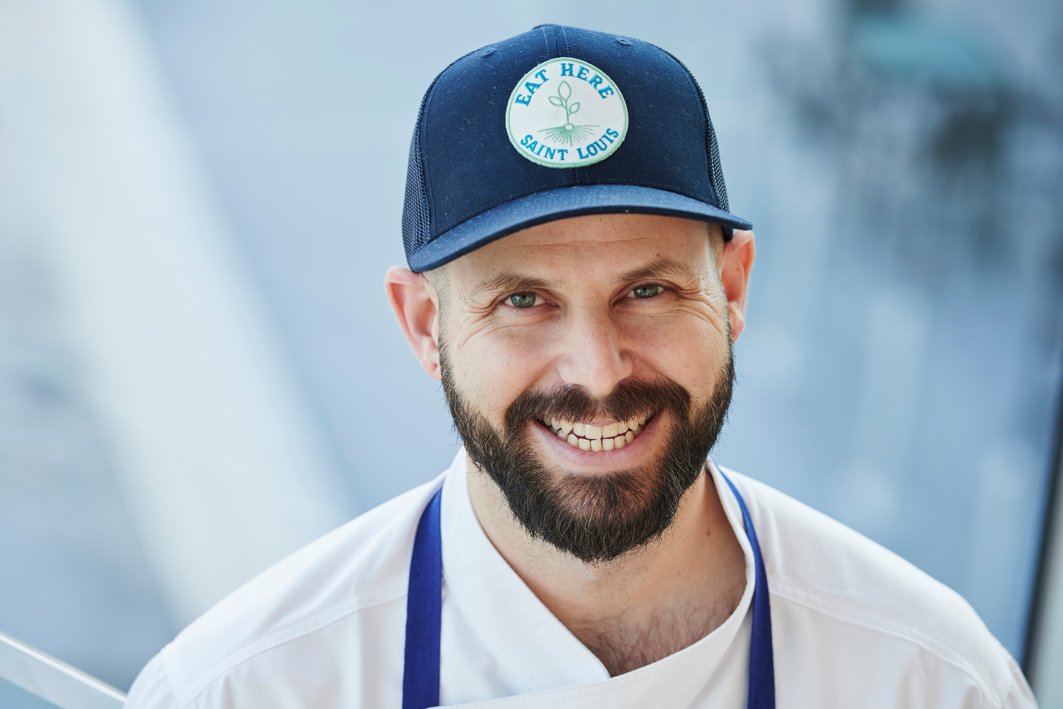 | March 7, 2022, St. Louis, U.S.A.  Cinder House at Four Seasons Hotel St. Louis Launches New "A Chef For All Seasons" Dinner Series  https://publish.url/stlouis/hotel-news/2022/dinner_series.html
February 28, 2022, St. Louis and Chicago, USA
Four Seasons Hotel St. Louis and Four Seasons Hotel Chicago Partner for the Ultimate Route 66 Road Trip
https://publish.url/stlouis/hotel-news/2022/route-66-road-trip.html

PRESS CONTACTS

Teresa Delaney
Director of Public Relations
999 North 2nd Street
St Louis
USA
teresa.delaney@fourseasons.com

+1 314 881 2025

