Les Clefs d’Or Member Zalan Schuster Appointed as Chief Concierge at Four Seasons Hotel Riyadh at Kingdom Centre

April 21, 2022, Riyadh, Kingdom of Saudi Arabia

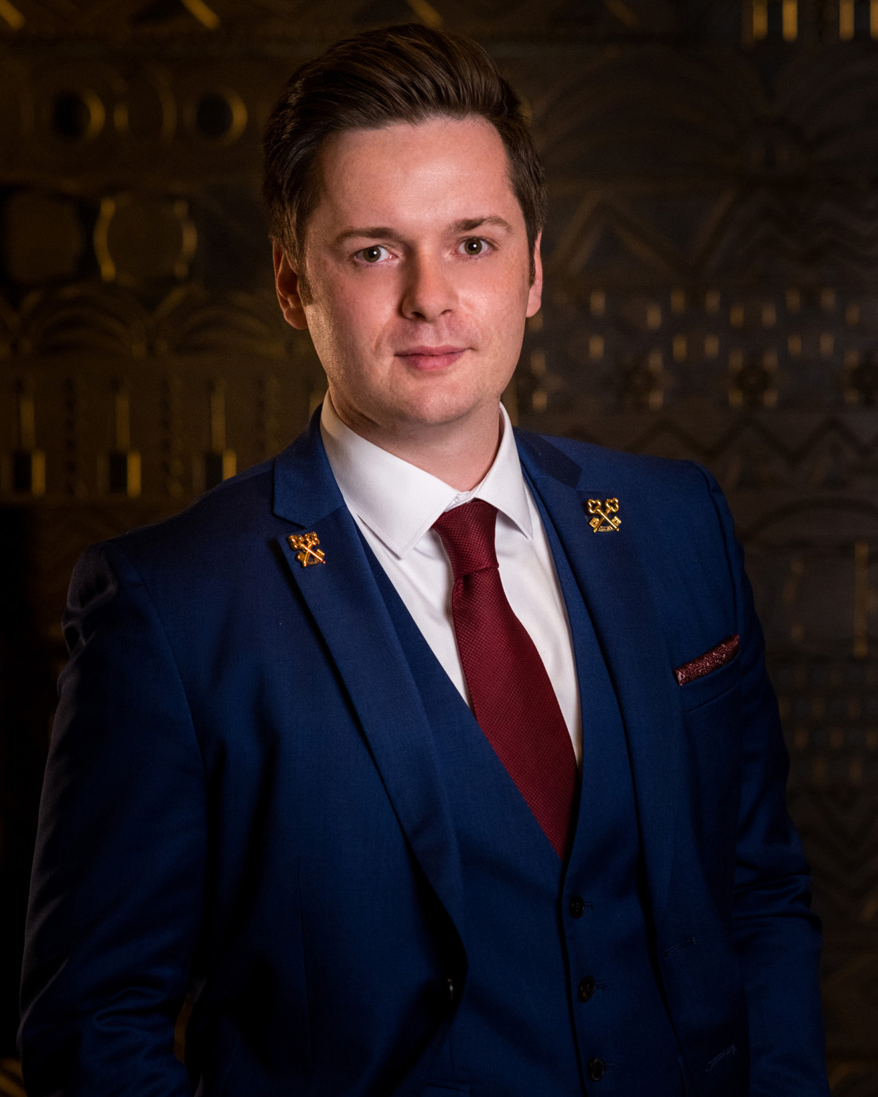
Four Seasons Hotel Riyadh at Kingdom Centre has announced the appointment of Zalan Schuster as its new Chief Concierge. Impassioned about his profession, experience at luxury hotels, and a member of Les Clefs d’Or, the international organization of the crème de la crème of hotel concierges, Schuster arrived at the sky-high Hotel in the Saudi Arabian capital on a mission to curate enriching and exciting destination experiences for guests.
“Being a concierge is so much more than a job – it’s a lifestyle,” says Schuster. “Welcoming guests and going the extra mile to ensure they’re getting the most of their stay here in Riyadh gives me as much pleasure as I hope their experiences give them.”
Appointed in late 2021, Schuster quickly set about learning every detail of Riyadh and making connections with fine-dining restaurants, upscale retailers, and local transportation and tour operators to ensure his team can satisfy all guest requests. He also got his name around to hotel concierges throughout the city, better to have a reliable network of experts to tap as necessary. “Concierge is a society,” he says. “We all work together toward success for guests.”
Key to those connections is Schuster’s membership in Les Clefs d’Or, which he joined in early 2021 based on his experience and testing. An “elite fraternity,” of globally-connected hotel concierges, the non-profit association counts some 4,000 members in 80 countries and 530 destinations all over the world, including Riyadh.
Schuster started his hotel career as a bellboy in 2011 at a hotel on the island of Crete in Greece where, along with aiding guests with baggage, he began studying the concierge concept and decided to make membership in Les Clefs d’Or his career goal. He relocated to England in 2013 to work as a hall porter and took his first position as a concierge the following year at Alexander Hotels. In 2016, Schuster moved on to Guernsey, Channel Islands, where he became head concierge at Red Carnation Hotels, and one year later returned to mainland England for the same role on the pre-opening team of University Arms Hotel in Cambridge, part of Marriott’s Autograph Collection.
Now on his first assignment with Four Seasons, Schuster is excited to be part of the top luxury brand as well as in the Middle East. “This region has been on my bucket list since I was 22,” he says. “The hospitable Saudis and Hotel team have been incredibly welcoming and friendly, and I’m enjoying every moment.”

RELATED

April 21, 2022, Riyadh, Kingdom of Saudi Arabia
تعيين زالان شوستر عضوLes Clefs d'Or كمدير خدمات الكونسيرج في فندق فور سيزونز الرياض في مركز المملك
https://publish.url/ar/riyadh/hotel-news/2022/new-chief-concierge-zalan-schuster-2.html

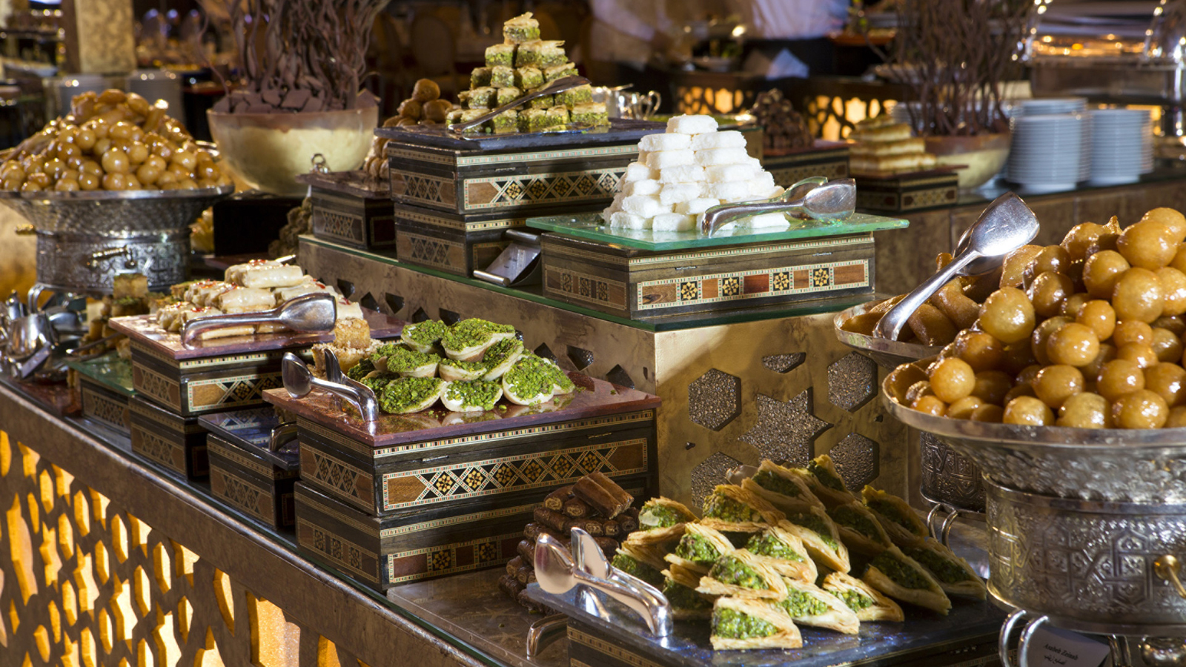 | March 21, 2022, Riyadh, Kingdom of Saudi Arabia  Legendary Ramadan Tent Returns at Four Seasons Hotel Riyadh  https://publish.url/riyadh/hotel-news/2022/ramadan.html

PRESS CONTACTS

Nada Atieh
Director of Public Relations and Communications
Kingdom Centre, P.O. Box 231000
Riyadh
Kingdom of Saudi Arabia
nada.atieh@fourseasons.com

