Four Seasons Resort Palm Beach Opens for New Arrivals and Local Experiences

Relaxed oceanfront sophistication on the island’s best beach
April 2, 2021, Palm Beach, U.S.A.

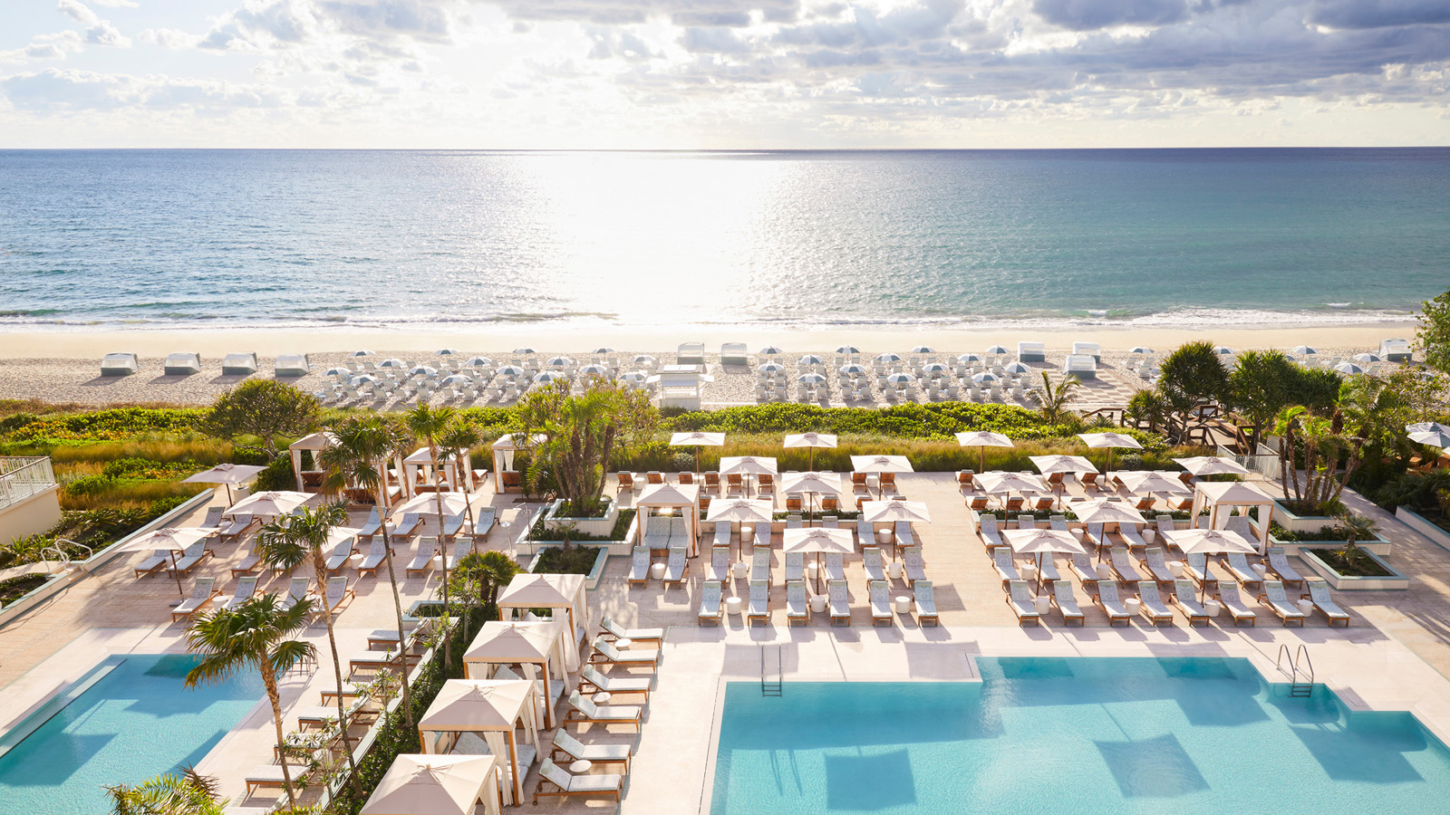
 | 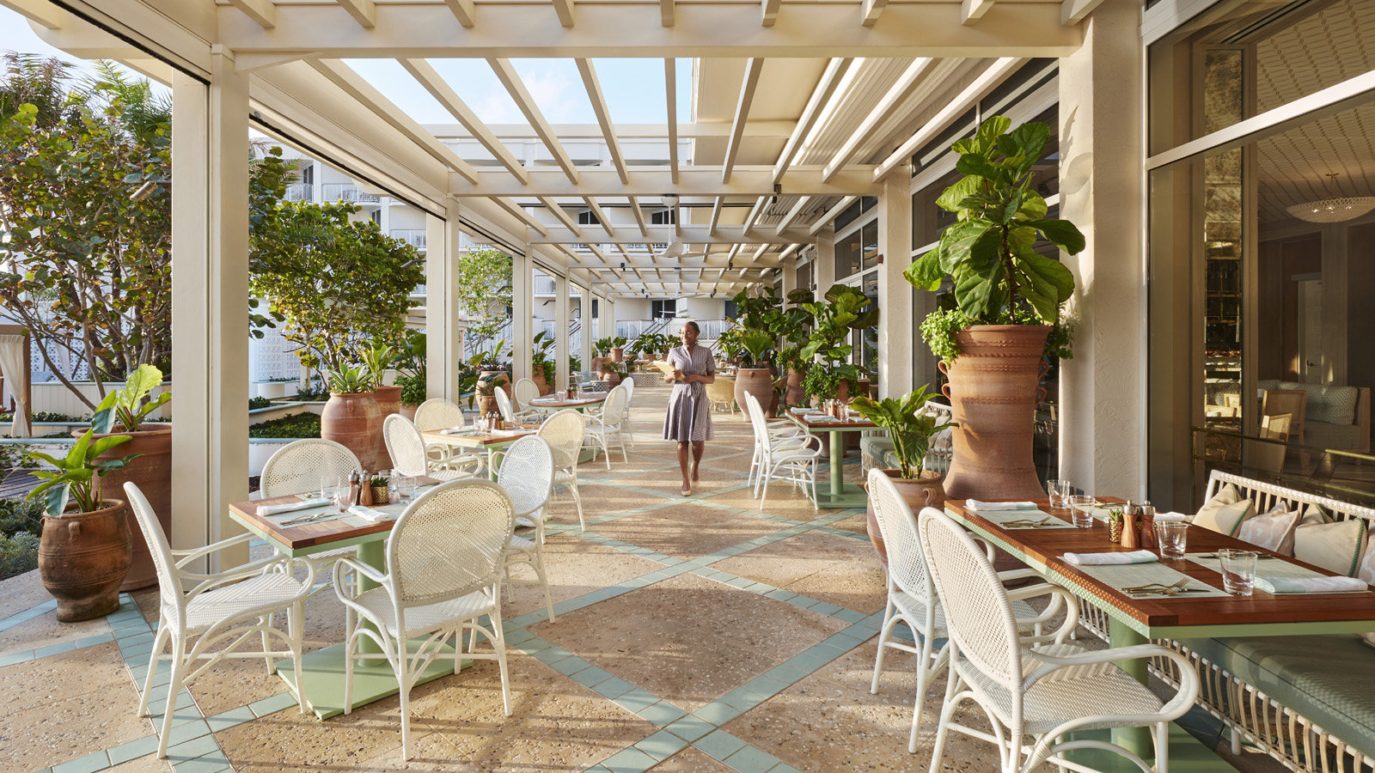 | 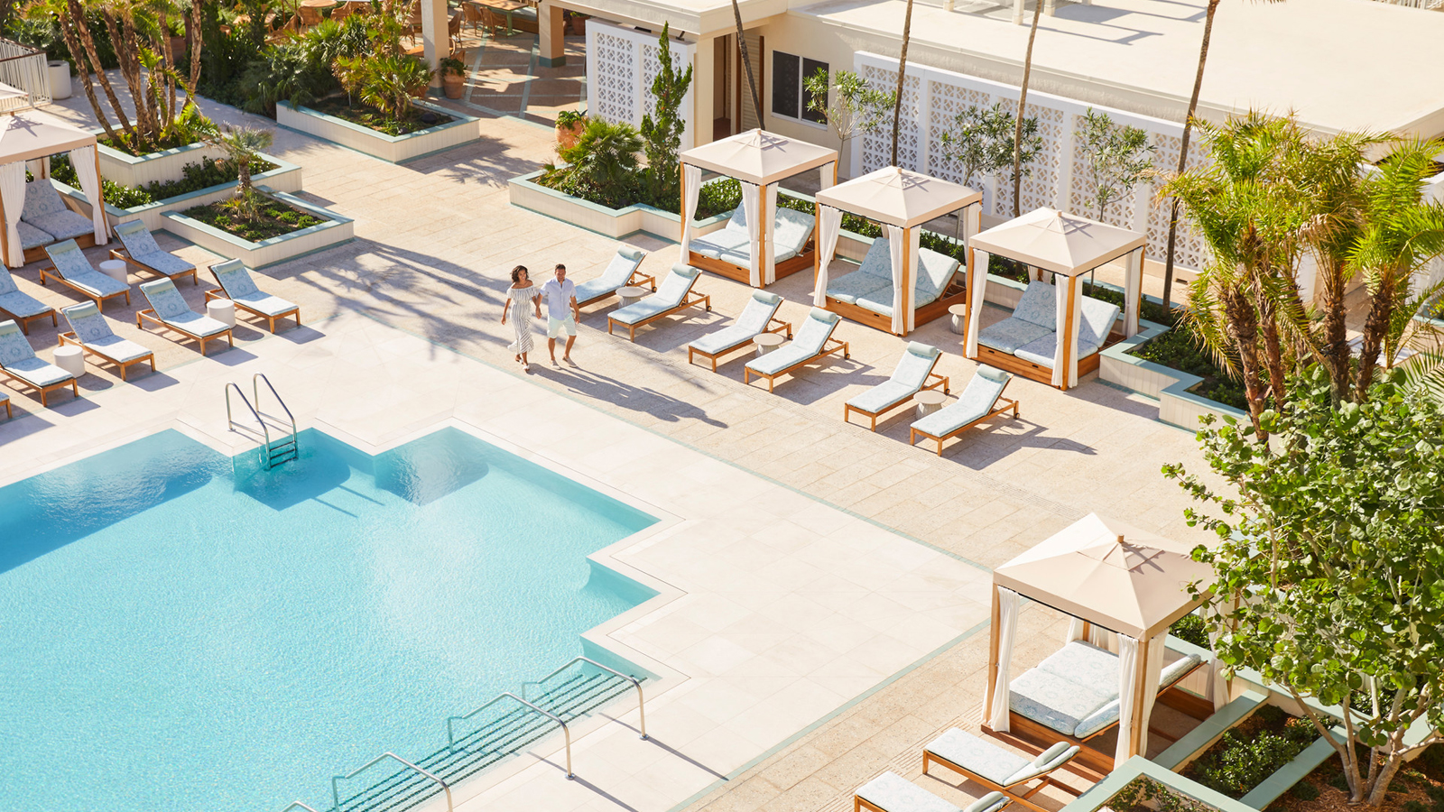
After a year of being privately reserved, Four Seasons Resort Palm Beach is now open for new arrivals and local experiences. Within the six-acre (2.5 hectare) Five-Star, Five-Diamond oceanfront oasis, guests can now relax into an easy-going pace with a private beachfront, day-to-night oceanfront dining, and a genuine and inviting energy that offers a Palm Beach experience unlike any other.
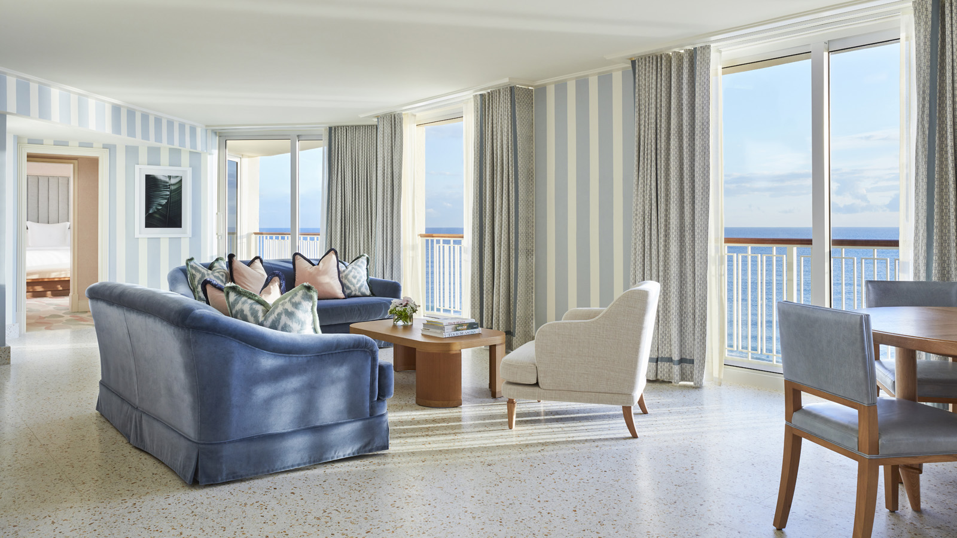
“I am most excited to welcome back our guests and locals who have been visiting for years, and to welcome guests who have yet to experience the new Four Seasons Resort Palm Beach,” says Mohamed Elbanna, Regional Vice President and General Manager of Four Seasons Resort Palm Beach. Early 2020 marked the completion of an incredible multi-million dollar, Resort-wide transformation that introduced all new guest rooms and suites as its crowning touch. Quickly becoming new favourites, the residential-style Sea Breeze Suite boasts panoramic ocean views while the new first floor Cabana Terrace Rooms offer a quintessential way to experience the Resort featuring expanded terraces with private and direct access to the pools.
“Now we have the opportunity to showcase our new look while also providing a safe environment through Lead With Care and our unique ability to lead with experience after being privately reserved as a safe haven over the past year,” continues Elbanna.
In addition to feeling right at home in new accommodations, guests will also arrive to a host of new experiences. At Florie’s, the only restaurant and bar in the United States in partnership with three-Michelin-starred Chef Mauro Colagreco, guests can feed their culinary passion in Florie’s open kitchen as chefs dish up their favourite recipes for the adult’s academy and kid’s kitchen cooking classes. At Florie’s Bar, mixologist Matthew Dress invites guests to partake as he shakes up unique creations from the new Botanical Guide, an artfully curated selection of floral-inspired and garden-driven cocktails.
With the open-air and ocean breeze luring travellers to Palm Beach, couples and families can unwind on the most expansive beach on Palm Beach Island, private for guests and just steps away. Discover the calm waters of the Atlantic with an array of new water sports, or explore the charming island by bicycle. The afternoon is met with poolside pop-ups that invite guests to come as they are for s’mores and shaved ice, or take in the best ocean view of Palm Beach under a canopy of sea grape trees while enjoying a seafood menu at the beachside Seaway restaurant.
From sunrise beach yoga to the Five Star Spa, guests have the opportunity to create a personal oasis. A new menu of hyper-personalised Spa experiences inspired by the natural elements of land, sky and sea includes Oceanique massages and body treatments, taking total body therapy to new depths with a Spa Dream aqua bed by LEMI that serenely supports and melts away tension.
An authentic Palm Beach experience, Four Seasons Resort Palm Beach is an intimate getaway where guests can truly embrace the Florida lifestyle. While the Resort’s pristine shoreline and all-new design and experiences capture the timeless charm of Palm Beach, the Resort’s greatest asset is its gracious and passionate team wholeheartedly committed to thoughtful service. “Our guests will feel the ocean breeze and be at ease as they recapture their time together and allow us to take care of everything else,” says Elbanna.
To begin planning a stay at Four Seasons Resort Palm Beach, book online or call 561 582 2800.

RELATED

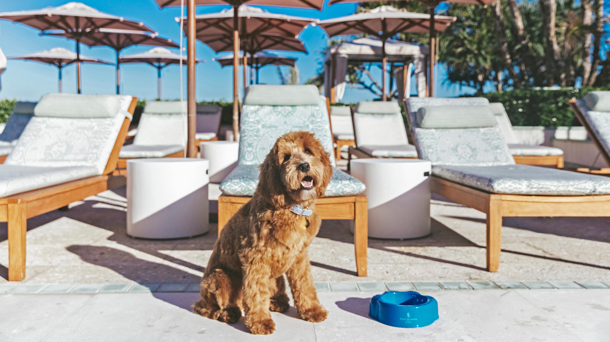 | March 26, 2021, Palm Beach, U.S.A.  Four Seasons Resort Palm Beach Welcomes Therapy Dog into Family  https://publish.url/palmbeach/hotel-news/2021/on-site-therapy-dog.html
February 16, 2021, Palm Beach, U.S.A.
Four Seasons Resort Palm Beach Continues Decades-Long Honour of Five-Star Distinction in Forbes Travel Guide’s 2021 Star Awards
https://publish.url/palmbeach/hotel-news/2021/forbes-five-star-resort-and-spa.html

PRESS CONTACTS

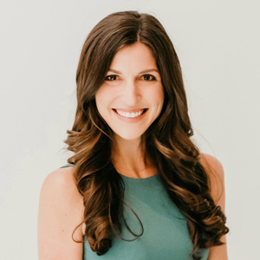 | Laurie Herrick  Regional Director of Public Relations and Communications  2800 South Ocean Boulevard  Palm Beach  USA  laurie.herrick@fourseasons.com  1 561 493 5549

