Four Seasons Hotel Jakarta Celebrates Mid-Autumn Festival with Exquisite Mooncakes

August 22, 2019, Jakarta, Indonesia

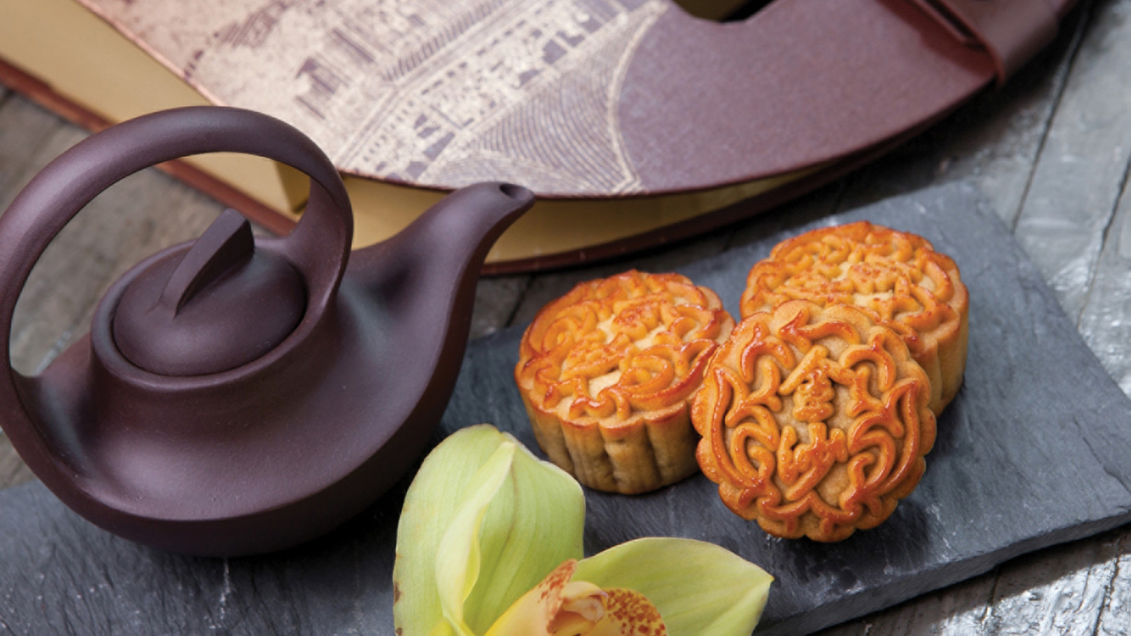
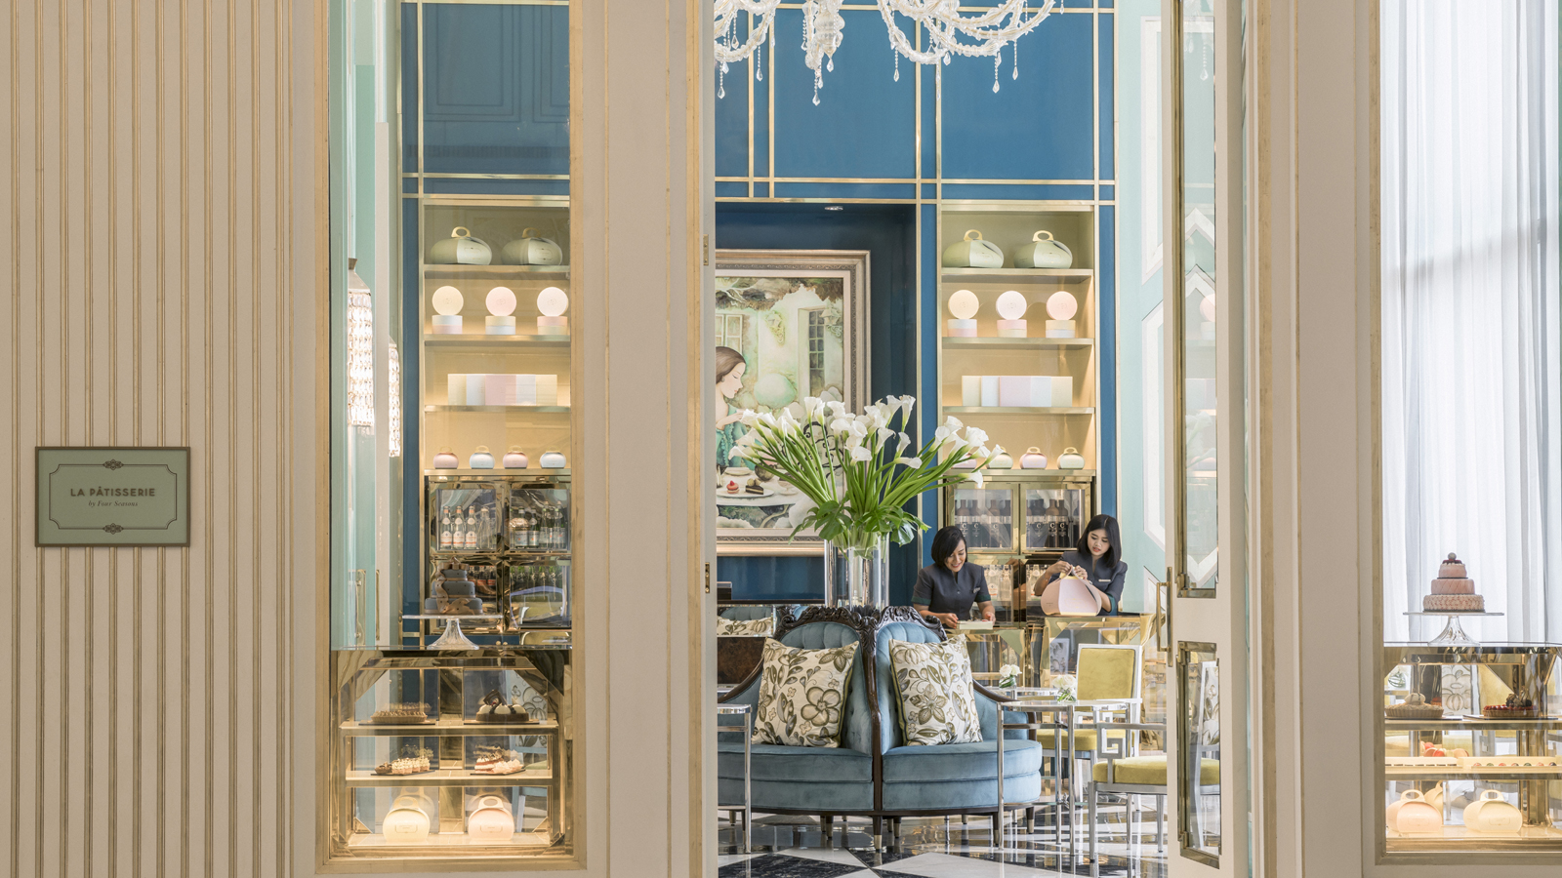
Mid-Autumn Festival is the second grandest festival among the Chinese after Chinese New Year. Falling at the eight month of the lunar calendar, a symbolic tradition that is not to be missed is sharing the indulgence of tasty mooncakes over a pot of tea with family and friends.
Four Seasons Hotel Jakarta celebrates the Mid-Autumn Festival by offering a variety of premium crafted mooncakes presented in an exquisite elegant packaging. Handcrafted by the skilful pastry team with fine ingredients, the classic mooncakes include pandan custard, white lotus, red bean and black sesame with egg yolk.
Also a thoughtful gift for the loved ones and business associates, Four Seasons mooncakes are sure become everyone’s favourite joy to indulge.
The mooncakes are available for purchase until September 15, 2019, priced at IDR 588.000++ for box of four. For order, call +6221 2277 1888.

RELATED

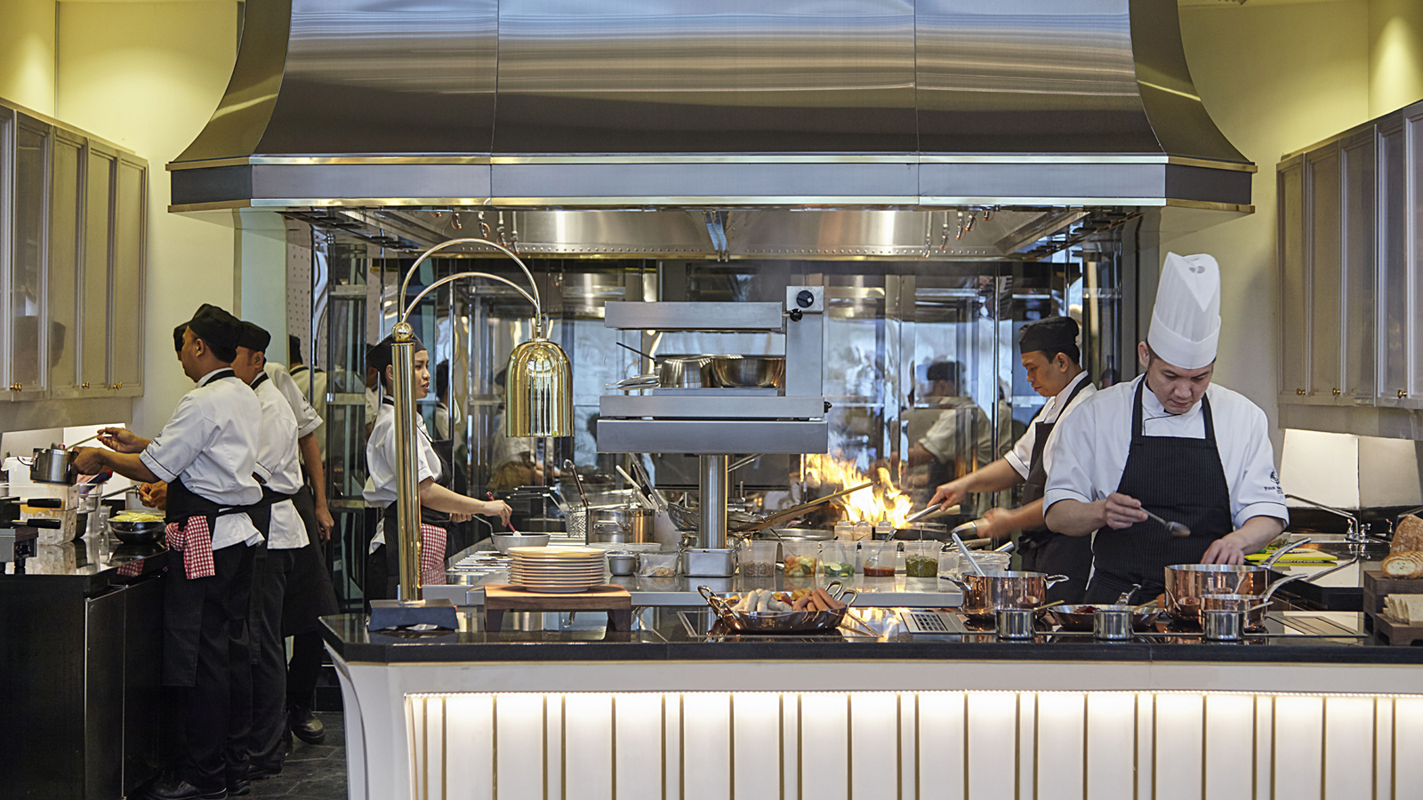 | July 29, 2019, Jakarta, Indonesia  Celebrating Indonesia’s 74th Independence Day with a Taste of Noesantara at Four Seasons Hotel Jakarta  https://publish.url/jakarta/hotel-news/2019/independence-day-celebrations.html
July 22, 2019, Jakarta, Indonesia
Nautilus Bar at Four Seasons Hotel Jakarta Welcomes Keith Motsi from Charles H. as Part of Takeover Series
https://publish.url/jakarta/hotel-news/2019/charles-h-takeover-at-nautilus-bar.html

PRESS CONTACTS

Rumman Amanda
Director of Public Relations and Communications
Jalan Jenderal Gatot Subroto Kav. 18
Jakarta
Indonesia
rumman.amanda@fourseasons.com

+62 21 227 71888

Cindy Yuwono
Public Relations and Communications Executive
Jalan Jenderal Gatot Subroto Kav. 18
Jakarta
Indonesia
cindy.yuwono@fourseasons.com

+62 812 80940637

