Four Seasons Hotel Nashville Announces Exclusive Gibson Guitars Stay Package

Launching this January, the Hotel celebrates partnership with the iconic American guitar brand Gibson to offer a one-of-a-kind Music City experience for guests
January 25, 2023, Nashville, USA

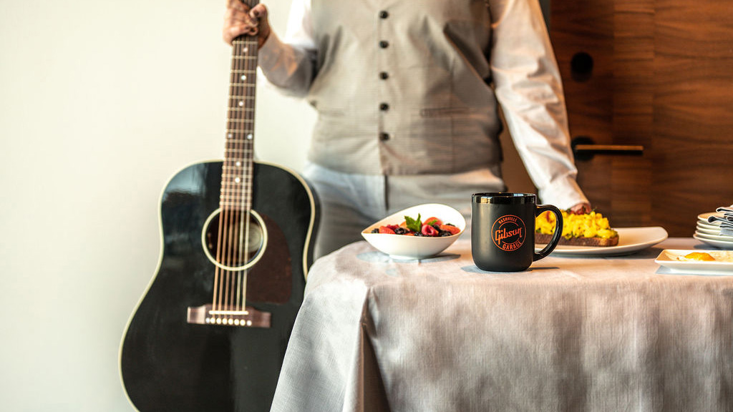
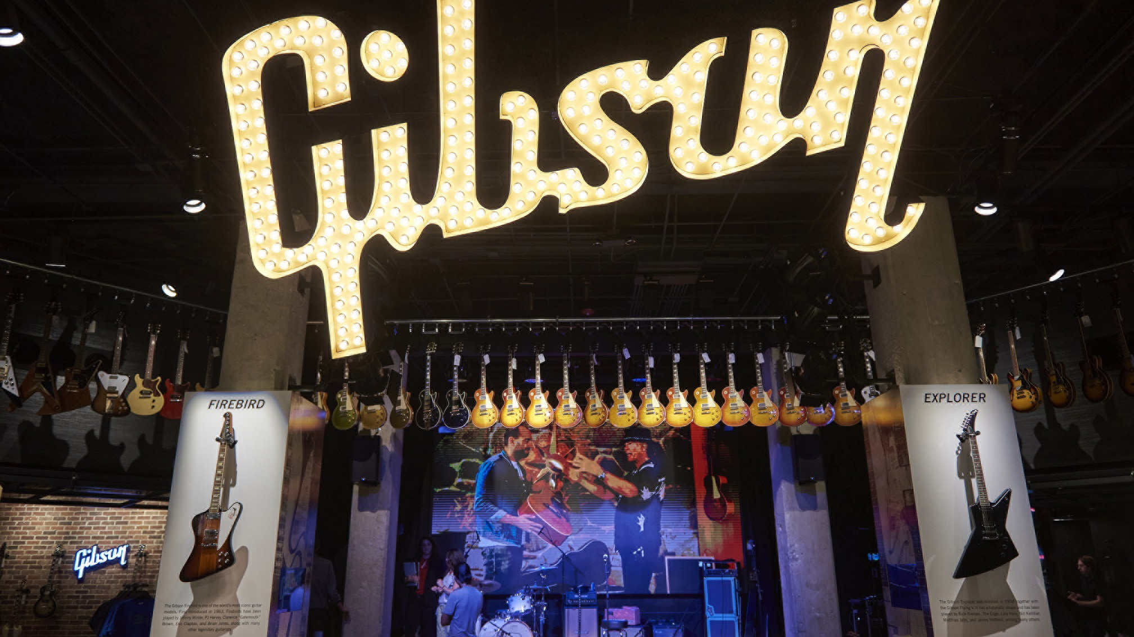 | 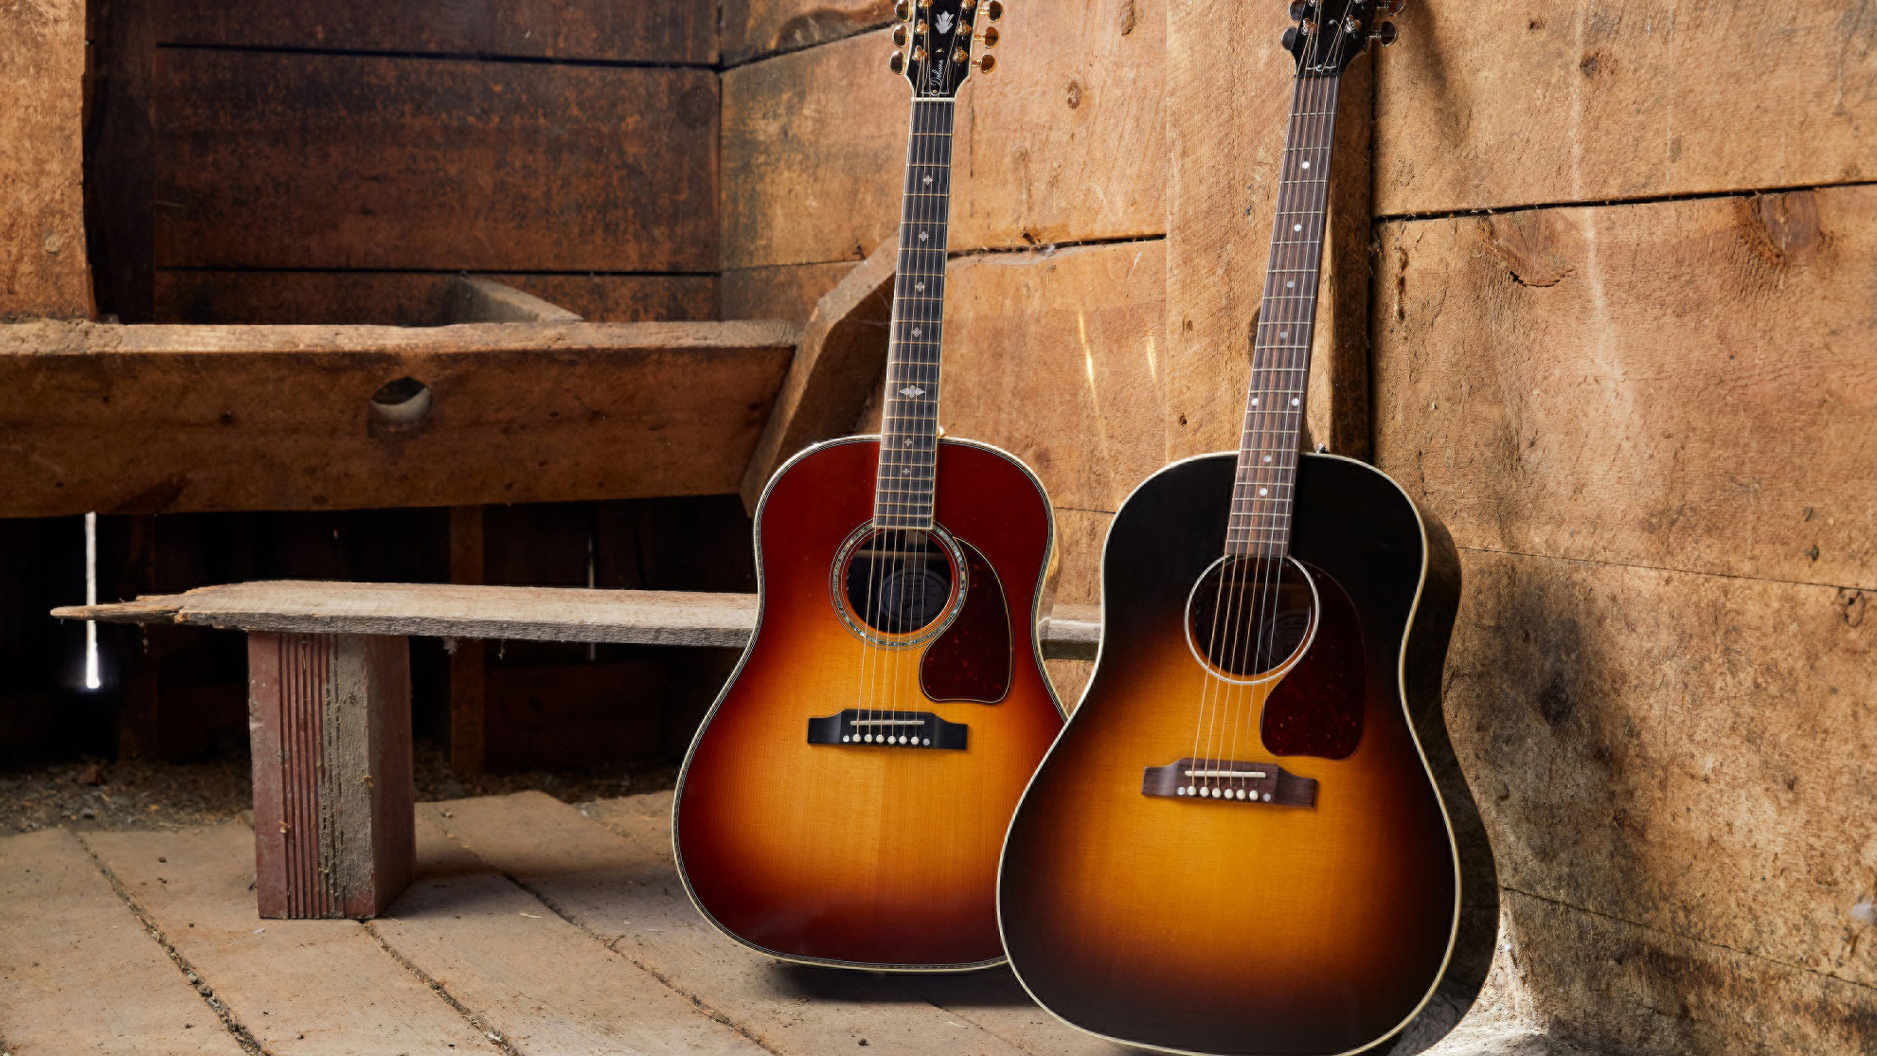
Four Seasons Hotel and Private Residences Nashville, the newly opened five-star luxury hotel in downtown Nashville, announces Room Service By Gibson Guitars, a special stay offer in partnership with the legendary guitar brand Gibson.
Four Seasons Hotel Nashville is allowing guests to stay like a rock star with this exclusive offer, designed specifically for the Hotel in collaboration with Gibson. The rock ‘n’ roll getaway begins from the moment guests arrive in their room or suite and are greeted with a Gibson guitar-themed welcome amenity, and a gift bag from the iconic American instrument brand to take home. A stunning Gibson acoustic guitar will be available in-room for guests to play during their stay.
A guided tour of the flagship Gibson Garage store - the ultimate guitar experience and destination for music lovers in downtown Nashville - delivers a hands-on experience of the exquisitely crafted instruments under the various Gibson Brands portfolio, and a behind-the-scenes peek at the company’s illustrious 130-year history. The tour includes access to vintage guitars, one-of-a-kind instruments, celebrity memorabilia, and a secret vault.
Room Service By Gibson Guitars also includes a USD 150 dining credit to be enjoyed on room service or at the Hotel’s flagship Mimo Restaurant and Bar, where Southern Italian cuisine meets Southern hospitality.
“Music is the heartbeat of Nashville, so it has been our top priority from day one to build meaningful relationships and partnerships within the city’s thriving music scene,” says Richard Poskanzer, General Manager of Four Seasons Hotel and Private Residences Nashville. “Our relationship with the team at Gibson is one of the first we built in the city, and they have been a dedicated partner to the Hotel since before we even opened our doors. At every Four Seasons property, we strive to create authentic, one-of-a-kind experiences for our guests that are a reflection of the destination. Room Service By Gibson Guitars perfectly captures the creative, musical energy and collaboration of Nashville and provides the type of tailored, unique experiences that is synonymous with our brand.”
“We are proud to partner with Four Seasons Hotel Nashville on Room Service By Gibson Guitars,” says Cesar Gueikian, Brand President, Gibson. “Four Seasons means premium quality, experience, and exceptional personal service. At Gibson, we follow the same ethos and have built a foundation of innovation, world-class quality, and craftsmanship with a human touch. Gibson has been shaping sound for 130 years, our instruments have been featured on almost every record since the beginning of recorded music, and Nashville, Music City is our home base. From all of us at Gibson we hope the Four Seasons Room Service by Gibson Guitars collaboration will make your Nashville experience unforgettable.”
Room Service By Gibson Guitars requires a two-night minimum stay, must be booked 14 days in advance and is subject to availability.
Room Service By Gibson Guitars can be booked online or by calling +1 615 610 6995.

RELATED

December 7, 2022, Nashville, USA
Mimo Restaurant and Bar Reveals Holiday Specials and Menus at Four Seasons Hotel Nashville
https://publish.url/nashville/hotel-news/2022/festive-season.html

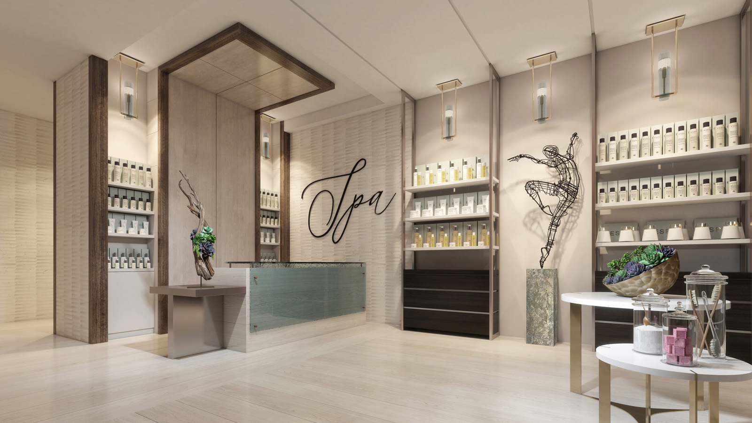 | November 28, 2022, Nashville, USA  The Spa at Four Seasons Hotel Nashville Now Accepting Reservations  https://publish.url/nashville/hotel-news/2022/spa-now-open.html

PRESS CONTACTS

Robert Chinman
Director of Public Relations and Communications
100 Demonbreun Street
Nashville
USA
robert.chinman@fourseasons.com

+1 629 250 8912

