Celebrate the Season of Love at Four Seasons Hotel Tunis

February 13, 2023, Tunis

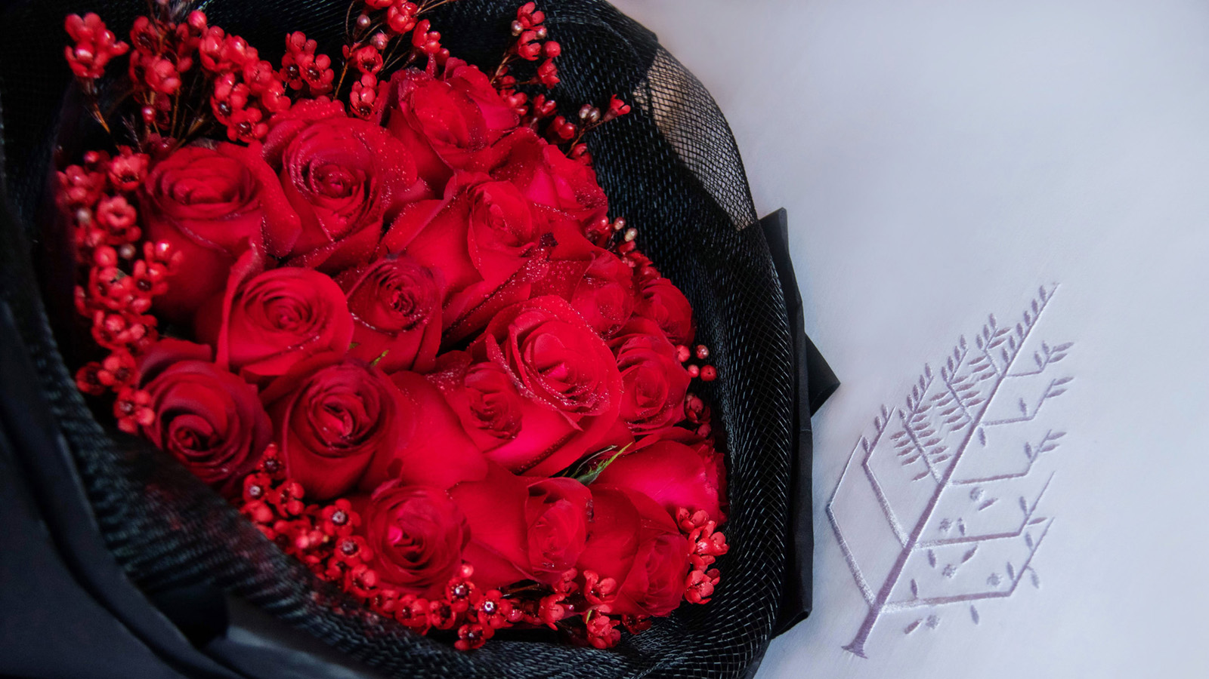
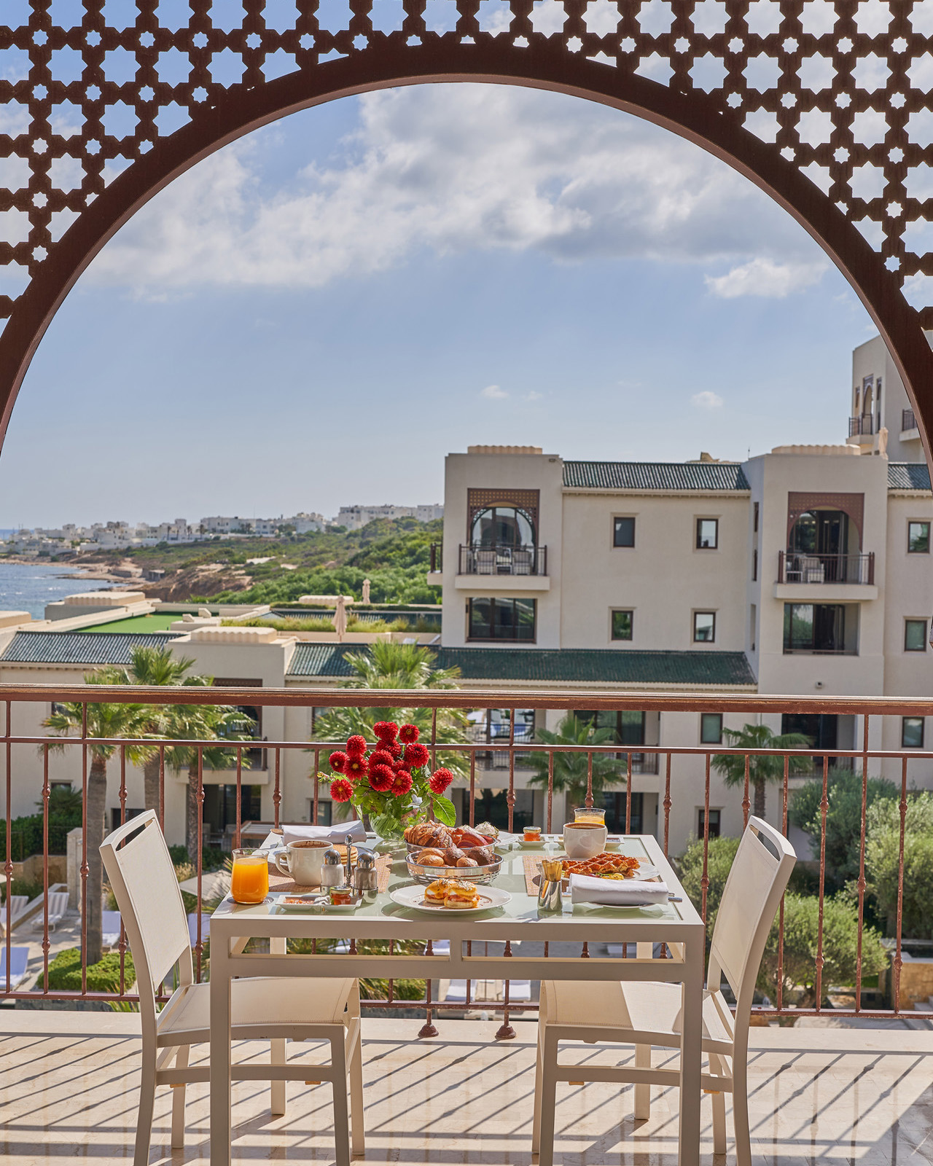 | 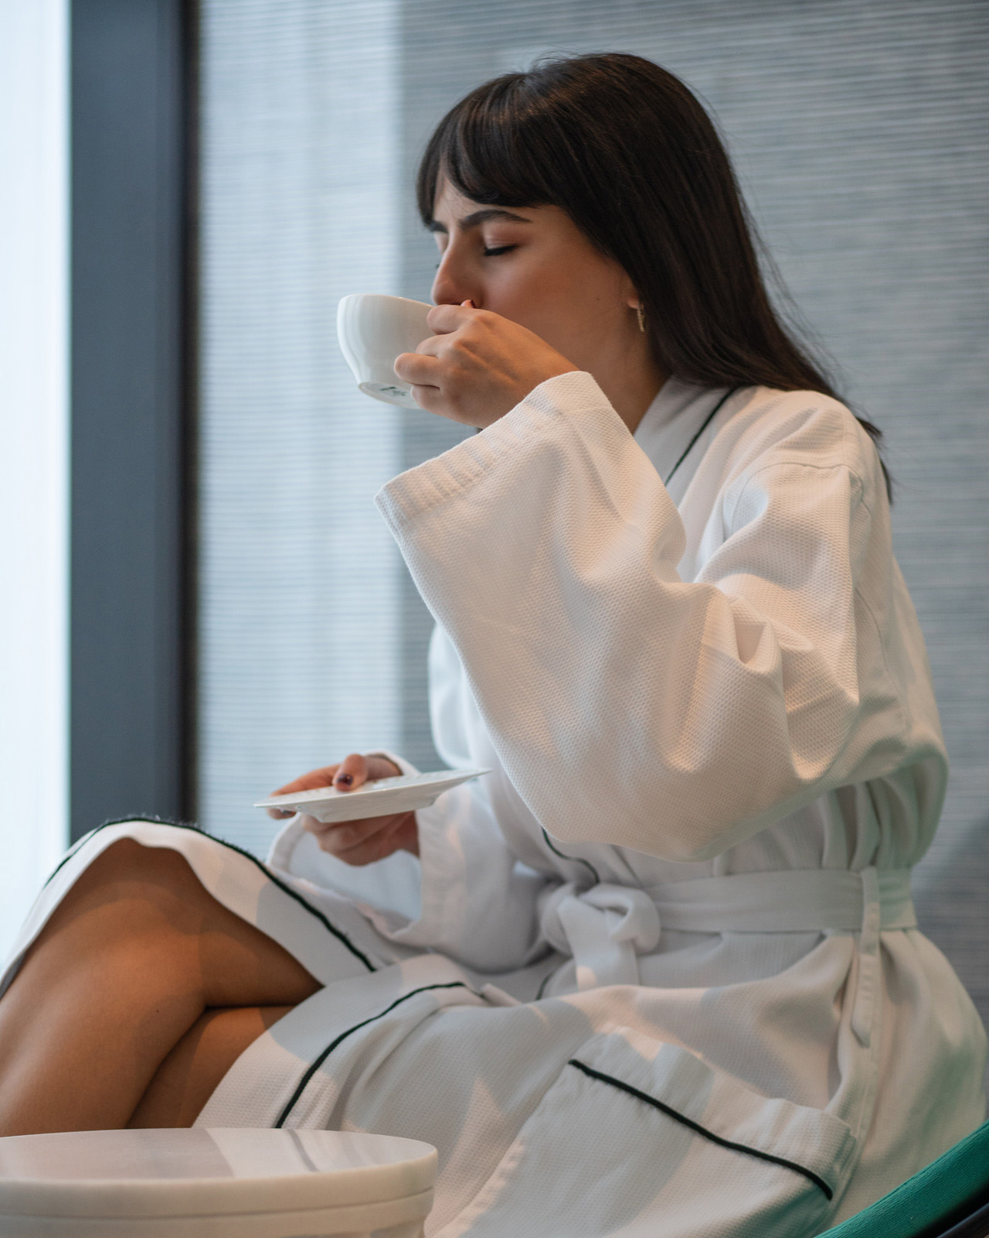 | 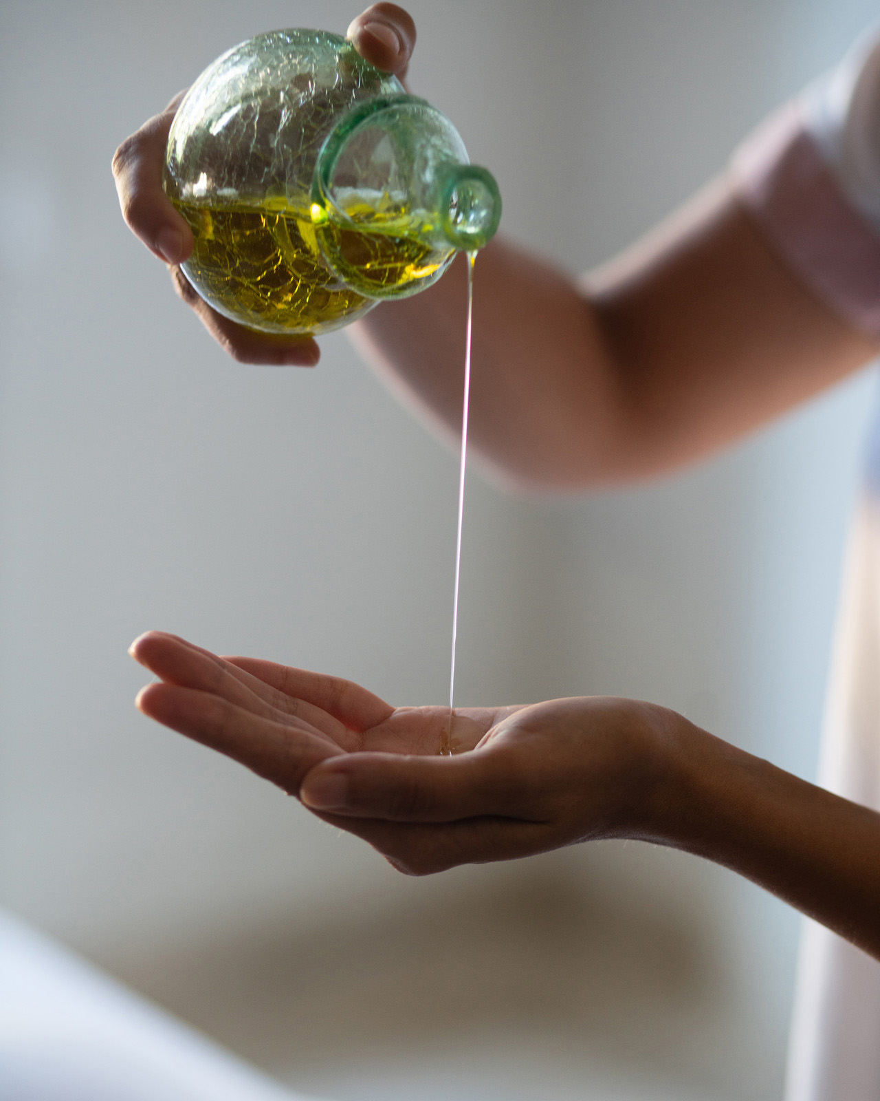
Prepare to fall in love all over again this February as Four Seasons Hotel Tunis is hosting the ultimate romantic escape to celebrate love in all of its shapes and forms by crafting a full range of signature spa treatments and curated experiences, each carefully designed to make guests feel special.
Romantic Getaway Package
Guests are invited to step into a fairytale and make the season of love last longer by enjoying a dreamy escape for two the whole month of February 2023.
This package is created to make couples fall head over heels, with an exquisite daily breakfast for two, alongside a bottle of sparkling wine accompanied by a heart shaped chocolate cake for even more sweetness.
For a total immersion, an ultimate in-room celebration will be set featuring a romantic welcome amenity of red flower petals and the opportunity of an early check-in and late check-out in addition to an upgrade to the next accommodation category.
To make this staycation exceptional guests can relax and unwind at the Spa with 25 percent savings on the treatments.

RELATED

December 6, 2022, Tunis
Celebrate the Magic of the Holidays with Four Seasons Hotel Tunis
https://publish.url/tunis/hotel-news/2022/festive-season.html

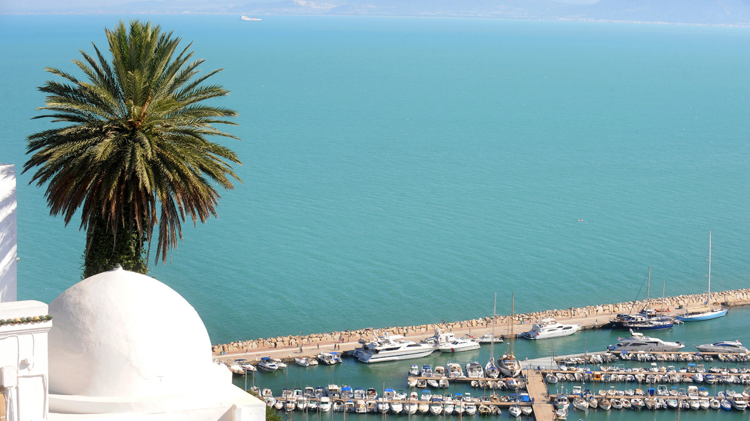 | July 13, 2022, Tunis  Summer Escape at Four Seasons Hotel Tunis  https://publish.url/tunis/hotel-news/2022/summer-activities.html

PRESS CONTACTS

Arij Ben Othmen
Public Relations and Marketing Communications Manager
Zone Touristique Cap Gammarth
La Marsa, Tunis
Tunisia
arij.benothmen@fourseasons.com

+216 58 555 776

