Four Seasons Hotel Riyadh Launches Weekend Family Getaway Package

October 12, 2017, Riyadh, Kingdom of Saudi Arabia

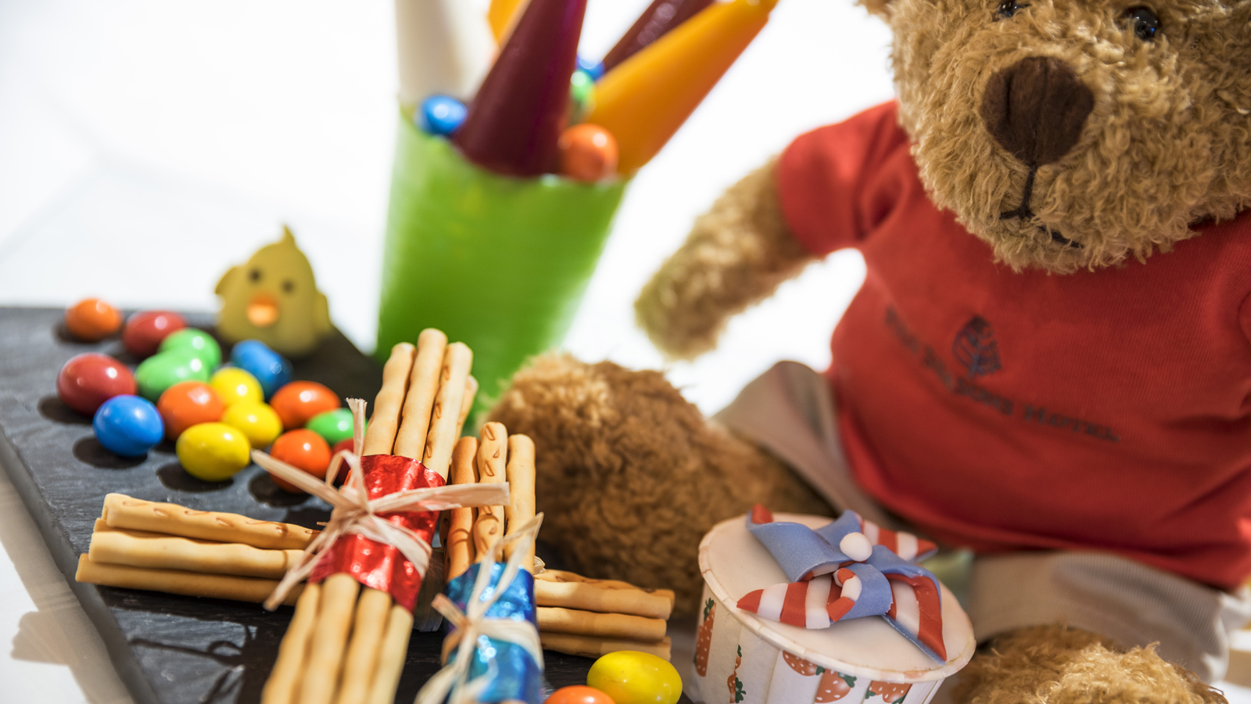
Four Seasons
Hotel Riyadh at Kingdom Centre invites guests to treat their family and friends to an unforgettable weekend stay with the new Weekend Family Getaway Package. This exclusive package has been especially designed to meet all guests' needs for relaxation and comfort; guaranteeing an unforgettable experience.
This package includes luxurious accommodations in the room or suite of choice, 50 percent off the second room for children up to 18 years old, four complimentary tickets to Sky Bridge (two adults and two kids) once per stay, one access card per stay to Sparky's Kids Zone at Kingdom Mall (with the value of SAR 100), buffet dinner for two adults and two children each night in Elements Restaurant, complimentary valet parking, free premium internet, 25 percent off any spa treatment, complimentary access to kid's play area at the Hotel, customised room set-up and amenities for kids' room, and special in-room dining amenities. All these added-values have been especially selected to guarantee the enjoyment of each member of the family during their stay.
Hotel visitors can also expect elegance, comfort, and intuitive services at the luxurious
Four Seasons
Hotel Riyadh, which is centrally located at the iconic Kingdom Tower. This prime location allows for direct access to the Kingdom Mall, an upscale three-level shopping centre with a kid’s play area called Sparky’s. The Hotel also presents an array of facilities for the enjoyment of each member of the family, including an outdoor pool, men-only Spa & Wellness Centre, and tennis, squash and racquetball courts, in addition to a luxurious ladies-only lounge, gym, and female spa therapist at The Pearl Floor. Guests can also watch their favourite movies and shows on Apple TV or select from more than 100 TV channels. To top all this, be assured that a weekend stay will be highlighted with impeccable
Four Seasons
personalised service and breathtaking panoramic views of Riyadh city.
Four Seasons
Hotel Riyadh also presents a diverse selection of dining outlets including Elements, The Grill, and Rosso, each providing an exceptional gastronomic experience with contemporary ambience. Guests can also take advantage of this great opportunity to try the infamous Friday Brunch, where the culinary team prepares a special buffet and dedicated activities for younger guests.
The Weekend Family Getaway Package – valid on Thursdays, Fridays and Saturdays - is subject to availability at the time of booking. For reservations call +966-11-2115888.

RELATED

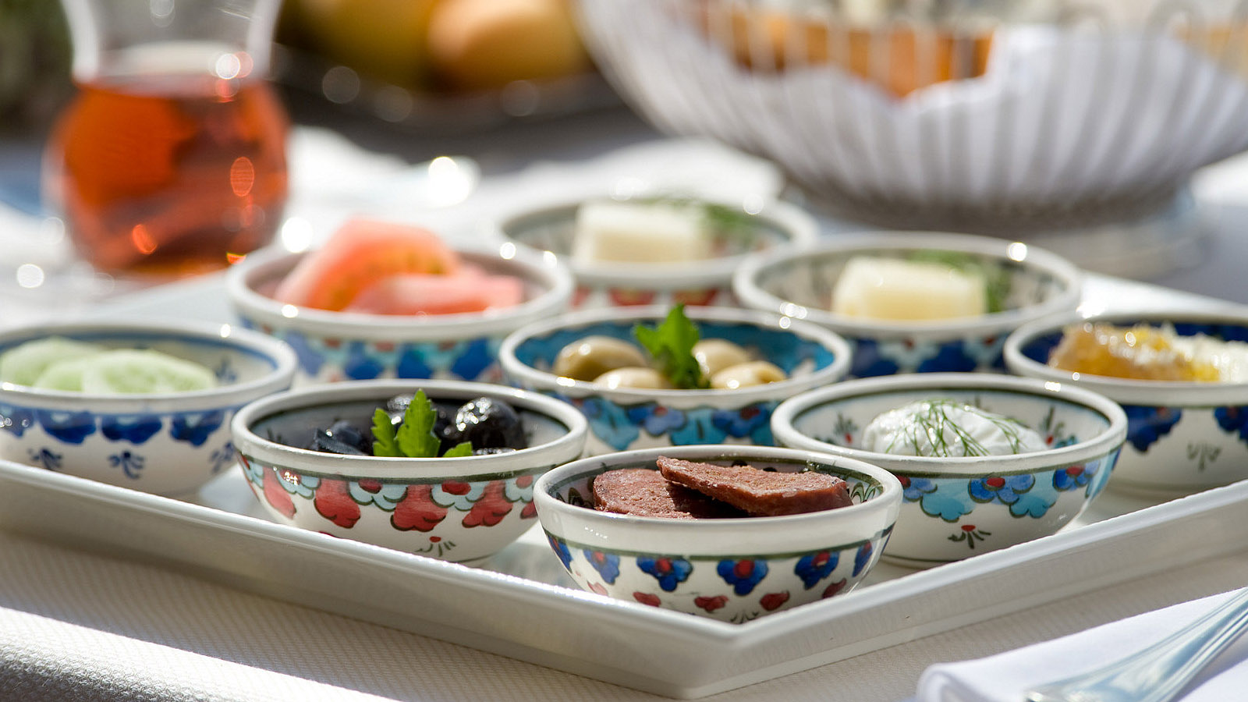 | October 19, 2017, Riyadh, Kingdom of Saudi Arabia  الليلة التركية كل ثلاثاء في فندق فورسيزونز الرياض  https://publish.url/ar/riyadh/hotel-news/2017/turkish-theme-night-2.html
October 19, 2017, Riyadh, Kingdom of Saudi Arabia
Turkish Theme Night Every Tuesday at Four Seasons Hotel Riyadh
https://publish.url/riyadh/hotel-news/2017/turkish-theme-night.html

PRESS CONTACTS

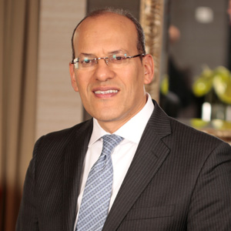 | Tarek Bekhiet  Regional Director of Marketing  Kingdom Centre, P.O. Box 231000  Riyadh 11321  Kingdom of Saudi Arabia  tarek.bekhiet@fourseasons.com  966 (11) 211-5000
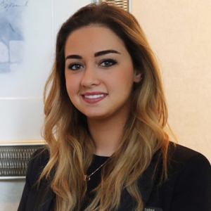 | Sarah Alkhani  Public Relations Manager  Kingdom Centre, P.O. Box 231000  Riyadh  Kingdom of Saudi Arabia  sarah.alkhani@fourseasons.com  + 966 11 211 5000

