Vacay and Play with Sky-High Staycations at Four Seasons Hotel Tokyo at Otemachi

February 16, 2021, Tokyo, Japan

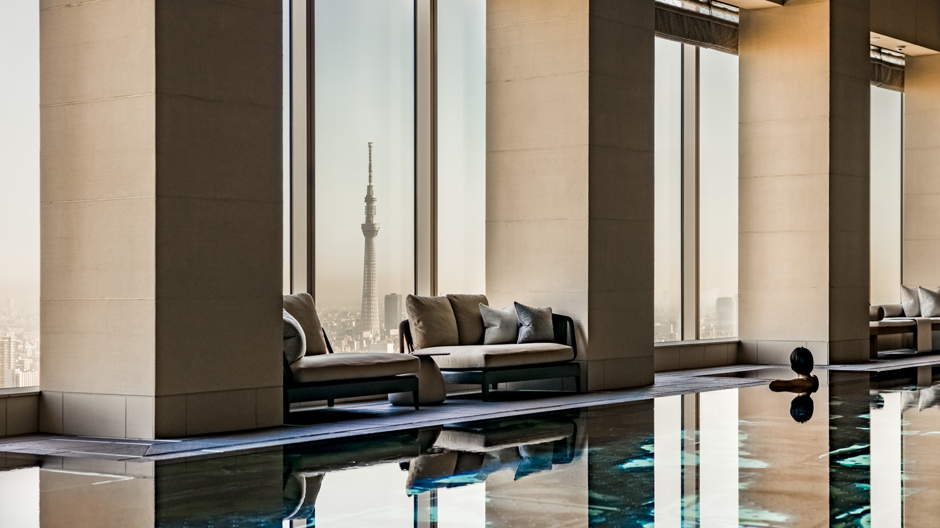
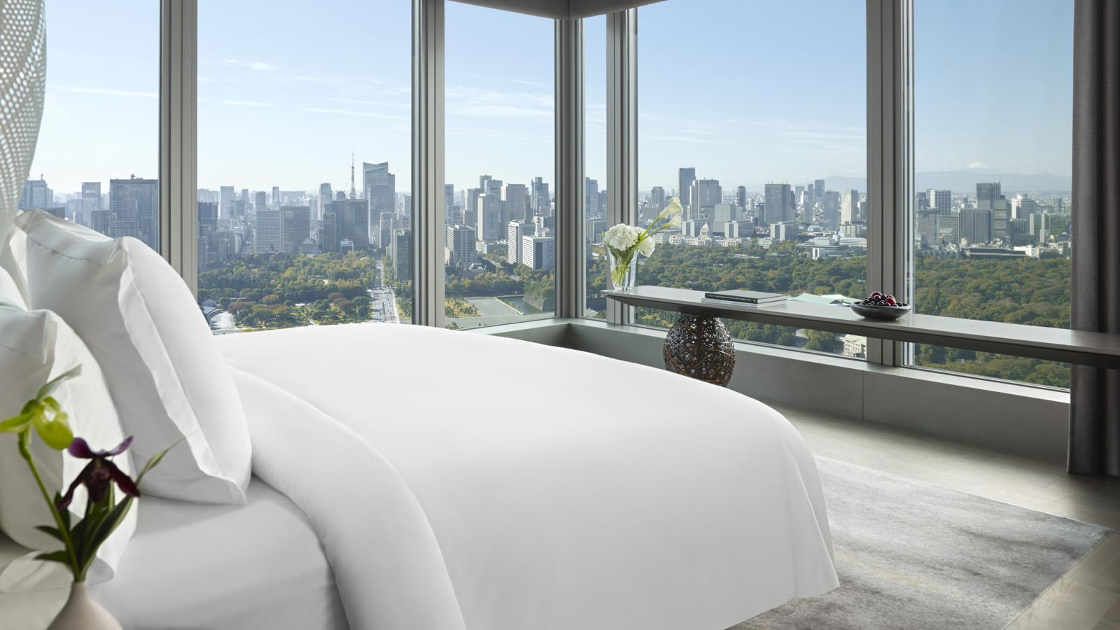 | 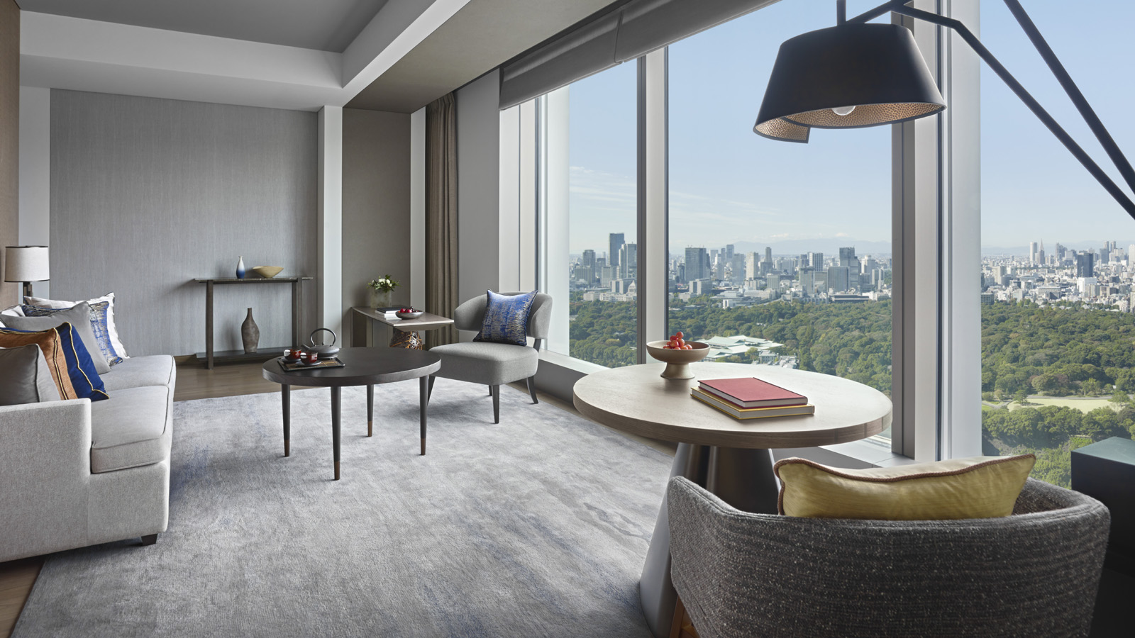 | 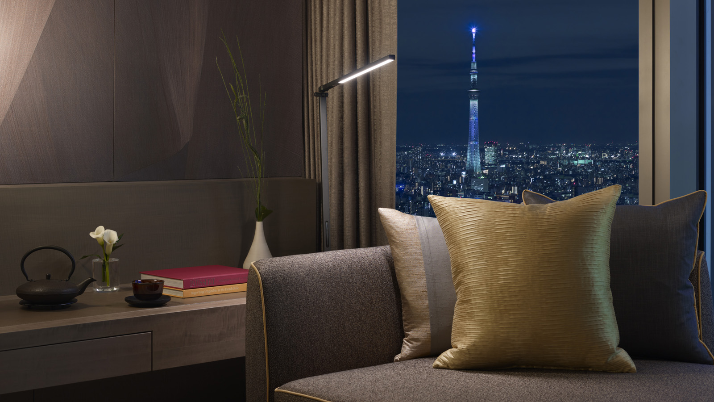
For Tokyoites who are missing that glorious holiday feeling, Four Seasons Hotel Tokyo at Otemachi introduces three spectacular staycation offers, available from February 16, 2021. Designed to provide a much-needed change of scenery and pace, these mini-retreats offer residents and expats the chance to go on a memorable vacation - right here in the heart of Tokyo.
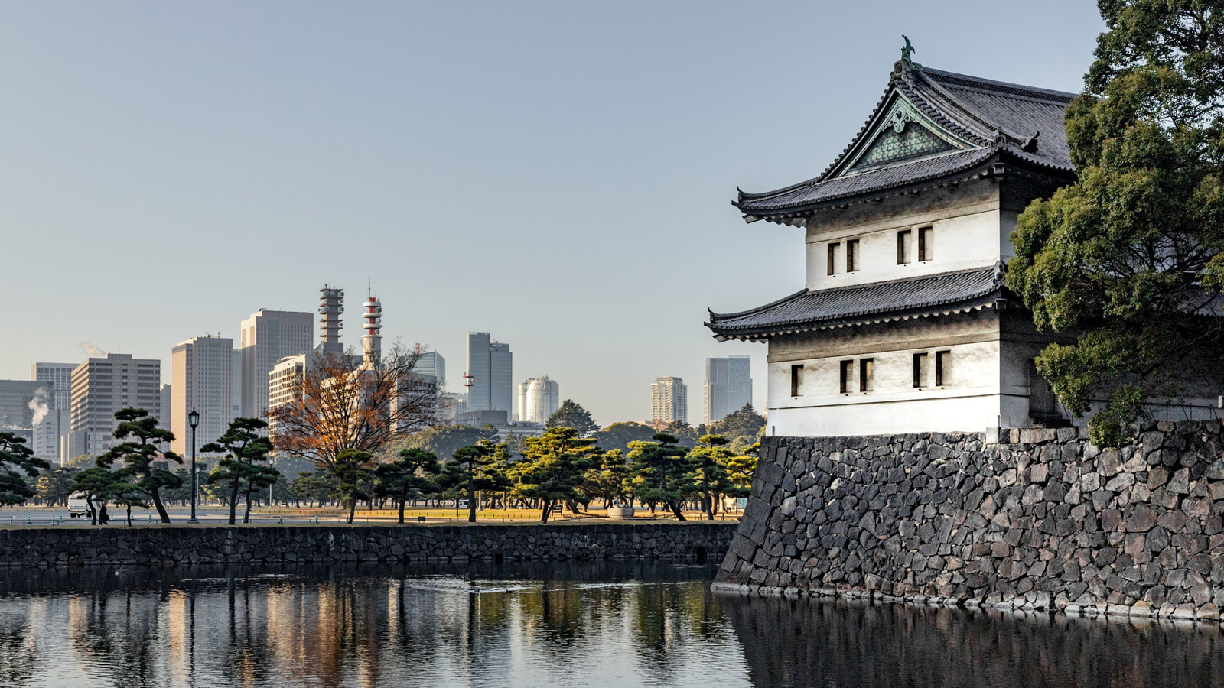 | 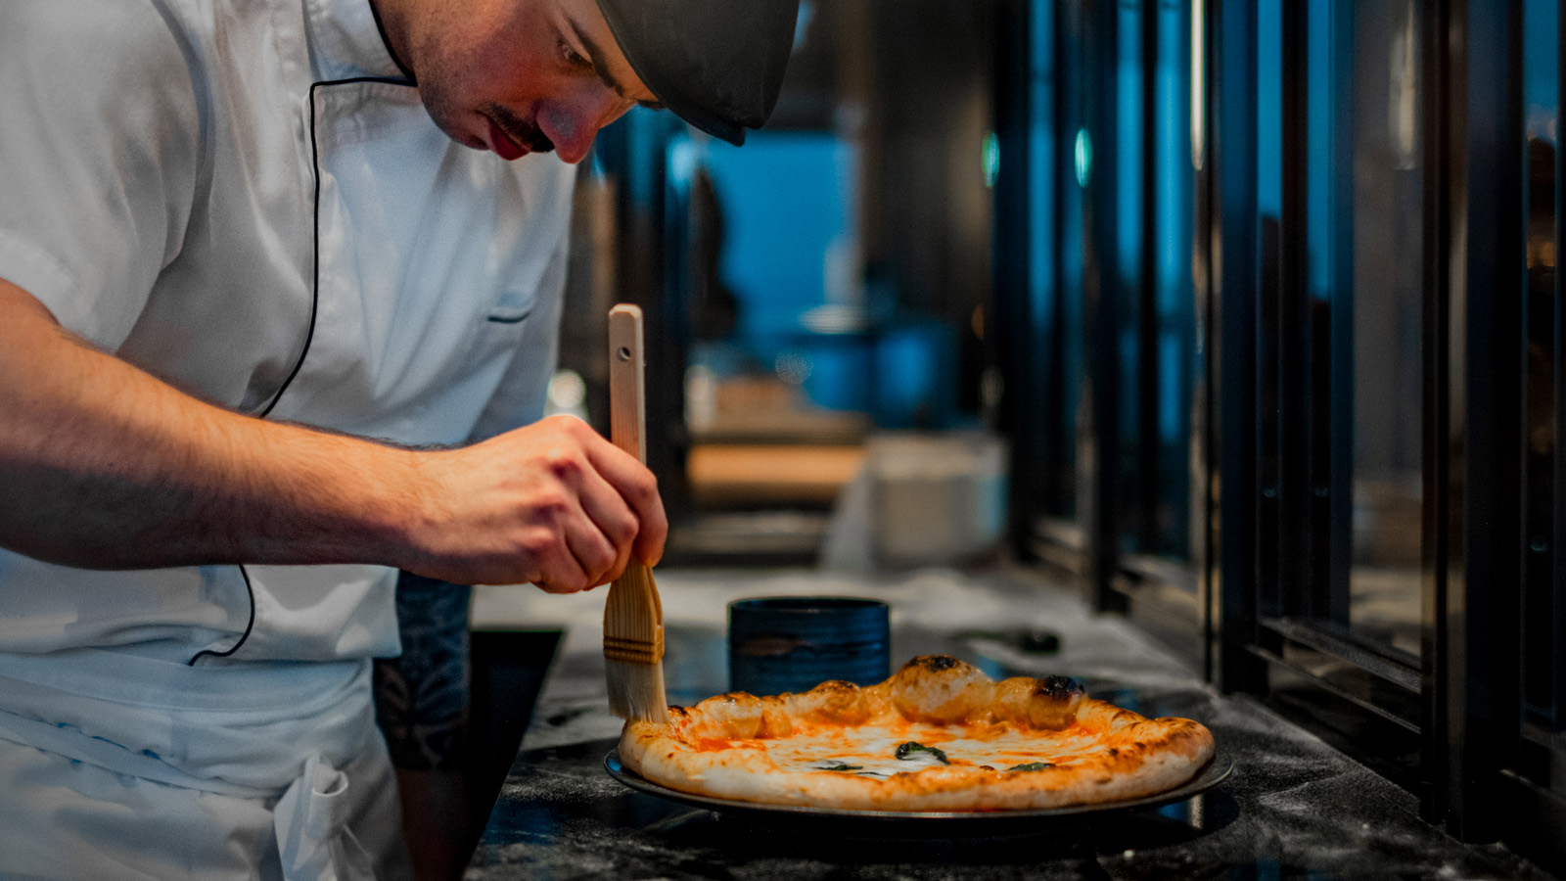 | 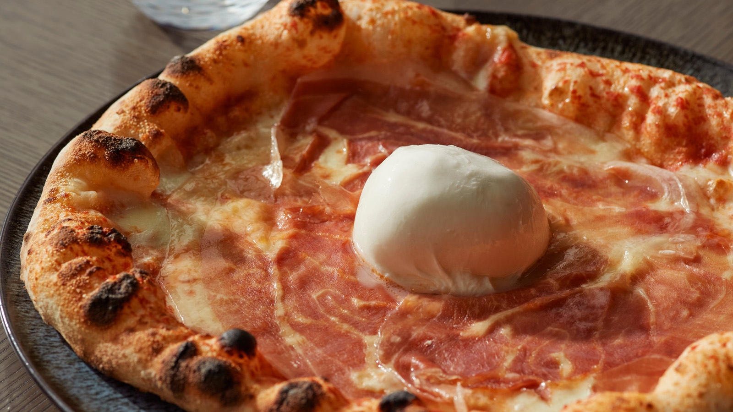
“We are very excited to welcome our local patrons for a complete Four Seasons holiday experience,” says Andrew De Brito, Regional Vice President and General Manager. “Since outbound international travel is still quite limited, our team has recreated the magic of vacation within the safety and care of our very own premises.”
Experience Tokyo in a Whole New Way
At this luxurious sanctuary, located in prestigious Otemachi, guests can escape the everyday and be transported into a world of relaxation, discovery and indulgence. Floating high in the sky, the Hotel’s light-filled guest rooms and suites are a destination in themselves. Take in day-to-night views of the stunning Tokyo skyline or verdant Imperial Palace gardens – the perfect backdrop to making new memories with loved ones.
A window-side daybed invites moments of pure tranquillity: curl up with a favourite book, savour an afternoon nap, or simply daydream while gazing out at Japan’s iconic capital. With wonderfully spacious interiors and at-your-fingertips access to all Hotel services, these rooms are tailormade for staying in.
Wonder-Filled Spaces
Marvel at the seamless blend of comfort and style by celebrated designer Jean-Michel Gathy, who brings together classical Japanese elements with ultramodern accents. Signature artwork by Namiko Kitaura graces the walls of each guest room, evoking a sense of lightness and movement – a nod to the gauzy fabrics by fashion icon Issey Miyake.
“The sustainability duck by the bedside is made with scraps of leftover fabric, reflecting an age-old sustainability practice in Japan,” notes Andrew. “Our Japanese guests might also notice the embroidered door hangers inspired by temari, a folk craft that is traditionally used for making toys.”
Stay, Play, Vacay
After a restful night’s sleep in the signature Four Seasons Bed, linger a little while longer over a gourmet breakfast in bed. Later, savour authentic Italian specialties in the privacy of the room or in the welcoming ambience of PIGNETO. The menu features handcrafted pizzas by maestro pizzaiolo Alessandro de Leo and housemade tagliatelle al tartufo by Chef Yoshihiro Kigawa.
Afternoon tea aficionados can taste a dazzling array of sweets and savouries by award-winning Executive Pastry Chef Yusuke Aoki, served in-room or framed by sweeping Imperial Palace views at THE LOUNGE. Bring in the evening with a refreshing walk in the next-door palace gardens, followed by drinks at VIRTÙ, the Hotel’s glamorous Paris-meets-Tokyo bar, with crafted cocktails by Head Bartender Joshua Perez.
It’s the Little Things That Count
Four Seasons rolls out the red carpet with extra perks for staycationers. An early check-in extends precious relaxation time, while complimentary self-parking allows for a seamless arrival and departure experience. Depending on their choice of package, guests can also enjoy benefits such as an accommodation upgrade, airport transfers or the Hotel’s drop-off service.
Signature Staycations
Guests can select from three bespoke staycation packages.
Stay Local – The Ultimate Getaway. Unwind and recharge with a getaway in the heart of Tokyo. Starts at JPY 60,000 for a double room. Inclusions:
- Daily breakfast and dinner for two, in-room or at PIGNETO
- Four pieces of laundry daily
- Overnight self-parking
- Early check-in at 10:00 am
- Complimentary drop-off service within 3 kilometre radius of Hotel
Let’s Tea! Take afternoon tea to new heights with this superb offer. Starts at JPY 57,000 for a double room. Inclusions:
- Accommodation upgrade
- Daily breakfast for two, in-room or at PIGNETO
- Seasonal afternoon tea, in-room or at THE LOUNGE
- Overnight self-parking
- Early check-in at 1:00 pm
Extend Your Stay. Discover a home away from home with this thoughtful long-stay package, available for stays of 14 consecutive days or more. Starts at JPY 49,000 for a double room. Inclusions:
- 15 percent savings on room rate
- Daily breakfast for two, in-room or at PIGNETO
- Return airport transfer (complimentary for Haneda Airport, 50 percent savings for Narita Airport)
- Twice-weekly private sessions with fitness trainer
- Personal concierge service
- Customised dietary and wellness plan by Chef and Spa team
- 20 percent savings on laundry, dining and Spa treatments
- Complimentary self-parking
Four Seasons Hotel Tokyo at Otemachi continues to operate with enhanced health and safety protocols through the Lead With Care program. Grounded in healthcare expertise, the program focuses on providing care, confidence and comfort to all Four Seasons guests and employees within the new COVID-19 environment.

RELATED

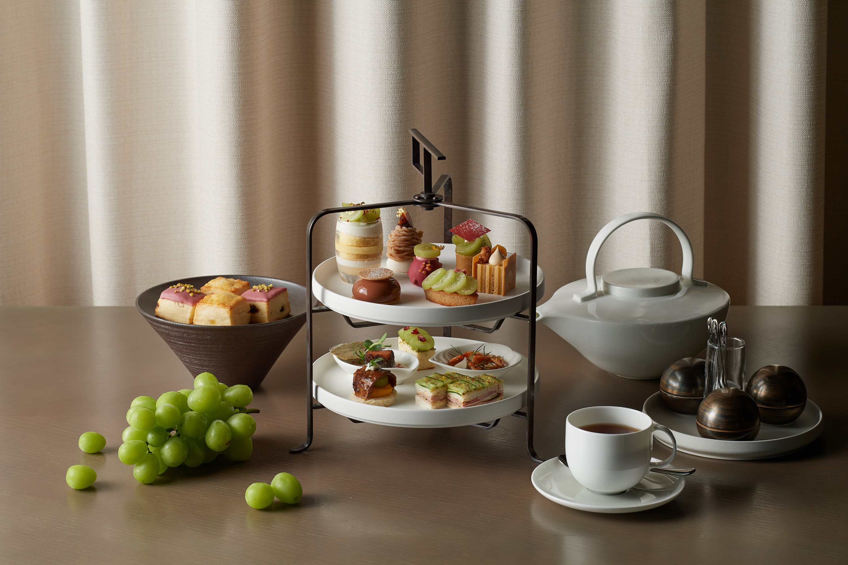 | August 19, 2022, Tokyo, Japan  秋の訪れを五感で愉しむ シャインマスカット アフタヌーンティーとパフェ  https://publish.url/jp/otemachi/hotel-news/2022/autumn-afternoon-tea.html
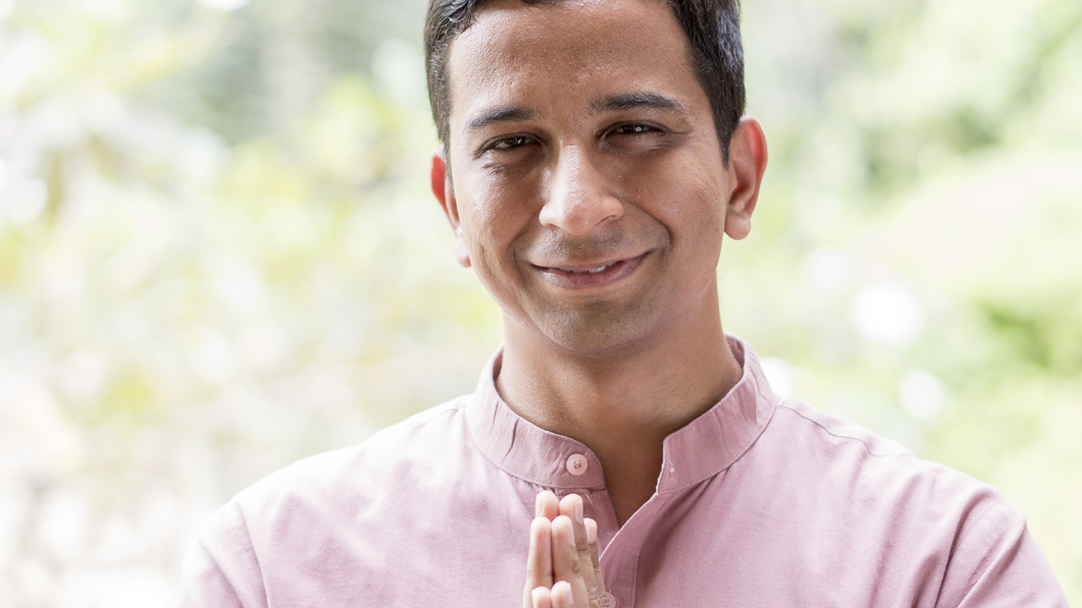 | August 11, 2022, Tokyo, Japan  Moving Into Stillness with Wellness Expert Faraaz Tanveer at Four Seasons Hotel Tokyo at Otemachi  https://publish.url/otemachi/hotel-news/2022/stillness-workshop-and-summer-spa-treatment.html

PRESS CONTACTS

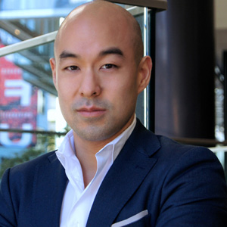 | Shingo Kido  Director of Public Relations and Communications  1-2-1 Otemachi  Chiyoda-ku, Tokyo  Japan  shingo.kido@fourseasons.com

