Four Seasons Hotel Houston Hosts Camp H-Town

Hotel converts an entire floor into urban campground for pediatric cancer patients
July 24, 2019, Houston, U.S.A.

Four Seasons Hotel Houston is hosting the second annual Camp H-Town taking place on July 22-26, 2019. Camp H-Town is a summer oncology sleep-away camp conducted at the Hotel in collaboration with The University of Texas MD Anderson Children’s Cancer Hospital and provides pediatric cancer patients and their siblings ages 9-12 with a fun and safe camp environment at no financial cost to the campers’ families.
This year’s camp takes on a “Reaching for the Stars” theme, inspired by the 50th anniversary of the moon landing. Campers enjoy activities both at the Hotel and surrounding city attractions including a day at NASA Johnson Space Center, a visit from an astronaut, an Astros game at Minute Maid Park, a visit to the Houston Museum of Natural Science, dinner and a dance party at the House of Blues, an art project with a local artist, pajama movie night, and more.
“We are looking forward to another successful year of Camp H-Town and continuing to provide these children with a safe and fun camping environment through the support of our staff, community and volunteers,” says Tom Segesta, General Manager of Four Seasons Hotel Houston and Co-Founder of Camp H-Town. “We are proud to continue the long-standing and unwavering commitment of Four Seasons Hotels and Resorts to raising global awareness and support for cancer research.”
This year Four Seasons Hotel Houston hosted several fundraising events to support Camp H-Town including a Topgolf tournament, proceeds from holiday gingerbread house sales and H-Town Celebrity Chefs Against Cancer event featuring creative bites from seventeen of Houston’s best restaurants and a silent auction.
About Camp H-Town
Camp H-Town is a 501(c)3 non profit organisation that strives to bring back the joys of childhood to a unique population of children touched by cancer through an urban camp experience at Four Seasons Hotel Houston. During the summer, the Hotel converts an entire floor into a “campground” with bunk beds and camping gear, in which the campers will stay four nights under the supervision of medical staff from MD Anderson and local volunteers. Campers enjoy activities both at the Hotel and at surrounding city attractions.

RELATED

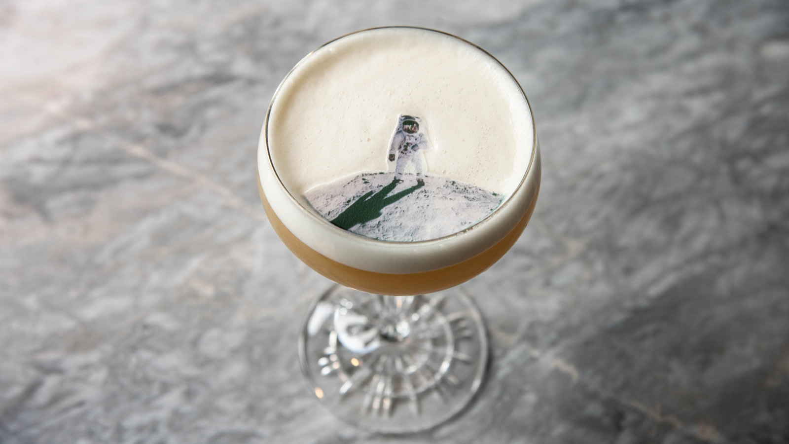 | July 16, 2019, Houston, U.S.A.  Celebrate Space City Month at Four Seasons Hotel Houston  https://publish.url/houston/hotel-news/2019/moon-landing-anniversary.html
May 14, 2019, Houston, U.S.A.
Four Seasons Hotel Houston Celebrates Global Wellness Day with Line-Up of Complimentary Activities
https://publish.url/houston/hotel-news/2019/global-wellness-day.html

PRESS CONTACTS

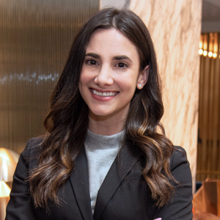 | Jessica Meyerson  Public Relations Manager  1300 Lamar Street  Houston  USA  jessica.meyerson@fourseasons.com  +1 832 507 9768

