Bali Fun Facts

April 9, 2018, Bali, Indonesia

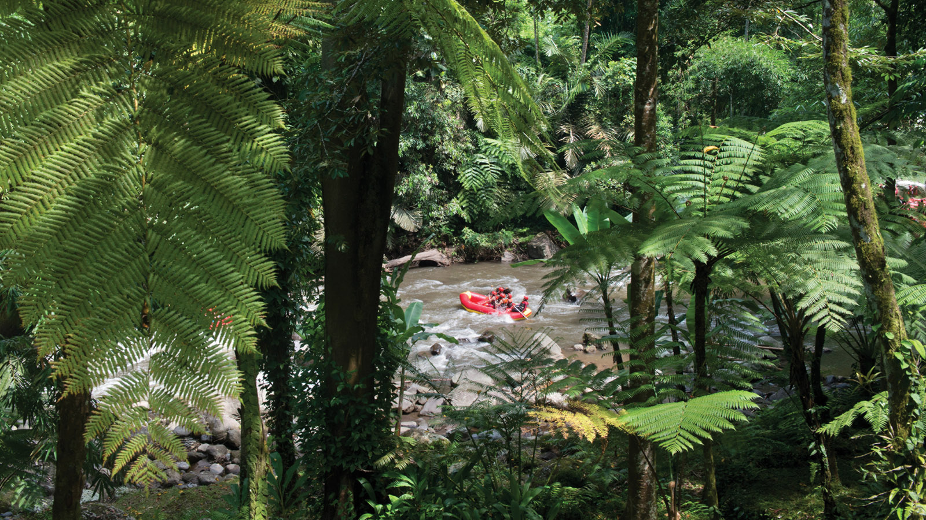
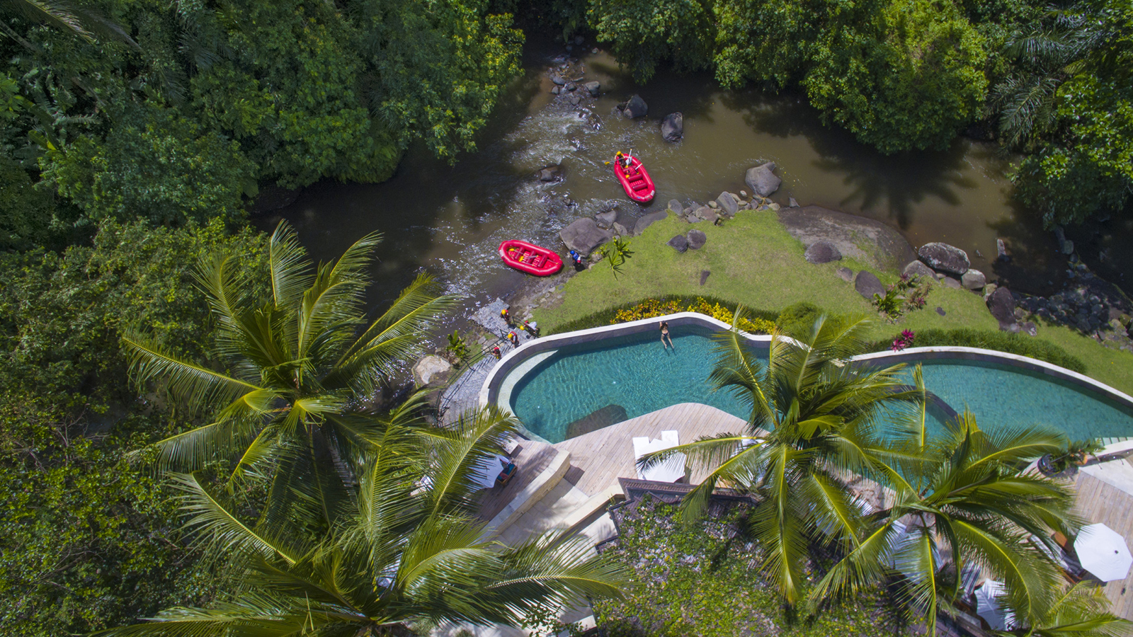 | 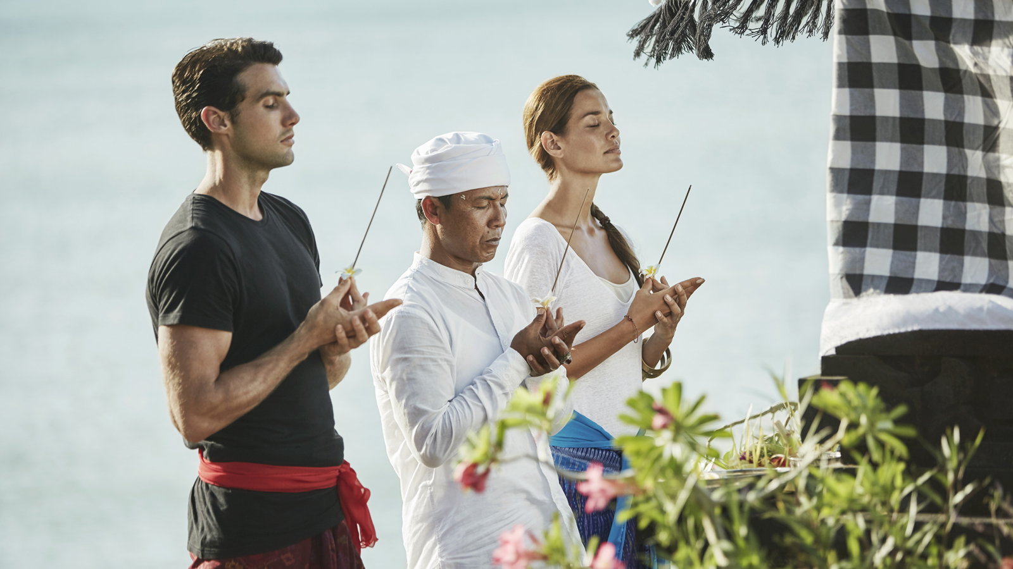 | 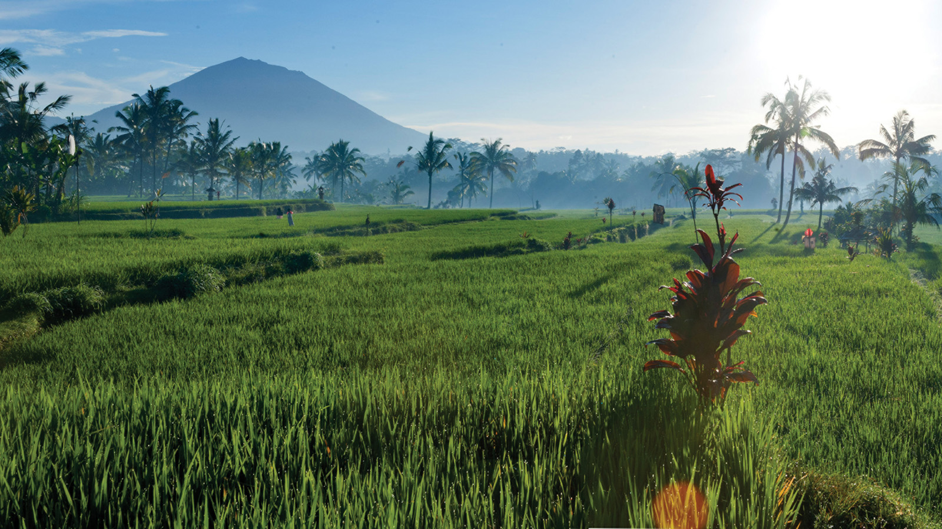
Four Seasons
Resorts Bali at Jimbaran Bay and Sayan offer the following fun facts about Bali.
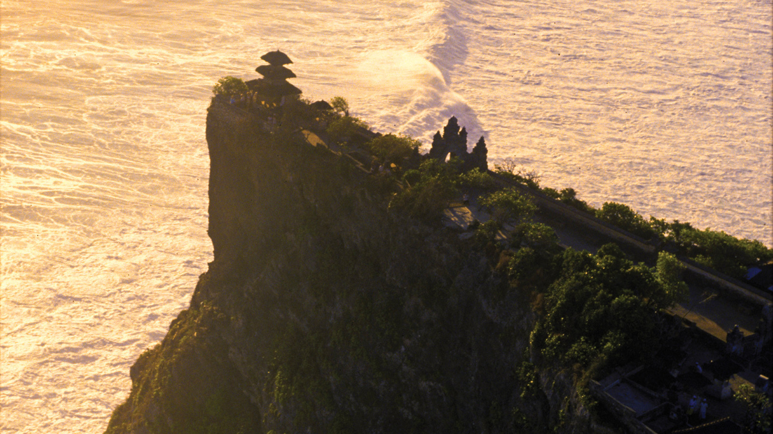 | 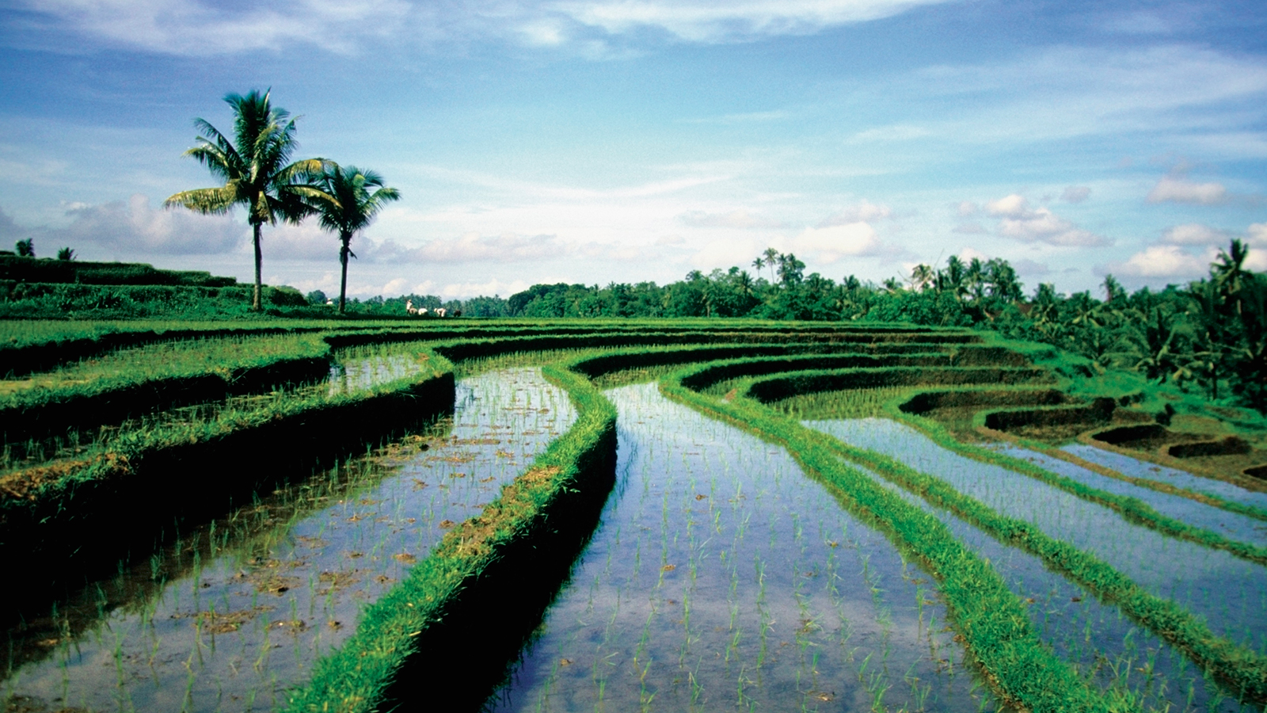 | 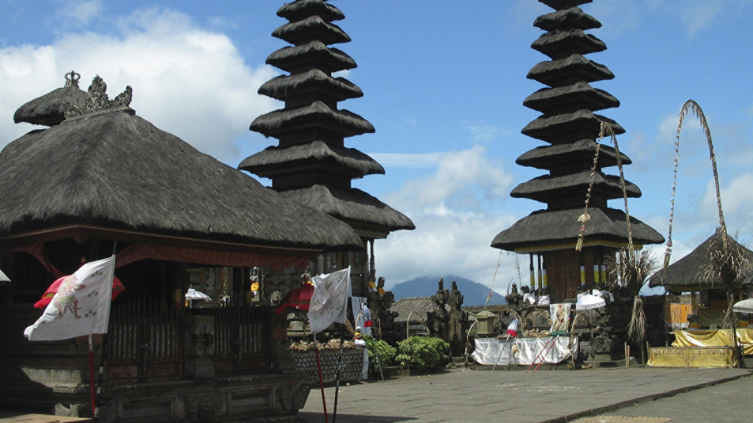
- Bali has its own language – one of 583 languages and dialects spoken in the Indonesian archipelago. Bahasa Indonesia is the national language; English is widely spoken in Bali’s main tourist areas.
- Bali is home to approximately four million people. The vast majority follows a special version of Hinduism, different to that practiced in India, and witnessing the rituals and ceremonies of daily life is a highlight of visiting the island.
- The island is home to more than 20,000 temples, earning its nickname “the island of a thousand temples” or “the island of the gods.”
- Some temples date back as far as the 9th century; Pura Besakih at Mount Agung is the island’s Mother Temple, the stunning Pura Lempuyang in Karangasem is at the highest elevation and has breathtaking views of Mount Agung, while the cliff-top Pura Uluwatu is touristic with its sunset kecak dance performances and cheeky monkeys. As for
Four Seasons
Jimbaran Bay, it has its own Resort temple and guests are welcome to take a guided tour of it with Resort Priest Aji Ngurah, or visit the nearby Goa Gong cave temple for a water purification ritual.
- The island has a 593 kilometre (370 mile) coastline surrounded by coral reefs. Beaches in the south tend to have white sand while those in the north and west have black volcanic sand. The longest river, the Ayung, extends for approximately 75 kilometres (47 miles). Explore it with a
Four Seasons
Private Rafting Adventure.
- Bali's central mountains include several peaks over 2,000 metres high (6,500 feet); the highest is Mount Agung (3,031 metres or 9,944 feet), known as the "mother mountain." Adventurous travellers can enjoy panoramic sunrise views across Bali’s mountainous interior with a trek up Mount Batur (1,717 metres or 5,633 feet); ask our concierge teams at
Four Seasons
Jimbaran Bay and
Four Seasons
Sayan to arrange your climb with our tour guide.
- Bali’s volcanic landscapes and climate support the highly productive agriculture sector. Spend a Day in the Life of a Balinese Farmer and learn about the UNESCO-listed 9th century subak waterways that connect the island's paddy fields.
- Bali is home to the first sea-floating toll road in the country, stretching across the gulf of Benoa 12.7 kilometres (8 miles) in length, an example of the modern development that blends with Bali’s very traditional lifestyle.
- Three small islands lie to the immediate south east and all are administratively part of Bali: Nusa Penida, Nusa Lembongan and Nusa Ceningan. Great for an extension to your stay on the mainland, or for a day trip especially for excellent snorkelling and diving.

RELATED

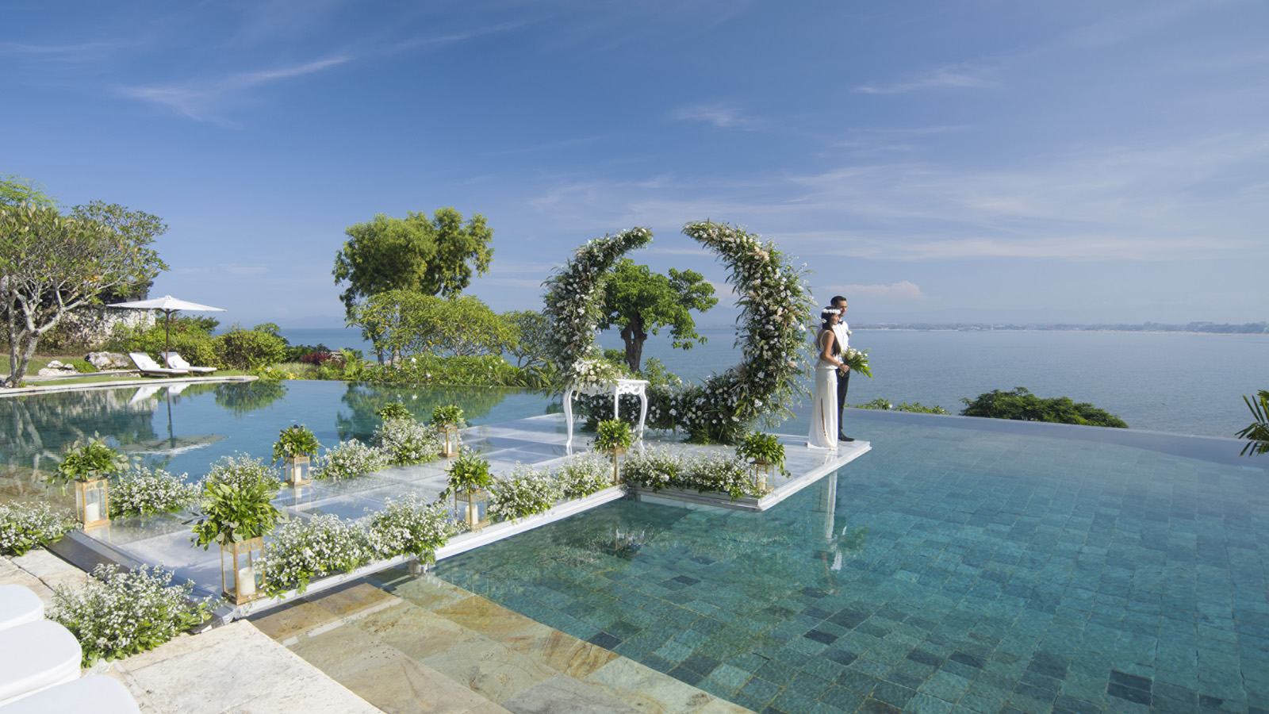 | March 15, 2018, Bali, Indonesia  在巴厘岛最长的水上婚礼走廊上说“我愿意”  https://publish.url/zh/jimbaranbay/hotel-news/2018/ultimate-water-wedding-experience-2.html
March 15, 2018, Bali, Indonesia
Say "I Do" on Bali's Longest Overwater Wedding Aisle at Four Seasons Resort Bali at Jimbaran Bay
https://publish.url/jimbaranbay/hotel-news/2018/ultimate-water-wedding-experience.html

PRESS CONTACTS

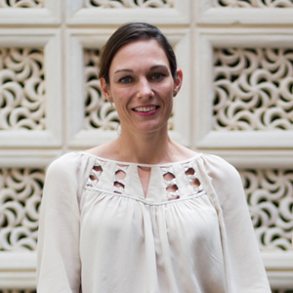 | Marian Carroll  Director of Public Relations  Jimbaran  Indonesia  marian.carroll@fourseasons.com  +62 (361) 701010

