Celebrate the Month of Love in Balt-Amour at Four Seasons Hotel Baltimore

January 7, 2020, Baltimore, U.S.A.

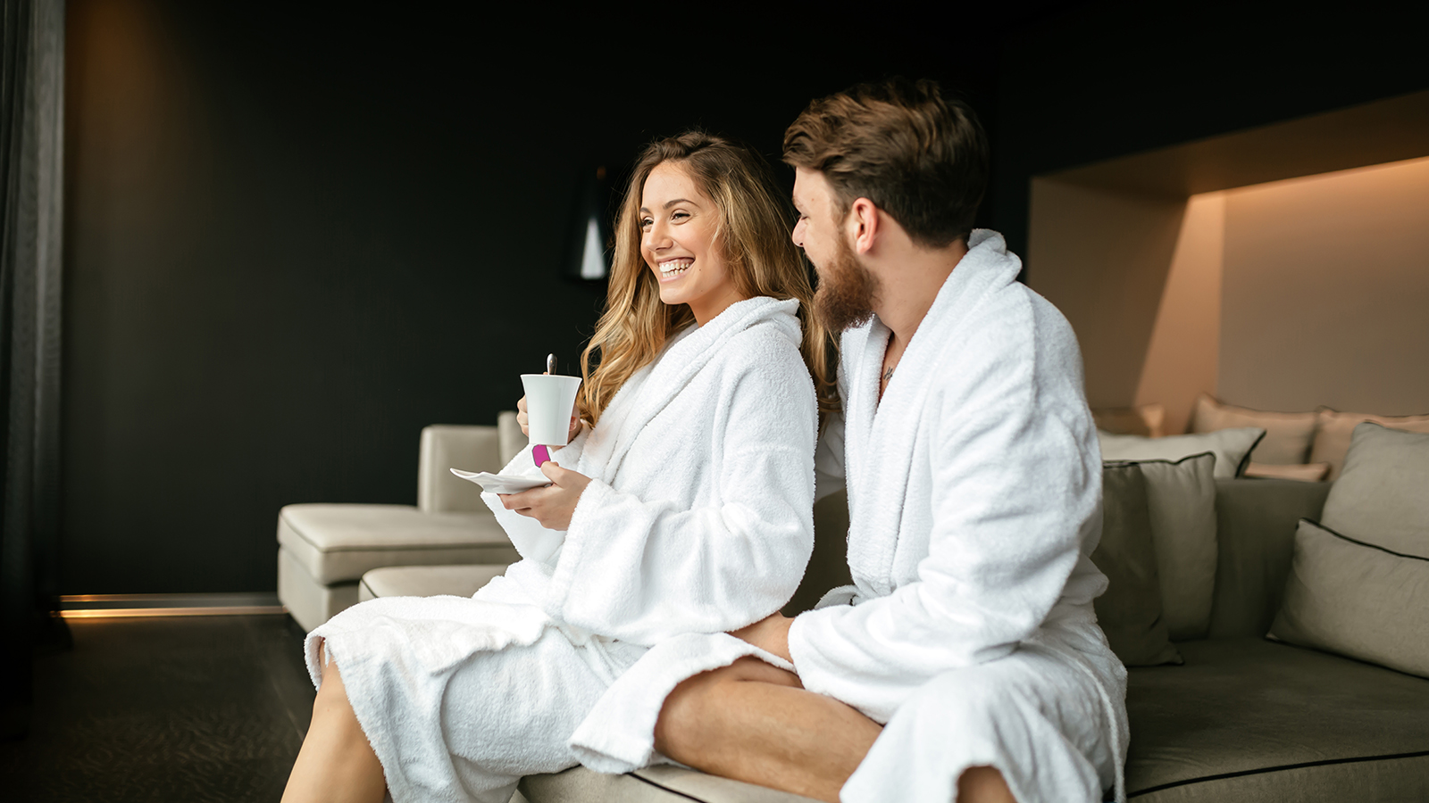
Celebrate the most romantic time of the year with a variety of special getaway offers from Four Seasons Hotel Baltimore in honour of Valentine’s Day.
Timeless Love
Extend the romance this holiday: this effortless package invites guests to take advantage of luxury accommodations in a Harbor Suite, accompanied by the choice of one of four premium timepieces (each valued at approximately USD 2,000) hand selected by Radcliffe Jewelers. Make the stay that much sweeter with a bottle of Veuve Clicquot Yellow Label and chocolate-covered strawberries upon arrival, a rose petal entry, followed by celebratory cocktails for two in the sky at The Bygone, located atop the Hotel on the 29th floor. To complete the experience, conclude with a full American breakfast for two through in-room dining or Maximón, located right off the lobby.
Due to the limited and exclusive nature of this package, contact 410 223 1493 for reservations directly. The Timeless Love Package is available to book any night from February 14-16, 2020. Pricing starts at USD 3,285.
Month of Love Offerings at The Spa
This Valentine’s Day, treat a loved one to a memorable experience at The Spa at Four Seasons Hotel Baltimore. Choose from the following offerings available for the entire months of January and February 2020:
- Galentine’s Massage - Indulge in a day of self-care with bubbly, pampering, and reconnecting. Take advantage of a 25-minute Express Massage and 25-minute Carboxi Express Facial.
- Lovers Only - Up the romance with two glasses of bubbly and chocolate-covered strawberries while relaxing in a Couples Suite. Then, unwind side-by-side with a 50-minute, 80-minute, or 110-minute candlelit aromatherapy massage.
- Night Spa Experience - Pamper a loved one with an unforgettable personalised Night Spa Experience in the tranquil setting of the Hotel’s 10,000-square-foot (930 square metre) state-of-the art Zen playground. Lovebirds will enjoy exclusive late-night one-on-one time complete with a welcome tea ritual, two monogrammed bathrobes, and joint access to the Heat Experience. Additionally, receive two 80-minute Swedish Massages, a candle-lit rose petal drawn bath, and a multi-course tasting menu prepared by in-room dining, which includes one bottle of house champagne or wine, all in the comfort of the VIP Couples Suite.
To book, contact The Spa directly at 410 223 1440.
Romance Getaway
Seeking to extend the romance? Celebrate love all weekend long with an overnight stay. The Romance Package provides complimentary bubbly and treats in luxurious accommodations. Enjoy early check-in to kick-off the getaway as early as possible, chilled sparkling wine and chocolate covered strawberries upon arrival, and late check-out to take advantage of a leisurely morning to maximise the time together and savour each unforgettable moment. And sometimes a gift can speak a thousand words, so the Concierge will be on hand to assist with getting the perfect gift or planning a proposal.

RELATED

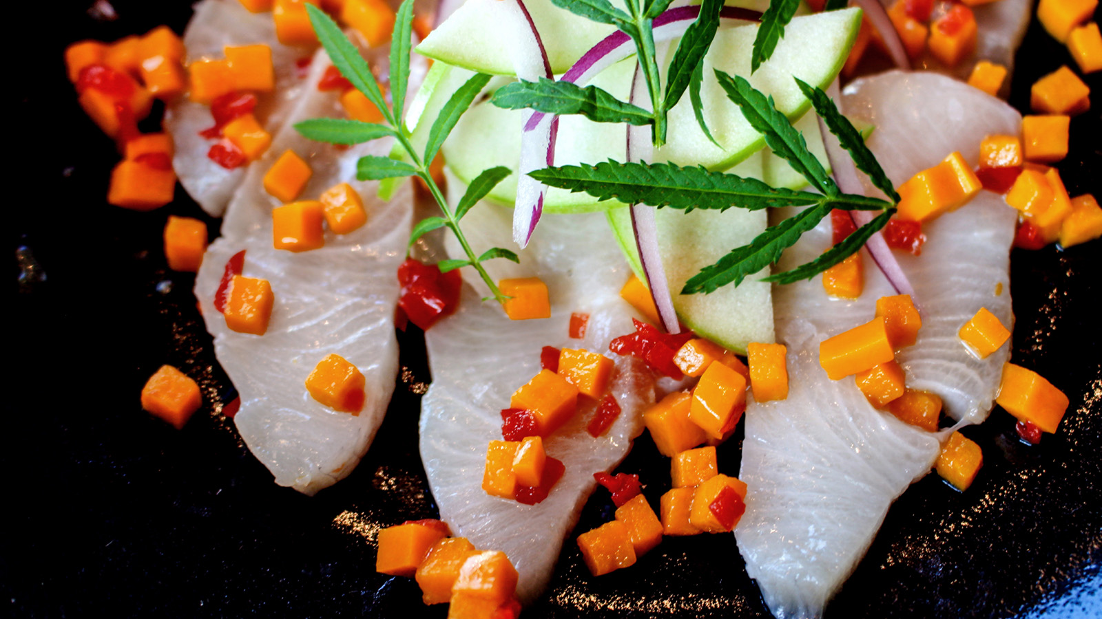 | January 6, 2020, Baltimore, U.S.A.  Atlas Restaurant Group Presents Maximón at Four Seasons Hotel Baltimore  https://publish.url/baltimore/hotel-news/2020/new-maximon-restaurant.html
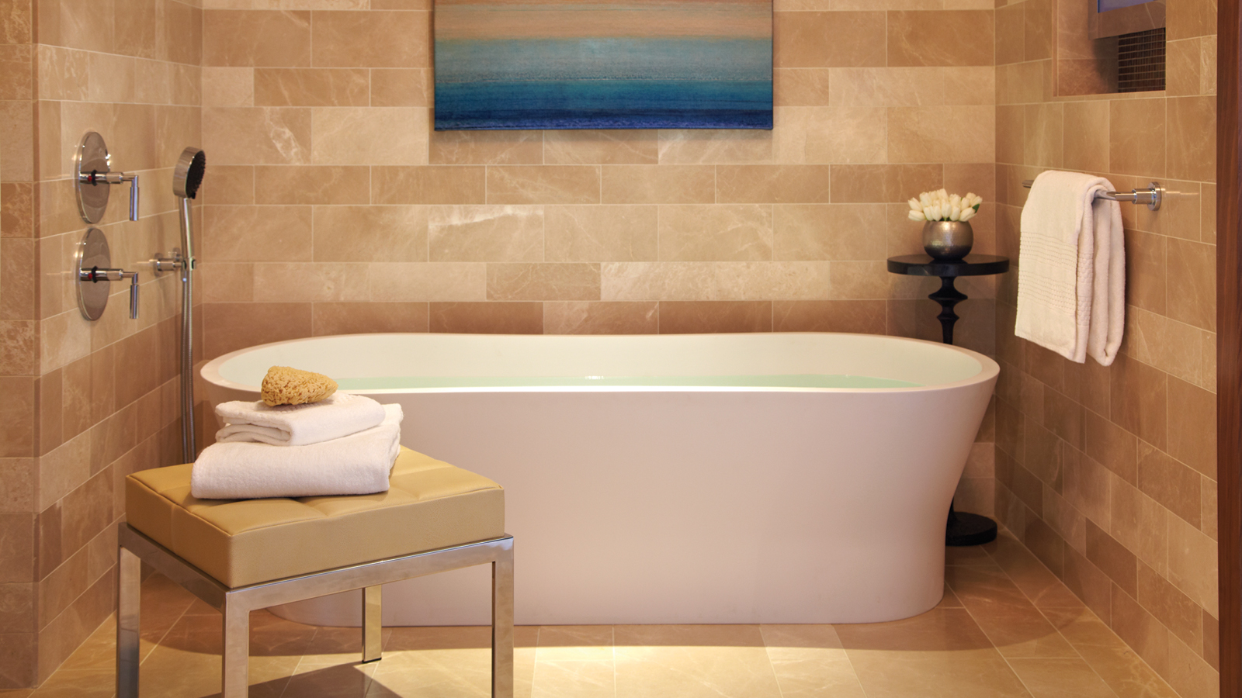 | December 10, 2019, Baltimore, U.S.A.  Four Seasons Hotel Baltimore Launches In-Room Deep Soaking Tub Service  https://publish.url/baltimore/hotel-news/2019/in-room-soak-service.html

PRESS CONTACTS

Christina Criss
Public Relations Manager
200 International Drive
Baltimore
USA
christina.criss@fourseasons.com

+1 (410) 223-1343

