Four Seasons Resort Oahu at Ko Olina and MINA Group Partner to Bring Michael Mina’s Brand to West Oahu

Mina’s Fish House gala opening scheduled for December
September 20, 2017, Hawaii, Oahu, U.S.A.

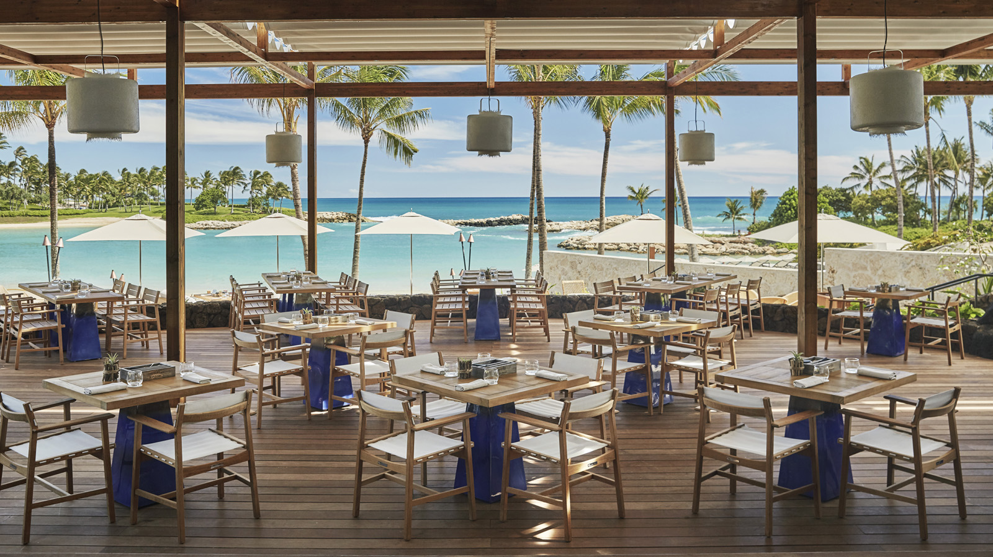
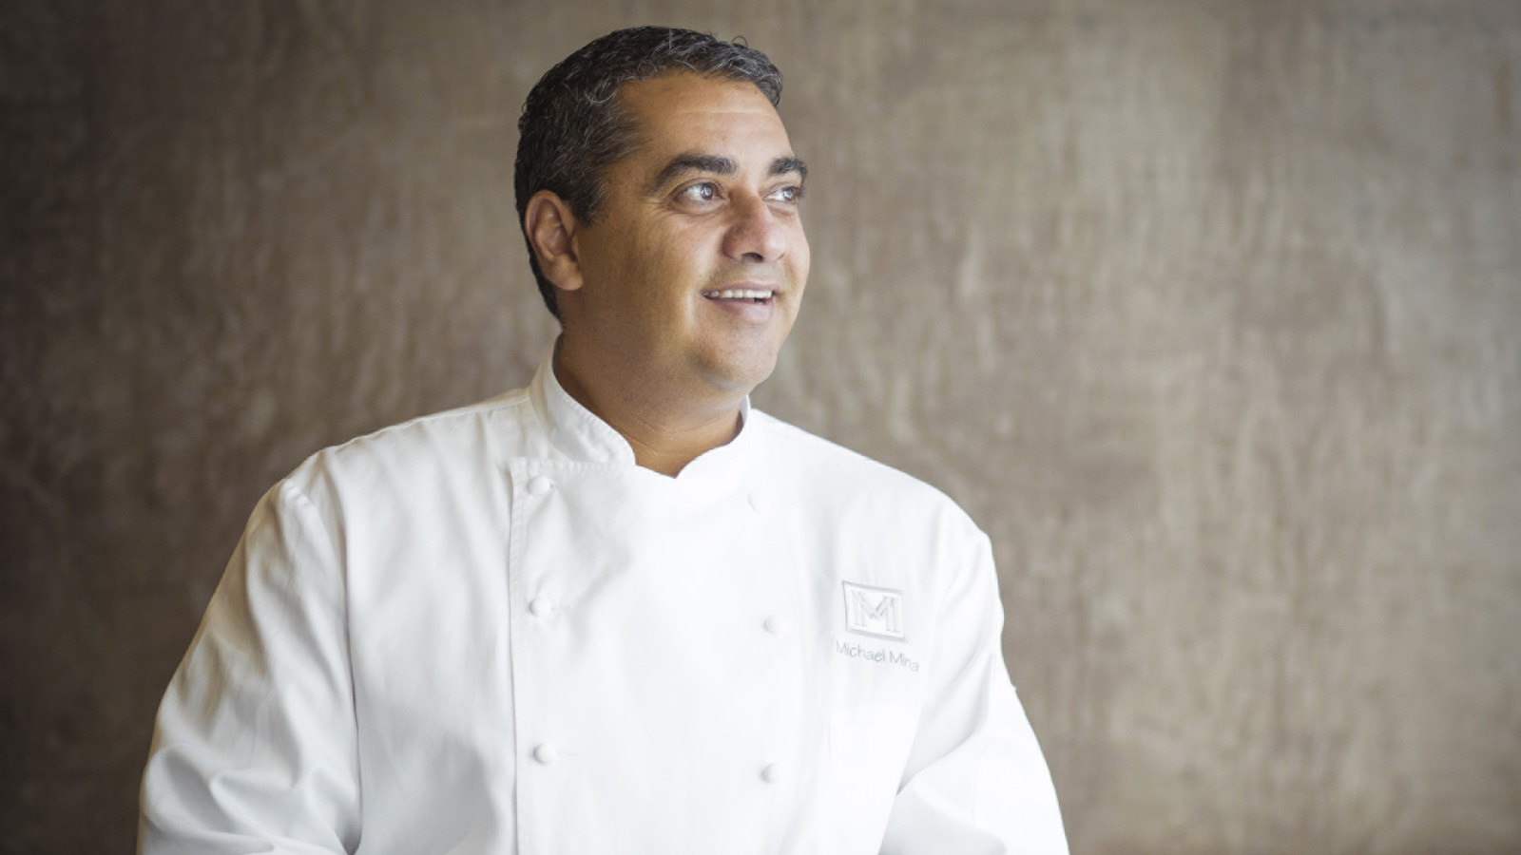 | 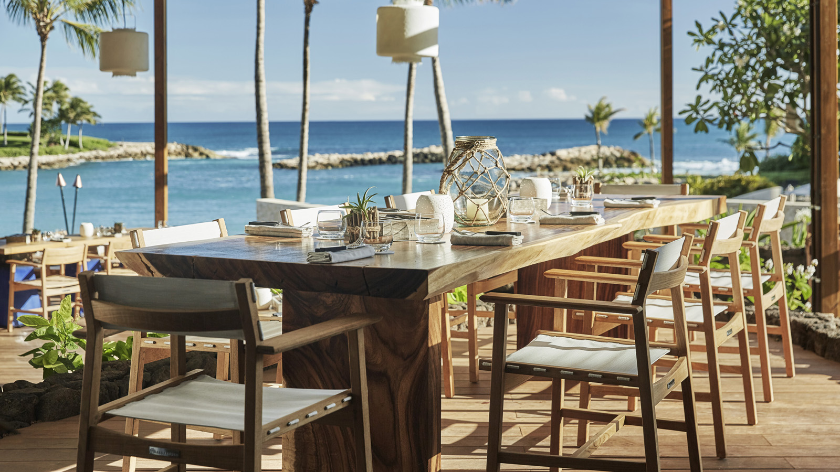 | 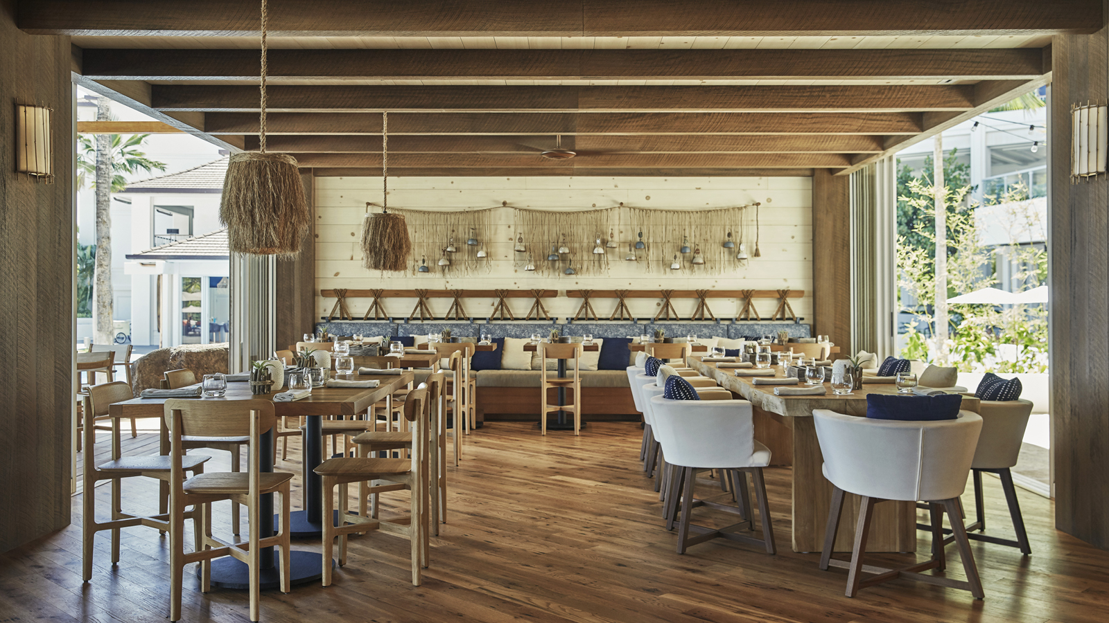
Four Seasons
Resort Oahu at Ko Olina announces a new partnership with award winning chef and restaurateur Michael Mina that will see Fish House, the Resort’s signature line-to-table restaurant, become Mina’s Fish House.
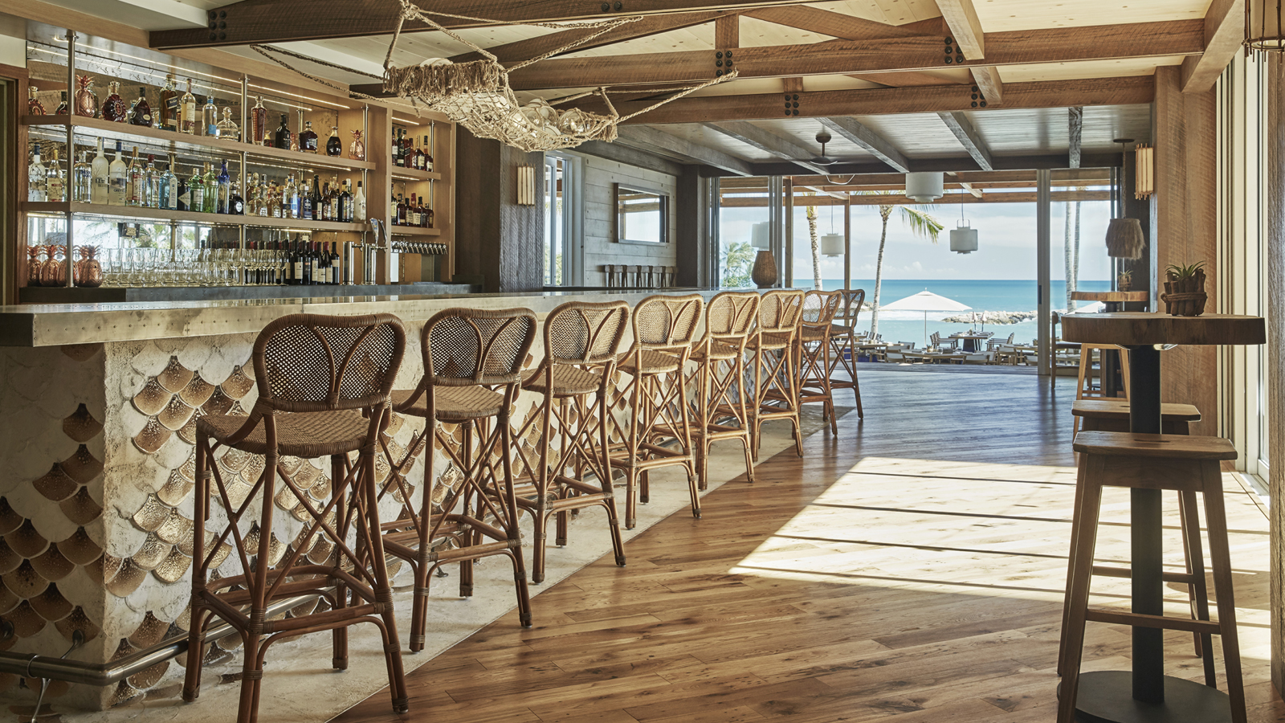 | 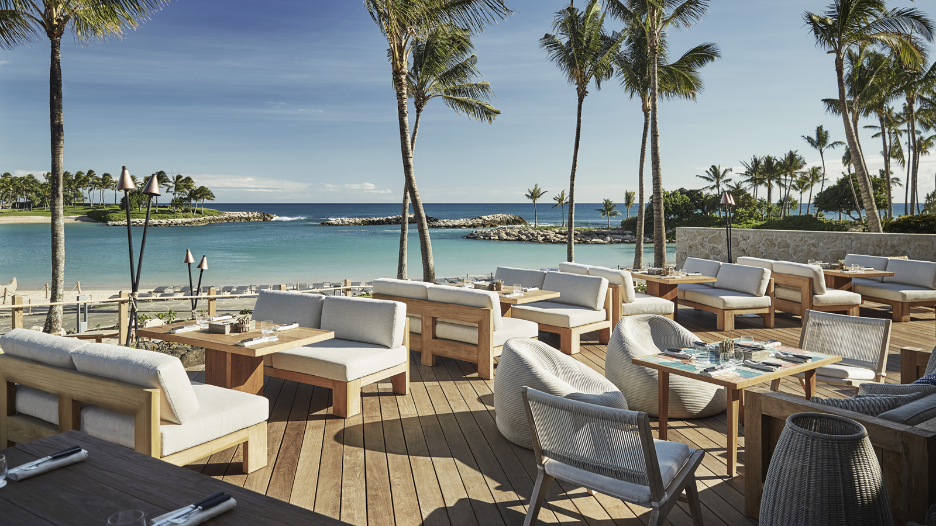
“We are incredibly excited as we take on the next step in positioning our Resort as an epicentre for culinary experience in Hawaii,” says
Four Seasons
General Manager Sanjiv Hulugalle. “This exciting evolution of Fish House will usher in our 2017 festive season.”
“I couldn’t be more thrilled to be opening Mina’s Fish House in Ko Olina and with
Four Seasons
, one of our great partners,” says Michael Mina. “I have a special love for Hawaii, and spend many of my vacations here on the islands. This property is very beautiful and special; the perfect home for a project that I am especially excited about.”
Chef Mina’s story is one of two decades of influence, passion and achievement. With accolades including James Beard Foundation “Who’s Who of Food & Beverage” inductee in 2013, Bon Appétit Chef of the Year 2005, San Francisco Magazine Chef of the Year 2005, as well as the International Food and Beverage Forum’s Restaurateur of the Year 2005, Mina continues to dazzle the culinary world with bold dining concepts that have contributed to San Francisco’s reputation as a world-class epicurean destination and made him an integral part of the dining scene across the country and internationally, including at
Four Seasons
locations in Jackson Hole, Washington, DC, Baltimore and Dubai.
Some architectural and décor changes are planned for the iconic beach side dining experience, including an outdoor bread oven and private dining room. Guests can expect an exciting new menu, tailored exclusively for the Four Seasons Resort Oahu at Ko Olina.

RELATED

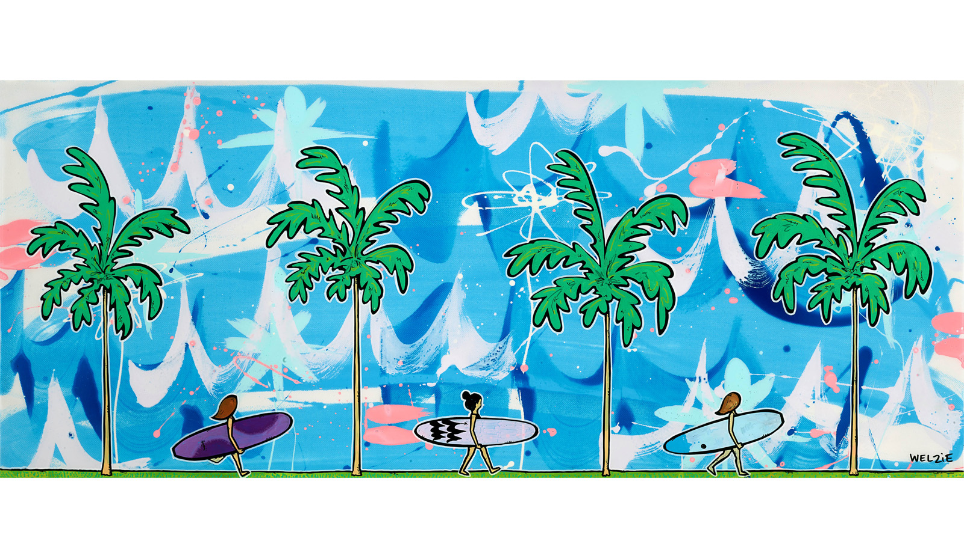 | September 19, 2017, Hawaii, Oahu, U.S.A.  Welzie Art x Two Crows Surfboards Fine Art Collection Debuts at Four Seasons Resort Oahu at Ko Olina  http://publish.url/oahu/hotel-news/2017/artist-in-residence-welzie.html
August 8, 2017, Hawaii, Oahu, U.S.A.
Say I Do Where Heaven Meets the Earth: Four Seasons Resort Oahu at Ko Olina is Hawaii’s Ultimate Wedding and Honeymoon Destination
http://publish.url/oahu/hotel-news/2017/weddings-and-honeymoons.html

PRESS CONTACTS

Yvonne Hunter
Director of Public Relations
92-1001 Olani Street
Kapolei
U.S.A.
yvonne.hunter@fourseasons.com

+1 (808) 729-0686

