Four Seasons Hotel Toronto Honours Global Wellness Day with a Series of Virtual Activities

June 4, 2021, Toronto, Canada

Four Seasons Hotel Toronto and the Spa at Four Seasons Toronto will once again celebrate Global Wellness Day on Saturday, June 12, 2021, with a curated itinerary of virtual activities to be enjoyed in the comfort of one’s home.
“Now more than ever, we know individuals are making a conscious effort to dedicate themselves to living a healthy and fulfilled life,” says Viviana Quesada, Senior Spa Director. “It’s our hope that this Global Wellness Day experience continues to encourage our community to seek moments of mindfulness on a daily basis.”
Participants of all ages are invited to celebrate this annual event by visiting the property’s official Instagram channel @fstoronto for a variety of wellness-focused activities held via Instagram Live. The property’s expert Spa team has developed an inspired itinerary collaborating with leading Toronto-based wellness professionals including 889 Community, a long-term Global Wellness Day partner; Luciana Santaguida, energy healer and creator of NÜLOVE; and Café Boulud’s very own Chef de Cuisine Nicholas Trosien.
Global Wellness Day - Saturday, June 12, 2021
- 9:30 am - Enjoy a 45-minute yoga session with a talented 889 Yoga instructor and mindfully explore various aspects of yoga including dynamic movements, breathing and meditation.
- 11:30 am - Café Boulud Chef de Cuisine Nicholas Trosien will lead an at-home cooking class as he demonstrates how to prepare a healthy and delicious heirloom tomato and quinoa salad.
- 3:30 pm - The youngest members of the family can enjoy a 45-minute children’s yoga class led by an 889 Yoga instructor as they are guided through the basics of yoga and mindfulness.
- 5:30 pm - The day will come to an end with a 45-minute sound healing meditation led by Luciana Santaguida of NÜLOVE. Unwind and embark on a journey of discovery and relaxation while connecting with sound, realigning and resting.
The entire team at Four Seasons Hotel Toronto looks forward to virtually welcoming everyone to join them in celebrating a day dedicated to living well. Follow along and share Global Wellness Day experiences by tagging @fstoronto, #FSWellness and #GWD2021.

RELATED

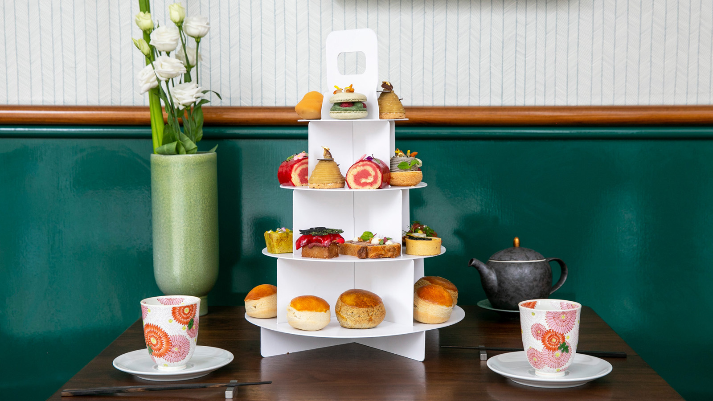 | May 19, 2021, Toronto, Canada  Four Seasons Hotel Toronto and Aburi Hana Launch an Exclusive Afternoon Tea Collaboration  https://publish.url/toronto/hotel-news/2021/aburi-hana-afternoon-tea.html
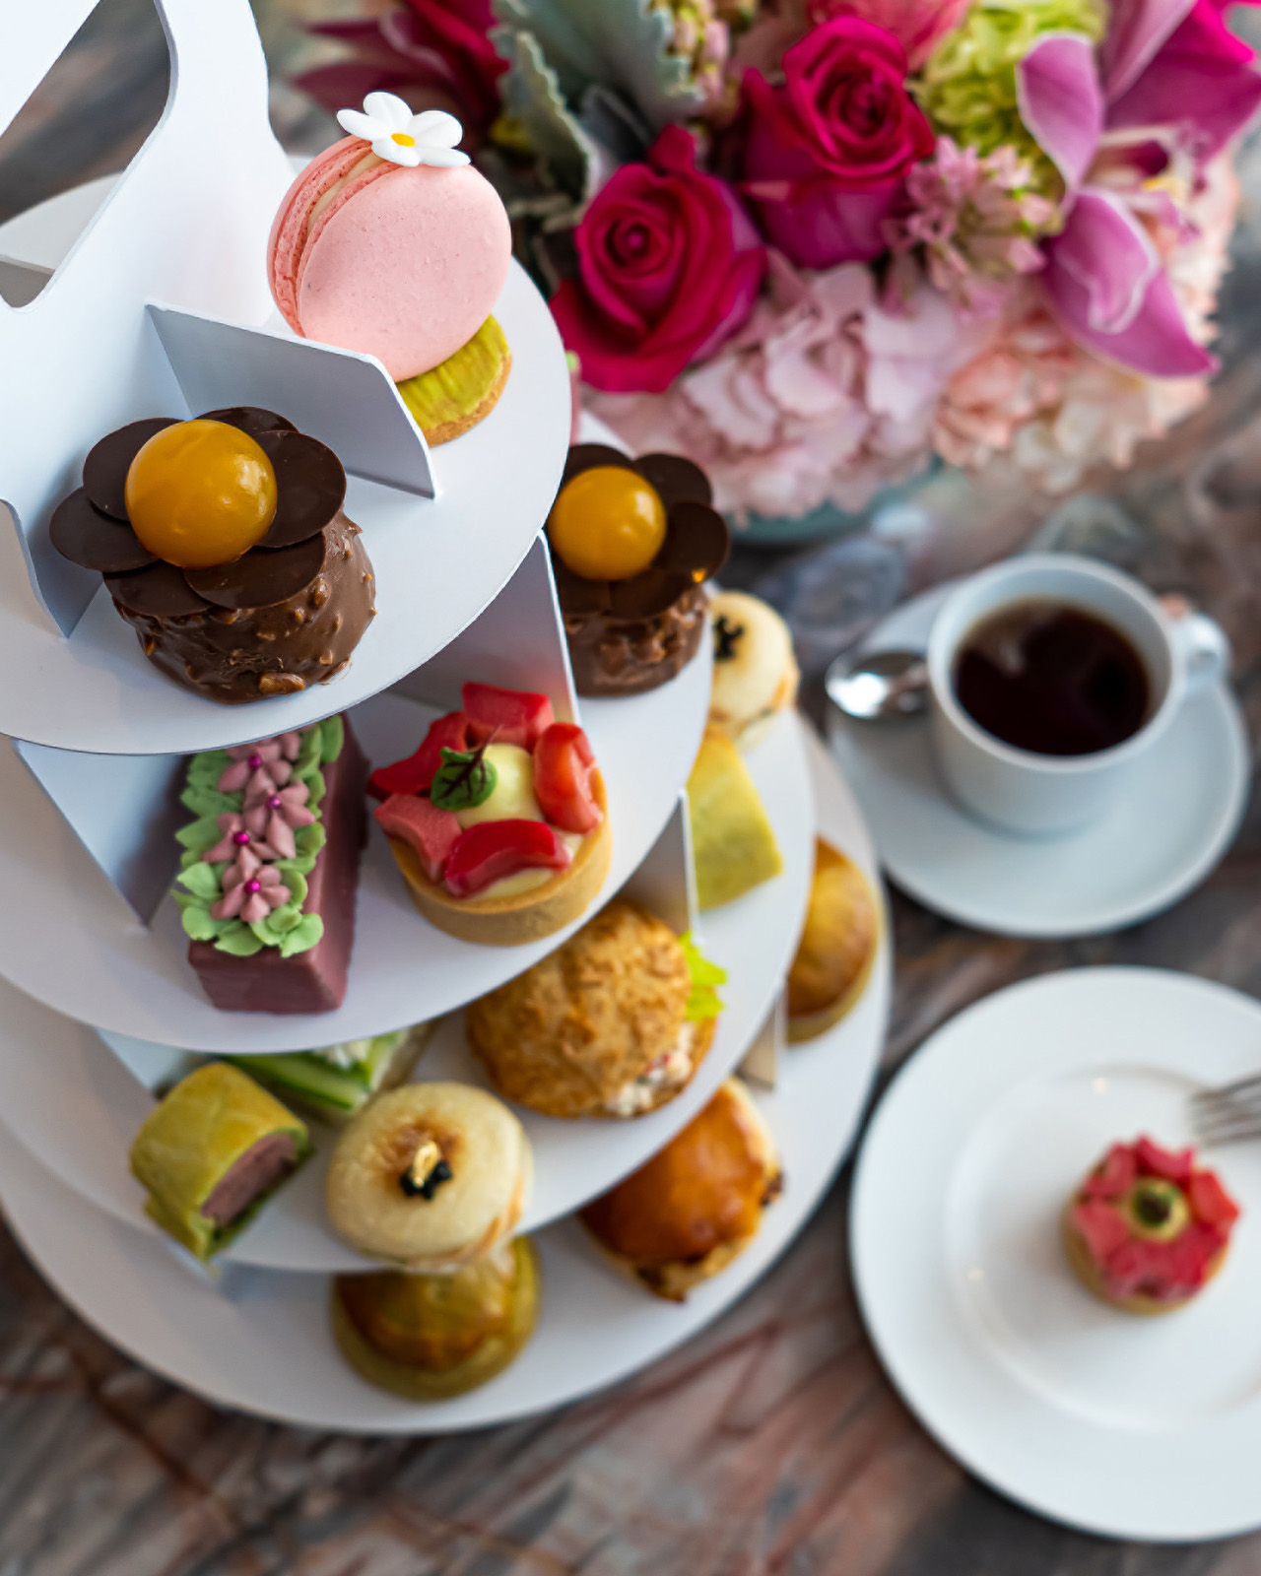 | April 26, 2021, Toronto, Canada  Mother’s Day Moments with Four Seasons Hotel Toronto  https://publish.url/toronto/hotel-news/2021/mothers-day.html

PRESS CONTACTS

Halla Rafati
Public Relations Director
60 Yorkville Avenue
Toronto
Canada
halla@haloandco.co

+1 416 364 0404

