Four Seasons Hotel Mumbai Unveils “The Four Seasons Brunch” at Café Prato

January 10, 2020, Mumbai, India

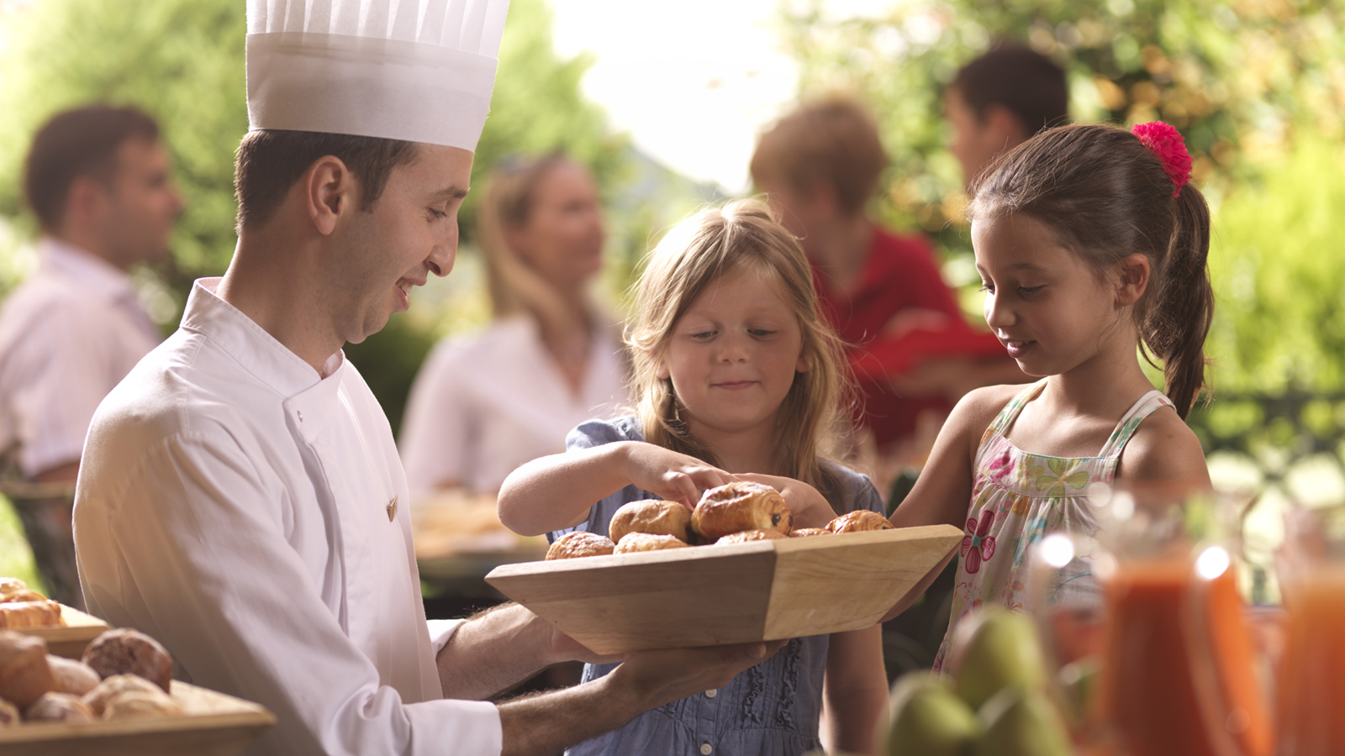
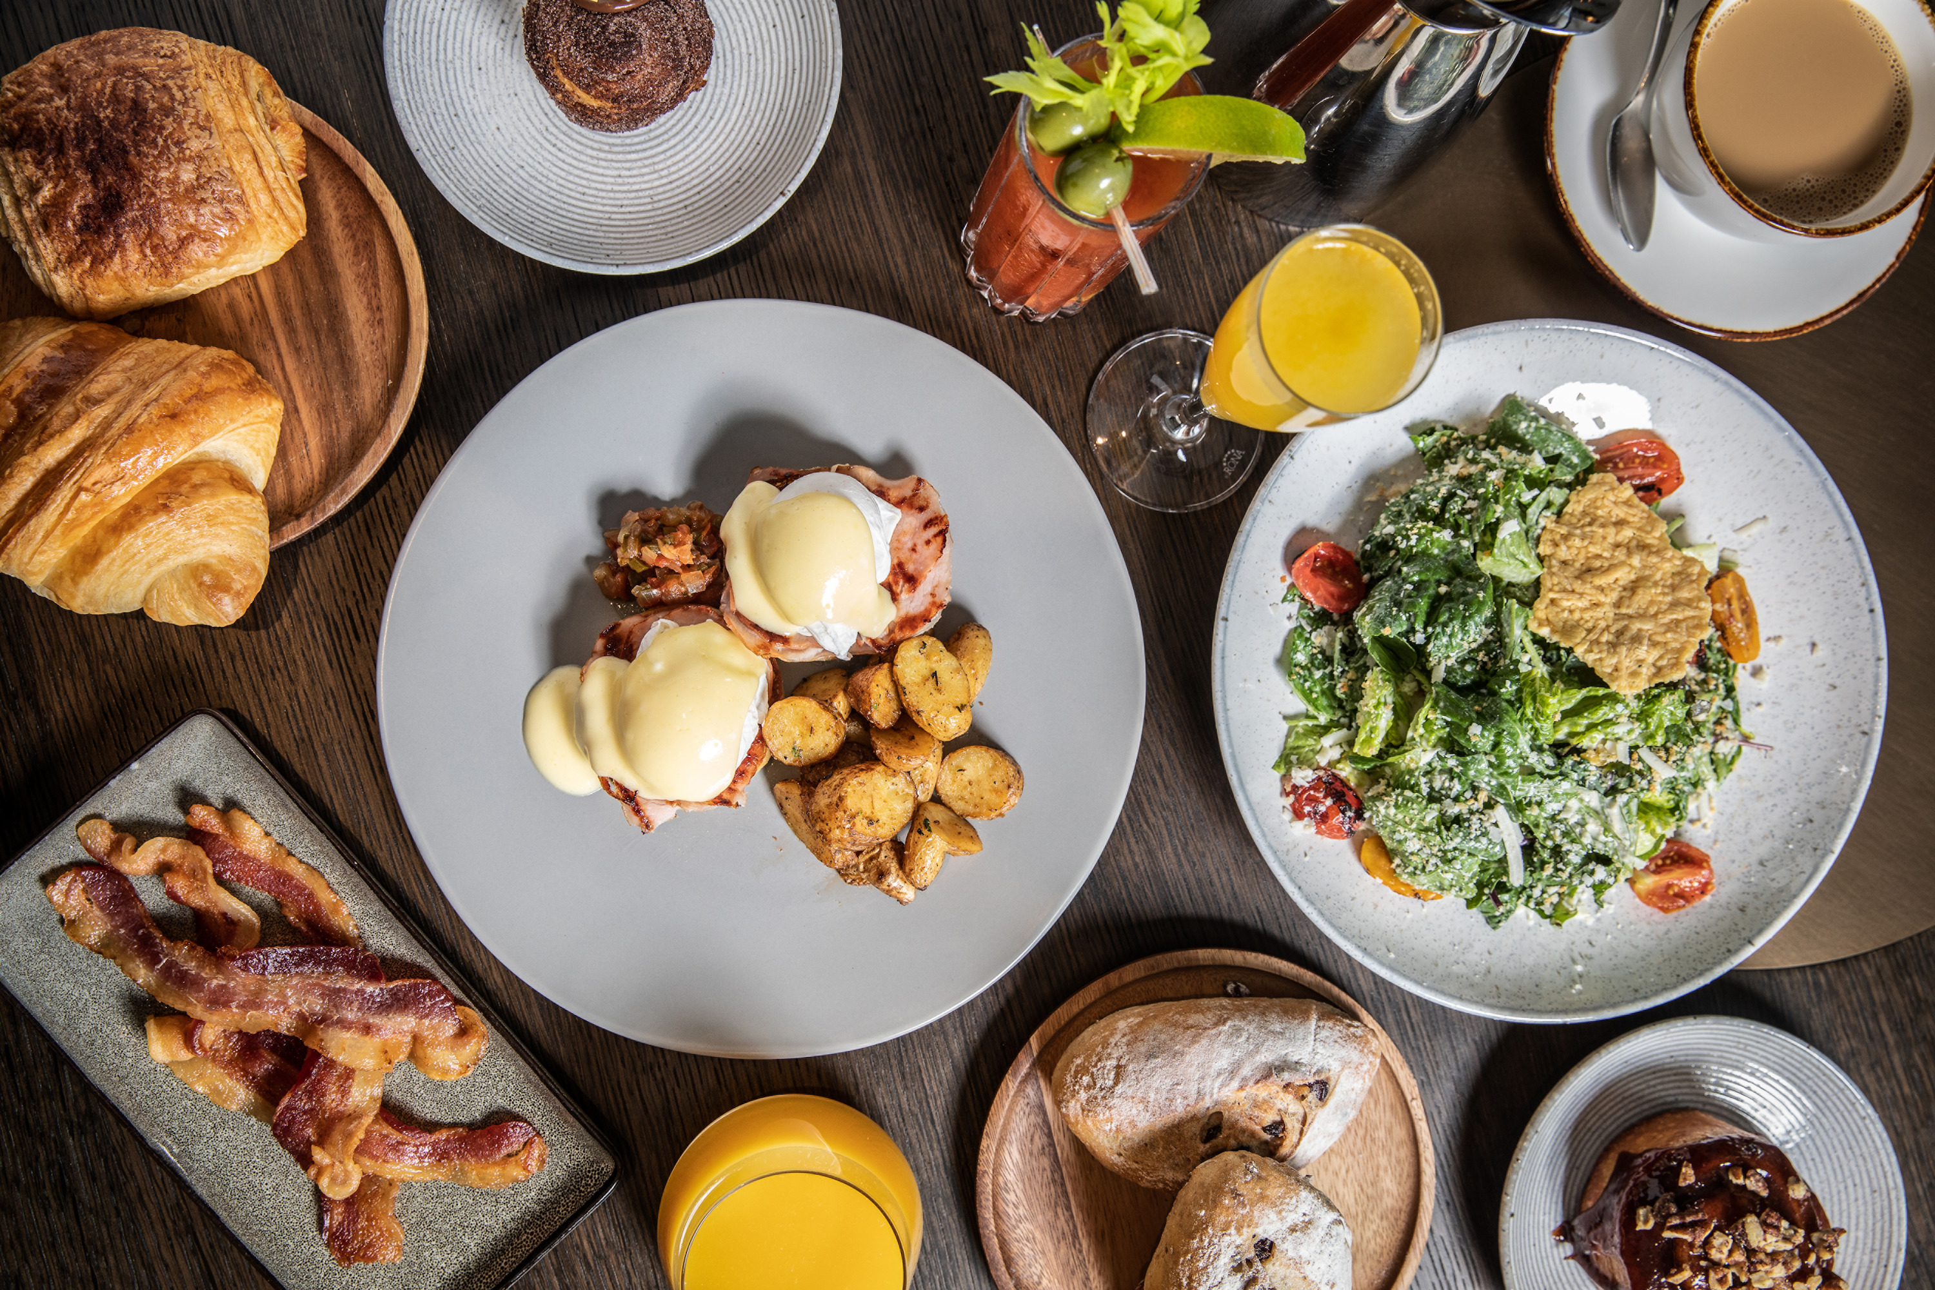 | 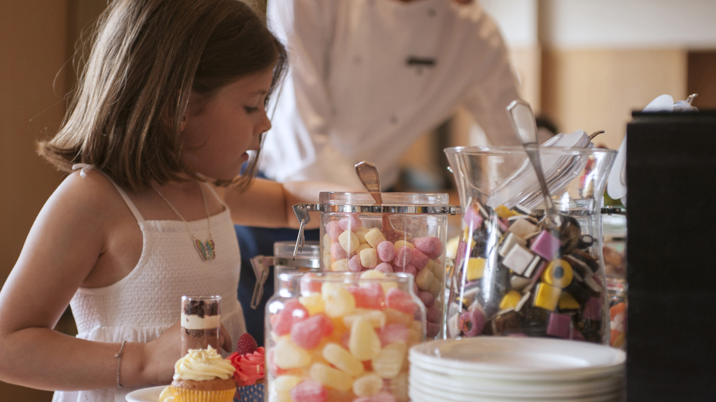 | 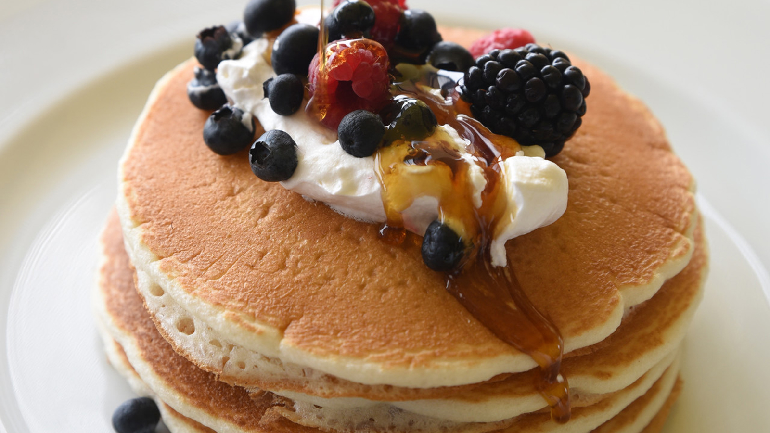
Adding a vibrant twist to 2020 Sunday afternoons, Four Seasons Hotel Mumbai introduces The Four Seasons Brunch at Café Prato between 12:45 and 3:30 pm. Guests can now indulge in delightful brunch favourites, and local and international selections every Sunday in the heart of Mumbai.
Designed for families, large gatherings and intimate get-togethers, Café Prato offers a spread of spectacular flavours to be enjoyed in the company of loved ones – what Sunday brunch dreams are made of.
Curated and spearheaded by Executive Chef Anupam Gulati, Café Prato’s team of master craftsmen whip up an extraordinary feast using the finest local, homegrown ingredients and freshly sourced international flavours. What’s more? The café offers a play area for kids complete with selection of activities such as temporary tattoos, clowns, icing cupcakes, colouring and more while parents get to enjoy some relaxed down time. A live band gets the mood going with soulful tunes by a live singer and guitarist, creating a lively, relaxed ambience.
Featuring a glorious spread of live stations, decadent cocktails, traditional and Indian brunch favourites and a wide dessert spread, guests can look forward to a wide variety of offerings to choose from. Indulge in classic egg preparations such as eggs benedict, florentine, sunny side up or Indian brunch specials such as parathas and a well-stocked South-Indian spread comprising of idlis, medu vada and varieties of dosas. Meat lovers can take delight in specials such as the haleem station crafted by Chef Majeed Shaikh or seafood specials specially thought up for Sunday indulgence. Also on the menu are local delicacies with a delightful twist such as the purple vada pav – available exclusively at the Hotel during the brunch.
Indulge in this vibrant showcase of food, beverage and lively entertainment and celebrate Sundays like never before at Café Prato starting January 12, 2020.
- Brunch without alcohol: INR 2,999 plus taxes
- Brunch with alcohol: INR 4,499 plus taxes
- Brunch for kids (5 to 12 years): INR 1,500 plus taxes.

RELATED

December 17, 2019, Mumbai, India
Celebrate the Festive Season and Make Lasting Holiday Memories at Four Seasons Hotel Mumbai
https://publish.url/mumbai/hotel-news/2019/festive-season.html

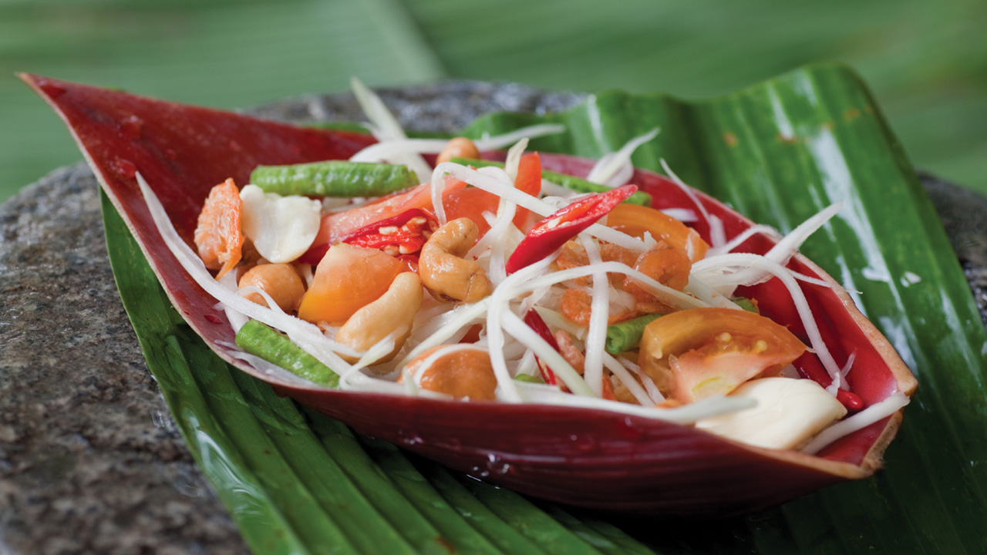 | November 7, 2019, Mumbai, India  Celebrate Loy Krathong with Festive Thai Preparations at San:Qi at Four Seasons Hotel Mumbai  https://publish.url/mumbai/hotel-news/2019/loy-krathong-at-san-qi.html

PRESS CONTACTS

Stephanie D'Silva
Director of Marketing
1/136 Dr. E. Moses Road, Worli
Mumbai
India
stephanie.dsilva@fourseasons.com

986 706 1900

Neha Nair
Marketing Communications Manager
1/136 Dr. E. Moses Road, Worli
Mumbai
India
neha.nair@fourseasons.com

+91 (22) 2481 8062

