Rediscover Baku with a Fourth Night Free at Four Seasons Hotel Baku

Spend more time exploring the very best of Baku
July 12, 2021, Baku, Azerbaijan

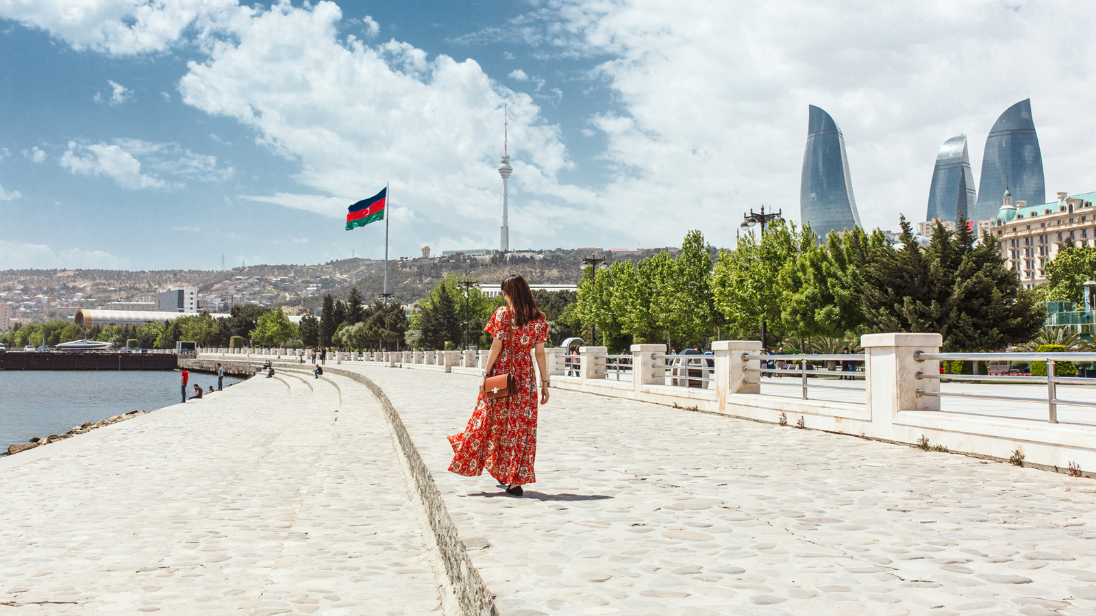
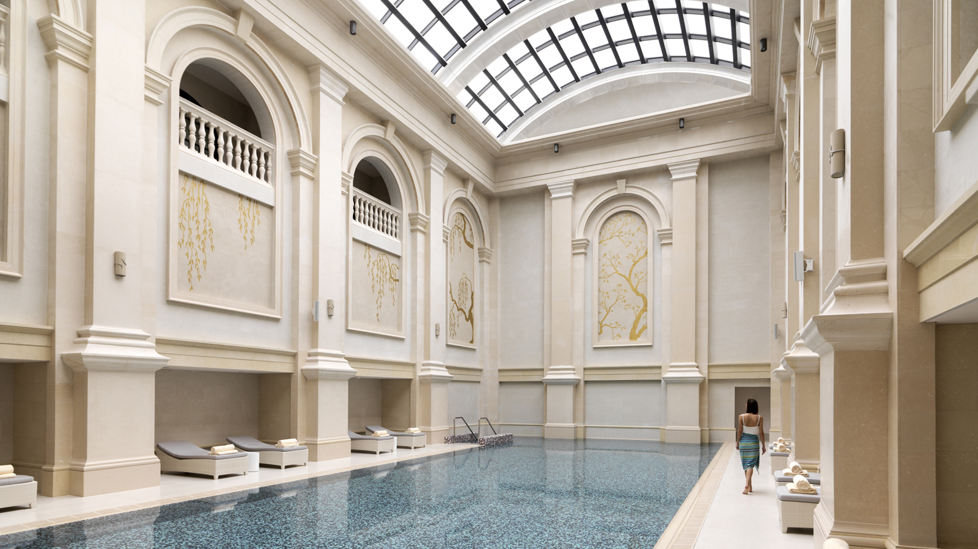 | 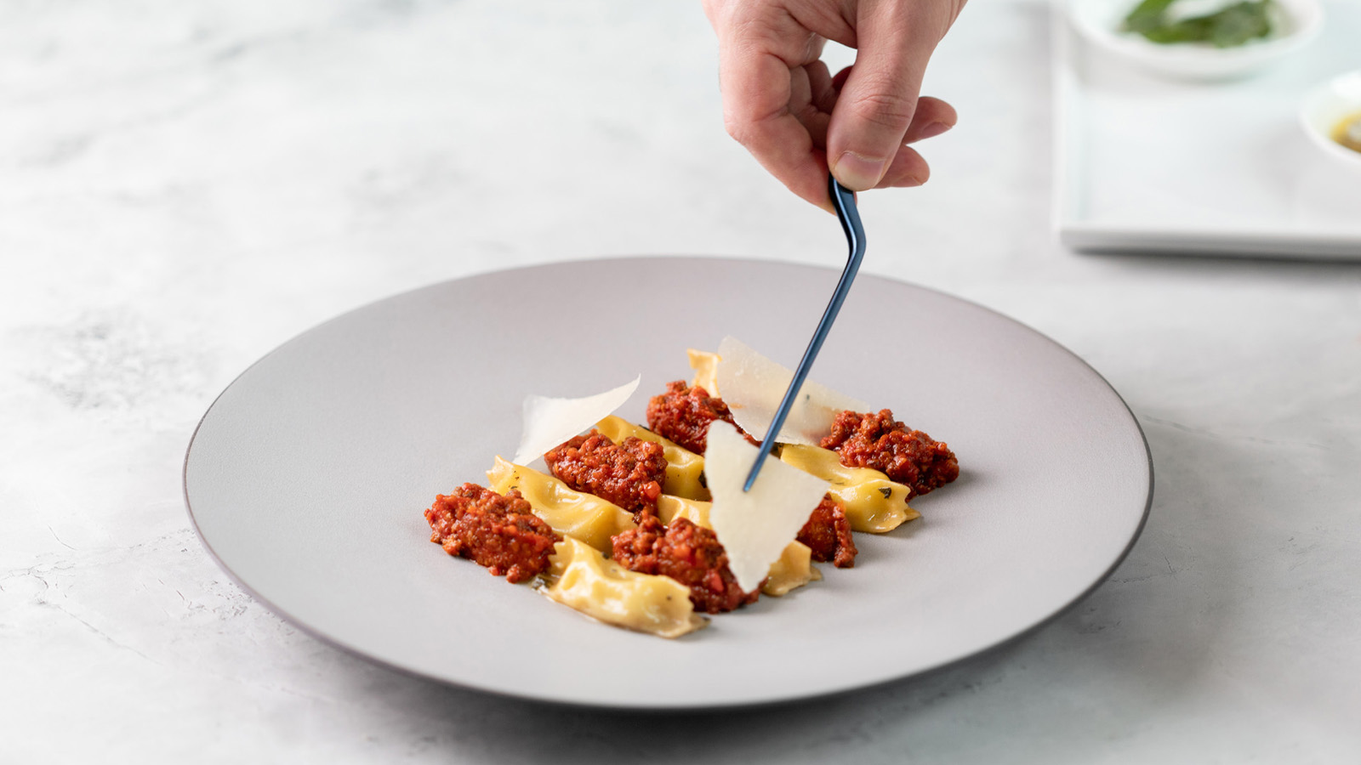 | 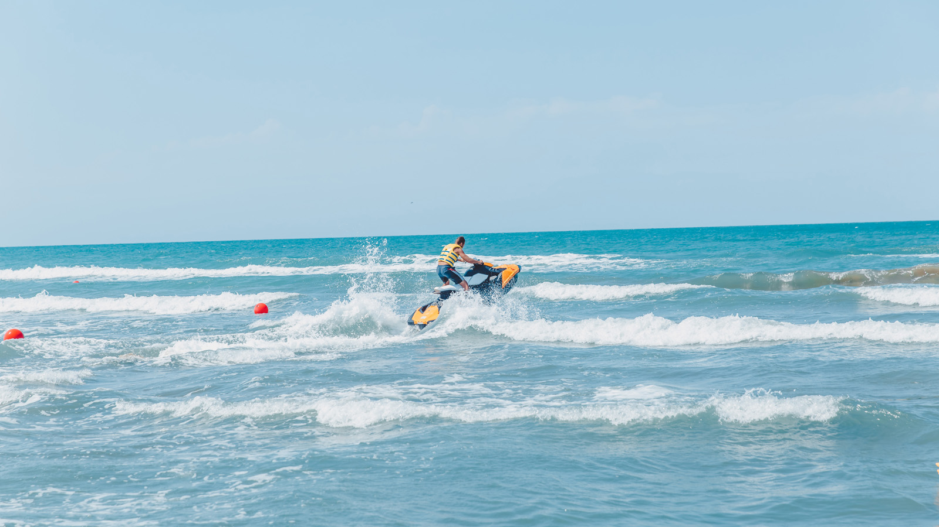
Located between the Old City and the remarkable waterfront Boulevard, Four Seasons Hotel Baku presents guests with a special offer to explore the city once again and discover new treasures with the help of the Hotel’s Concierge team.
Book a room with Rediscover Baku offer and get the fourth night complimentary with every three consecutive paid nights.
The heart of Azerbaijan, the city of Baku combines both traditions and modernity changing literally every second. Chef Concierge Vusal Isagov and his team are always staying on top of new entertainment places, architectural projects, green spaces and museums to fill every visit with memorable moments and life-long experiences.
Family in Style
On the first day of visiting the city the best is to wander around the streets and have some shopping time along with family members. The newly opened Daniz Mall is located within five minutes walk from the Hotel. The architecture of this stunning leisure and entertainment venue is a masterpiece of eight star-shaped wings inspired by Azerbaijan’s national emblem. For a more luxury shopping experience the Concierge team recommends Port Baku Mall, located within 10 minutes drive from the Hotel. Here guests can find most popular and coveted high end international brands as well as experience personalised shopping.
Time Travel
Located just few steps away from the Hotel, the Old City, Azerbaijan’s first UNESCO World Heritage Site, is definitely one of those places one cannot get enough of. Explore the beautiful narrow alleys, museums, mosques, hamams, Shirvanshakh Palace and monuments including the Maiden Tower dating back to the 12th century.
Right from the past it is highly recommended to travel to the future by visiting Heydar Aliyev’s Cultural Center designed by Zaha Hadid. The Center consists of a museum, library, conference centre and separate room for events, celebrations and concerts.
Promenade Along the Caspian Sea
Hit the open road and explore Baku cruising on a scooter by the beautiful promenade along the Caspian Sea. Whether a seasoned biker or a newbie, this experience makes the perfect getaway.
Escape to the Opal-Blue Waters
After a day of exploring the city centre, relax at one of the private beaches located just 30 minutes drive from the property. The Concierge team of Four Seasons Hotel Baku recommends a visit to the Sea Breeze Resort with its newly opened Rose Bar Baku, as well as the Amburan Beach Club, where one can have fun spending the entire day either by the beach or pool side, enjoying DJ performances with a dining experience at both clubs’ outlets.
Jaleh SPA
Later, after long walks in the city and hot day at the beach, the Hotel suggests guests unwind in its Jaleh SPA, based on the 9th floor and overlooking to the picturesque Caspian Sea. A range of beauty treatments is provided by professional well-trained therapists.
Culinary Journey
Zafferano Restaurant is available for all admirers of Italian cuisine, where they can treat themselves with traditional dishes of central Italy by the Hotel’s culinary craftsmen led by Executive Chef Talha Barkin. Piazza Lounge is designed to surprise and treat the sweet tooth with exceptional and unique desserts created by the Executive Pastry Chef Suraj Karmakar and his team.
The evening promises to be very beautiful on the cosy Eyvan Terrace, which will surprise its guests with a rich selection of exclusive cocktails and gastronomic offers.
To make a reservation, book online or call +994 124042424.

RELATED

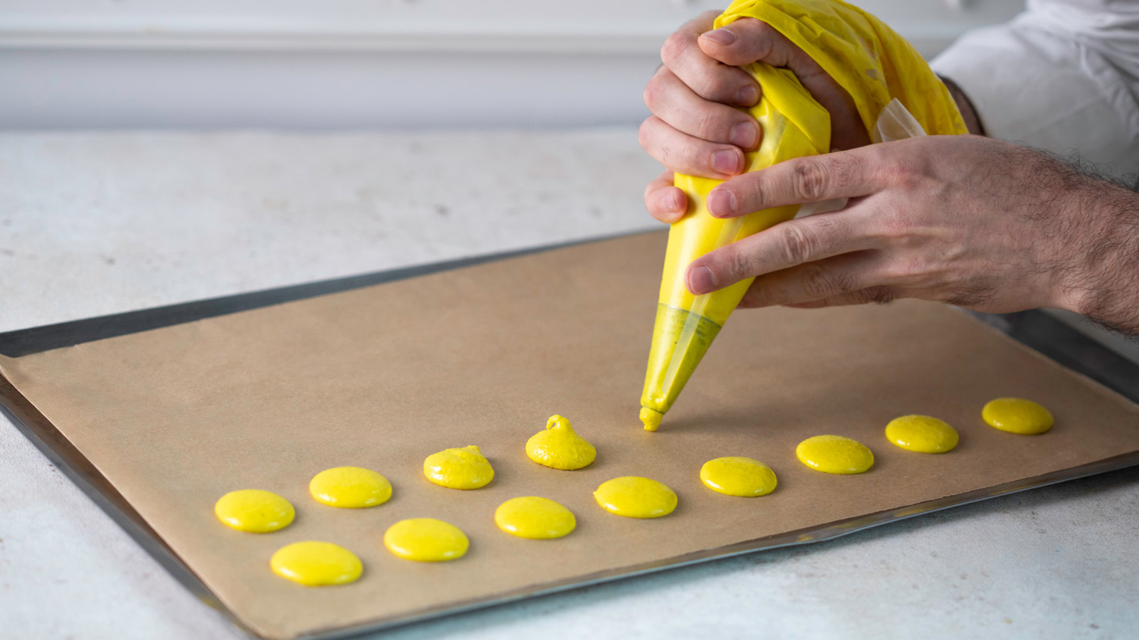 | June 23, 2021, Baku, Azerbaijan  Кулинарные уроки в отеле Four Seasons, Баку  https://publish.url/ru/baku/hotel-news/2021/culinary-classes-2.html
June 23, 2021, Baku, Azerbaijan
Culinary Classes at Four Seasons Hotel Baku
https://publish.url/baku/hotel-news/2021/culinary-classes.html

PRESS CONTACTS

Leila Aliyeva
Public Relations Manager
1, Neftchilar Avenue
Baku
Azerbaijan
leila.aliyeva@fourseasons.com

+994 12 404 2424

