Five Most Photogenic Spots at Four Seasons Resort Chiang Mai

January 4, 2021, Chiang Mai, Thailand

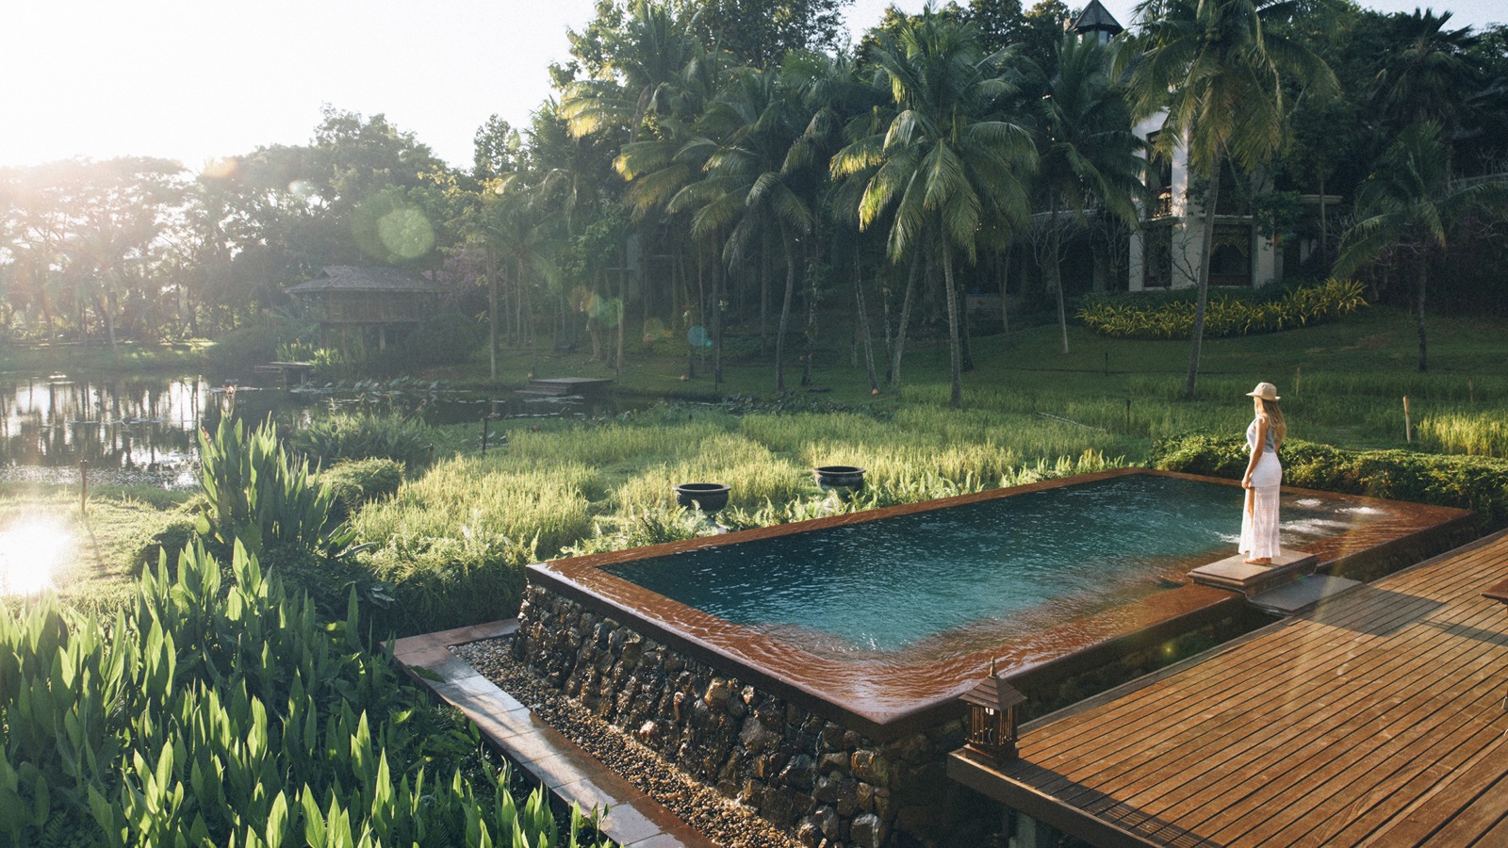
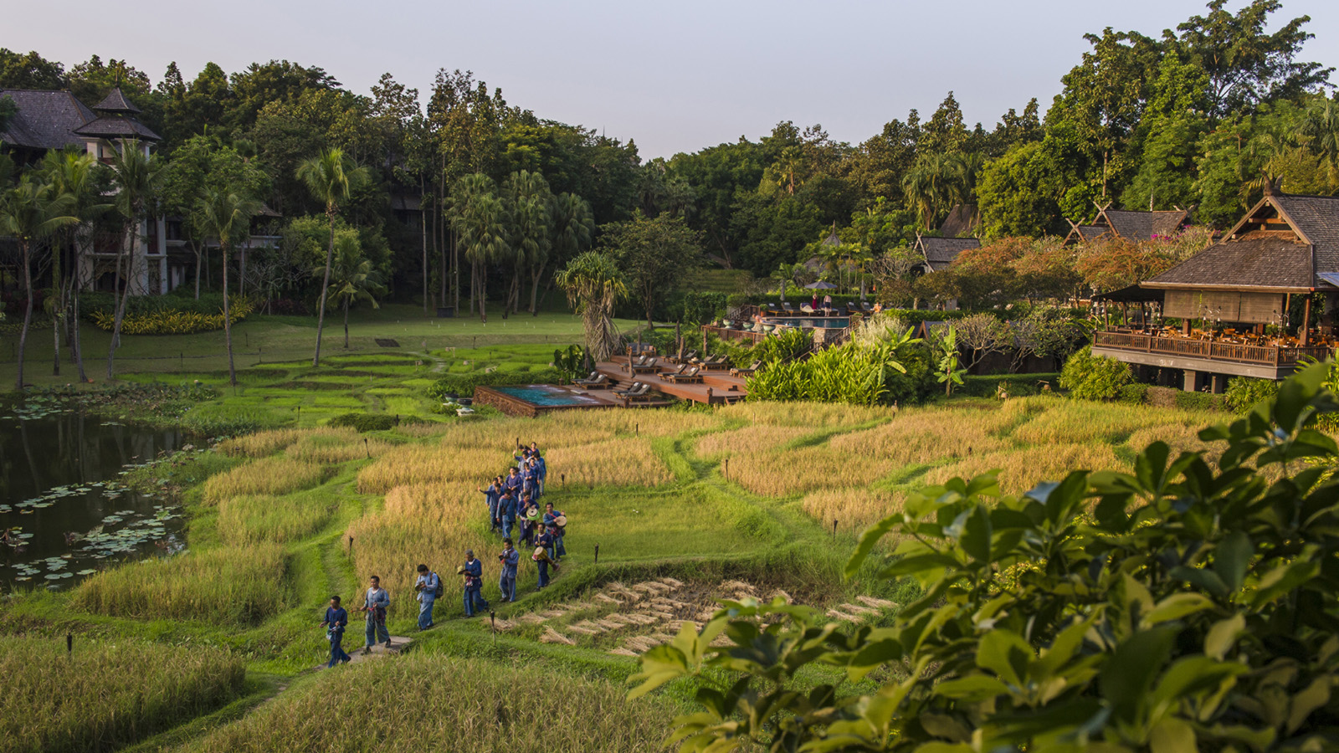 |  | 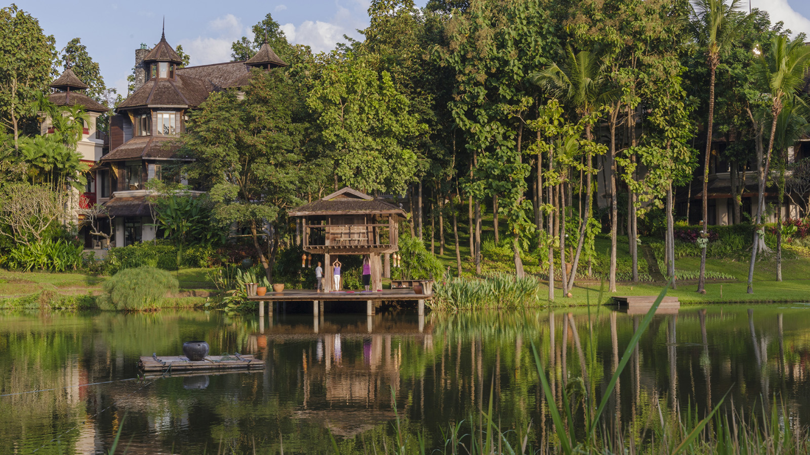

RELATED

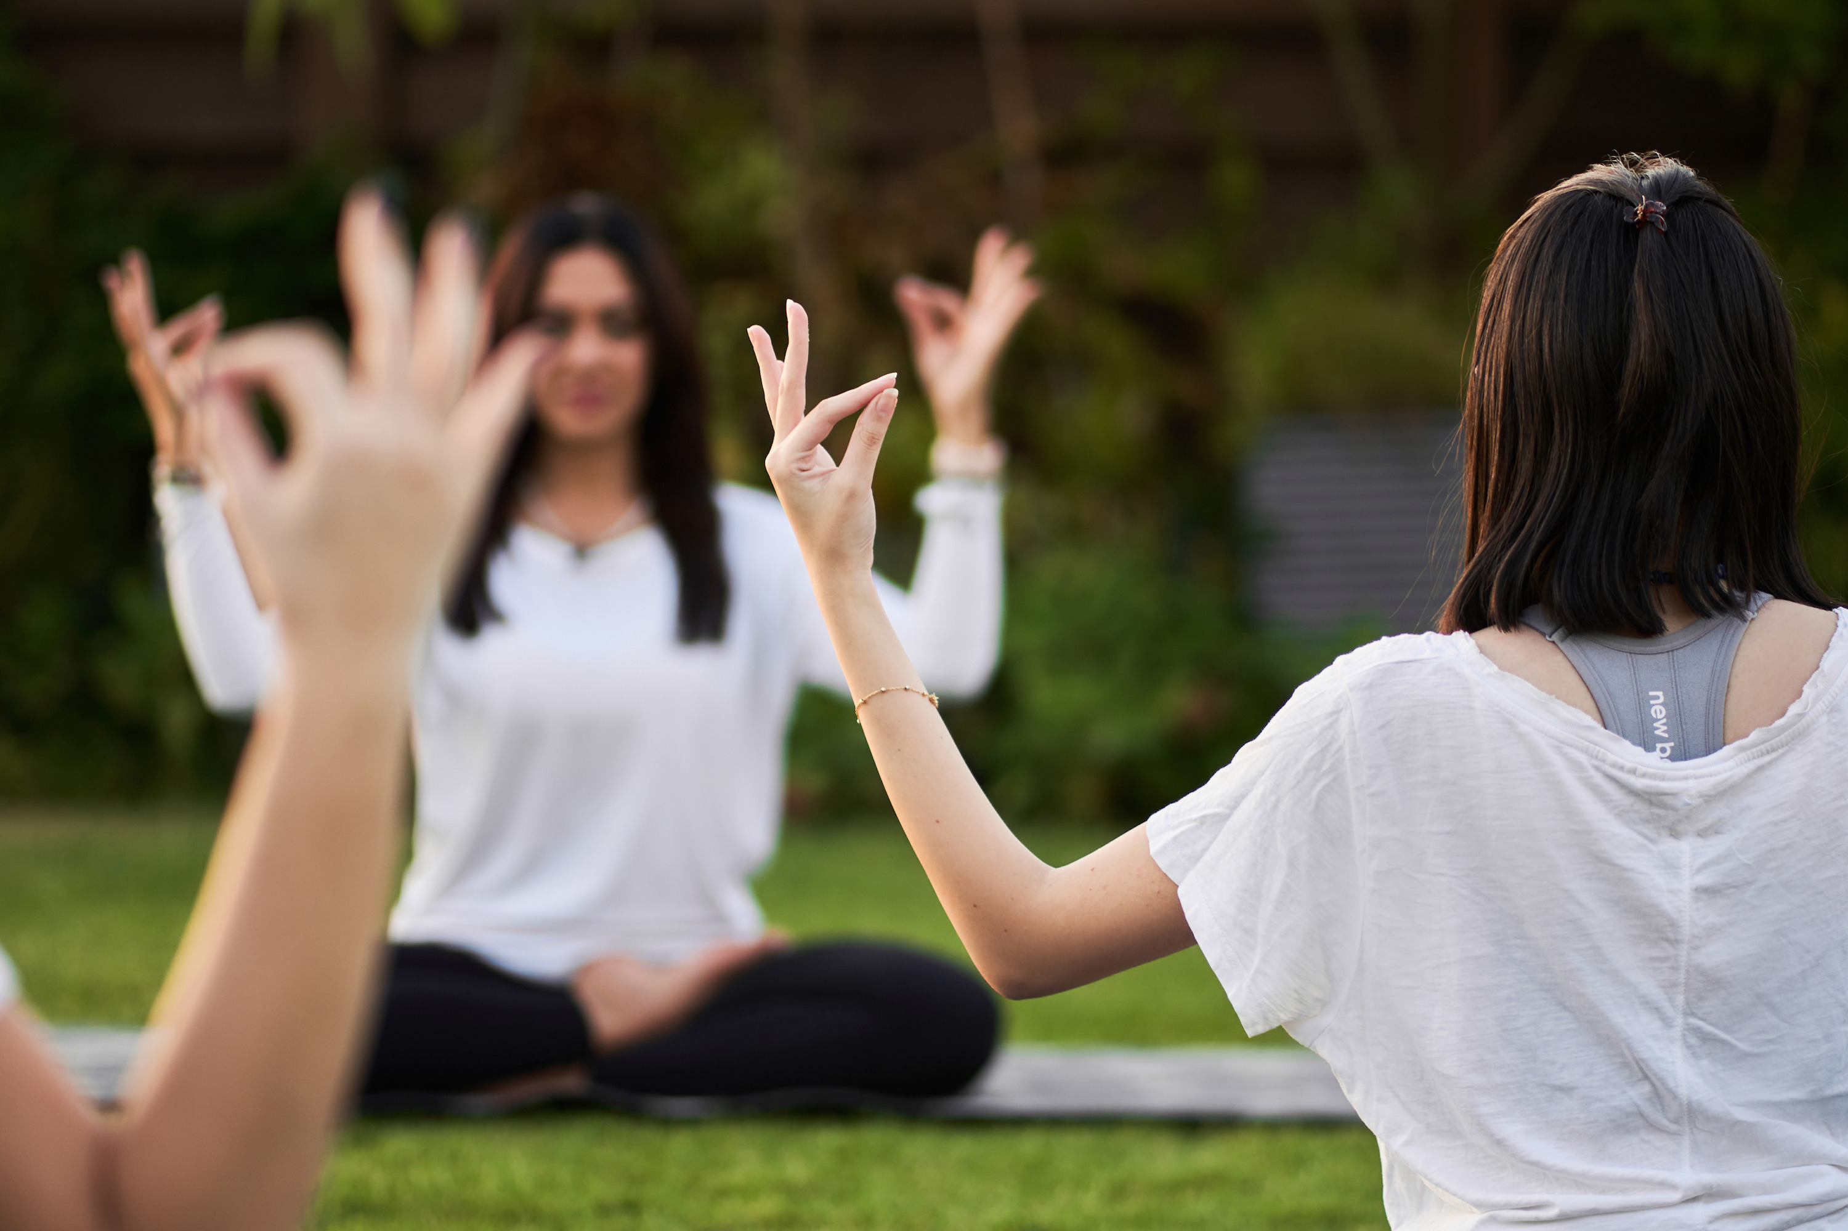 | February 18, 2023, Hoi An, Vietnam  Discover a World of Wellness in 2023 at The Heart of the Earth Spa at Four Seasons Resort The Nam Hai  https://publish.url/hoian/hotel-news/2023/visiting-wellness-practitioners.html
February 16, 2023, Chiang Mai, Thailand
Four Seasons Resort Chiang Mai Appoints Ashok Nair as Director of Rooms and Residences
https://publish.url/chiangmai/hotel-news/2023/ashok-nair-promotion.html

PRESS CONTACTS

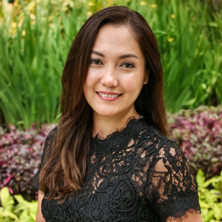 | Cristina Del Carmen  Senior Director of Public Relations and Communications  3/F, 159 Rajadamri Road  Bangkok  Thailand  cristina.delcarmen@fourseasons.com  +66 2207 8916
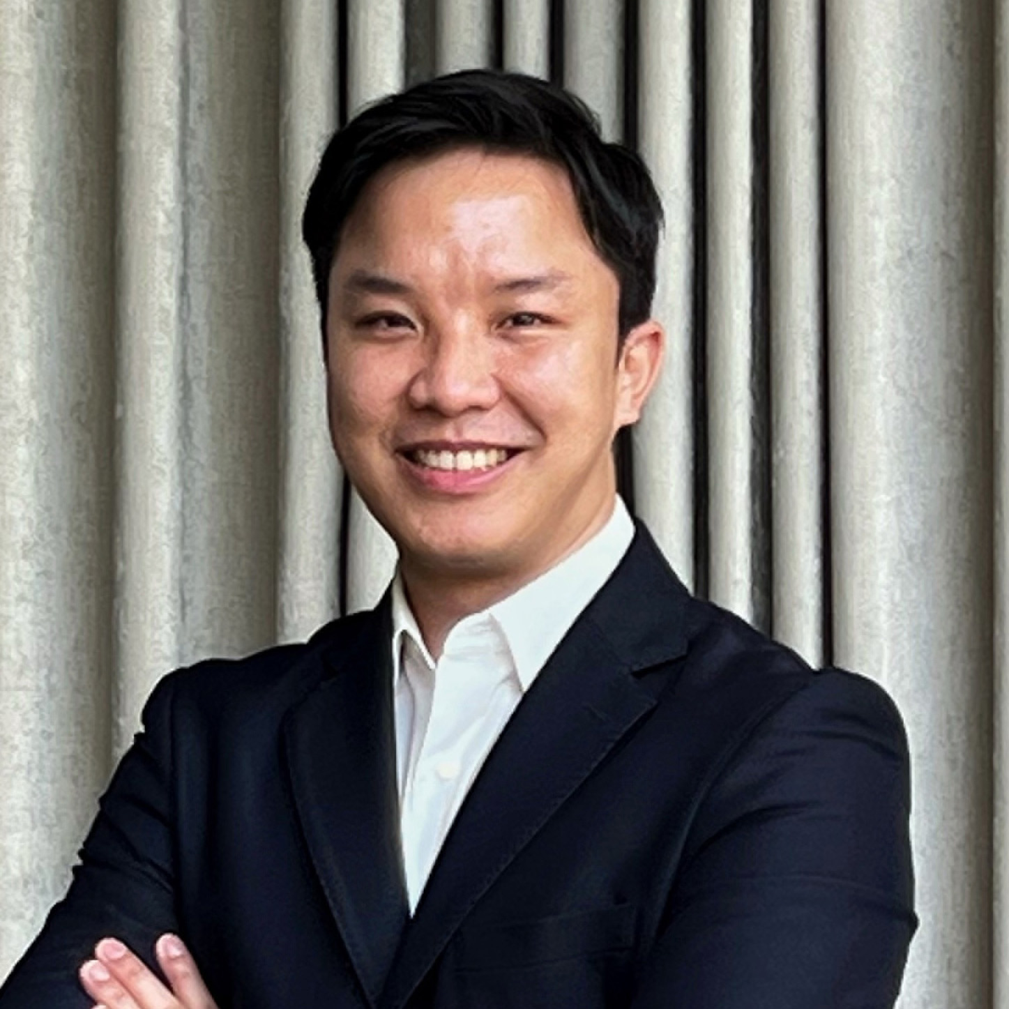 | Paponpat Sapsuwan  Assistant Public Relations Manager  3/F, 159 Rajadamri Road  Bangkok  Thailand  paponpat.sapsuwan@fourseasons.com  +66 02 207 8917
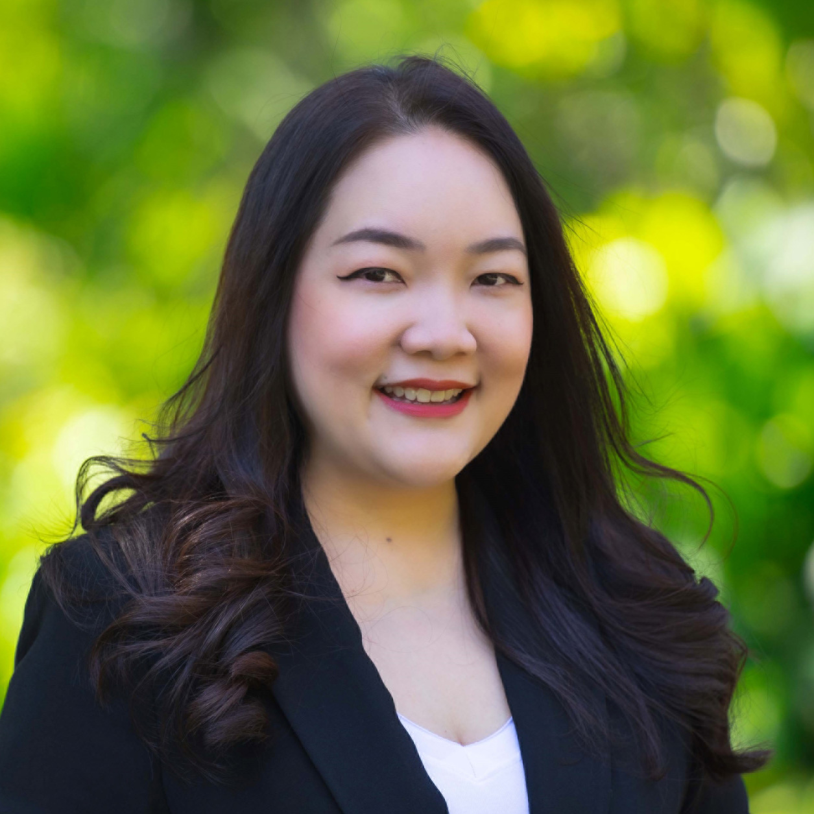 | Marissara Kummool  Assistant Public Relations Manager  502 Moo 1, Mae Rim-Samoeng Old Road  Chiang Mai  Thailand  marissara.kummool@fourseasons.com  +66 053 294 715
Waratah Jongsaeng
Assistant Manager – Digital Marketing
3/F, 159 Rajadamri Road
Bangkok
Thailand
waratah.jongsaeng@fourseasons.com

+66 2207 8918

