Four Seasons Resort and Residences Los Cabos at Costa Palmas Teams Up with Cortez Rescue & Outreach Center to Support the Re-Homing of Stray Canines on Baja Sur

The new program gives guests the opportunity to adopt, foster and volunteer with the local shelter
June 28, 2022, Costa Palmas, Los Cabos, Mexico

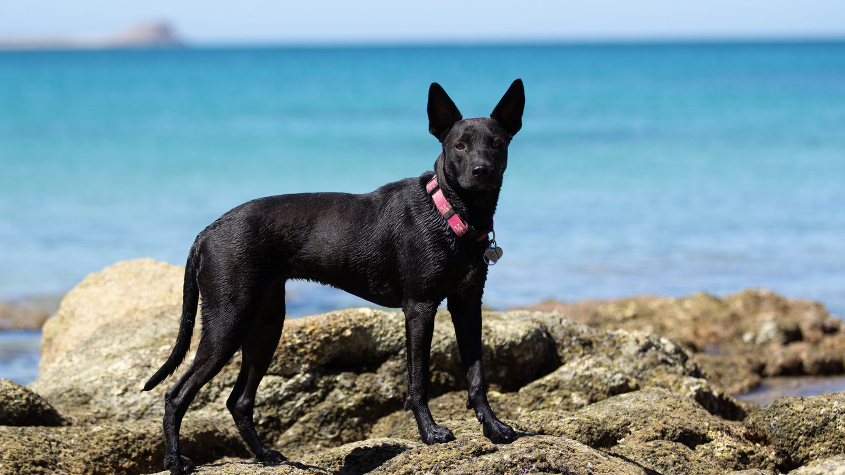
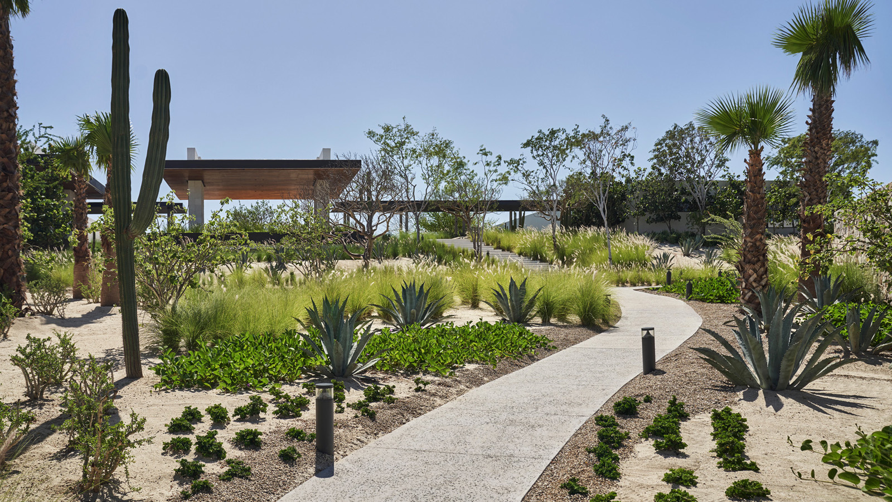
Four Seasons Resort and Residences Los Cabos at Costa Palmas announces that it has joined forces with local dog shelter Cortez Rescue & Outreach Center to help end canine homelessness in the communities that surround the East Cape of Baja. Guests of the award-winning Resort can foster a rescue dog throughout their stay, adopt a furry friend to take home with them or volunteer their time at the centre.
"We are delighted that Four Seasons is supporting Cortez Rescue and our efforts to responsibly care for and re-home abandoned or poorly treated dogs in our region,” says Jenn Peticlerc, Cortez Rescue Director. “This commitment by Four Seasons is a model of the community working together to help our special Baja doggies. There's nothing more rewarding than fostering or adopting a Baja dog whose personalities are renowned for their gentleness and affectionate natures.”
Since opening in 2018, Cortez Recue & Outreach Center has rescued nearly 1,500 dogs. Registered in both Mexico and the United States, the non-profit public benefit organization is dedicated to the health and well-being of stray and abandoned dogs, serving the East Cape of Baja where the Resort is located. In addition to supporting both foster and adoption opportunities, the centre promotes responsible pet ownership through collaboration with existing spay and neuter networks, and through educational programs to promote and inform the community about the treatment and re-homing of Baja’s canine friends in need of help.
Four Seasons Resort and Residences Los Cabos at Costa Palmas will host a series of Yappy Hour events throughout the year where guests and homeowners can meet and mix with the current residents of Cortez Rescue & Outreach Center. Resort guests may choose to foster a dog throughout their stay - the property does not place a weight limit on dogs permitted at the Resort - or they may adopt a dog to take home with them. Cortez Rescue assists every step of the way, from the necessary paperwork and documentation to coordinating safe travel arrangements for the pups. Guests also have the opportunity to volunteer their time at the rescue centre to help with walking, cleaning and general shelter maintenance.
“On the East Cape, we are all family,” says Borja Manchado, General Manager, Four Seasons Resort and Residences Los Cabos at Costa Palmas. “My team and I are so proud to work with the incredible people at Cortez Rescue to help better this community for all of its residents.”

RELATED

April 13, 2022, Costa Palmas, Los Cabos, Mexico
Tie the Knot at Four Seasons Resort and Residences Los Cabos at Costa Palmas
https://publish.url/loscabos/hotel-news/2022/weddings.html

December 8, 2021, Costa Palmas, Los Cabos, Mexico
Four Seasons Resort and Residences Los Cabos at Costa Palmas Celebrates the Holidays with Festive Experiences That Honour Mother Nature’s Four Elements: Water, Earth, Air and Fire
https://publish.url/loscabos/hotel-news/2021/festive-season.html

PRESS CONTACTS

Lauren Dutton-Breen
Director of Public Relations and Communications
Costa Palmas
Los Cabos
Mexico
lauren.dutton-breen@fourseasons.com

+1 508 596 8482

