Easter Weekend at Four Seasons Hotel Philadelphia at Comcast Center

Celebrate the weekend at Philadelphia’s Forbes Travel Guide Triple Five Star Hotel with specialty brunches and activities for the whole family
March 28, 2023, Philadelphia, U.S.A.

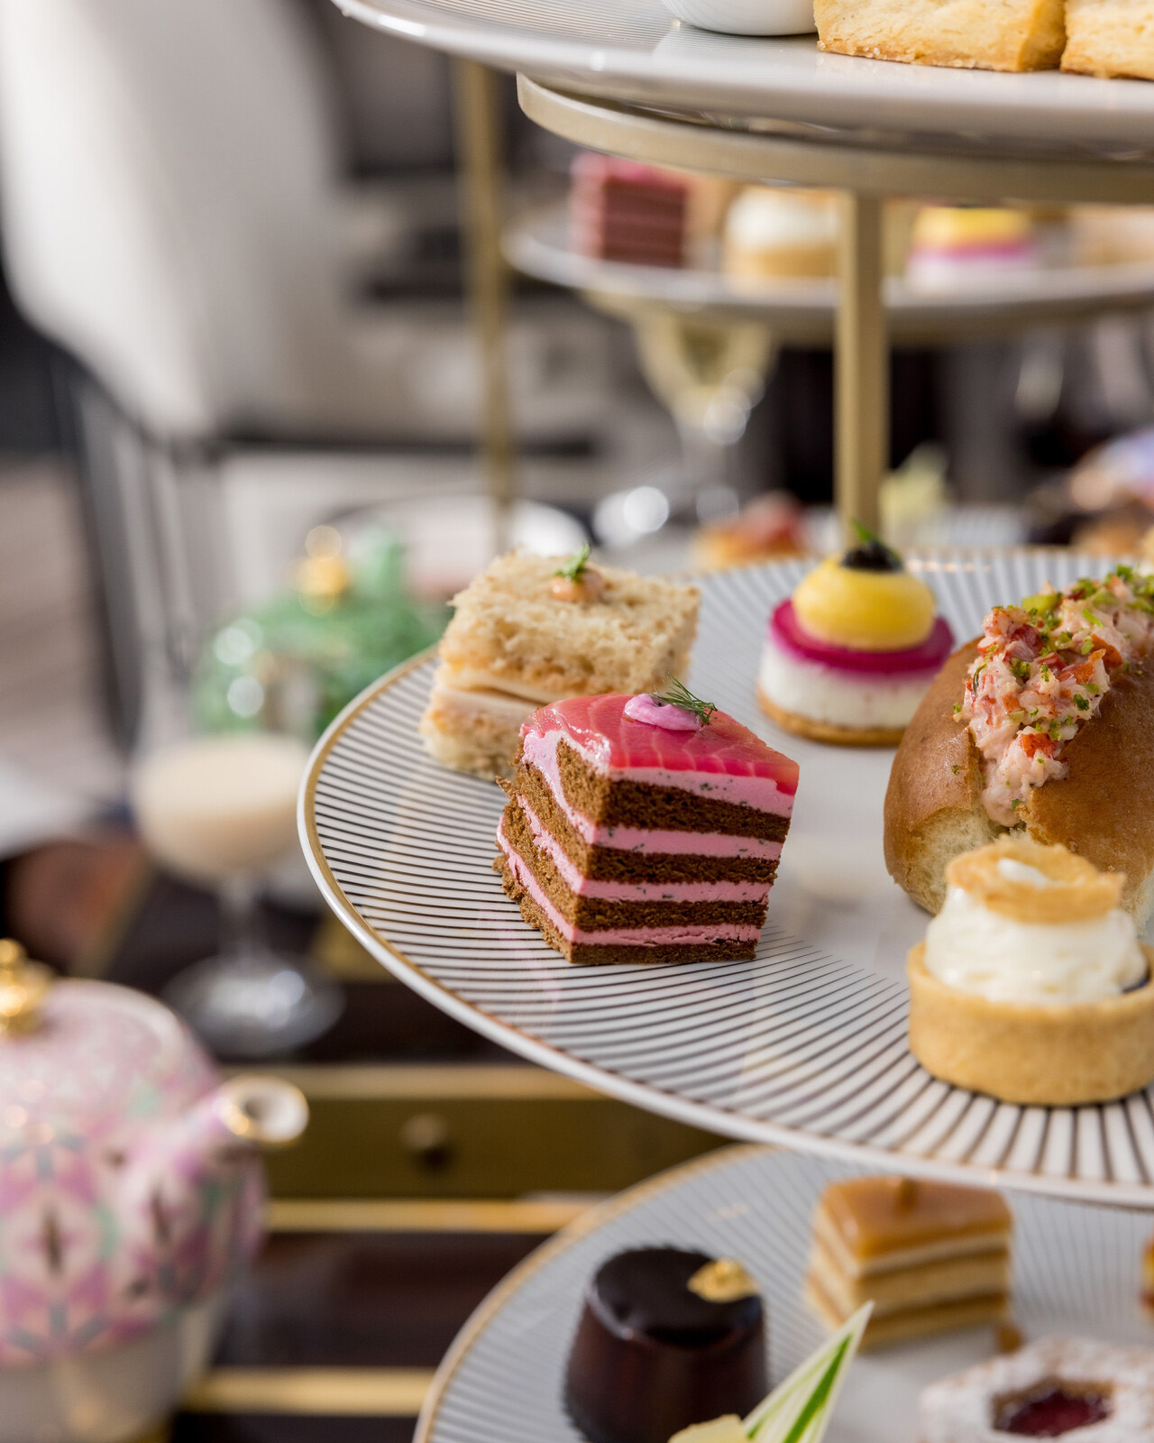
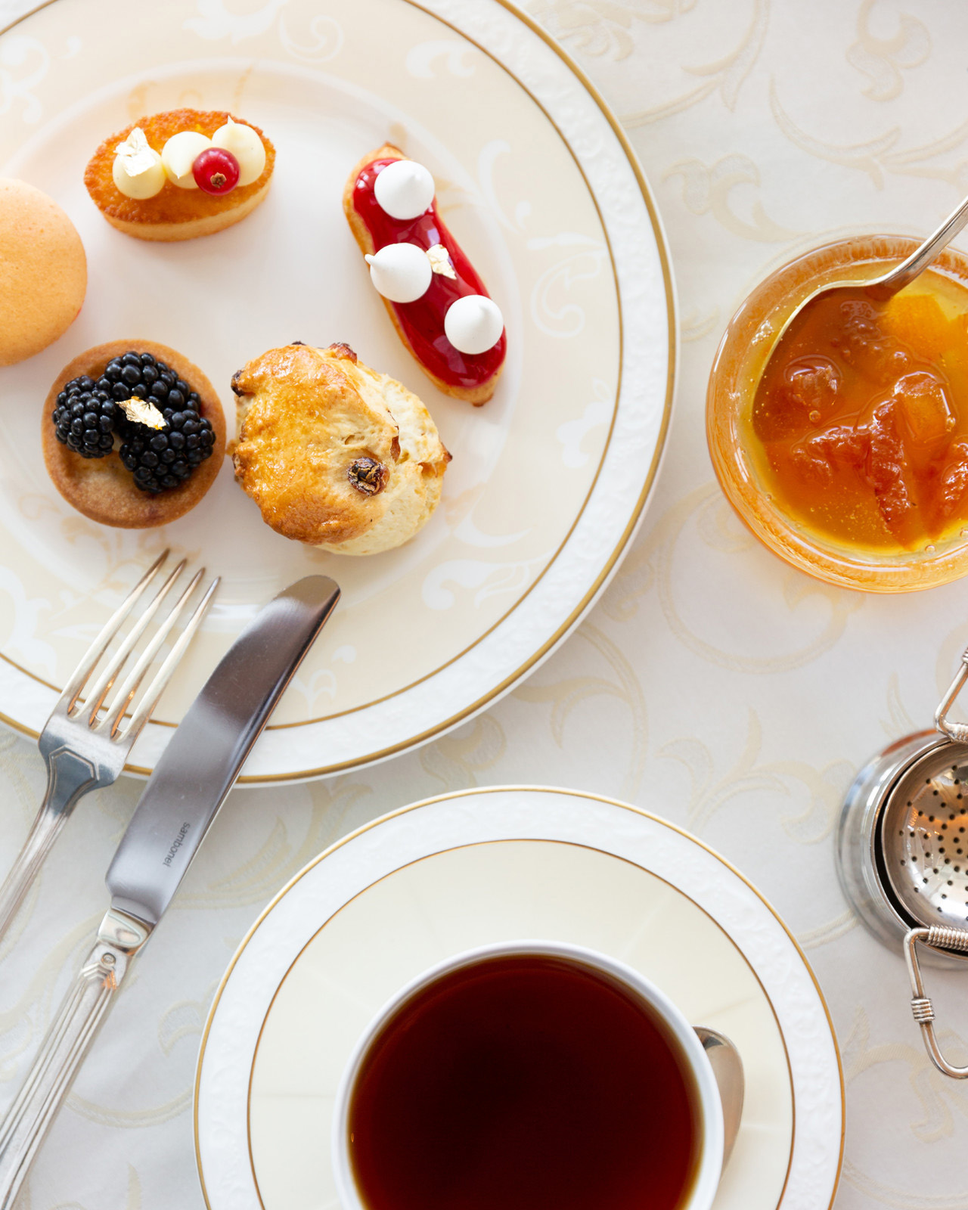 | 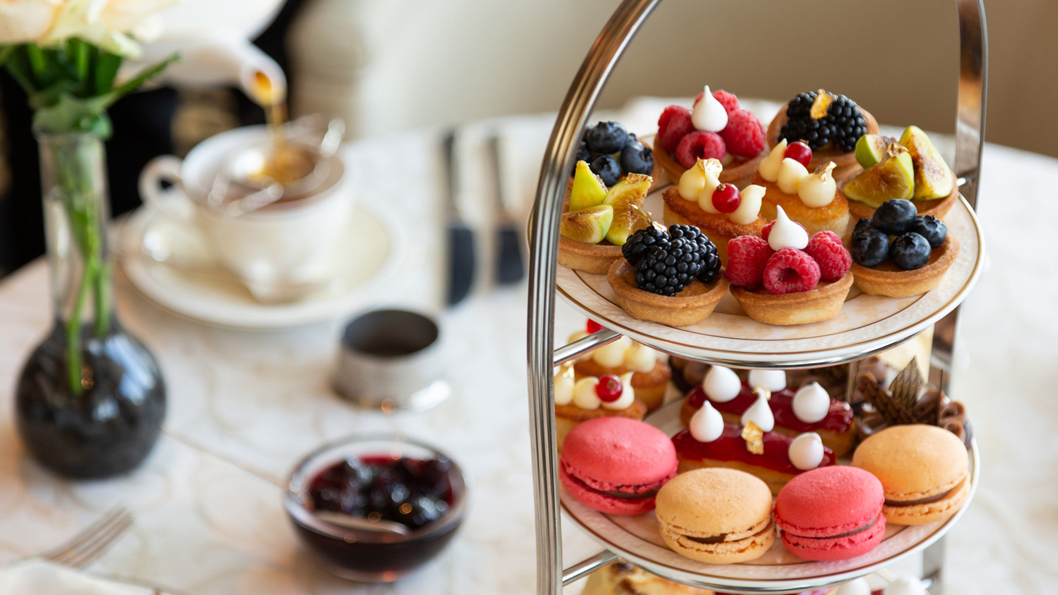 | 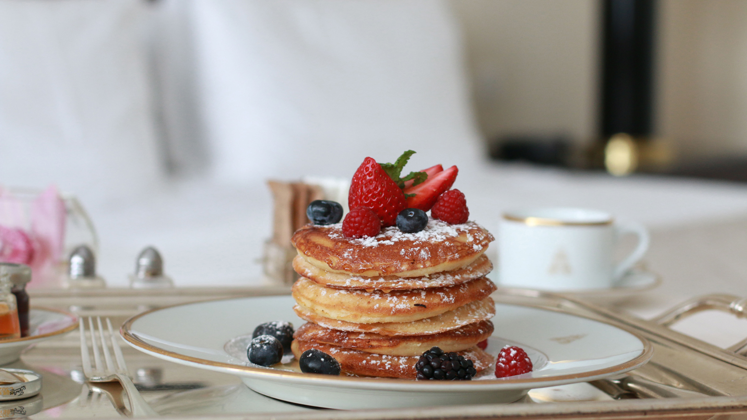
Four Seasons Hotel Philadelphia at Comcast Center invites local and Hotel guests alike to celebrate Easter above the clouds.
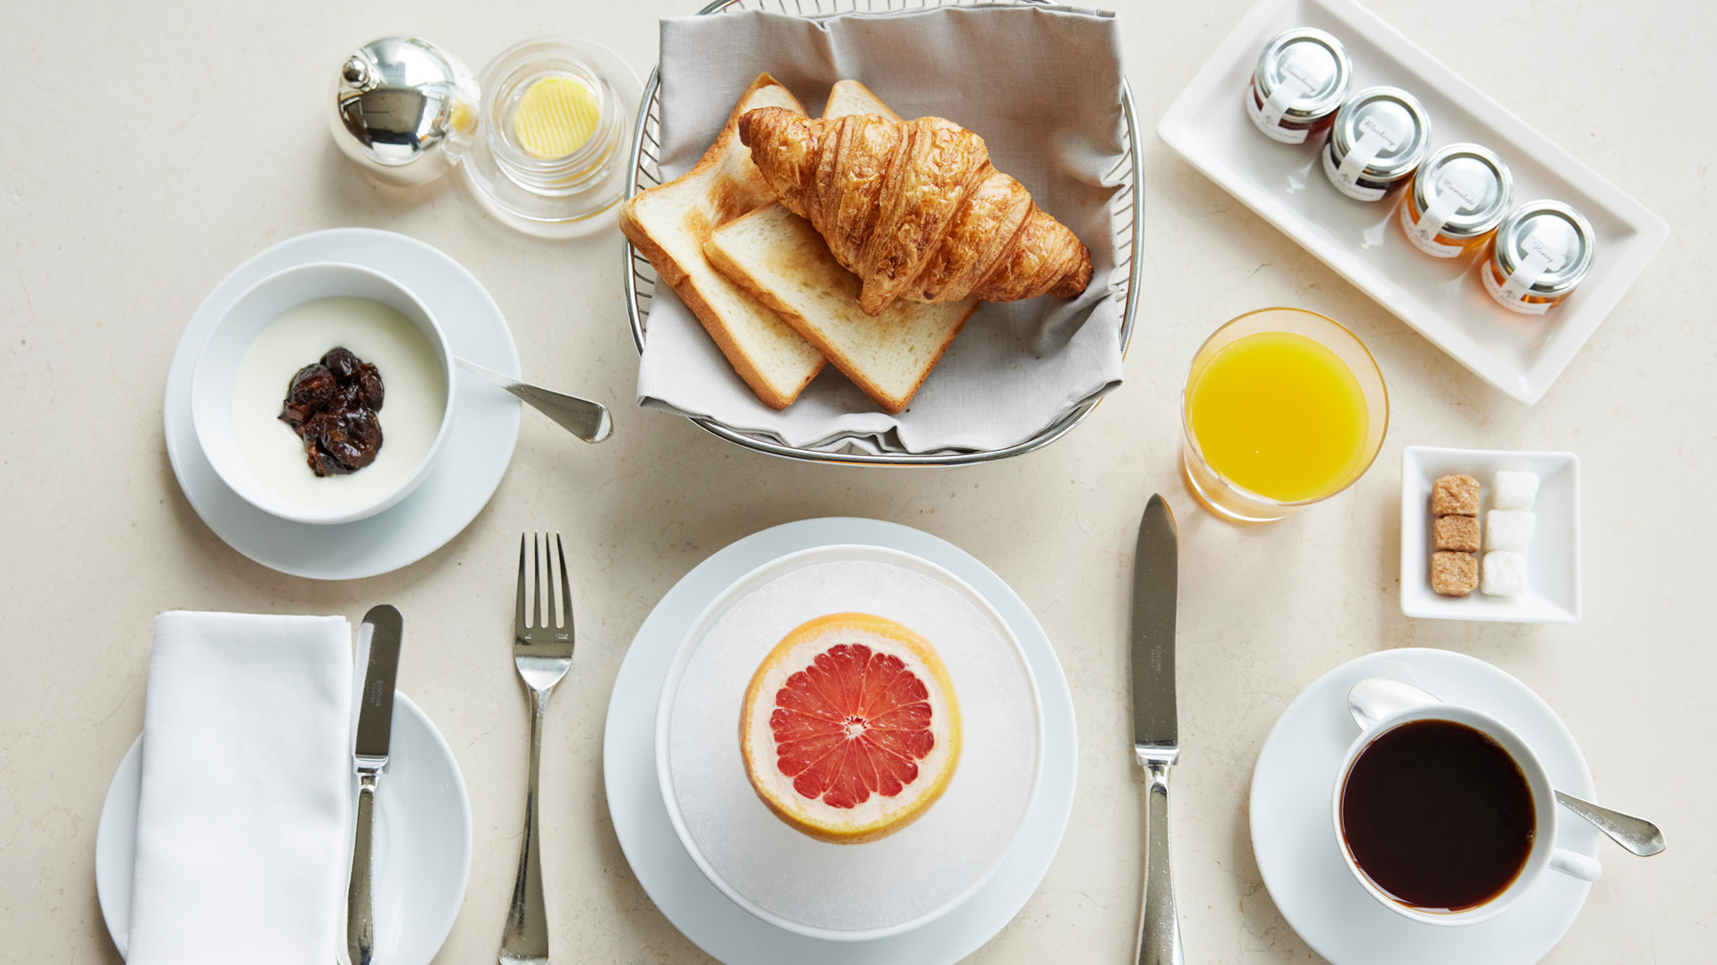
Easter Brunch Above the Clouds
Available on Sunday, April 9, 2023, celebrate Easter Brunch above the clouds at JG Sky High while taking in the views of spring in the city from 11:30 am to 3:00 pm. For USD 168 per person, the shared Easter brunch tower by Chef de Cuisine Patrick Rogala, featuring Avocado Lettuce Cups, Almond Pancakes topped with Fresh Berries and Maple Syrup, and Potato Latkes with Crème Fraiche and House Made Apple Compote, will be followed by a choice of one main entrée course, including Eggs Benedict with Lobster; Seared Salmon with Spring Peas, Ginger-Scallion and Lime; or Rack of Lamb with Chili Crumbs, Fiddlehead Ferns and Braised Artichokes. Save room for dessert, as Executive Pastry Chef Danielle Seipp and her team have prepared a variety of seasonal delicacies to choose from, including Strawberry Pavlova, Warm Chocolate Cake, and Rhubarb Tart Marzipan Ice Cream. The afternoon will be paired with a special jazz performance from local bassist, pianist, producer and music director Ray Bernard.
Reservations for JG Sky High’s Easter brunch can be made online here.
On Sunday, April 9, 2023, Jean-Georges Philadelphia will offer an elevated three-course family-style Easter Brunch. The USD 220 per person brunch includes three dishes per course, with Chef Cornelia Sühr’s seasonally inspired menu to delight guests of all ages. Specialty Champagnes will be featured on the Champagne cart and will be available by the glass.
Reservations for Easter Brunch at Jean-Georges Philadelphia can be made online here.
Hop into Spring
Capture the moment with friends and family in the 60th floor Sky Lobby with a spring floral display featuring golden forsythias from Artistic Director Jeff Leatham and team. On Sunday, April 9, 2023, an Easter Bunny guest will be in the Sky Lobby for photo opportunities.
Holiday Amenities
Four Seasons Hotel Philadelphia guests will be welcomed with seasonal amenities fit for the Easter holiday. A special kid’s welcome amenity will be available during Hotel check-in, featuring Easter baskets containing plush toys and curated Easter treats from the pastry team and more. Throughout the Hotel, stations will be set out with toys and treats for kids with Hotel reservations to fill up their baskets for an Easter Egg Hunt.
Vernick Coffee Bar
Attending a holiday brunch or visiting family and friends? Stop by the Café Counter for beautiful hand-crafted pastries such as the fan favourite Carrot Cake Pie and specialties including a blueberry compote fruit tart or seasonally themed bonbons. Available for pre-order beginning March 27 and available for pickup on Thursday, April 6 and Friday, April 7, 2023.
Be the First to Reserve
Four Seasons Hotel Philadelphia guests will have unparalleled insider access opportunities including first access to Hotel dining reservations and seasonal events. To book an escape, call 215 419 5000 or visit the Hotel website.

RELATED

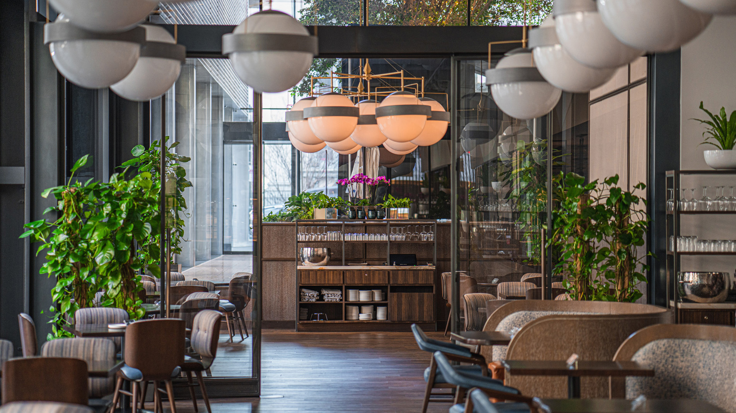 | February 21, 2023, Philadelphia, U.S.A.  Cookie Till Brings a Taste of Steve & Cookie’s to Vernick Fish at Four Seasons Hotel Philadelphia  https://publish.url/philadelphia/hotel-news/2023/steve-and-cookies-at-vernick-fish-event-collaboration.html
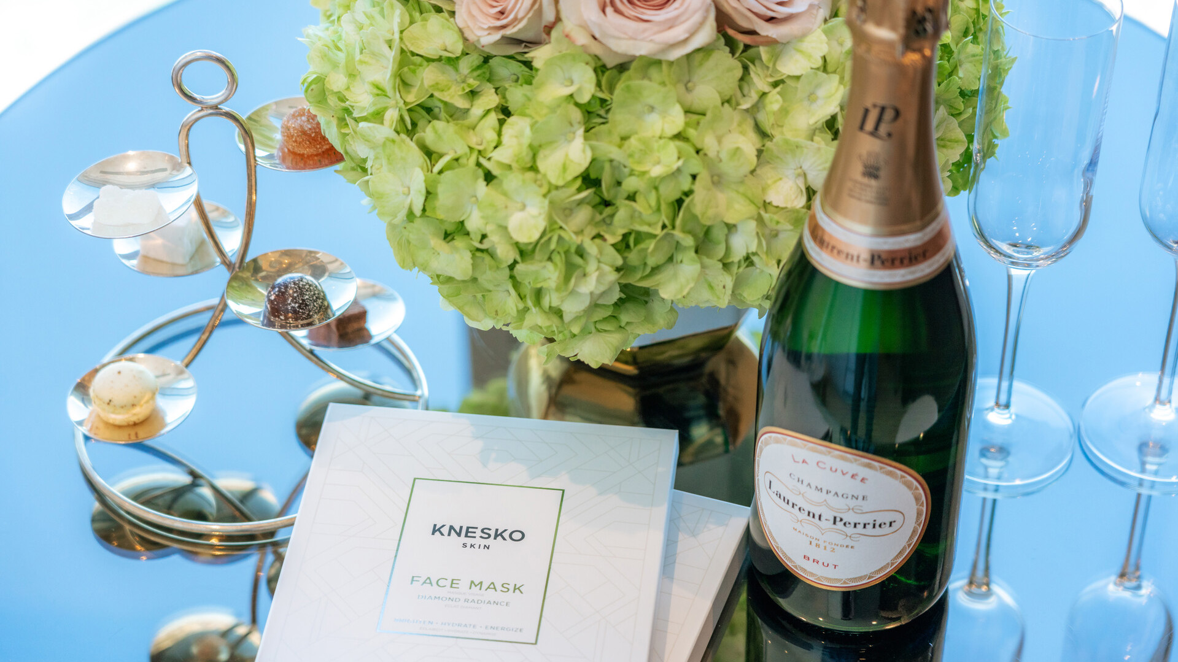 | February 15, 2023, Philadelphia, U.S.A.  Jean-Georges Philadelphia at Four Seasons Earns Five-Star Restaurant Recognition in Forbes Travel Guide 2023 Star Awards  https://publish.url/philadelphia/hotel-news/2023/forbes-five-star-hotel-restaurant-and-spa.html

PRESS CONTACTS

Lisa Tareila
Director of Public Relations and Marketing Communications
One North 19th Street
Philadelphia
USA
lisa.tareila@fourseasons.com

+1 215 419 5033

