Exploring Athens as a Family

Athens offers an endless list of family-friendly activities.
February 7, 2019, Athens, Greece

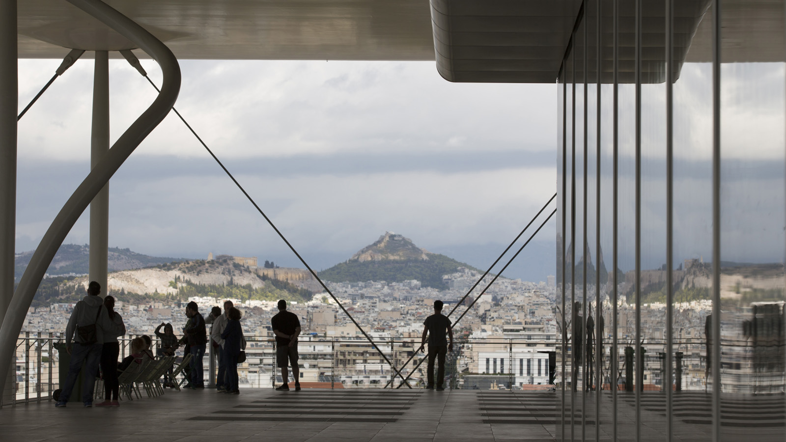
With Four Seasons Astir Palace Hotel Athens to assist with planning, your little ones are sure to be entertained.
Discover the Acropolis and Ancient Agora
No trip to Athens is complete without climbing to the top of the Acropolis, as well as exploring the archaeological site of the Ancient Agora that lies beneath. There are many hills to climb in Athens, but if you can only climb one, this would be it!
Family fun at The Acropolis Museum
The Acropolis Museum offers family fun packages that are available on request to allow families to work together and complete activities as they make their way around the museum. A perfect place to visit before or after the Acropolis, you will enjoy the uninterrupted views overlooking the Parthenon with glimpses of an ancient city that is visible through glass panelled floors on the ground level, which excite children and adults alike.
Happy Train around the city sites
This toy-like street train allows you to hop on and off as you please. The journey lasts approximately 40 minutes and takes in key sites and locations such as Hellenic Parliament, the Temple of Olympian Zeus, Hadrian’s Arch and the Museum of Cycladic Art. It’s a convenient way to explore the historical neighbourhoods of downtown Athens including Plaka and Monastiraki. The train provides commentary in both English and Greek and departs every 30 - 40 minutes from Ermou Street and Syntagma Square.
Horse and Carriage ride through the Old City
Young children will be squealing with excitement on this horse and carriage ride that moves around the base of the Acropolis. The driver and his horse chariot can be found at the intersection of Dionysiou Areopagitou and Apostolou Pavlou Streets and is a novel way to explore the historic heart of Athens. No pre-bookings are possible; simply arrive and be ready to hop on or arrange a suitable time.
A day of fun at the Stavros Niarchos Center
The newly opened Stavros Niarchos Foundation Cultural Center (SNFCC) has been a significant addition to the lives of Athenians thanks to the vast array of fun activities available for families. During the winter months, a section of its artificial canal is turned into a large ice rink, making it a popular outdoor ice-skating venue for all ages and abilities. The centre also offers kayaking and sailing along its 400 metres (1,312 foot) canal that is available all year round, weather permitting.
Athens Zoological Park
What originally started as a bird park is now home to thousands of wildlife species. You will find lions, tigers, elephants, giraffes, zebras, monkeys, rhinos, camels, penguins, crocodiles and much more in this superbly maintained park where all the animals are happily living in large spaces.
Sundays in Athens are for families
Sunday is the perfect day to explore Athens as a family. Arrive at Hellenic Parliament in Syntagma by 10:30 am to see the ceremonious grand changing of the guard, where the Evzones (Greek Presidential Guard), dressed in their traditional white kilts (“Foustanella”), march in perfect harmony towards the parliament building. Move on to the nearby National Gardens where you will find an animal sanctuary and duck and tortoise pond that all kids, big and small, adore.
Exit the gardens directly into the iconic Panathenaic Stadium, the only venue in the world built entirely out of marble and where the first modern Olympic Games took place in 1896. It’s a perfect spot for children of all ages to release their Olympic spirit and run an imaginary race around the track.

RELATED

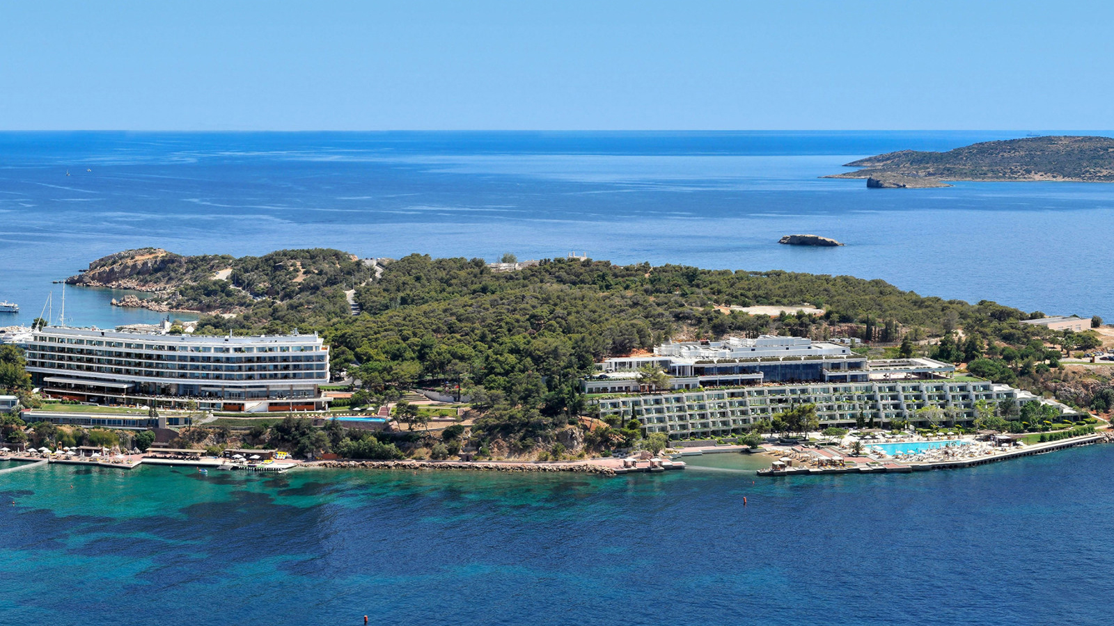 | December 5, 2018, Athens, Greece  Renaissance d’une icône glamour en bord de mer : le Four Seasons Astir Palace Hotel Athens ouvrira au printemps prochain et accepte désormais les réservations  https://publish.url/fr/athens/hotel-news/2018/reservations-live-3.html
December 5, 2018, Athens, Greece
Reservas abertas para 2019: novo Four Seasons Astir Palace Hotel Athens traz glamour para a Riviera ateniense
https://publish.url/br/athens/hotel-news/2018/reservations-live-4.html

PRESS CONTACTS

Elia Kentrota
Director of Public Relations
40 Apollonos Street
Vouliagmeni, Athens
Greece
elia.kentrota@fourseasons.com

+30 210 8901077

