Four Seasons Hotel Hong Kong Celebrates Mother’s Day with Five Ways to Spoil Mom

April 15, 2021, Hong Kong, China

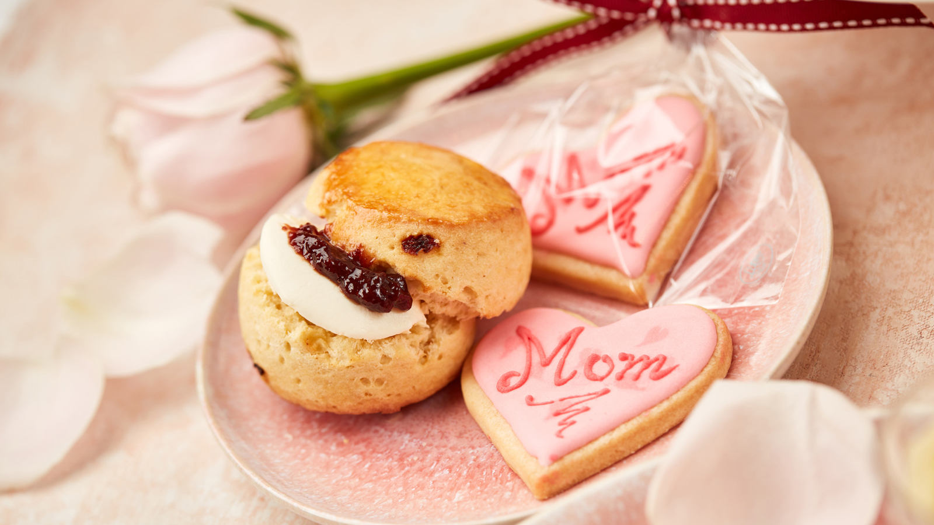
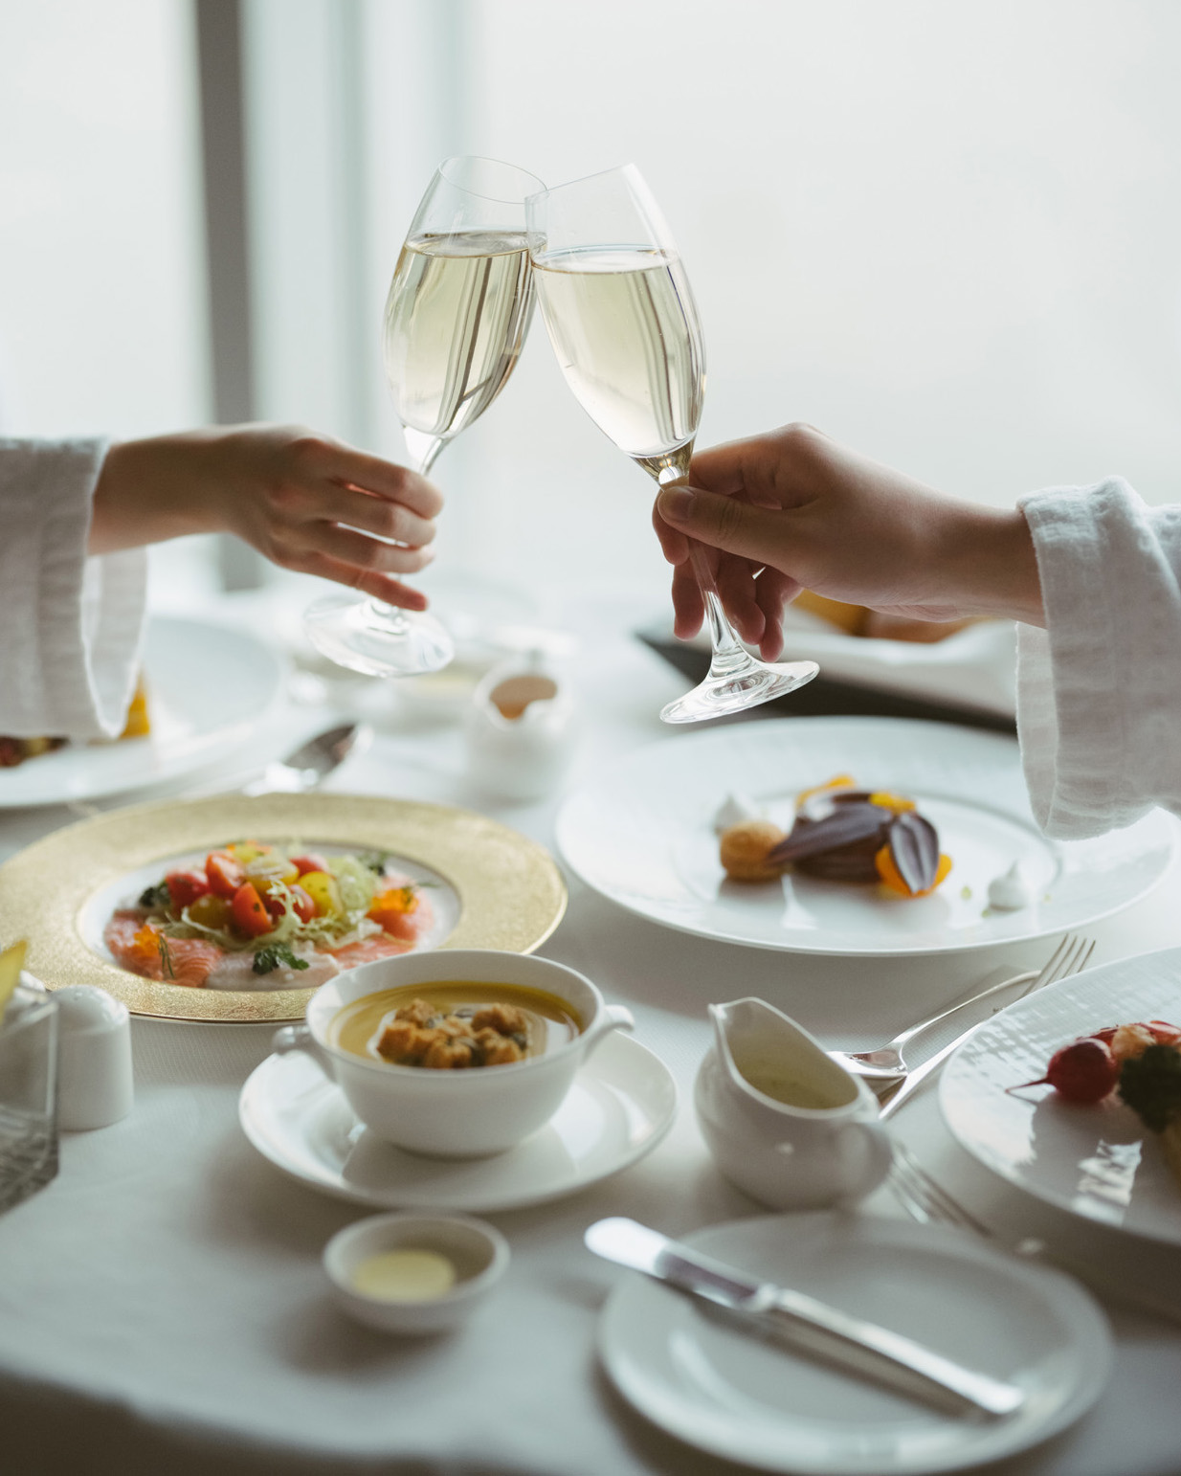 | 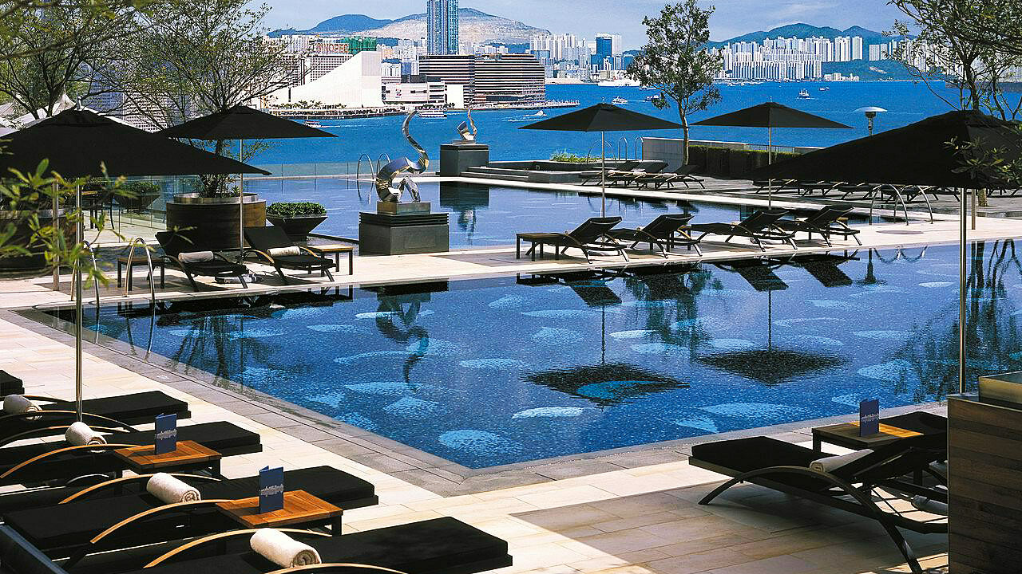
Every day is Mother’s Day but in May, we can always be more affectionate to the amazing woman who hold the family together.
Four Seasons Hotel Hong Kong narrows down five ways to treat Mom that will bring a smile to her face: fresh florals and cake on eShop, Afternoon Tea with Tatcha gifts, a Mother’s Day staycation, the Super Mom Facial at The Spa, and takeaway menus that allow her to take a break from the kitchen.
Gorgeous Bloom and Cake
Nothing says appreciation more than a classic bouquet of pastel pink roses and purple eustoma from Rococo. Together with a one-pound violet velvet cake, it is bound to brighten the day for Mom. This beautiful combination is available for purchase on eShop starting April 16, 2021 at the price of HKD 1,088.
For enquiries, call 3196 8690 or email boutique.hkg@fourseasons.com.
Tatcha Afternoon Tea
Four Seasons Hotel Hong Kong collaborates with Tatcha this May 2021, creating a Japanese inspired Shinsei afternoon tea set to celebrate the launch of The Dewy Serum.
Taking inspiration from this potent product that breathes new life to skin, which harnesses the benefits of Japanese superfoods: green tea, rice and red algae. This tea set is created to help guests glow from inside out.
The decadent tea set created by Chef Ringo Chan and team showcases Kyoto craftsmanship, including soft akita rice and sakura jelly, uji green tea and azuki bean cake, Okinawa sea salt caramel chocolate crème with biscuit and signature items from the pastry team.
For every afternoon tea for two ordered, guests will receive a Tatcha Dewy Skin Discovery Kit valued at HKD 431 at a first come first serve basis.
Tatcha Afternoon Tea Set is available exclusively on Saturdays and Sundays in May 2021 at the price of HKD 688 per two persons except for May 8 and 9, which will be priced at HKD 488 per person. Afternoon Tea at The Lounge will be available for two sittings from 2:00 to 4:00 pm and 4:15 to 6:15 pm. Prices are subject to 10 percent service charge.
For reservations, call 3196 8882 or email dining.hkg@fourseasons.com.
Mother’s Day Staycation
Treat Mom to a luxurious staycation right in the centre of Hong Kong boasting the magical skyline – a haven to enjoy gourmet meals, the infinity outdoor pools and a perfume workshop with luxury jewellery Fred.
The room package includes:
- A one-night stay in one of the newly renovated guest rooms
- Daily breakfast for two adults
- Mother’s Day three-course set dinner for two adults ordered via in-room dining or at The Lounge (subject to availability upon check-in)
- Complimentary virtual workout class from XYZ including HIIT, Yoga and Stretching
- Bath ritual – enjoy a Himalayan salt and lavender essential oil bath is drawn in the comfort of the guest room
- Fred perfume workshop for two persons (will require advance reservation)
- Complimentary upgrade to Deluxe Harbour View room if the stay is extended to two nights
- With stays in a suite: one-way transfer between the guest’s home in Hong Kong Island or Kowloon and the Hotel (surcharge applies outside Hong Kong Island and Kowloon)
Package rate starts from HKD 3,480 and is subject to 10 percent service charge.
For reservations, call 3196 8333 or email res.hongkong@fourseasons.com.
To Moms with Brave Faces
Spa Director Tania Bardhan has created the Super Mom Facial to honour unconditional love in mothers and the requirement to balance it with a healthy sense of self.
The 60-minute full facial is starts with cleansing, exfoliation and includes a lifting and relaxing massage to contour the face muscles. It is ideal for skin brightening and cell renewing and offers a choice of rose quartz masks, which balances the heart chakra and a nanogold repair mask, which balances the solar plexus. To conclude, moms are gifted a collagen hydrogel eye mask to continue with the experience at home.
Gift cards for Super Mom Facial are available on eShop and the treatment is priced at HKD 1,750, subject to 10 percent service charge.
Alternatively, get Mom something she loves – luxury jewellery to accessorise her daily outfits. EShop has a special offer for Jemocracy jewellery, where shoppers will receive a limited-edition travel organiser worth HKD 550 upon every purchase. This brand, founded by two ex-corporate warriors, aims to empower women through their statement pieces - a perfect gift for Mom.
Anthea Cooper is another interesting brand designed for confident women who love nature, using natural gemstones and precious metals as the basis of their design. Spend HKD 1,000 and receive HKD 200 savings this May 2021 on eShop.
For reservations or enquiries, call 3196 8900 or email spa.hkg@fourseasons.com.
Family Meals
Order a feast from eShop and treat Mom a restaurant-worthy meal in the comfort of home.
The four-course dinner priced at HKD 1,980 is fit for four persons, consisting of caesar salad with roasted tiger prawns, macaroni pasta salad with ham, roasted green pumpkin soup with brioche croutons, sweet corn with diced chicken, a choice of maple-glazed ham or baked salmon coulibiac with chive cream sauce, and a one pound violet velvet cake.
Either of the main courses comes along with truffle mashed potatoes or gratin potatoes, Mediterranean roasted vegetables, fresh corn on cob, wok-fried mixed vegetables with shiitake mushroom.
For enquiries, call 3196 8850 or email roomservice.hkg@fourseasons.com

RELATED

April 15, 2021, Hong Kong, China
香港四季酒店呈獻五種寵愛母親之道
https://publish.url/zh_hant/hongkong/hotel-news/2021/mothers-day-2.html

April 15, 2021, Hong Kong, China
香港四季酒店呈献五种宠爱母亲之道
https://publish.url/zh/hongkong/hotel-news/2021/mothers-day-3.html

PRESS CONTACTS

Chu Wong
Director of Public Relations
8 Finance Street, Central
Hong Kong
China
chu.wong@fourseasons.com

(852) 3196 8306

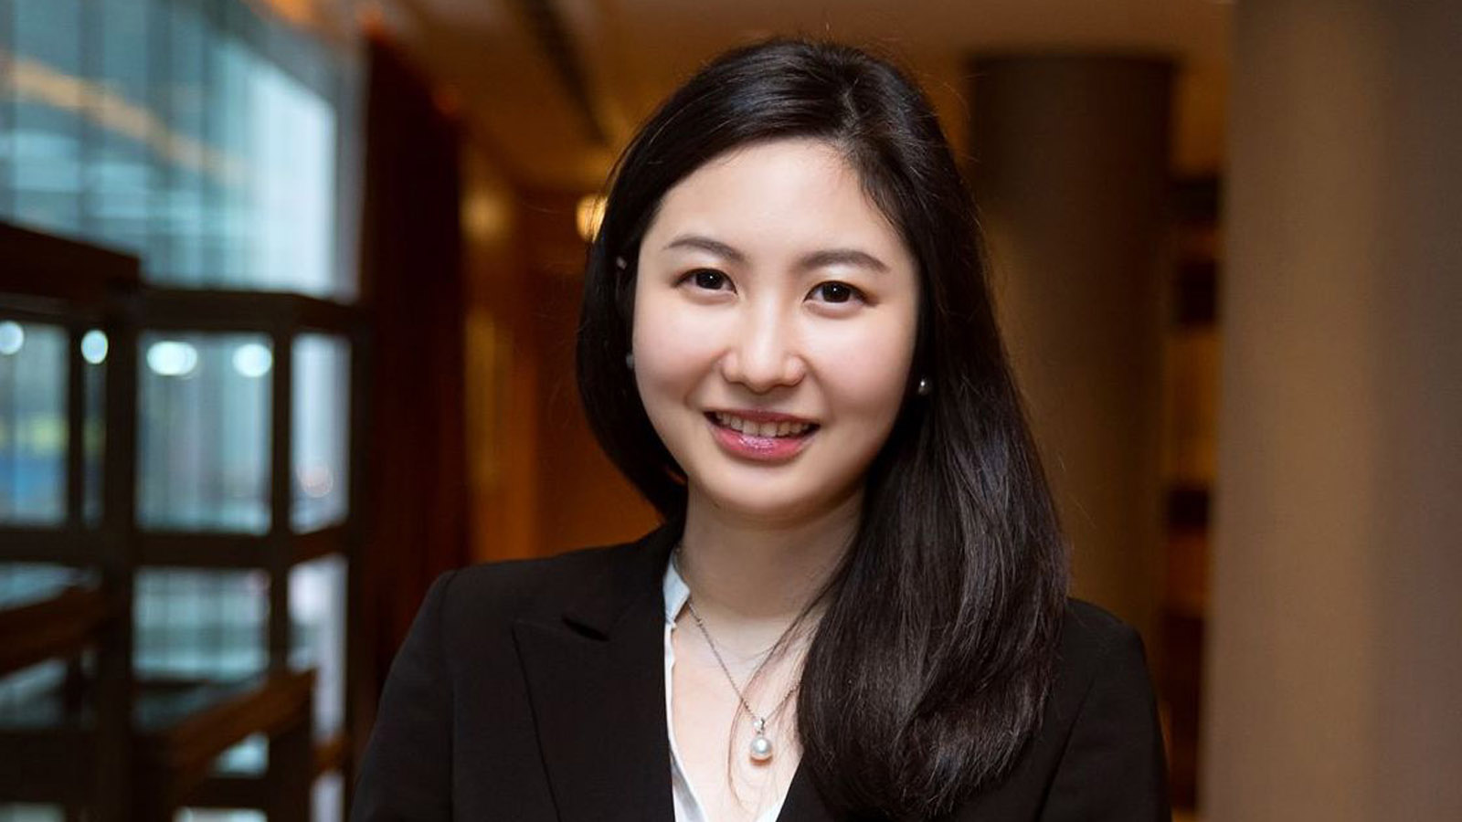 | Priscilla Chan  Assistant Public Relations Director  8 Finance Street, Central,  Hong Kong  China  priscilla.chan@fourseasons.com  (852) 3196 8307

