Après, the Old Fashioned Way

Local whiskey is the star of Back Country Old Fashioned at Ascent Lounge
September 8, 2021, Jackson Hole, U.S.A.

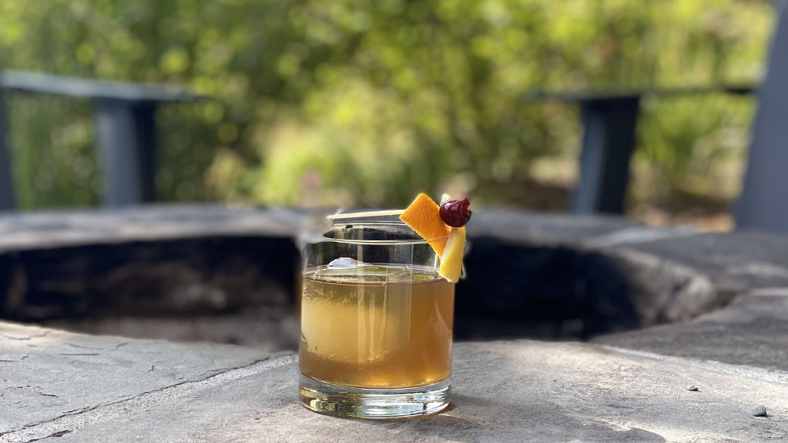
Winter visitors to Four Seasons Resort and Residences Jackson Hole enjoy slope-side access directly from the Resort’s door to premier skiing and snowboarding at Rendevous Mountain. After a day on the mountain, the après experience begins. Head to Ascent Lounge for cocktails with a view, and a taste of Wyoming’s finest local whiskey bottled exclusively for guests of Four Seasons in collaboration with the distillery.
Four Seasons small-batch, private barrel Wyoming Whiskey highlights Wyoming Whiskey's six-year-old single barrel, and comes in both traditional and cask strength. The cask strength boasts a robust 60 percent ABV (alcohol by volume), while the standard private barrel comes in at Wyoming Whiskey's traditional 46 percent ABV.
Guests can enjoy their choice of either whiskey in Ascent Lounge's signature Back Country Old Fashioned. Featuring a house-infused brown sugar syrup with spices and orange to balance the unique private barrel spices, this slope-side sip makes for a memorable conclusion to a day well-spent on the mountain.
The Back Country Old Fashioned is available for USD 25, or USD 30 with the cask strength.

RELATED

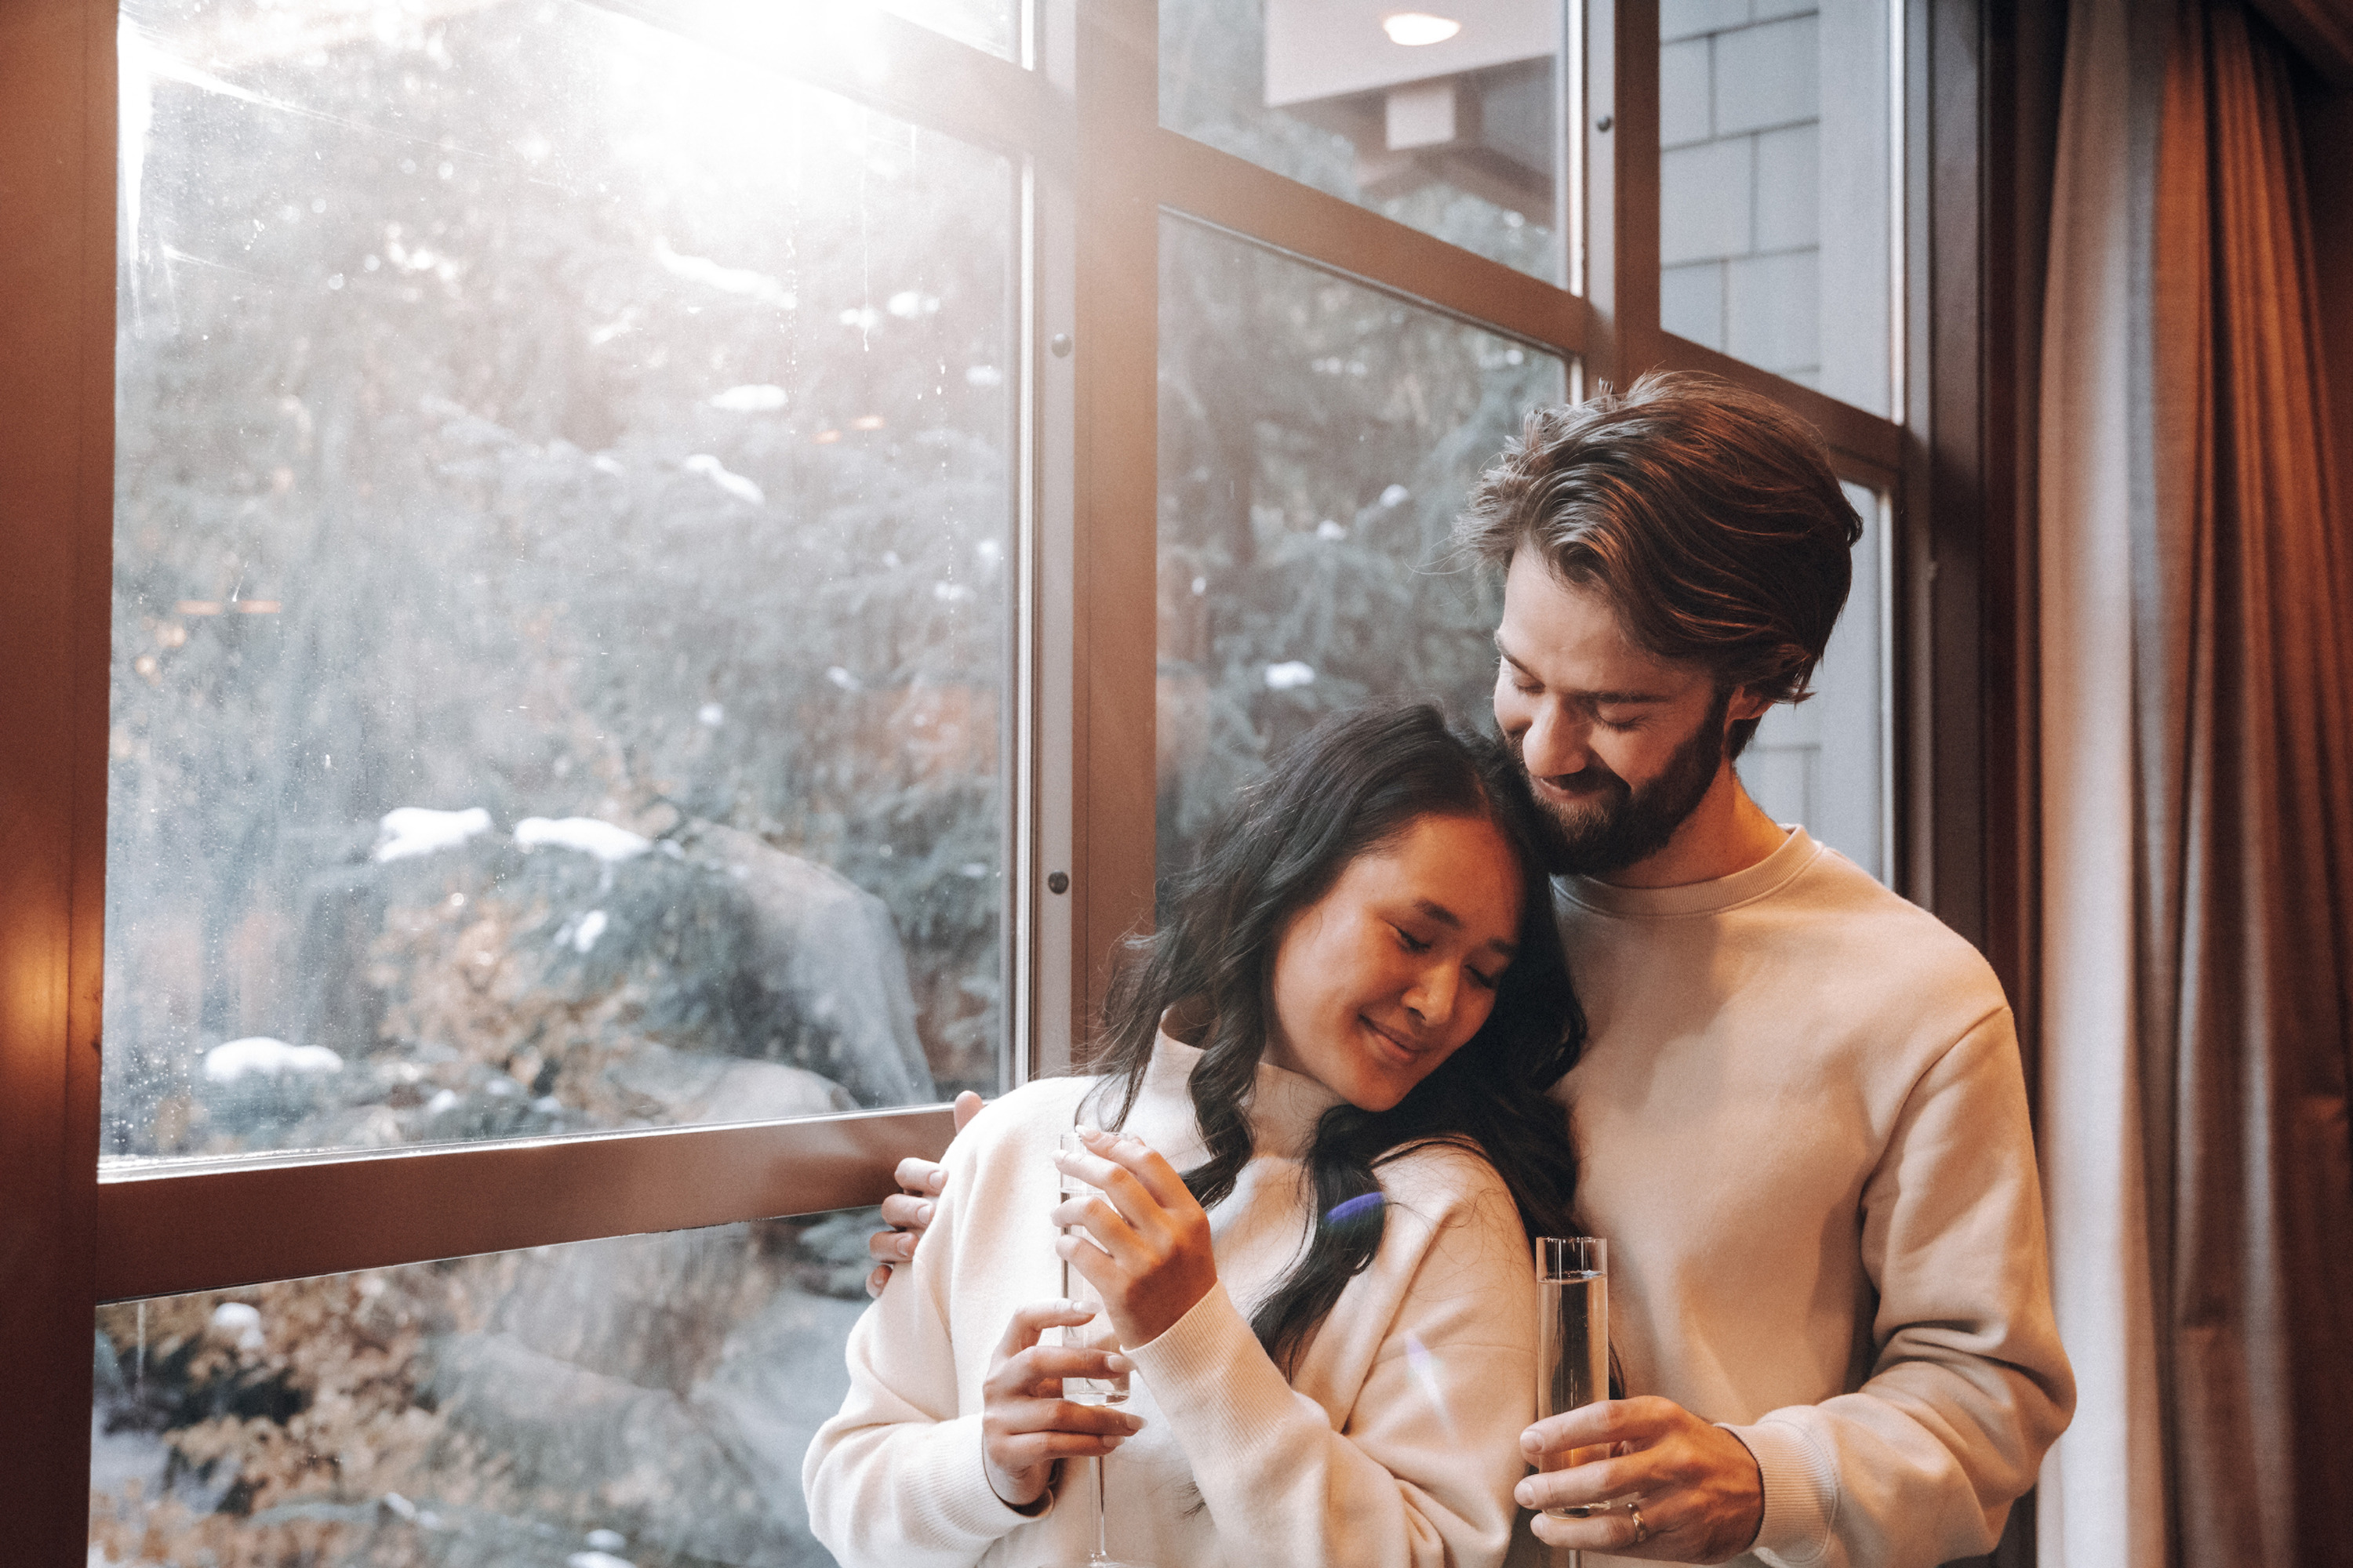 | January 18, 2024, Jackson Hole, U.S.A.  High-Altitude Romance This February at Four Seasons Resort and Residences Jackson Hole  https://publish.url/jacksonhole/hotel-news/2024/valentines-day.html
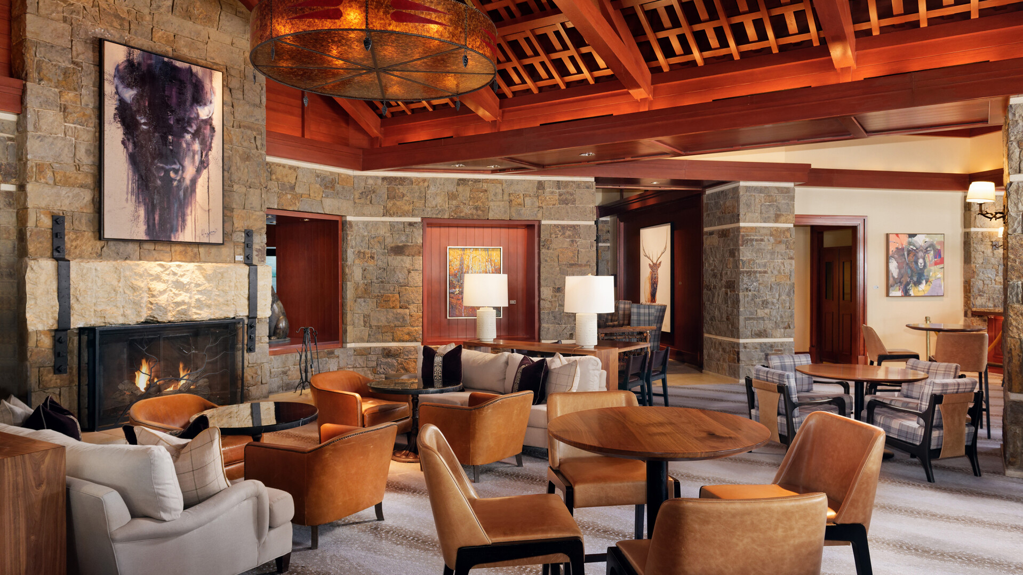 | December 22, 2023, Jackson Hole, U.S.A.  Unwind with Art This January at Four Seasons Resort and Residences Jackson Hole  https://publish.url/jacksonhole/hotel-news/2023/art-of-apres.html

PRESS CONTACTS

Kim Cole APR
Director of Public Relations
7680 Granite Loop Road, PO Box 544
Teton Village
USA
kim.cole@fourseasons.com

+1 480 980 8773

