Spirited Pool Scenes, Seasonal Spa Treatments and Blooming Menus Mark Spring at Four Seasons Resort Palm Beach

Refreshing experiences for couples, friends and families await at the Forbes Five Star Resort
March 10, 2023, Palm Beach, U.S.A.

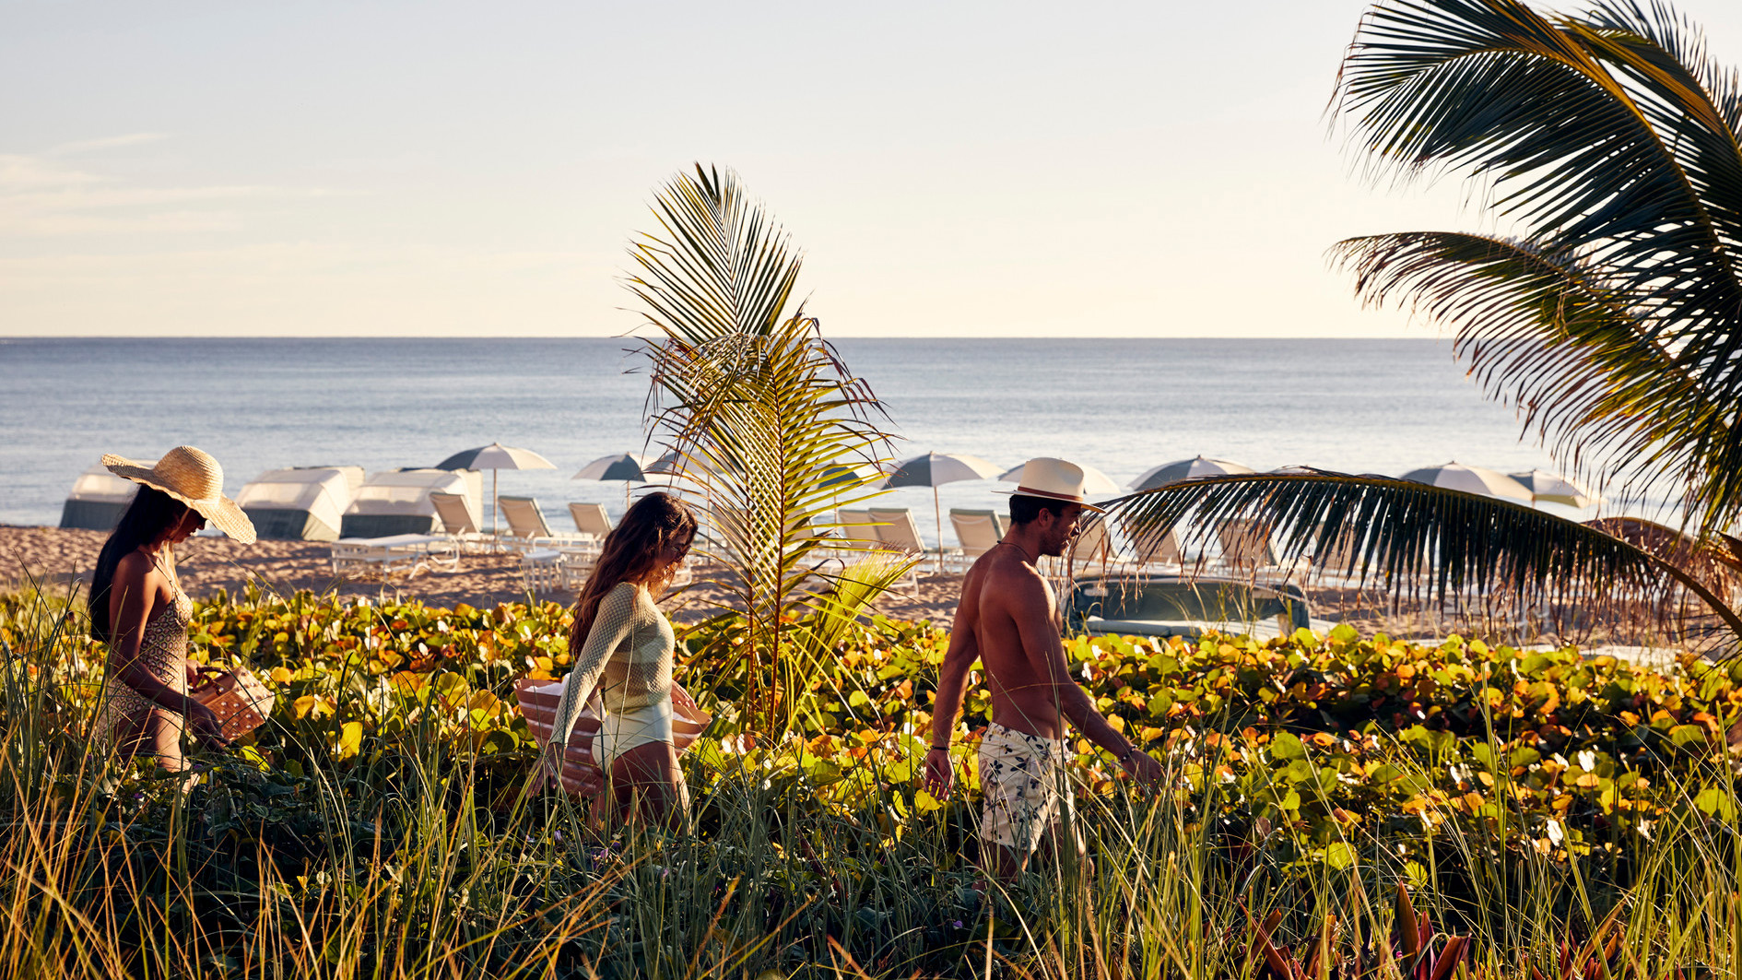
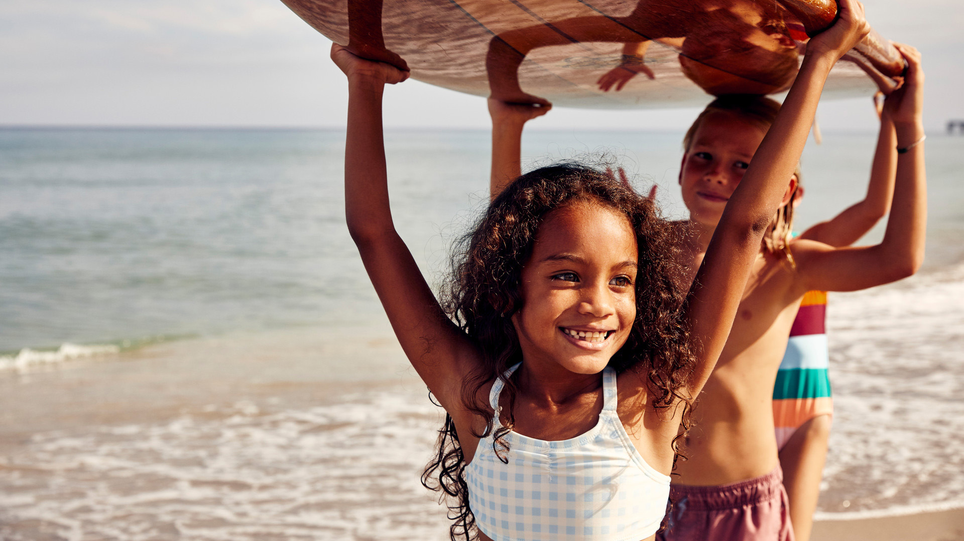 | 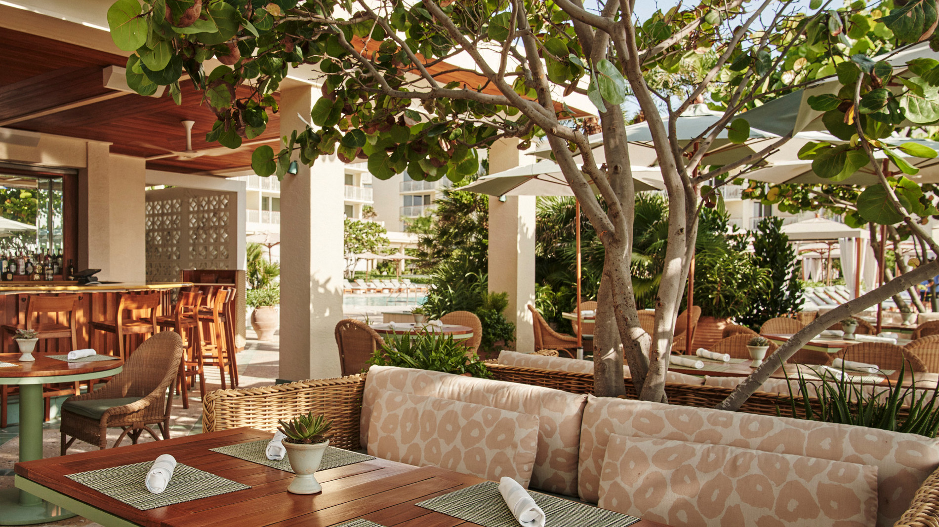
At the interplay between acres of private beachfront and oceanfront pools, instinctive cuisine, Palm Beach charm and leisurely activities, guests discover the art of living well at Four Seasons Resort Palm Beach. Spring at this iconic Resort destination is the ultimate season to reset and refresh with a 25-year legacy of Forbes Five Star hospitality at the centre.
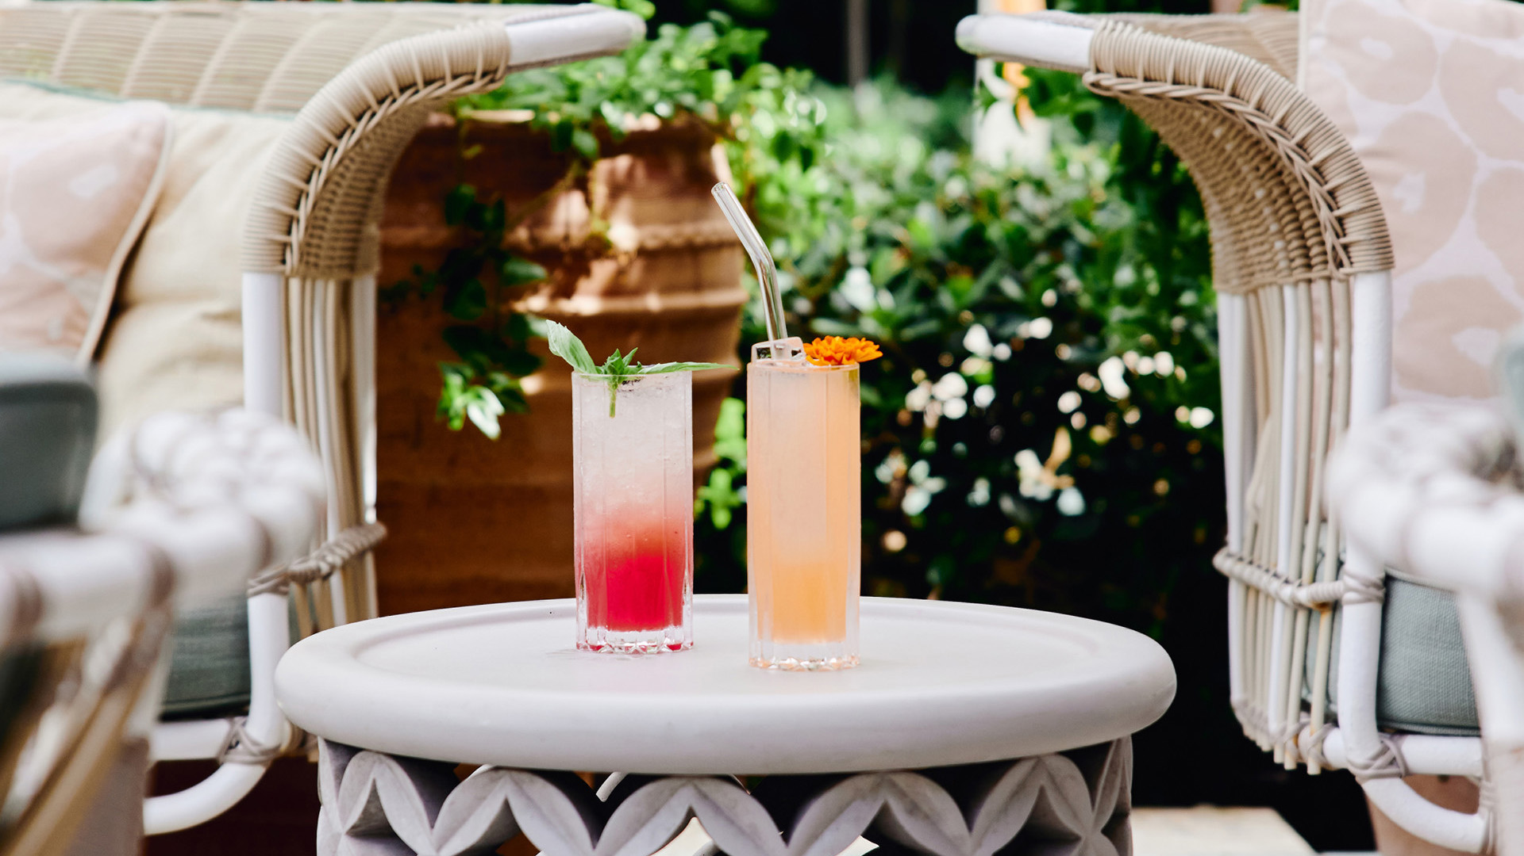
Sun, Sand and Surf
Whether guests opt for the plush daybeds dotted along pristine sands or the paddleboards and kayaks ready to coast the calm waters, this oceanfront getaway caters to both those yearning for unperturbed relaxation and the adventure seeking.
Take a dip in one of two pools overlooking the Atlantic Ocean, and emerge to a palm-fringed wonderland designed by renowned landscape designer Fernando Wong. Enriching the picturesque scene are pink cabanas and lounge chairs, and the routinely passed refreshments including mixologist-inspired mocktails and fresh fruit smoothies, house made guacamole, Florida Citrus Mimosas, and chilled Evian face mists. Cravings are curbed without having to leave the poolside post with chef-inspired pop ups from poke bowls to personal gourmet pizzas.
A stop at the bespoke gelato cart is the perfect interlude to sun-soaked days for a cool, handcrafted treat with flavours such as coconut, vanilla, salted caramel or affogato.
Kids For All Seasons
While the adults relax poolside, the on-site kids club offers engaging crafts and immersive activities including eco beach exploration hunts and playful moments with Fort, the Resort therapy dog. Teens find their own sense of place at the Arcade and Video Game Room, or can head out to the beach for friendly competition at the volleyball court or spike ball set up.
By night, the young ones are drawn under the stars for weekend Dive In Movies on the beach that include dinner and themed activities from karate sessions to wild wild west nights.
Fit and Well
Guests are welcomed to the Five Star Spa with a glass of prosecco before seasonal treatments that evoke the essence of spring in Palm Beach, including the Citrus Refresh Massage featuring a foot scrub enhancement and citrus-infused shea butter application. Following treatments, the chic seaside sanctuary becomes a day long affair with self-care from a dip in the whirlpool to sweating stress away in the steam room.
An array of fitness activities keeps routines in check with tennis clinics and lessons, beachside yoga classes and boot camps for all levels that are offered throughout the week. Local favourite pastimes can be discovered minutes away, with Polo in Paradise masterclass and spectator experiences with Nic Roldan, America’s leading polo player. Or guests can cruise along the storied Island and admire the fanciful architecture on one of the new e-bikes offered by the Resort.
For Spa reservations or to learn more about the locals’ Day Spa Beach Retreat package, call 561 582 2800.
Coastal Inspired Dining
From Zucchini Flower Stuffed with Crab Meat to Roasted Vegetable Tart with eggplant, tomato, pine nut pesto, Taggiasca olives and frisée salad, fresh menu items have bloomed just in time for spring at Florie’s by Mauro Colagreco.
Have the flowers and sip them too, with the recently launched second volume from Florie’s Botanical Guide, the collection of handcrafted, garden-driven cocktails. Preserving guest favourites such as the Lavender and Orchid, while introducing invigorating flavour profiles and vibrant aesthetics with the addition of Saffron (Botanist gin, Domaine de Canton, saffron pistil, cardamom), Pomegranate (Casa Dragones tequila, Cointreau, lime, pomegranate, jalapeno), and Passiflora (Vida mezcal, golden falernum, lime, passion fruit, agave nectar).
When not savouring the craftsmanship of the skilled chefs around the table, Florie’s welcomes guests behind the grand open kitchen and glamorous bar for complimentary programming for couples, friends and families including wine and cheese pairings, local chocolate tastings and the cooking academy.
For breakfast, dinner or Sunday brunch reservations, visit Florie’s OpenTable or call 561 582 2800.
At Seaway, the oceanfront restaurant, meal time views are just as decadent as the rich seafood cuisine thoughtfully-prepared with Latin influences. On the seasonal dinner menu, staples remain including the beloved Chirashi Bowl and Ceviche. Sharable dishes take centre stage such as the two-pound Snapper grilled butterfly style, served with classic chimichurri sauce and salsa criolla, local greens salad and mofongo.
Lunch is served daily, and dinner on Fridays and Saturdays through April 2023. For reservations, visit Seaway’s OpenTable or call 561 582 2800.
An Extra Day in Paradise, Complimentary Night or Credits
More time poolside lounging with sun-inspired cocktails from Seaway, indulging in live fire cooking at Florie’s or exploring local favourites such as The Royal Poinciana Plaza - whatever the fancy, Four Seasons Resort Palm Beach is gifting the Fourth Night Free or Experience More credits so guests can discover the very best of Palm Beach Island.
To experience the new spring offerings at Four Seasons Resort Palm Beach, an array of additional attractive offers and packages are available for booking online or by calling 561 582 2800.

RELATED

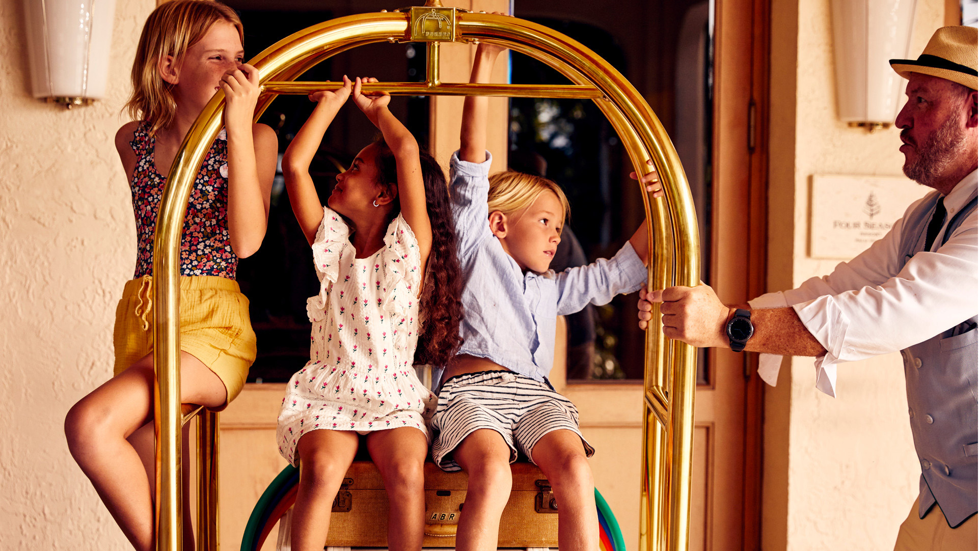 | February 19, 2023, Palm Beach, U.S.A.  Four Seasons Resort Palm Beach Celebrates Quarter Century Long Recognition of Highest Honours by Forbes Travel Guide  https://publish.url/palmbeach/hotel-news/2023/forbes-five-star-hotel-and-spa.html
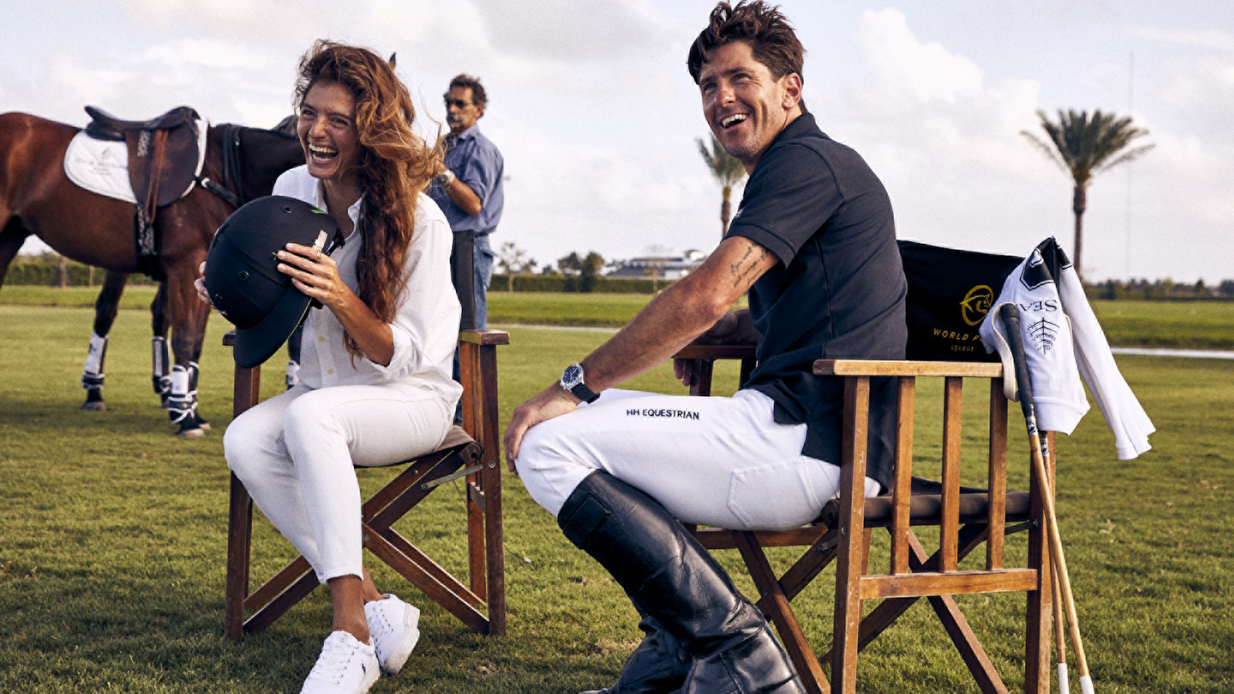 | February 16, 2023, Palm Beach, U.S.A.  Polo Experiences with Top Ranked Player Launches New High Goal Season with Four Seasons Resort Palm Beach  https://publish.url/palmbeach/hotel-news/2023/polo-season-experiences.html

PRESS CONTACTS

Eileen Sturgis
Public Relations and Communications Manager
2800 South Ocean Boulevard
Palm Beach
USA
eileen.sturgis@fourseasons.com

+1 561 493 5549

Laurie Herrick
Regional Director of Public Relations and Communications
2800 South Ocean Boulevard
Palm Beach
USA
laurie.herrick@fourseasons.com

