Take a Step Back Through Hollywood History

November 1, 2013, Los Angeles in Beverly Hills (Beverly Wilshire), U.S.A.

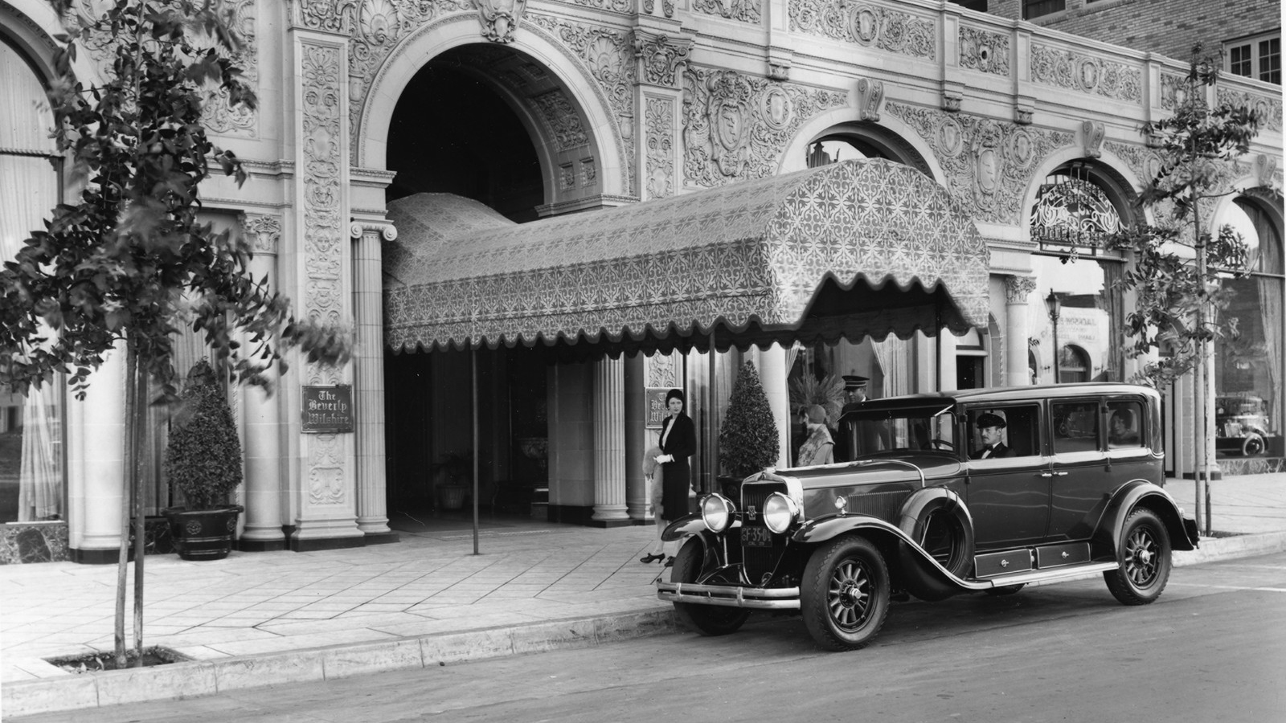
The iconic Beverly Wilshire, A Four Seasons Hotel opened its doors January 1928 in Beverly Hills, on the site of the Beverly Auto Speedway, which provided residents with an opportunity for picnics and Model T Ford races on Sunday afternoons. At the time, the population of Beverly Hills was less than 1,000 and it was still undiscovered by Hollywood’s in-crowd.
Beginning with only one building that withstood major earthquakes and was designated an air raid shelter during World War II, this historically rich landmark added the Beverly Wing in 1971, along with the Mediterranean-style pool modeled after Sophia Loren’s private Italian villa. It was only 16 years later that this great dame was added to the National Register of Historic Places, on June 12, 1987.
Beverly Wilshire, A Four Seasons Hotel is no stranger to fame as high-profile celebrities such as Elvis Presley, Warren Beatty and Steve McQueen have all lived in the Hotel. And the Hotel become well known throughout the world when in 1990, it was the central location for the movie Pretty Woman starring Julia Roberts and Richard Gere.
In 1992, Four Seasons Hotels and Resorts began managing the Hotel and continued to further the stature of this iconic landmark. Located only a few steps away from Rodeo Drive, the Hotel’s ornate European façade features rounded awnings and rows of sculpted trees, and is ever the see and be-seen hot spot in town.
Visit our Historic BW Photos Pinterest Board for more.

RELATED

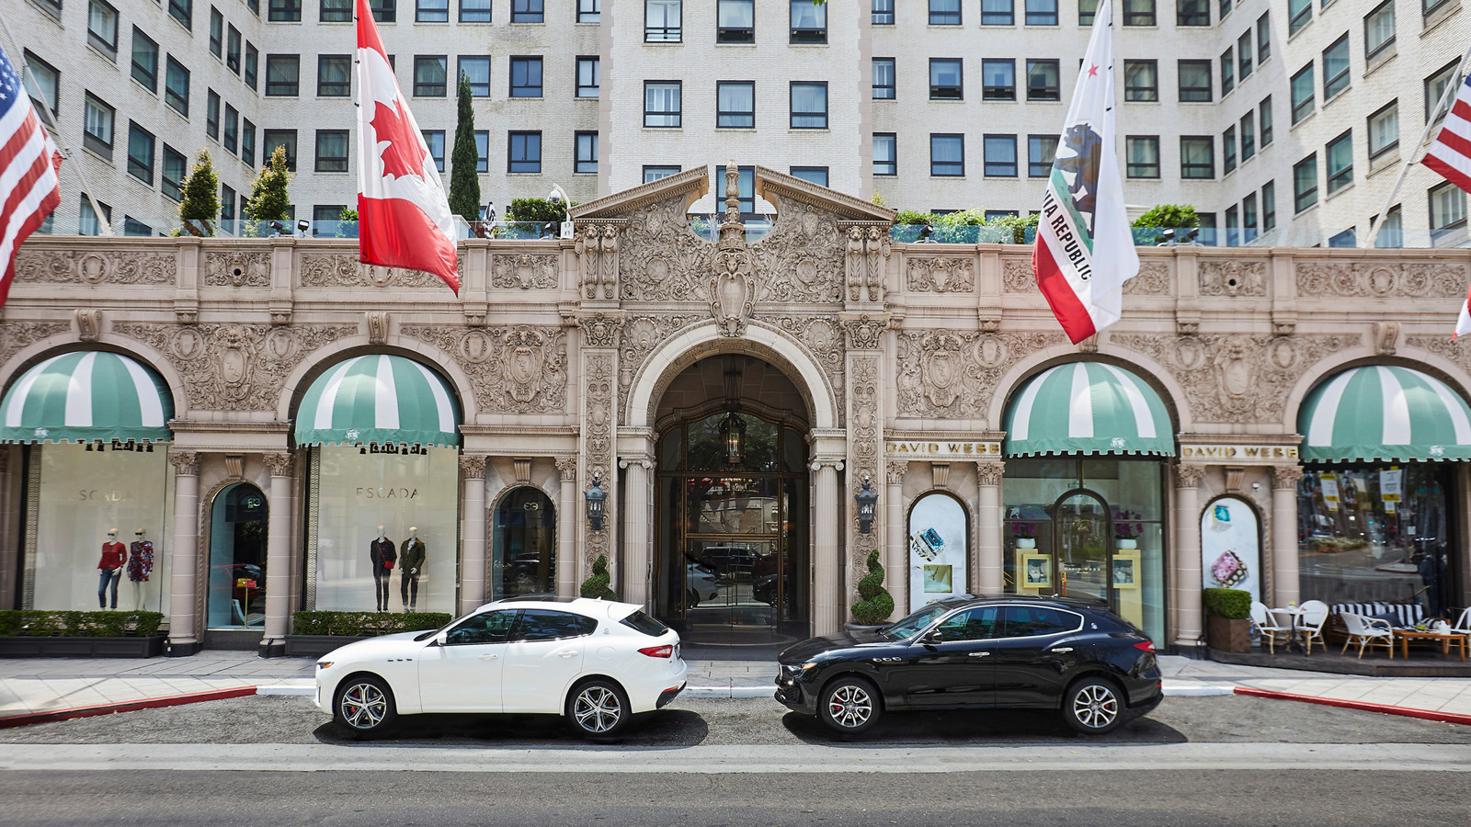 | August 16, 2019, Los Angeles in Beverly Hills (Beverly Wilshire), U.S.A.  Guests of Beverly Wilshire, A Four Seasons Hotel Suites to Experience Los Angeles’ Iconic Car Culture from the Comfort of a 2019 Maserati Levante  https://publish.url/beverlywilshire/hotel-news/2019/maserati-driving-tours.html
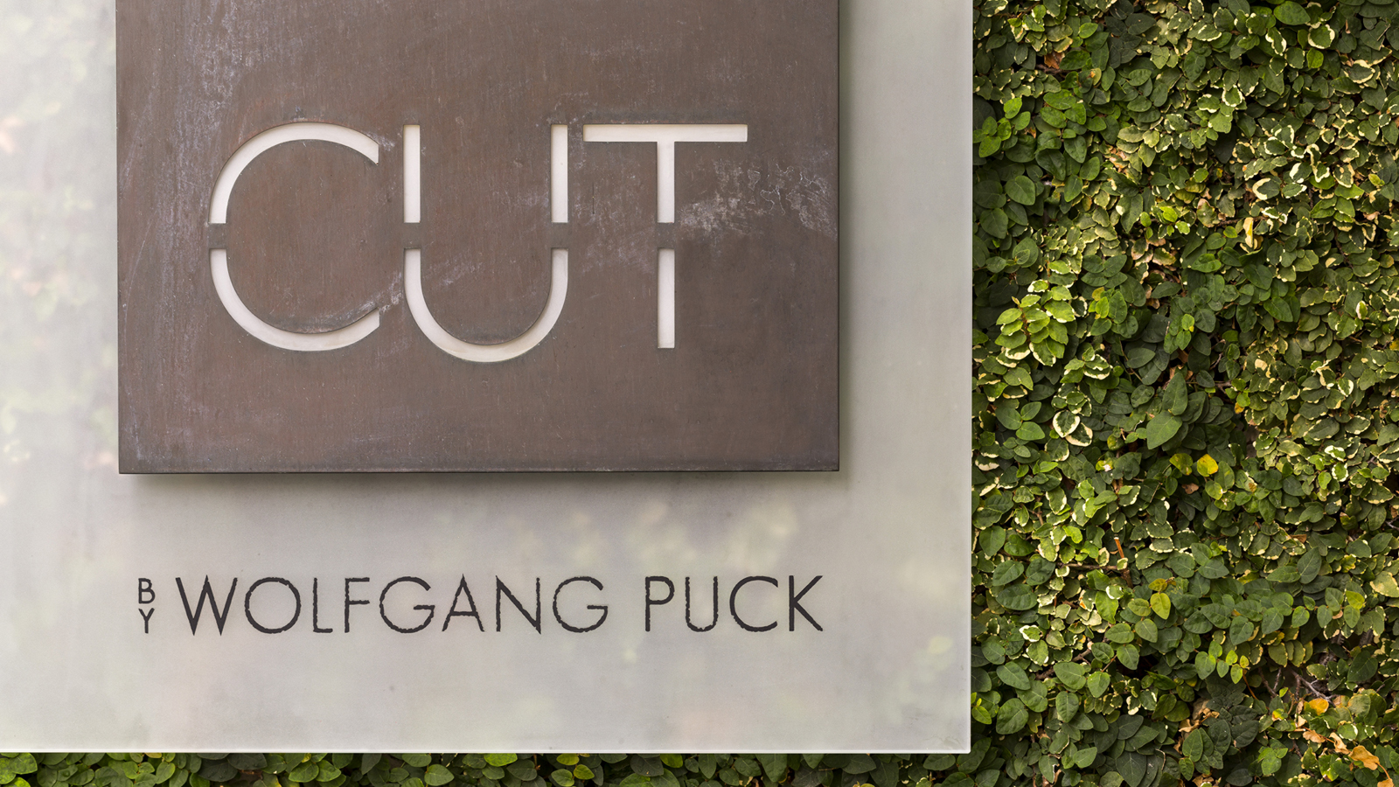 | June 4, 2019, Los Angeles in Beverly Hills (Beverly Wilshire), U.S.A.  CUT by Wolfgang Puck at Beverly Wilshire, A Four Seasons Hotel Receives Michelin Star Upon Guide’s Return to California  https://publish.url/beverlywilshire/hotel-news/2019/michelin-starred-cut-beverly-hills.html

PRESS CONTACTS

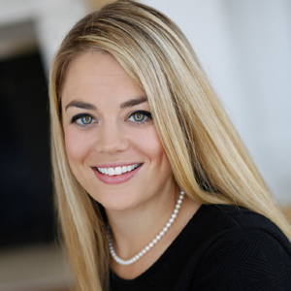 | Kiersten Dunn  Director of Public Relations and Communications  9500 Wilshire Boulevard  Beverly Hills  USA  kiersten.dunn@fourseasons.com  +1 310 385 3917

