GiellyGreen to Launch Boutique Salon at Four Seasons Hotel London at Ten Trinity Square

March 22, 2018, London at Ten Trinity Square

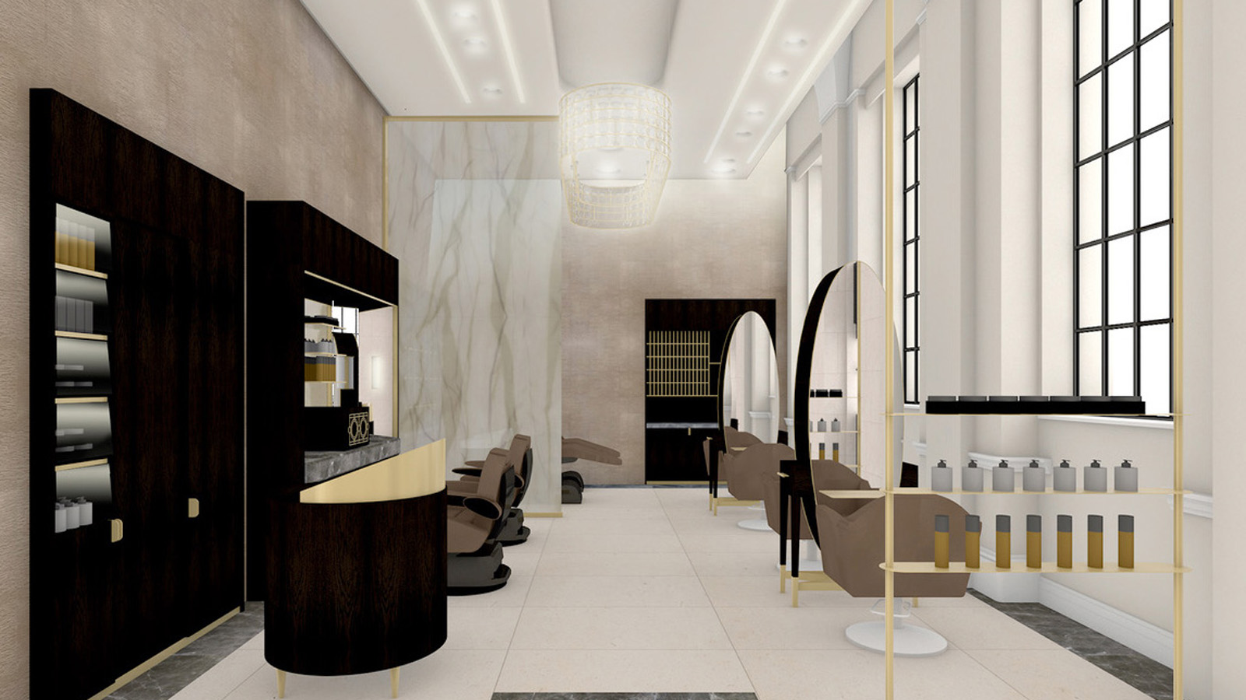
Four Seasons Hotel London at Ten Trinity Square welcomes the launch of London-based hair and beauty salon GiellyGreen on March 27, 2018. The luxurious on-site hair salon will take the Hotel’s beauty and wellness offering one step further and will mark the expansion of GiellyGreen from their flagship residence in George Street, Marylebone.
To complement services offered in The Spa at Four Seasons Hotel London at Ten Trinity Square, GiellyGreen’s award-winning stylists will offer hairdressing and barbering services for locals and guests. The salon will feature innovative technology and services, housed in a warm, welcoming space with a distinctive charm. Co-Founder and Creative Director of GiellyGreen Shai Greenberg has taken great care to create a contemporary, but also intimate and welcoming salon on the ground floor of the Hotel alongside the current Brioni menswear boutique.
Honed marble and limestone floors will complement the forms of the custom made, luxuriously finished dark oak furniture with chocolate, soft cream tones and decadent touches of gold throughout. Double height windows will allow natural light to pour in to the space. The client styling stations will feature vast oval mirrors cut from one sheet of glass, forming an eye-catching centrepiece. The stylist’s stations have been designed to look like personal dressing tables, making each guest feel at home in their own space in the salon.
An expert team led by Carmelo Guastella, GiellyGreen’s Men’s Grooming Director, will provide the salon’s dedicated barber services. The barbers at GiellyGreen will offer hair and grooming treatments, beard and hot towels treatments, as well as hot shaves delivered with precision, originality and professionalism.

RELATED

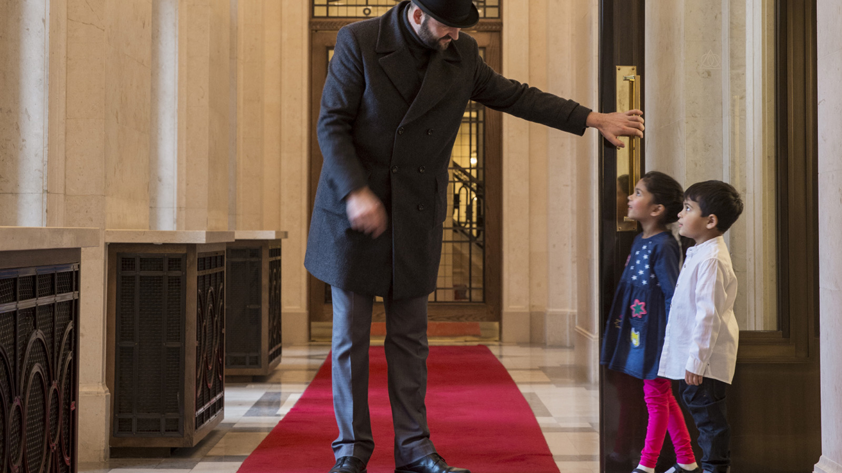 | March 13, 2018, London at Ten Trinity Square  A Family Occasion for Easter at Four Seasons Hotel London at Ten Trinity Square  https://publish.url/tentrinity/hotel-news/2018/easter.html
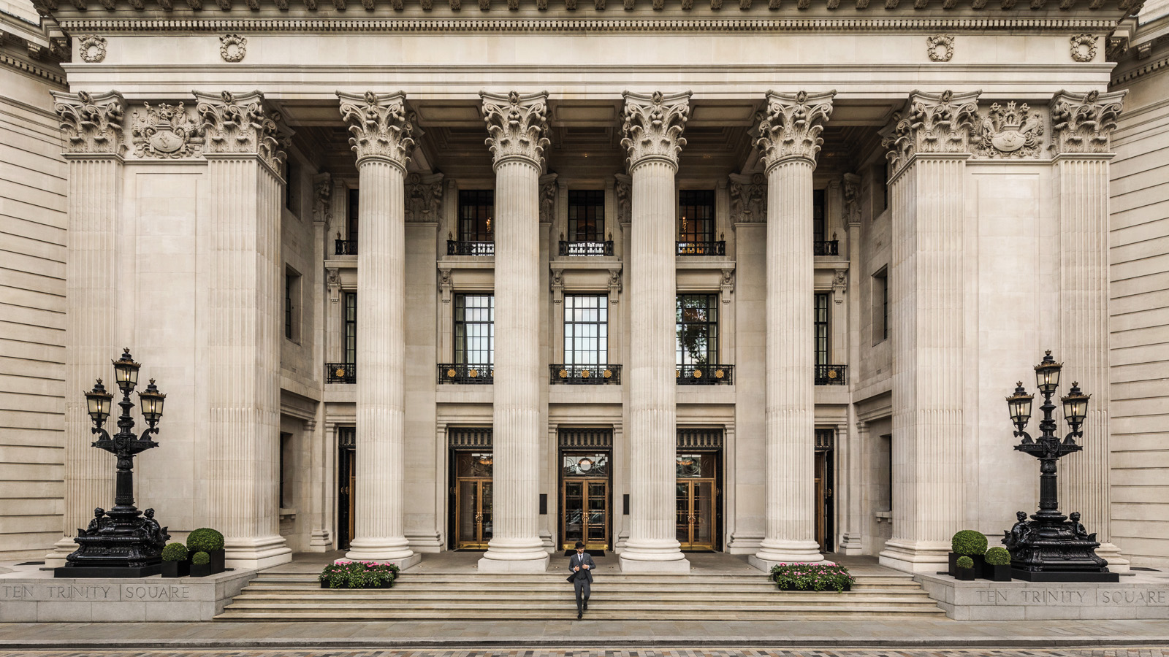 | January 5, 2018, London at Ten Trinity Square  Four Seasons Hotel London at Ten Trinity Square Celebrates First Anniversary  https://publish.url/tentrinity/hotel-news/2018/first-anniversary-promotions.html

PRESS CONTACTS

Gemma Minto
Public Relations Manager
10 Trinity Square
London
UK
gemma.minto@fourseasons.com

+44 (0) 203 297 9232

