Four Seasons Hotel Hong Kong Celebrates 2022 Mid-Autumn Festival with New and Popular Mooncakes

June 30, 2022, Hong Kong, China

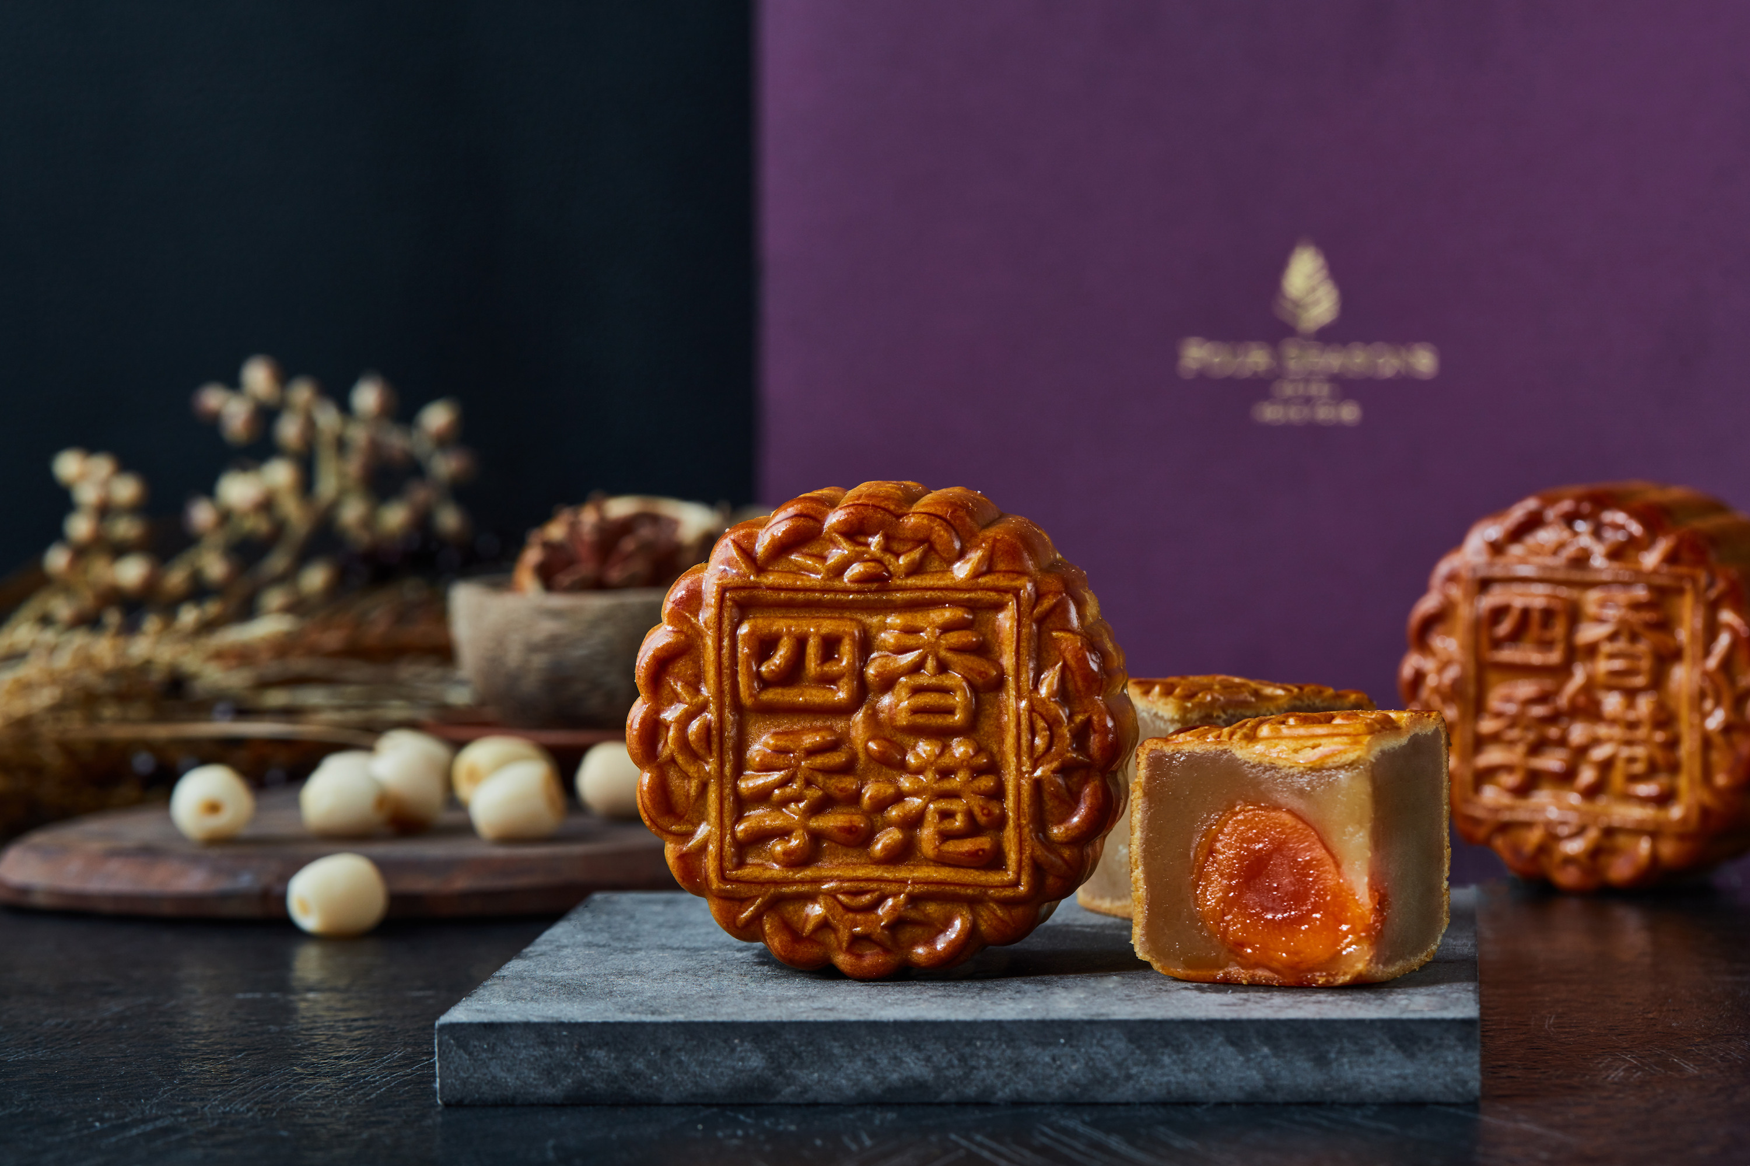
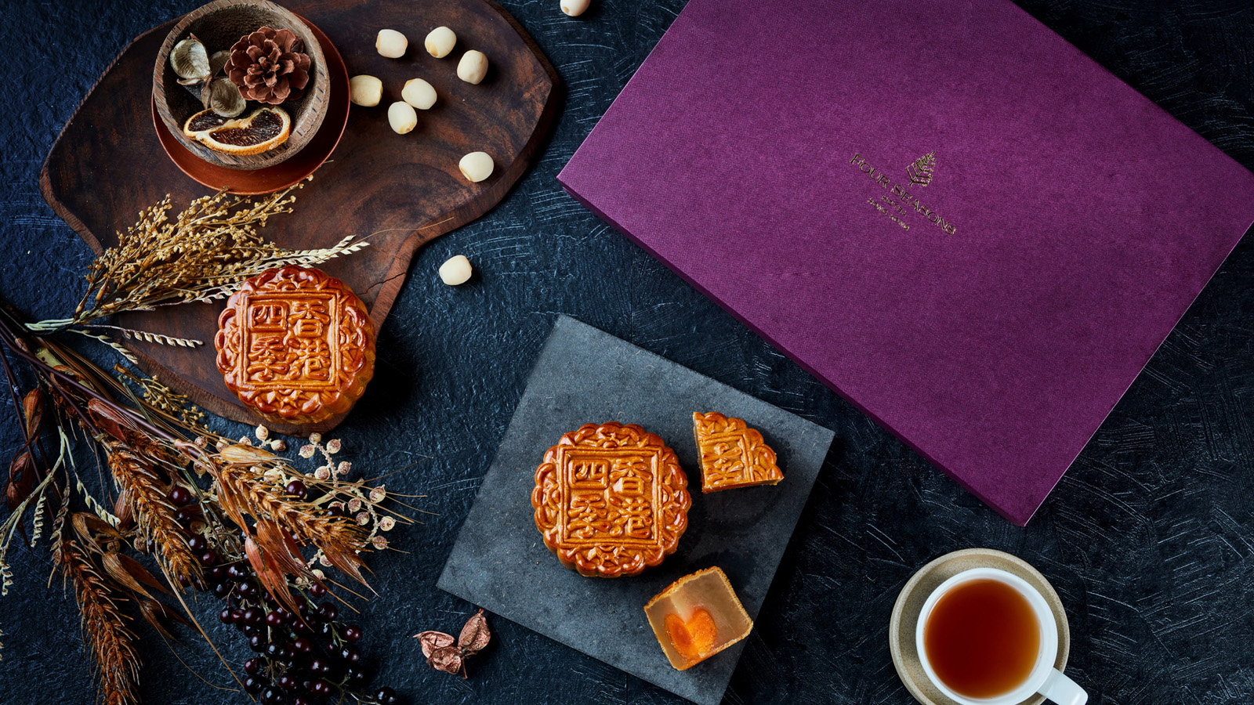 | 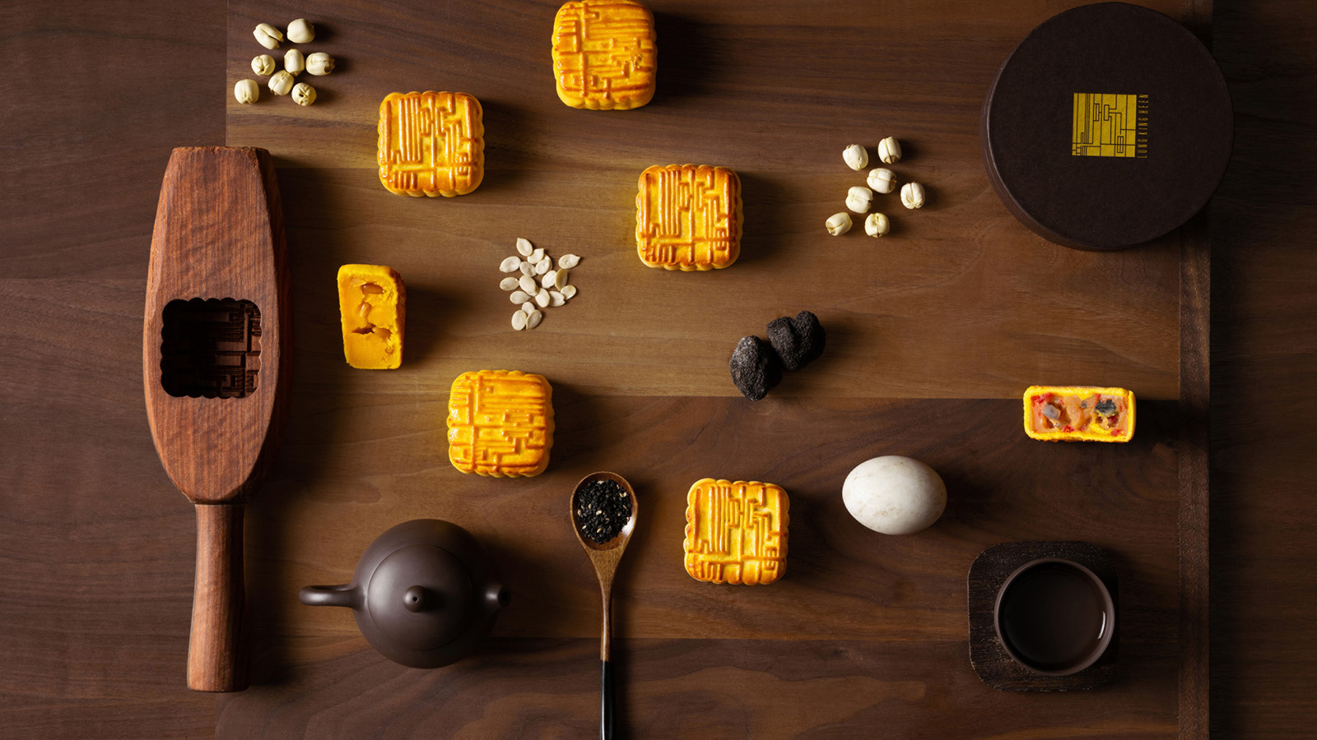 | 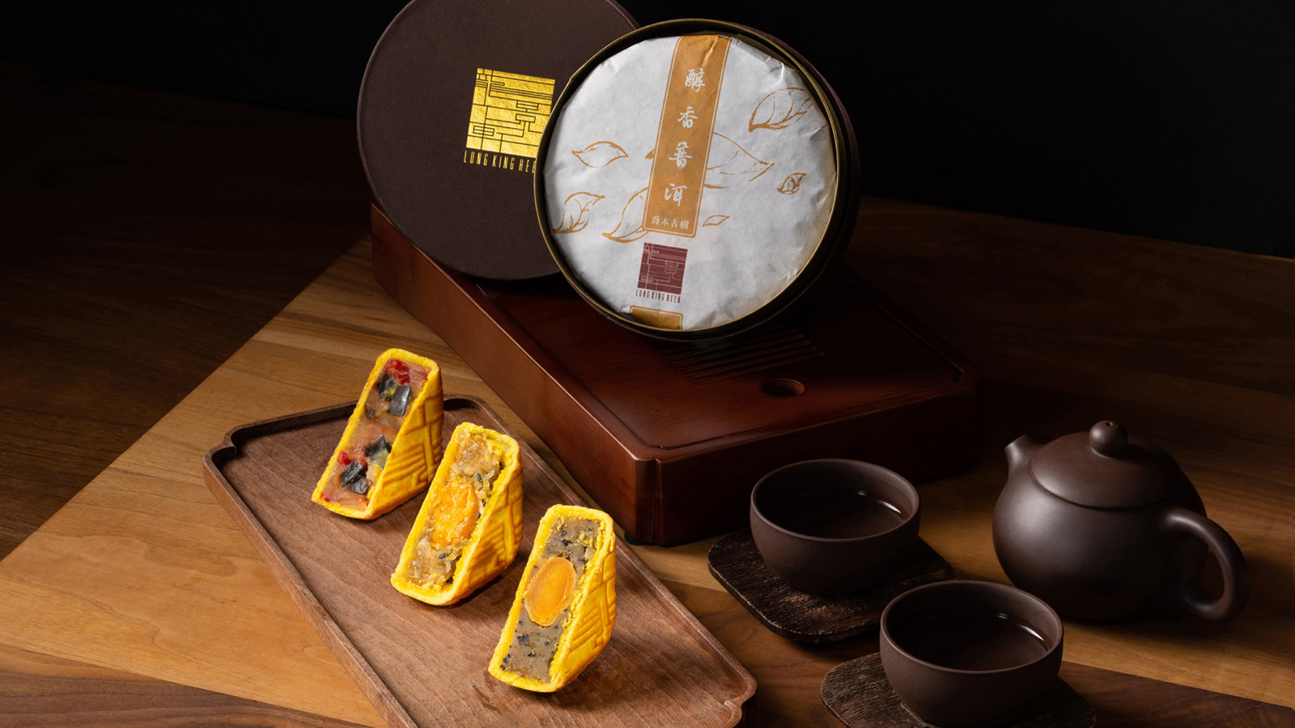
This Mid-Autumn Festival, enjoy moongazing with family and friends in the company of mooncakes by Four Seasons Hotel Hong Kong to ensure the celebration is filled with epicurean joy. This year, the selection includes a traditional mooncake flavour by the Hotel as well as new and popular mooncake creations by three-Michelin-starred Chinese restaurant Lung King Heen, promising a collection of offerings that cater to different preferences and palates.
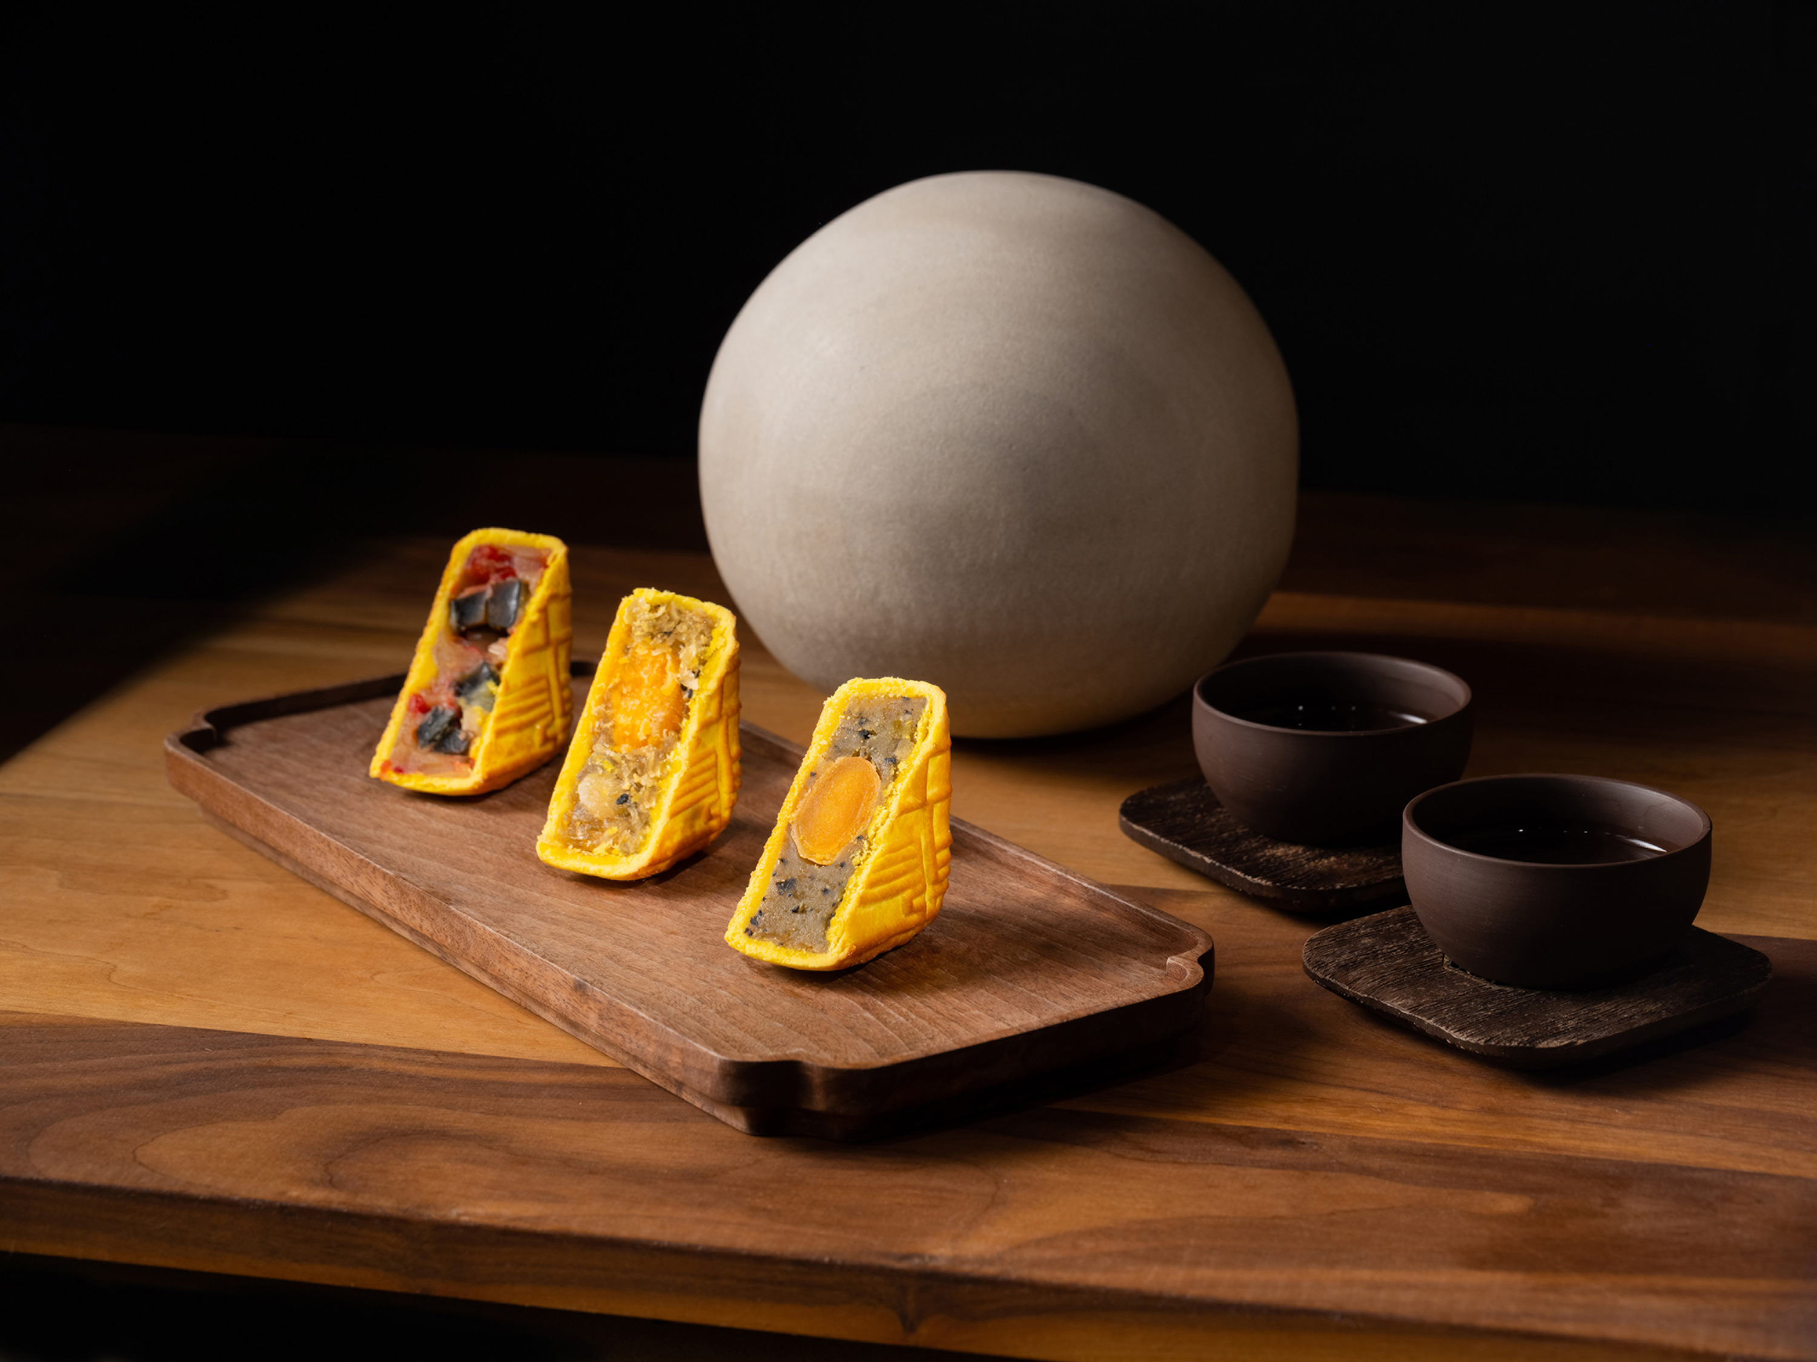 | 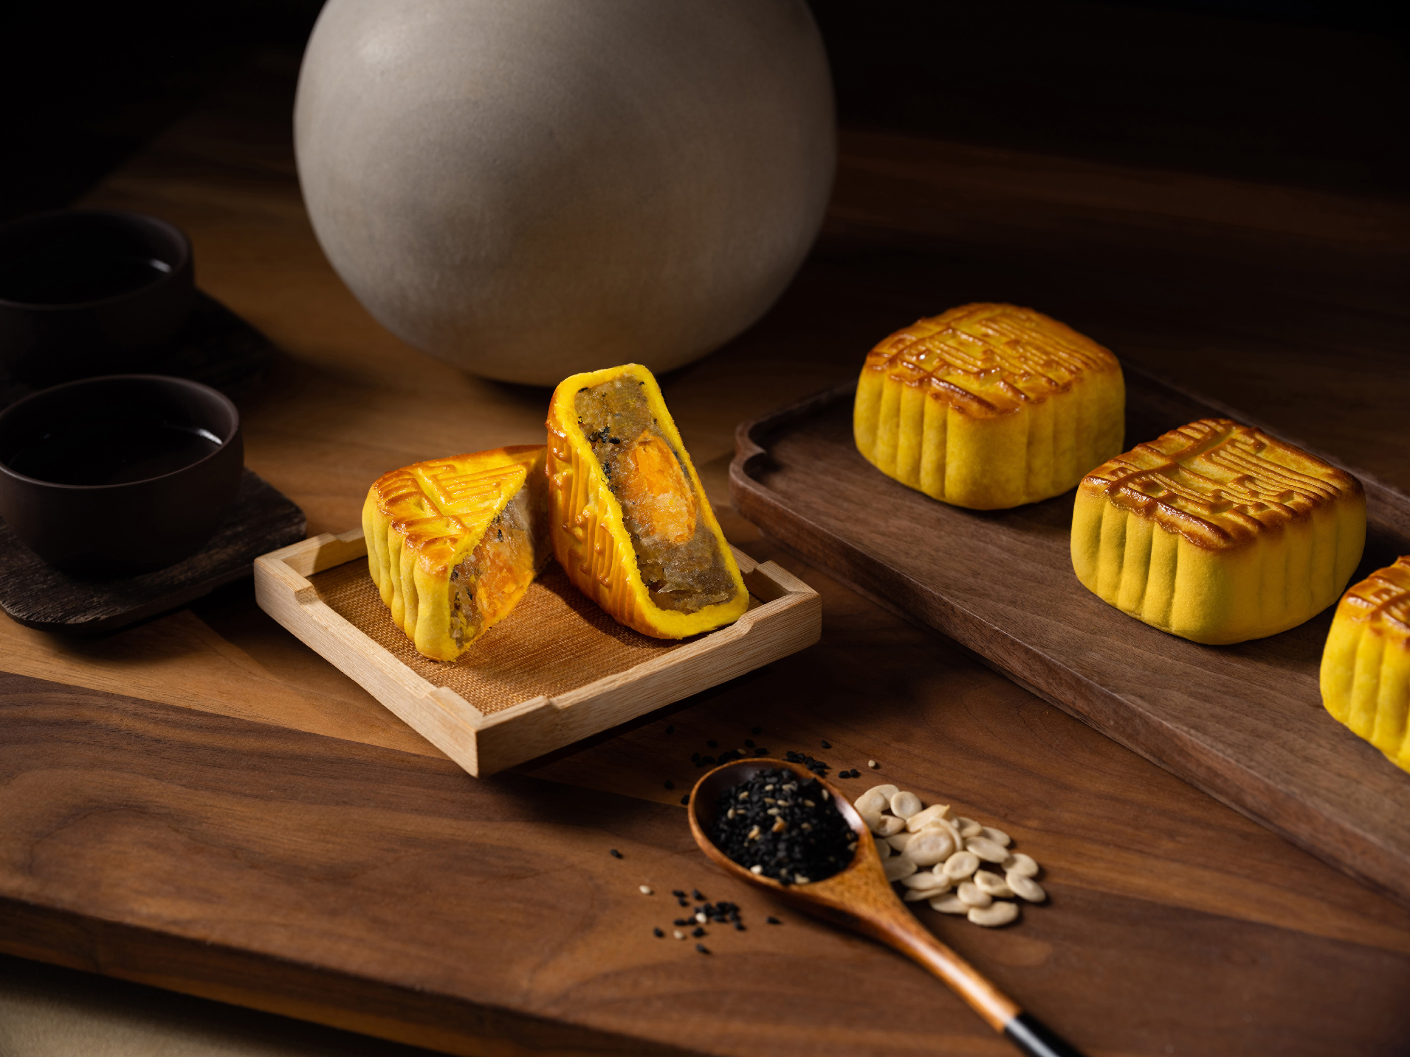 | 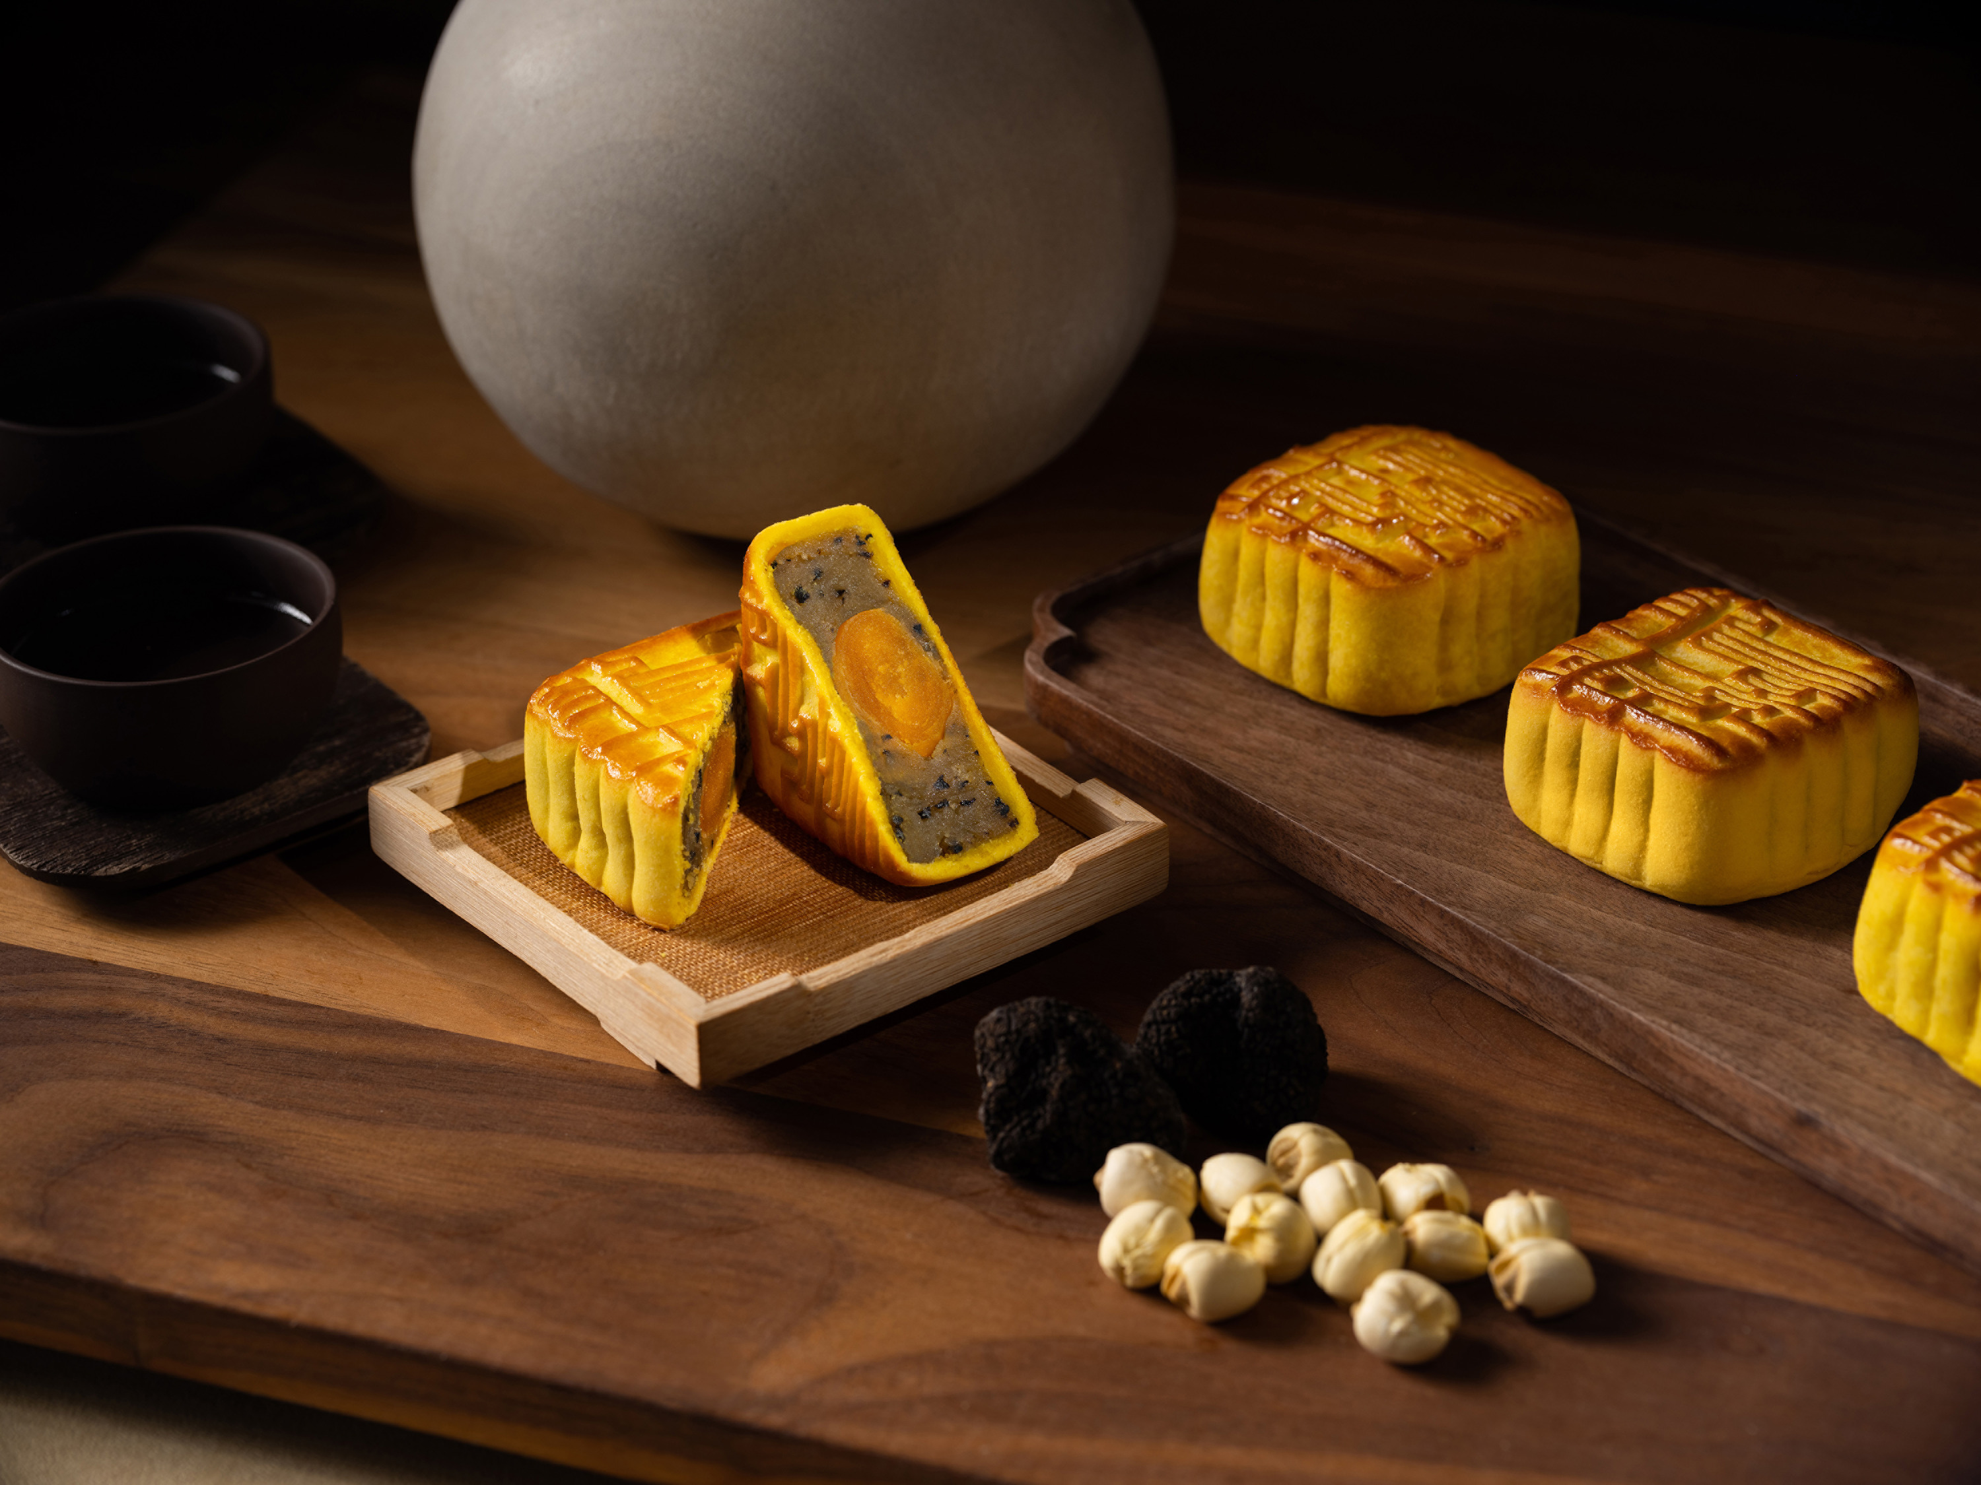
Guests who plan to buy early in large quantities should not miss the early bird and bulk purchase offers exclusive to the Four Seasons White Lotus Seed Paste Mooncakes with Double Salted Egg Yolk on the Hotel's e-Shop.
New and Popular Mooncake Creations by Lung King Heen
This year, Executive Chinese Chef Chan Yan Tak and his culinary team at Lung King Heen embrace the beauty of the Mid-Autumn tradition by introducing a new flavour: Winter Melon Paste Mooncakes with Black Sesame and Salted Egg Yolk. In this recipe, the black sesame is first toasted to bring out its unique aroma. The winter melon paste is selected for its beautiful golden colour and a pleasant level of sweetness. A bite into it guarantees a substantial mouthfeel with the right balance of tastes that will be sure to bring a smile to everyone's face.
In addition to the new flavour, Lung King Heen will also bring back the popular mooncake creations. White Lotus Seed Paste Mooncakes with Salted Egg Yolk and Black Truffle carry the unmistakable truffle fragrance. While egg and truffle have always been a match made in heaven, Chef Chan and his team go the extra mile to pair the truffle with salted egg yolk to deliver an unconventional combination widely loved by Lung King Heen's discerning guests in previous years. Preserved Eggs and Pickled Ginger Mooncakes feature ginger that is pickled in-house, and only the egg yolk part of the preserved egg is used as it is the most flavoursome. The mooncake flavour is making a return this year due to popular demand.
Guests can enjoy the privilege of indulging in all three flavours by ordering the Assorted Signature Mooncakes box that comes with the option of including an offering of vintage 2008 mellow pu'erh tea cake in the package. The tea cake is sourced from a family-owned tea farm in Yunnan province whose pu'erh tea is handpicked and processed by traditional techniques passed down by generations.
Cream Custard Mooncakes with Toasted Pine Nuts, a sought-after delicacy created by Chef Chan Yan Tak since the Hotel opened, is also available this year.
Lung King Heen mooncakes are handmade by the restaurant chefs and contain no preservatives. The mooncakes are elegantly presented in a gift box crafted by renowned designer Alan Chan.
A complete list of Lung King Heen’s mooncake offerings:
- Winter Melon Paste Mooncakes with Black Sesame and Salted Egg Yolk – HKD 568 per box (6 pieces)
- White Lotus Seed Paste Mooncakes with Salted Egg Yolk and Black Truffle – HKD 598 per box (6 pieces)
- Preserved Eggs and Pickled Ginger Mooncakes – HKD 568 per box (6 pieces)
- Assorted Signature Mooncakes (includes 2 pieces of Winter Melon Paste Mooncake with Black Sesame and Salted Egg Yolk, 2 pieces of White Lotus Seed Paste Mooncake with Salted Egg Yolk and Black Truffle, and 2 pieces of Preserved Eggs and Pickled Ginger Mooncake, 6 pieces in total) – HKD 598 per box, HKD 798 per box with an offering of Vintage 2008 Mellow Pu'erh Tea Cake
- Cream Custard Mooncakes with Toasted Pine Nuts – HKD 568 per box (6 pieces)
Traditional Favourite by the Hotel
For those who prefer the traditional mooncake flavour, Four Seasons White Lotus Seed Paste Mooncakes with Double Salted Egg Yolk makes the perfect choice.
This year, early bird and bulk purchase benefits are available, making Four Seasons mooncakes a great giveaway for corporate clients.
- Four Seasons White Lotus Seed Paste Mooncakes with Double Salted Egg Yolk – HKD 568 per box (4 pieces)
Early Bird Offer (from now to July 31, 2022)
- 1-19 boxes – 15 percent savings – HKD 482.80 per box
- 20-49 boxes – 20 percent savings – HKD 454.40 per box
- 50-99 boxes – 25 percent savings – HKD 426 per box
- 100 boxes or above – 30 percent savings - HKD 397.60 per box
Bulk Purchase Offer (from August 1, 2022 to September 9, 2022)
- 20-49 boxes – 5 percent savings – HKD 539.60 per box
- 50-99 boxes – 10 percent savings – HKD 511.20 per box
- 100 boxes or above – 15 percent savings - HKD 482.80 per box
Both savings options are exclusive to Four Seasons mooncake only.
Mid-Autumn Hampers
As families gather for this celebratory occasion, festive hampers are a great way to express gratitude and love. Four Seasons Hotel Hong Kong offers three hampers that include a variety of Lung King Heen handmade delicacies and all-time festive favourites such as Lung King Heen X.O. sauce, South African abalone, dried conpoy, and premium dried fish maw.
A complete list of Lung King Heen Mid-Autumn Hampers:
- Lung King Heen Gourmet Hamper - HKD 2,900
- Lung King Heen Deluxe Hamper - HKD 3,980
- Lung King Heen Ultimate Hamper - HKD 13,998
Purchase Information
Mooncakes and hampers are available to order via eShop now.
Collection dates:
- Lung King Heen mooncakes are available for collection from August 27, 2022 to September 9, 2022.
- Four Seasons mooncakes and hampers are available for collection August 1, 2022 to September 9, 2022.
Pick up location:
- Collection of mooncakes and hampers will be at the Four Seasons Cake Shop located at The Lobby, which is open from August 1 to September 9, 2022 from 10:00 am to 8:00 pm daily.
For enquiries, call (852) 3196 8708 or email shop.hkg@fourseasons.com.

RELATED

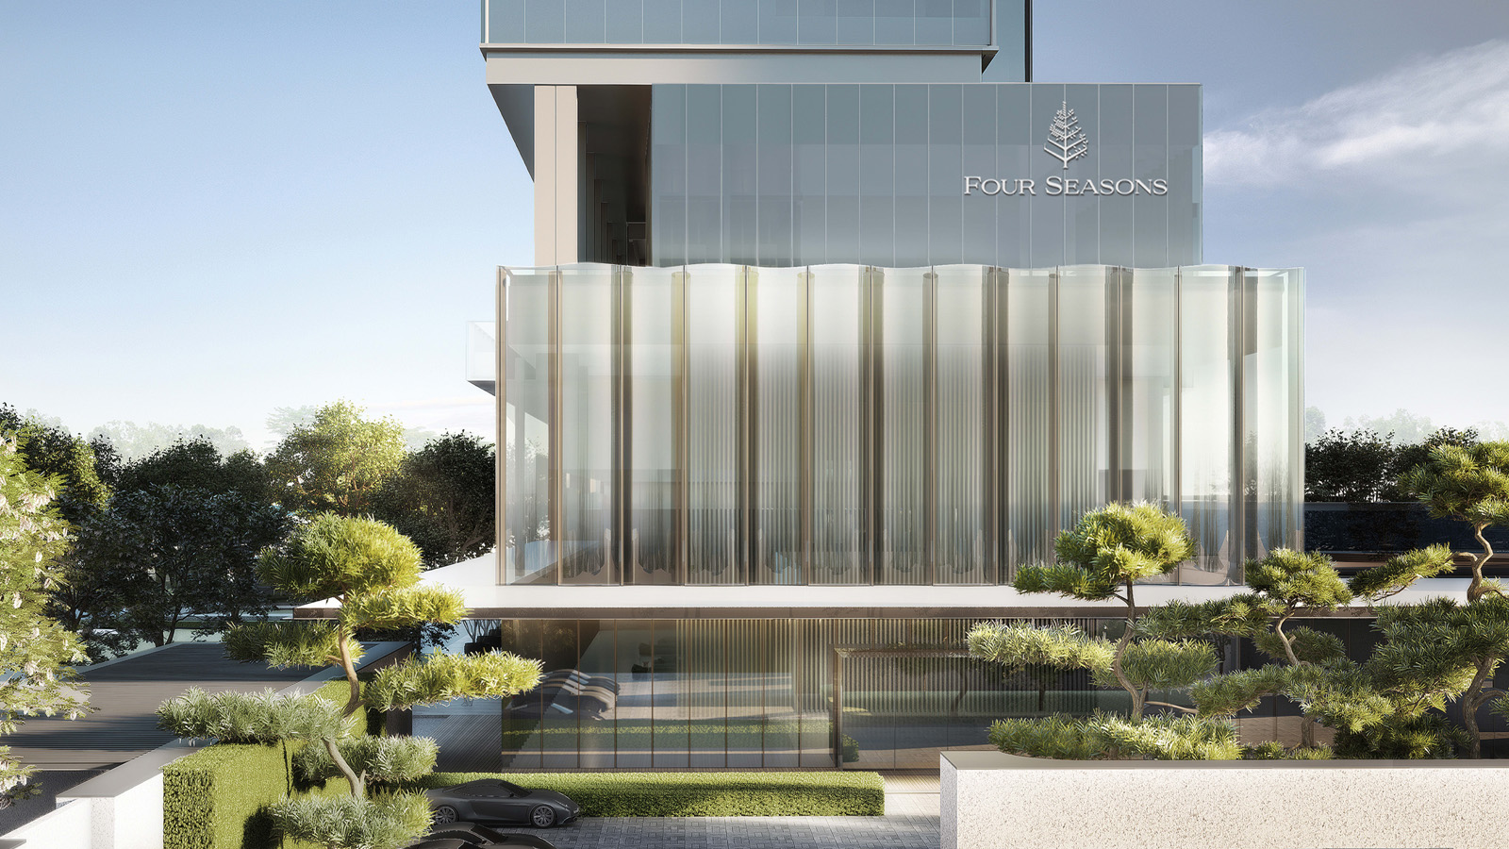 | June 28, 2022, Toronto, Canada  Four Seasons and Vanzhong Group Announce Luxury Hotel in Xi’an  https://publish.url/news-releases/2022/new-four-seasons-in-xian.html
June 28, 2022, Toronto, Canada
四季酒店集团携手万众集团正式宣布全新的奢华酒店项目即将落户西安
https://publish.url/news-releases/2022/new-four-seasons-in-xian-2.html

PRESS CONTACTS

Mandy Li
Assistant Director of Marketing Communications
8 Finance Street, Central
Hong Kong
China
mandy.li@fourseasons.com

(852) 3196 8307

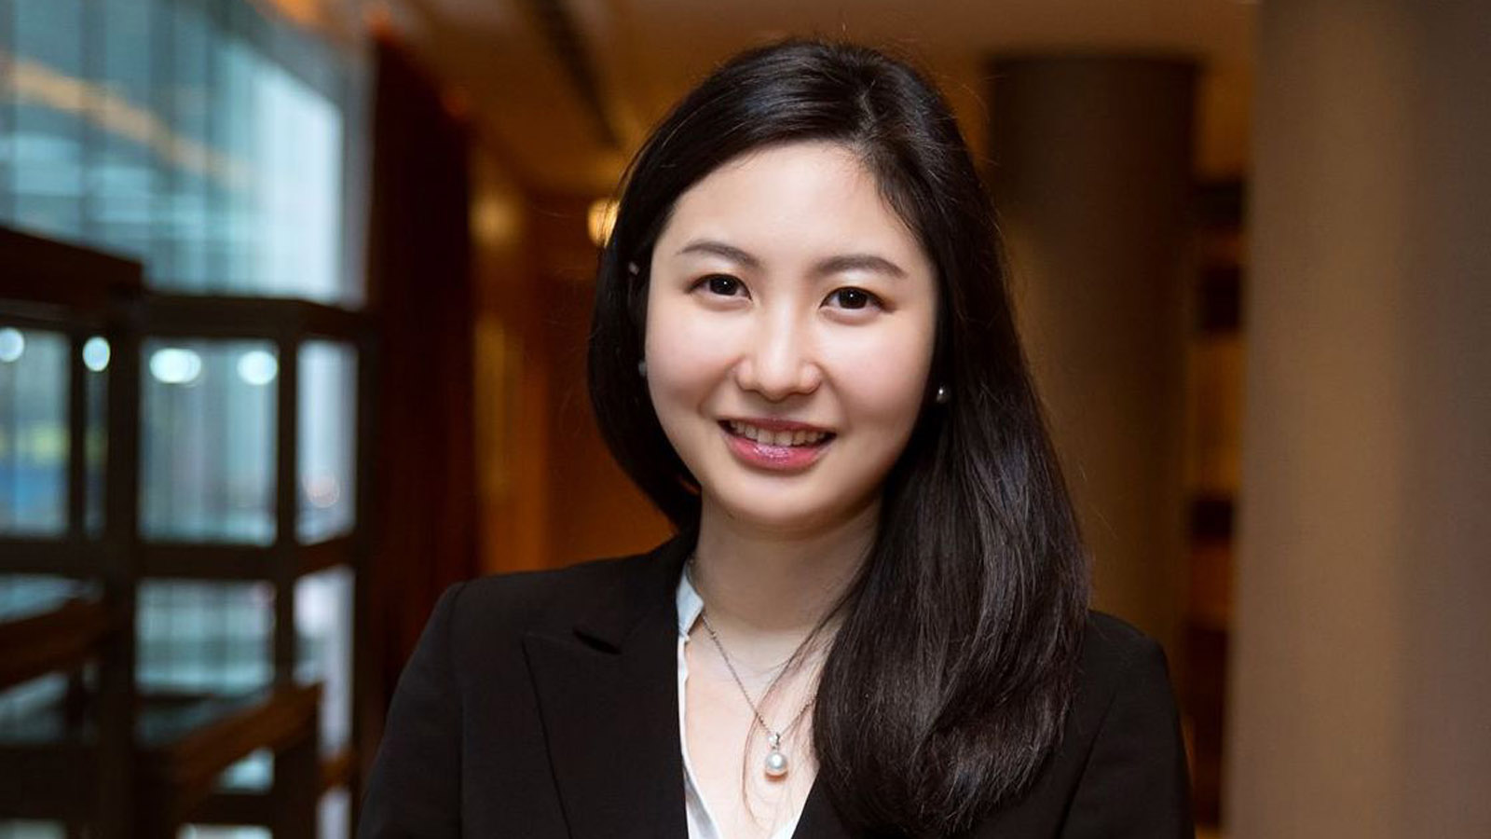 | Priscilla Chan  Assistant Public Relations Director  8 Finance Street, Central,  Hong Kong  China  priscilla.chan@fourseasons.com  (852) 3196 8306

