Raise a Toast to Spain at Four Seasons Resort Scottsdale

Talavera introduces a unique new cocktail experience
July 11, 2018, Scottsdale, U.S.A.

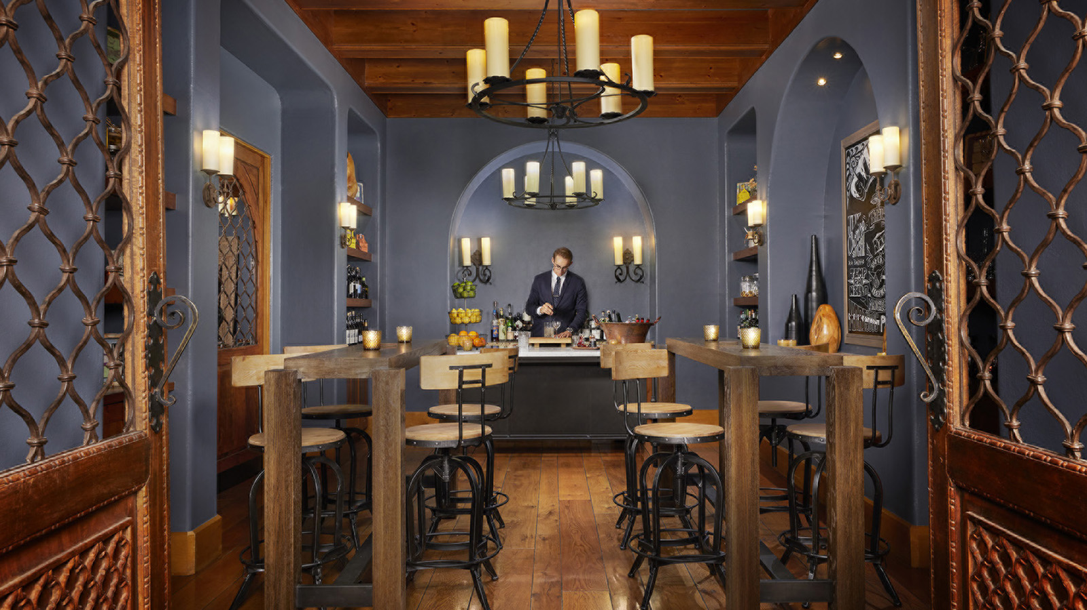
Created to pair perfectly with the new Latin concept of Talavera restaurant is its contemporary new Gin Bar, which features a Spanish-inspired menu of gin tonics, as well as sherry, beer, cider, vermouth and a selection of wines.
Located adjacent to the Talavera dining room at Four Seasons Resort Scottsdale at Troon North, the Gin Bar is a cosy space inspired by the tapas bars of Spain where guests can stand or sit to enjoy pintxos, small bites such as olives and crispy chickpeas, along with a drink while catching up with friends. The Gin Bar’s focus is its centrepiece bar, where talented mixologists craft cocktails from the finest spirits, tinctures and fresh-from-the-soil herbs.
Food and Beverage Manager Kelsey Jordan had a hand in creating the menu. He said the team compiled a list of the best gins from around the world that encompassed multiple different styles and flavour profiles to create a menu of ever-changing gins tonics. Gin tonics is the Spanish way of referring to a gin and tonic cocktail, he added.
“What stands out is that they are two- to three-ingredient cocktails with an incredible depth of flavour,” Jordan said. “This is due to our excellent selection of 20-plus gins, which allows us to choose just the right one to pair with our small-batch artisanal tonic selection and wide variety of house-grown herbs and dried citrus.”
In addition to its signature gin tonic menu, the bar also features seasonal sangria (blanco, rosado and tinto versions). The sangrias are crafted from Spanish wines and local ingredients designed to elevate the flavour of the wines. Each is served in a served in a traditional Spanish pórron, a unique glass vessel with a sleek pouring spout, alongside a glass of fresh fruit on ice.
This summer, the Gin Bar will host happy hour specials from 5:30 to 6:30 pm including USD 10 Gin Tonics and discounted pintxos. The Gin Bar at Talavera is open during restaurant hours. Talavera’s summer hours are 5:30 to 9:30 pm Thursday through Sunday. For reservations, call 480 513 5085 or book online.

RELATED

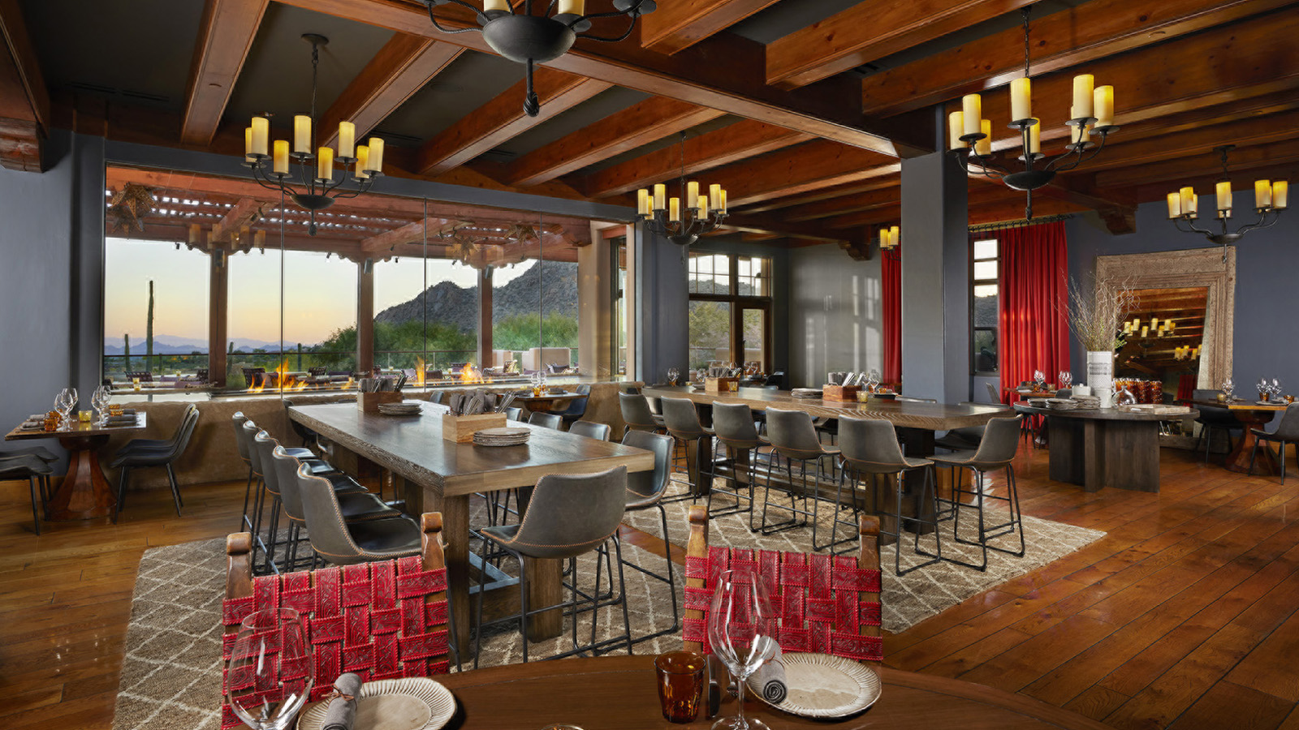 | June 6, 2018, Scottsdale, U.S.A.  Introducing Talavera, A Spanish Steakhouse at Four Seasons Resort Scottsdale at Troon North  https://publish.url/scottsdale/hotel-news/2018/talavera-spanish-steakhouse-debuts.html
April 30, 2018, Scottsdale, U.S.A.
Feed Your Soul for Global Wellness Day at Four Seasons Resort Scottsdale at Troon North
https://publish.url/scottsdale/hotel-news/2018/global-wellness-day.html

PRESS CONTACTS

Jennifer Franklin
Director of Public Relations and Communications
10600 East Crescent Moon Drive
Scottsdale
U.S.A.
jennifer.franklin@fourseasons.com

+1 (480) 513-5049

