Celebrate the Flavours of Asia This Lunar New Year at Four Seasons Resort Chiang Mai

January 6, 2023, Chiang Mai, Thailand

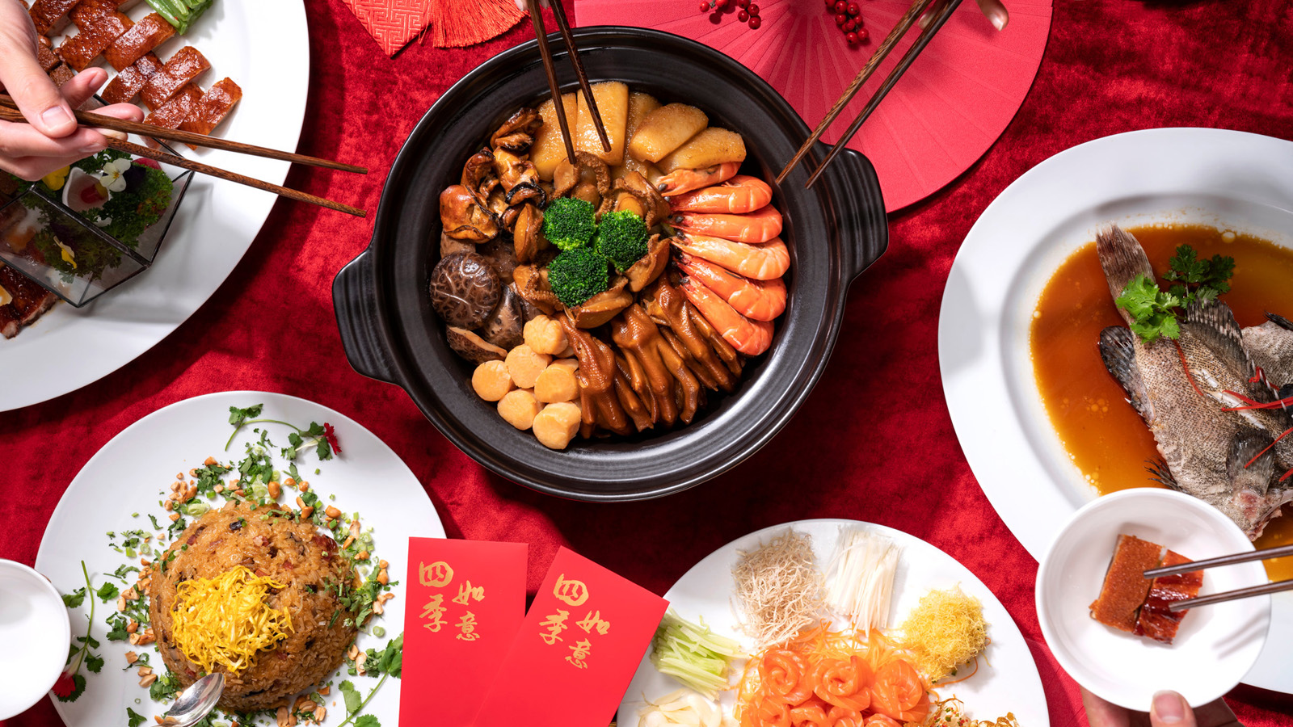
 | 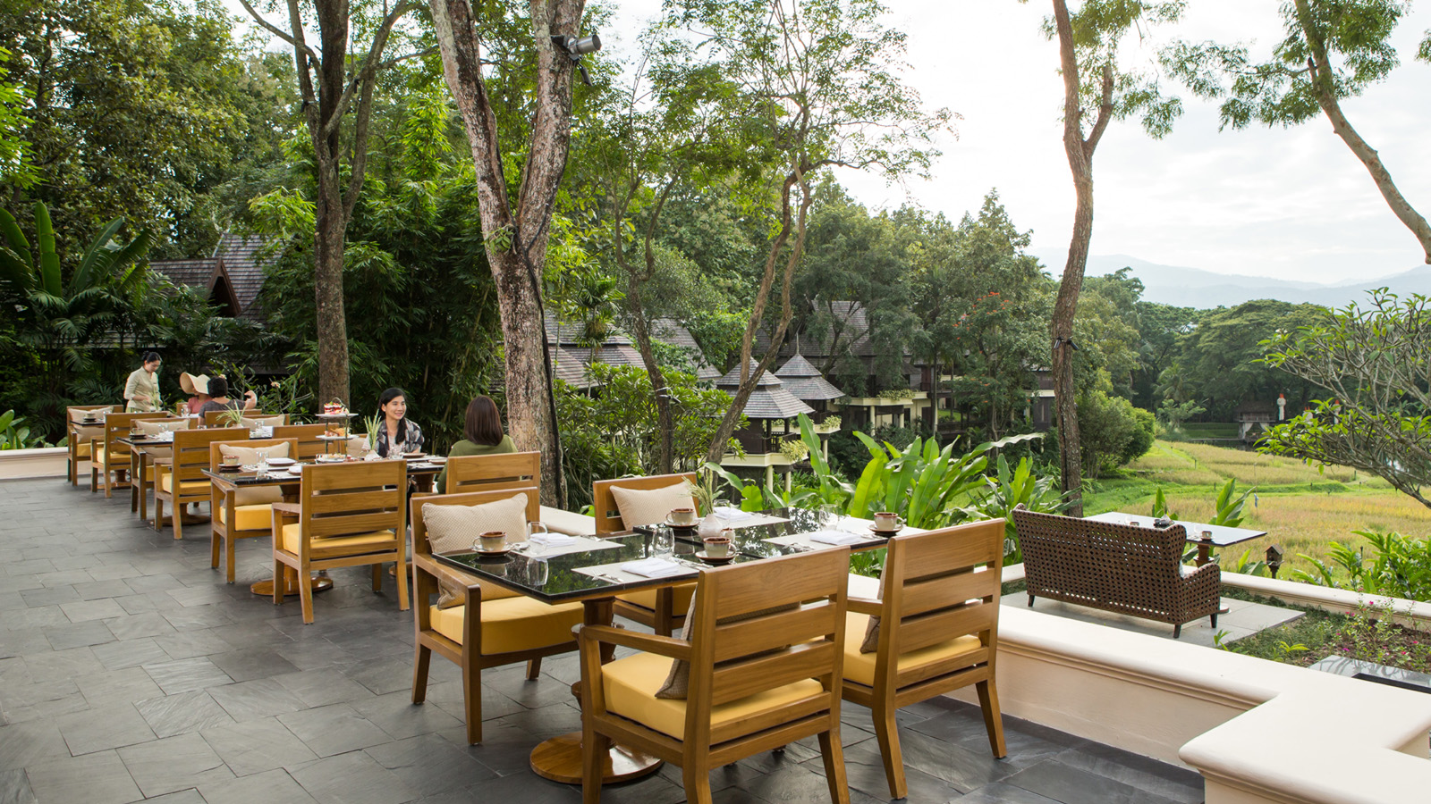 | 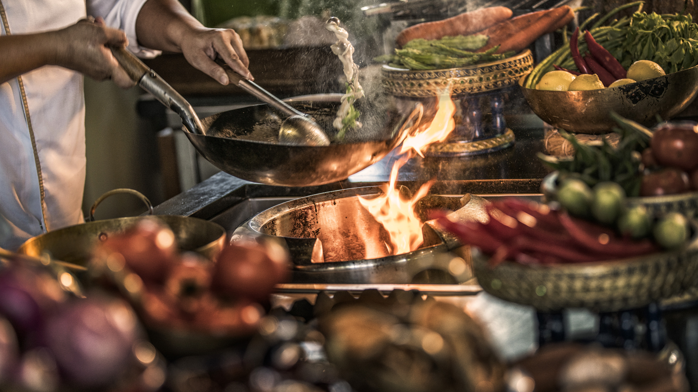
The Year of the Rabbit symbolises strengthened bonds with loved ones, as well as lasting connections with friends and family. Widely commemorated across South-East Asia and the Far East, the Lunar New Year is an especially auspicious occasion for families, for whom, sharing a meal in celebration is an age-old tradition. “What better way to bring in the Lunar New Year, than feasting at our Resort?” says Sean Mosher, General Manager, Four Seasons Resort Chiang Mai and Tented Camp Golden Triangle.
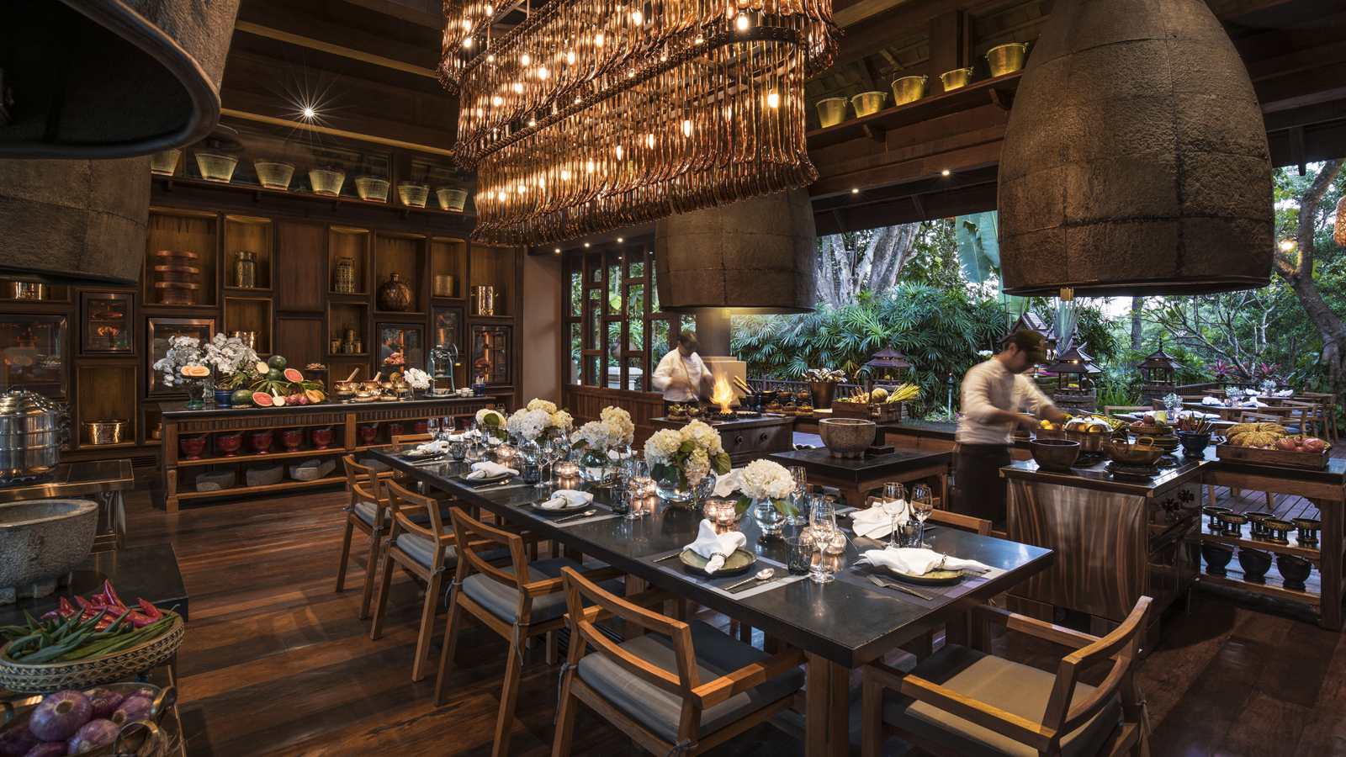
The Resort turns its focus this year on family get-togethers, and in particular, a culinary journey through the robust flavours and textures of Asia. Led by Executive Chef Jaeyoung Lee, the culinary palate at the Resort is a colourful exposition of Asian cuisine from January through March 2023, offering vibrant dining experiences this Lunar New Year.
Flavours of Asia
At Khao by Four Seasons, Sous Chef Naruchit Taintrong puts together a stellar pan-Asian journey that takes guests from the bustling streets of Bangkok to the surreal skyline of Seoul, in one momentous feast. Diners begin with a stirring selection of salads, including a charcoal grilled beef brisket with rucola, Peking duck, and a more traditional Thai style Yum Som O Goong (spicy shrimp and pomelo). Made-to-order are wholesome Korean Bulgogi and braised seabass in a Japanese wine sauce, while a live BBQ carving station with beef short rib in soy and pork collar in miso paste add an extra ounce or two of sizzle to this sensational buffet dinner.
North by Four Seasons transforms into a seafood lover’s haven as lobsters, king prawns, salmon and more, are showcased to perfection throughout the set menu with a finishing touch of strawberries. “Guests can relish this meal with a variety of sauces and dips to experience the true flavours of Asia,” shares Chef Jaeyoung.
All Aboard to Isaan
Bringing the unique flavours of this far-flung North-Eastern region to the table, Chef Naruchit familiarizes guests with one of the best kept secrets of Thai cuisine. “Known for its particular blend of piquant and tangy flavours, the cuisine straddles the borders between Thailand, Laos and Cambodia,” he shares, “Leaning heavily on seasonal produce, Isaan cuisine delivers many surprises, and is a tribute to the traditional communities that have lived here for centuries.” Classics such as the raw fruit salad, popular with Thai food enthusiasts, trace their origins to the Isaan people, and the seasonal menu at Khao by Four Seasons includes a special salad selection that champions this heritage. Chef Naruchit adds his own personal flair, bringing herbs from the chef’s garden and organically grown produce from local Thai farms, for a more authentic flavour. “Pla Ra is another peculiar umami flavour from Isaan,” he explains about the fermented fish paste that has been carefully woven into recipes, without over-powering the palate. The Ichigo strawberry is another locally-sourced ingredient that stars in this new menu, as the finest berries from a special Japanese-inspired farm in Thailand highlight the desserts on offer from January-March 2023.
Lanna Market
Khao by Four Seasons comes alive with fanfare and flair, bringing a fantastic Thai market experience to the comfort of the countryside retreat of Four Seasons Resort Chiang Mai. From local cuisine to crafts and cultural immersion, this promises to be a night to remember. “Guests will be treated to an authentic Thai street-market style dining experience,” shares Chef Naruchit Taingtrong who leads the culinary innovations at the Michelin Guide-recommended restaurant.
“A Kad Mua is essentially a Lanna style street-market, and we are recreating that local ambience with typical busy counters, live music and lots of merriment,” he explains.
Guests can expect stir-fry stations and salad counters churning out some spicy Isaan style cuisine such as Larb E-San Moo, which incorporates all the elements of a Northern Thai salad and a few of Chef Naruchit’s Chiang Mai specials will be on offer, too.
Folk music is central to the carnival-like atmosphere at a Kad Mua, and at Khao by Four Seasons, a troupe of traditional performers will add revelry during the dinner. Local artisans plying their craft will complete the classic market feel, and bring the street-side sensation right up to the tables. “Guests may stroll through the ‘market’ and explore a variety of local handicrafts such as candle carving, soap carving, Lanna tung cutting,” says Chef Naruchit. Performing especially for the occasion will be a troupe of expert Lanna dancers showcasing the Fon Khan Dok, a Buddhist ceremonial special.
Romancing Korea
With a deep dive into classic Korean cuisine, the chef instructors at Rim Tai Kitchen share their expertise in the fine balance of flavour and texture. “Learn the little nuances that make Geotjeori kimchi just that little bit more special,” smiles Jaeyong, who will personally guide guests through some simple techniques to perfect a variety of Sanjeok (beef and vegetable skewers), and even a Beef Galbi Jim (braised short ribs) at this special cooking class.
Spirited Festivities
Pineapple is the flavour of the season, as Thailand erupts with a delectable variety grown across the country. Working with local farms from around the region, the beverage experts at Ratree Bar and Lounge have created a stunning array of cocktails that blend the tangy sweetness of the pineapple with home-grown herbs and spices. “The Nang Lae pineapple, native to the mountains of Chiang Rai, has a particularly aromatic profile,” shares Anthony Tschudin, Resort Manager, “Paired with ginger or mint from our chef’s garden, it is transformed into an exquisite Pineapple Ginger Mojito.” The Missionary’s Downfall can be attributed to this temptation, as the rum-infused pineapple drink, with lime juice and peach liqueur, is truly hard to resist.
“At Chiang Mai, the festivities bring together common themes of warmth and sharing that are symbolic of this special occasion,” shares Sean. “We look forward to welcoming you to experience our beautiful countryside retreat to ring in the Lunar New Year.”
To reserve, call +66 (0) 53 298 181, email fb.chiangmai@foursesaons.com, or chat real-time via the Four Seasons App Chat.

RELATED

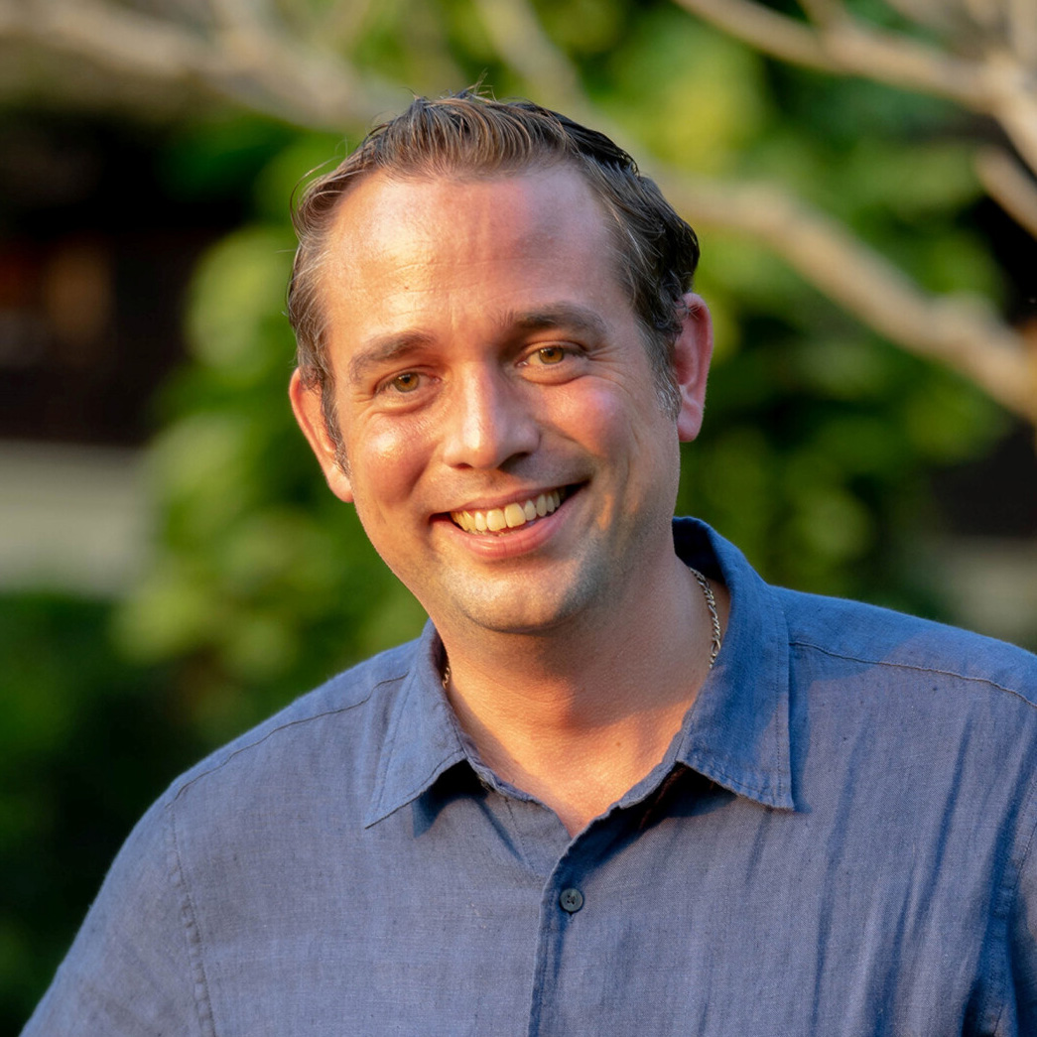 | January 6, 2023, Chiang Mai, Thailand  Four Seasons Resort Chiang Mai Appoints Anthony Tschudin as Resort Manager  https://publish.url/chiangmai/hotel-news/2023/new-resort-manager-anthony-tschudin.html
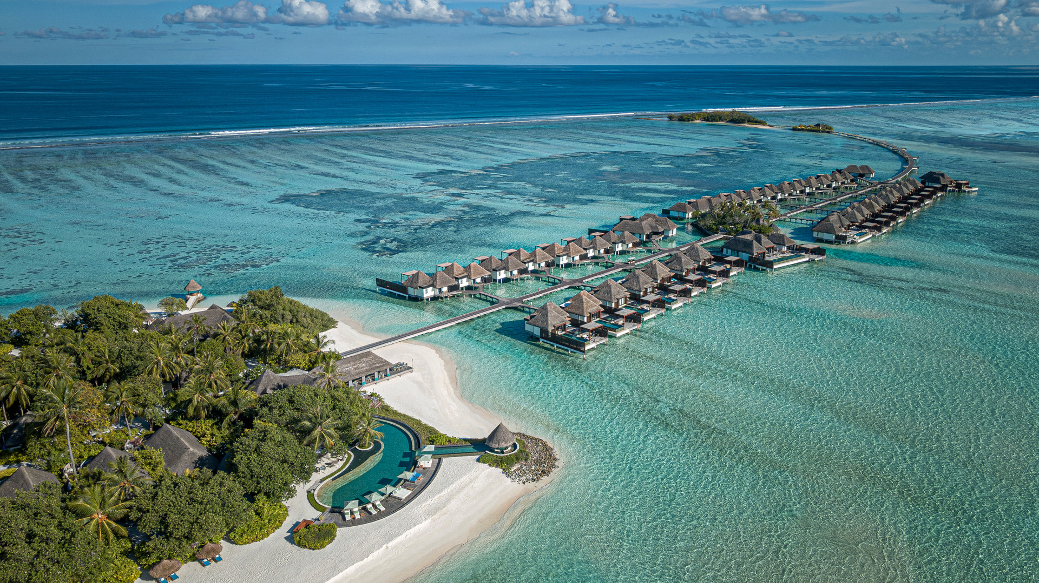 | December 20, 2022, Maldives at Kuda Huraa, Republic of Maldives  Step into Carnivaland This Festive Season at Four Seasons Resort Maldives at Kuda Huraa  https://publish.url/maldiveskh/hotel-news/2022/festive-season.html

PRESS CONTACTS

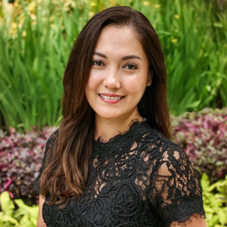 | Cristina Del Carmen  Senior Director of Public Relations and Communications  3/F, 159 Rajadamri Road  Bangkok  Thailand  cristina.delcarmen@fourseasons.com  +66 2207 8916
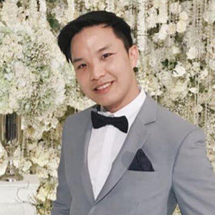 | Paponpat Sapsuwan  Assistant Public Relations Manager  3/F, 159 Rajadamri Road  Bangkok  Thailand  paponpat.sapsuwan@fourseasons.com  +66 02 207 8917
Waratah Jongsaeng
Assistant Manager – Digital Marketing
3/F, 159 Rajadamri Road
Bangkok
Thailand
waratah.jongsaeng@fourseasons.com

+66 2207 8918

