Four Seasons Resort Lāna‘i Launches Love Lāna‘i Cultural Exchange Program

Speaker series debuts with physics of pō
July 18, 2022, Hawaii, Lanai, U.S.A.

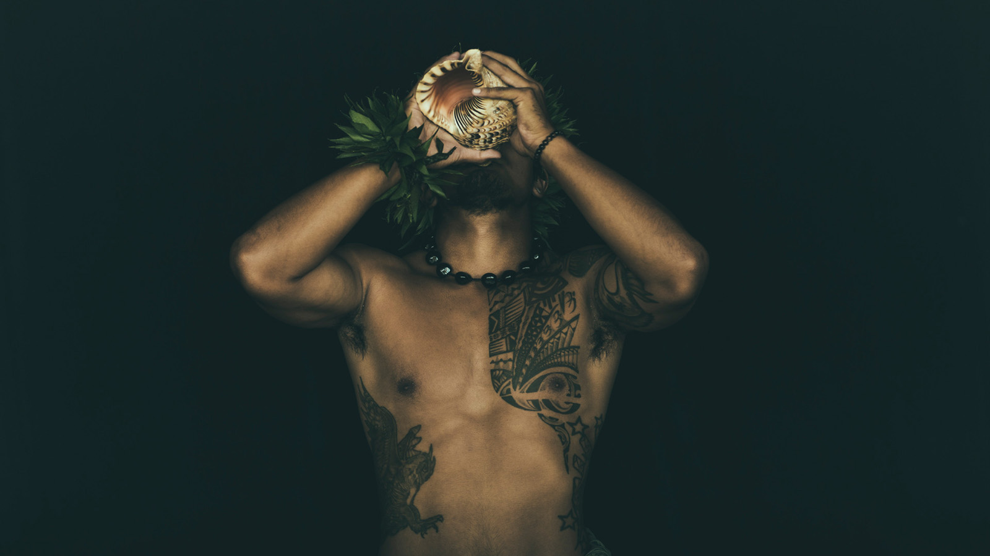
Love Lāna‘i is honoured to partner with scientists, practitioners and academics to share their knowledge and expertise of Hawaiian language and culture with guests in a new speaker series. The Love Lāna‘i Cultural Exchange Program’s inaugural event will take place August 26 and 27, 2022 at 7:30 pm in the Hulopo'e Ballroom at Four Seasons Resort Lāna‘i.
The Resort will host a special evening presentation by Larry Kimura, Associate Professor, Hawaiian Language & Hawaiian Studies and Doug Simons, Executive Director, Canada-France-Hawaii Telescope.
The speakers will share their insights on the first 11 lines of the Kumulipo, incorporating Hawaiian cultural perspectives and astronomy theories on the origins of the universe. The Kumulipo is an approximately 2,000-line Hawaiian genealogical chant that was written in circa 1690 for the birth of a prominent chief of Hawai’i Island. It describes the formation of the universe and precedes an extensive description of the evolution of life forms on Earth through to the establishment of the first humans. The term pō appears more than 100 times in the chant. Understanding pō, a vast region of dark empty space from which everything emerged long ago, is essential to understanding Hawaiian cosmology and gaining a deeper understanding of world views and knowledge systems.
The event is open to Resort guests, Island Club and Lāna‘i residents with reservations. Attendees can click here or phone 808 565 2822 to reserve. Visit the online calendar for Hawaiian crafts and culture sessions and excursions with the Resort’s Love Lanai Cultural Advisors. The event will also be livestreamed and recorded; check the Resort’s Facebook page for details.
Four Seasons Resorts Lāna‘i is committed to caring for the land and understanding, preserving, and sharing the island’s culture, traditions and history throughout its operations. Conserving energy and precious natural resources, developing strategic partnerships, implementing sustainable practices and engaging colleagues in education and stewardship allow the two resorts to respect and care for its island home. Through Love Lāna‘i guests can experience the island’s unique living environment and cultural-historical legacy that spans nearly 1,000 years of Hawaiian residency and a diverse cultural heritage though a variety of tours, demonstrations, and cultural experiences through unique, authentic and respectful programming.

RELATED

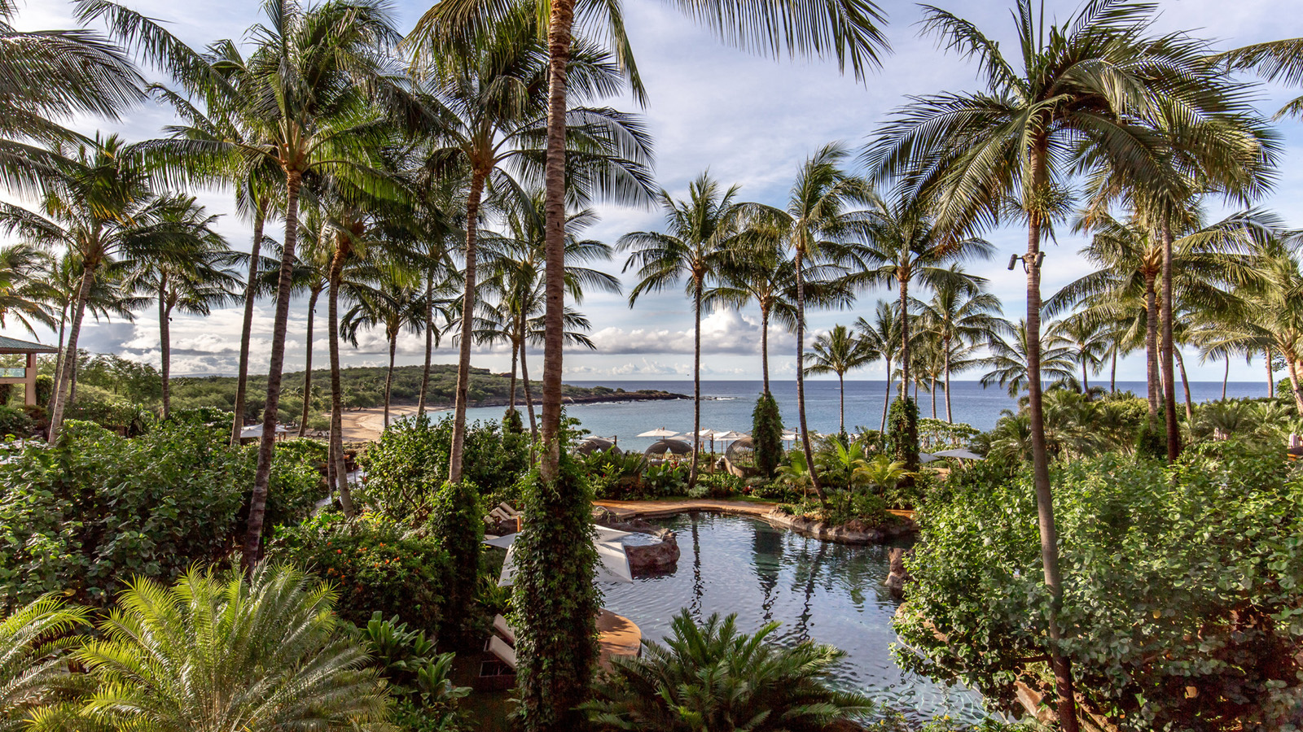 | July 14, 2022, Hawaii, Lanai, U.S.A.  Stay Longer at Four Seasons Resort Lanai with Complimentary 4th Night  https://publish.url/lanai/hotel-news/2022/4th-night-free-offer.html
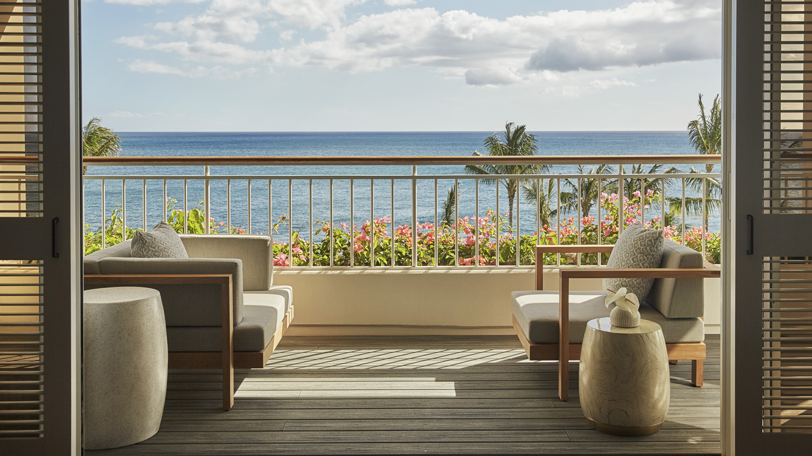 | July 11, 2022, Hawaii, Oahu, U.S.A.  Discover Vacation Zen with Exclusive, On-Demand In-Room Meditation Classes at Four Seasons Resort Oahu  https://publish.url/oahu/hotel-news/2022/in-room-meditation-series.html

PRESS CONTACTS

Lori Holland
Senior Director of Public Relations
6100 Center Drive, Suite 1250
Los Angeles
USA
lori.holland@fourseasons.com

+1 201 294 7810

Anna Peirano
Digital Marketing Manager

Lanai
USA
anna.peirano@fourseasons.com

+1 808 649 8970

