Celebrate Summertime in the Clouds at Four Seasons Hotel Guangzhou with Signature Offerings

May 10, 2021, Guangzhou, China

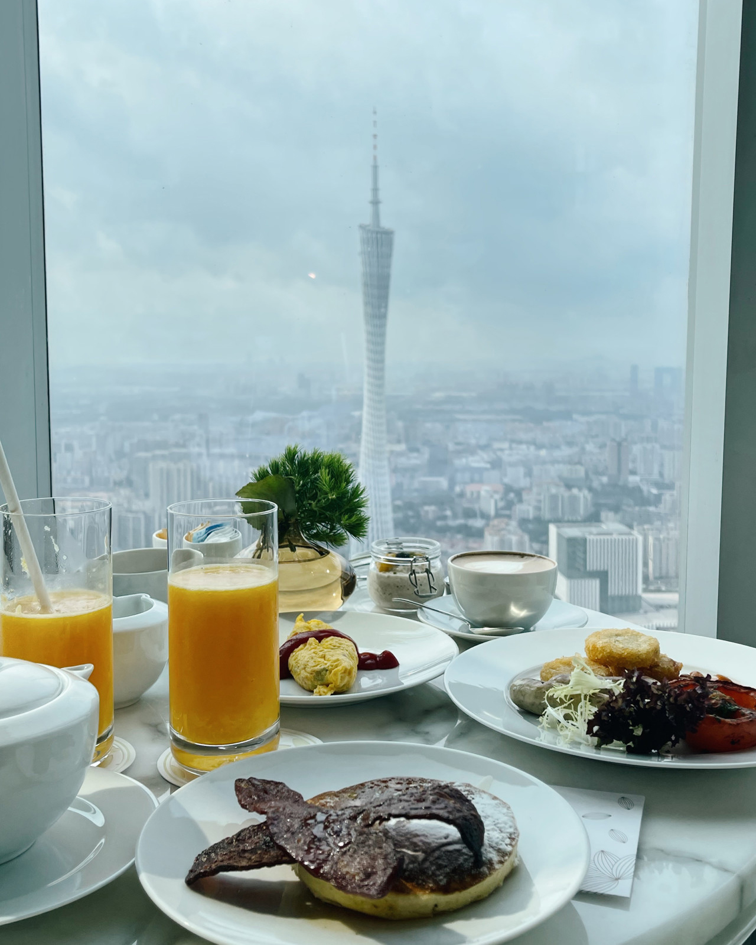
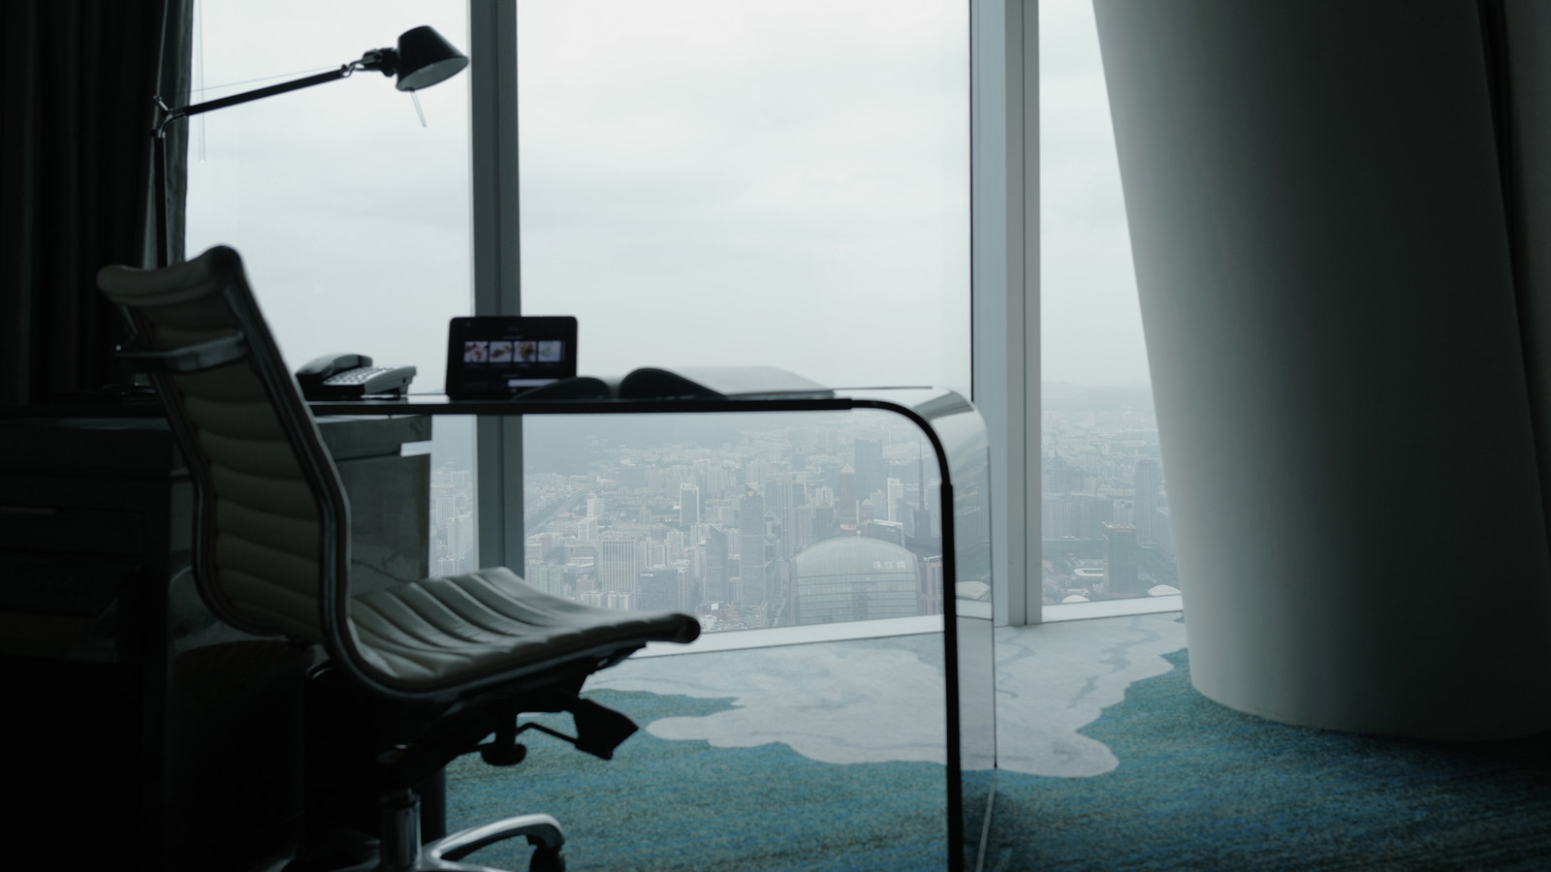 |  | 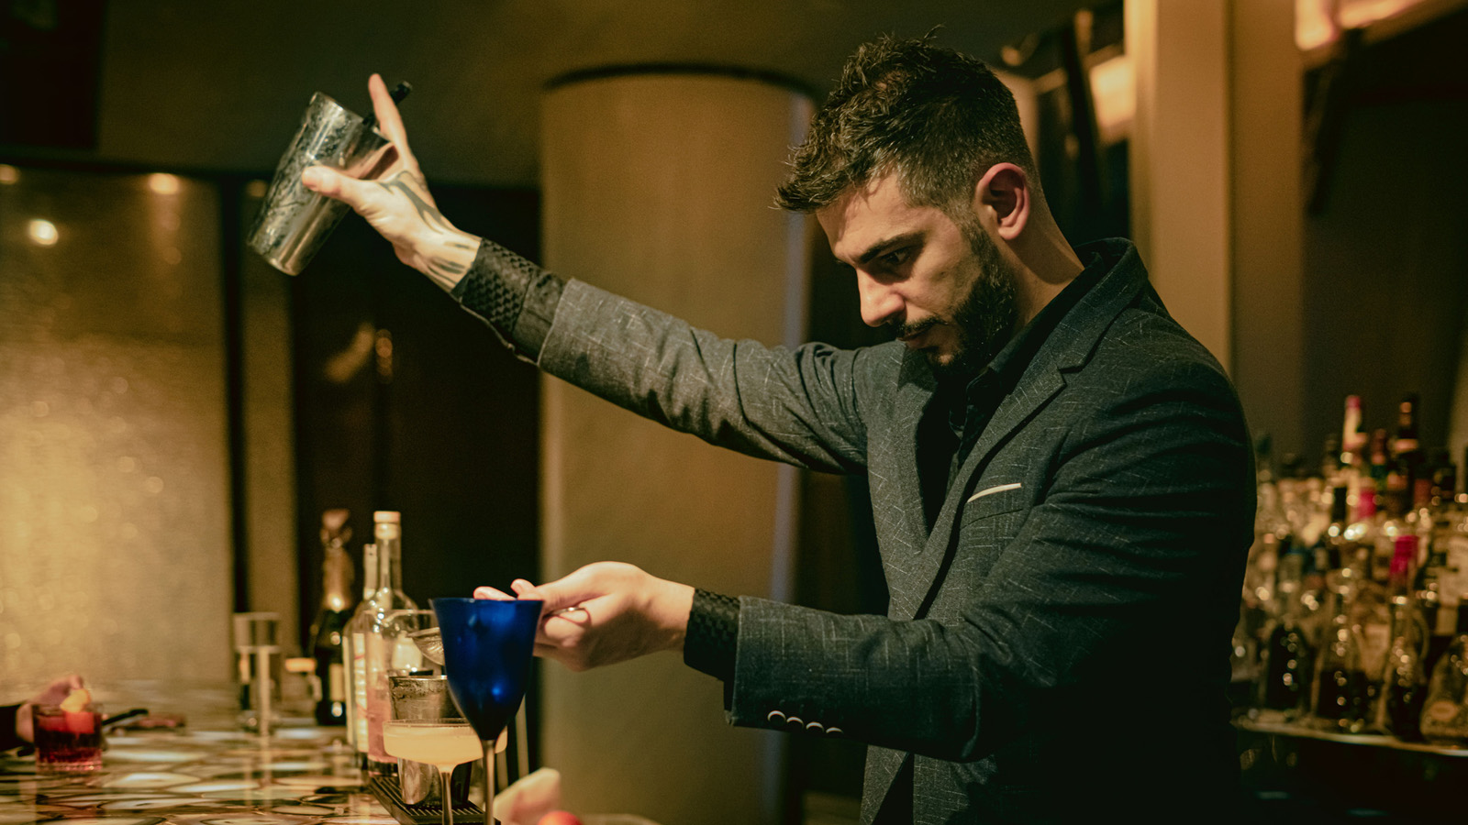
Four Seasons Hotel Guangzhou welcomes the city’s hottest season with multiple offerings including asStaycation combined with an art tour, sky-high gastronomy and personal wellness activities.
Art Staycation
Craving an "art fix"? Four Seasons Hotel Guangzhou invites guests to a specially curated package that includes an excursion to the recently opened He Art Museum, to enjoy the world-class Tadao Ando designed museum in Foshan. The package starts from CNY 2,000 for a Tower King room, with the following inclusions:
- One-night stay in a Tower King Room, with spectacular city views, including two breakfasts at Caffe Mondo
- Two tickets with the fast-track pass to the He Art Museum
- A complimentary artists' memento from the souvenir shop at The Museum
In addition, in-house guests are invited to a personalised ART OF LIVING TOUR featuring highlights of the Hotel’s art collection. Four Seasons Hotel Guangzhou presents a collection of more than 1,000 pieces of art – from classic to contemporary – throughout the Hotel. The Hotel concierge team will share the artists' inspiration and background of a selection of the major pieces.
ART OF LIVING TOUR 9:30-10:30 am daily
The tour guide will be waiting for guests in the centre of the Hotel Lobby on the 70th floor. This tour is only available for in-house Hotel guests. One day advance reservations are required.
Michelin Star Dining Experience Canton style
Yu Yue Heen Michelin starred Chinese restaurant not only features one of the most amazing views of the city’s skyline, but also offers among the best Cantonese cuisine in Guangzhou. Enjoy a leisurely dim sum lunch curated by Chef Mai Zhi Xiong- gourmands cannot miss the new selection of dim sum including baked oatmeal buns with rosemary, egg yolk cakes with pistachio nuts, and a choice of signature Cantonese barbecued dishes and delectable fresh seafood.
Land and Sea in the Sky
Framed by views of the city’s skyline and Canton Tower, Catch Restaurant, which is located on the 100th floor of the Hotel, is the ideal venue for anniversaries, birthdays, marriage proposals or any special celebration. Chef de Cuisine Jeffrey Zeng combines French techniques with seasonal meat, game, fish and seafood. Chef Jeffrey has just introduced a new degustation menu featuring seasonal fresh ingredients. Also on offer, a selection of handpicked wines from the world’s best regions.
- CNY 888 per person 5 courses and CNY 1,288 per person with wine pairing
- CNY 1, 088 per person 7 courses and CNY 1,588 per person with wine pairing
- Tuesday to Saturday, 6:00 to 10:00 pm
Mixology with Antonio at Tian Bar
Guests are invited to experience mixology with Antonio De Luca, the Head Bartender of Tian Bar. One doesn't have to be a professional to create cocktails - be a mixologist with tips, tricks and techniques from Antonio, while taking in the intoxicating views from Tian Bar. Meanwhile, in collaboration with Hope and Sesame – #15 of the Asia's 50 Best Bars list – Tian Bar has created the flower-centric cocktail menu 2.0, taking guests on a multi-sensory journey of fusion flavours and visual indulgence, which heightens the cocktail experience.
- Cocktail Making Session: CNY 188, drink to one's heart’s content, from a bespoke menu; every Tuesday to Friday, 5:00–7:00 pm
*All prices above are in CNY and subject to 15 percent service charge (applicable government tax included)
Revival, Health and Wellness
Relax and rejuvenate at the Hotel Spa. Enjoy an afternoon enjoying the panoramic indoor infinity pool and fitness centre and then discover the Hotel's tailored health and wellness programs. The program ranges from private stretching sessions, stress relief and mindfulness exercises, boxing courses, singing bowl sound therapy, and a series of body shaping fitting training programs.
- Stress Relief Classes starting from CNY 1,080 per clas,s which includes a fresh salad; Star Trainers one-on-one tailor-made fitness classes from CNY 800 per class. 48 hours advanced booking is required.

RELATED

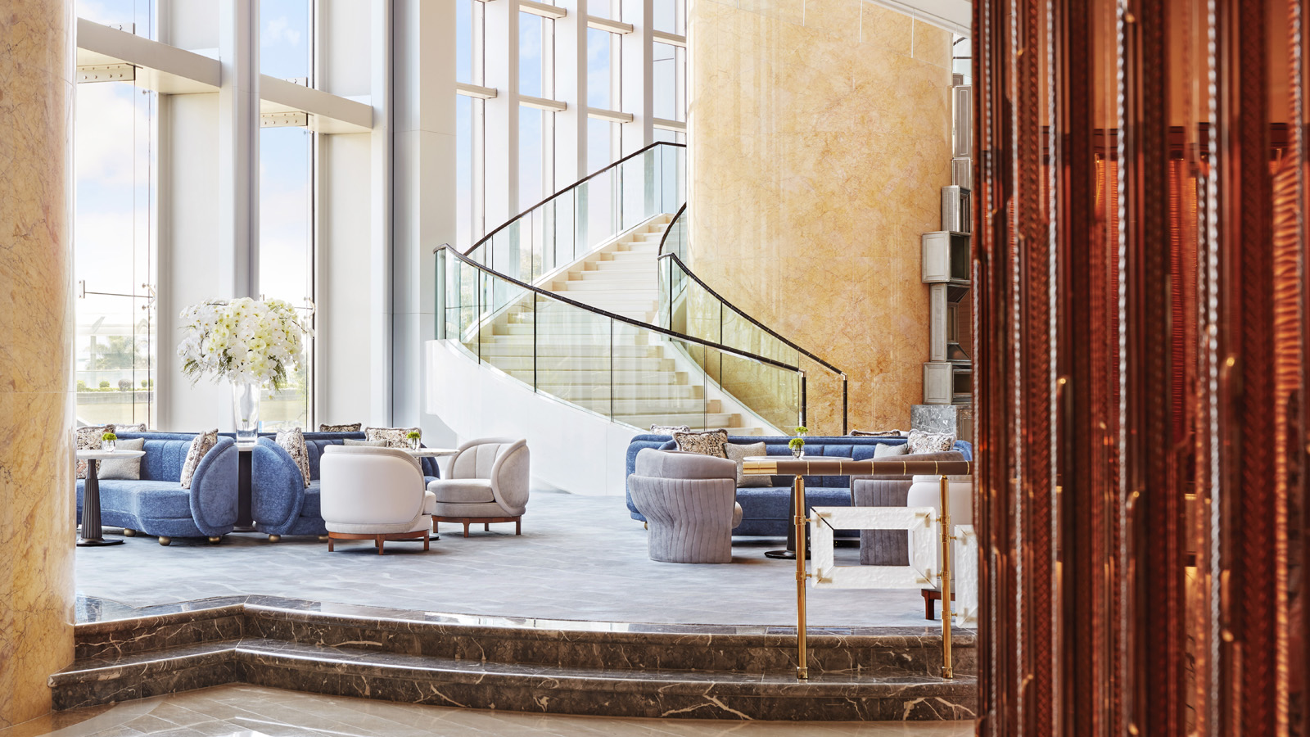 | May 6, 2021, Hong Kong, China  香港四季酒店完成首階段翻新計劃 展現大堂、客房及套房全新面貌，帶來煥然一新的到訪體驗  https://publish.url/zh_hant/hongkong/hotel-news/2021/renovated-lobby-guest-rooms-suites-2.html
May 6, 2021, Hong Kong, China
Four Seasons Hotel Hong Kong Completes First Phase of Hotel Transformation, Revealing a New Arrival Experience and Reimagined Guest Rooms and Suites
https://publish.url/hongkong/hotel-news/2021/renovated-lobby-guest-rooms-suites.html

PRESS CONTACTS

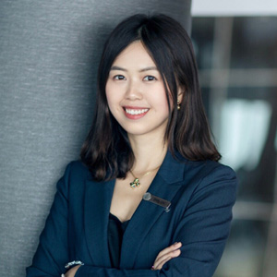 | Ditty Liu  Director of Public Relations  5 Zhujiang West Road, Pearl River New City, Tianhe District  Guangzhou  China  ditty.liu@fourseasons.com  86 (20) 8883-3901

