Tranquilo Golf Club at Four Seasons Resort Orlando Welcomes PGA TOUR Champions Stars in Challenge Season Event

The Diamond Resorts Invitational, January 13-15, to benefit Florida Hospital for Children
December 19, 2016, Orlando at Walt Disney World Resort, U.S.A.

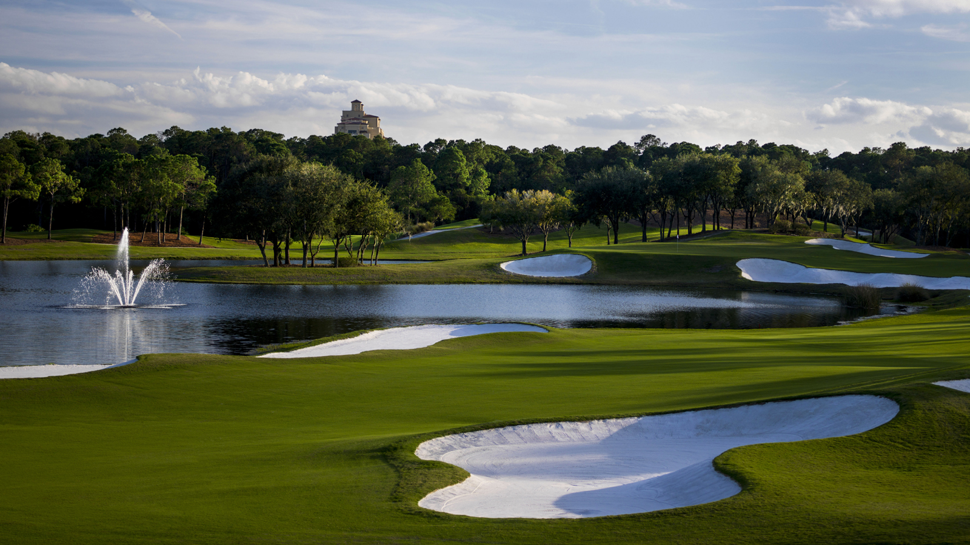
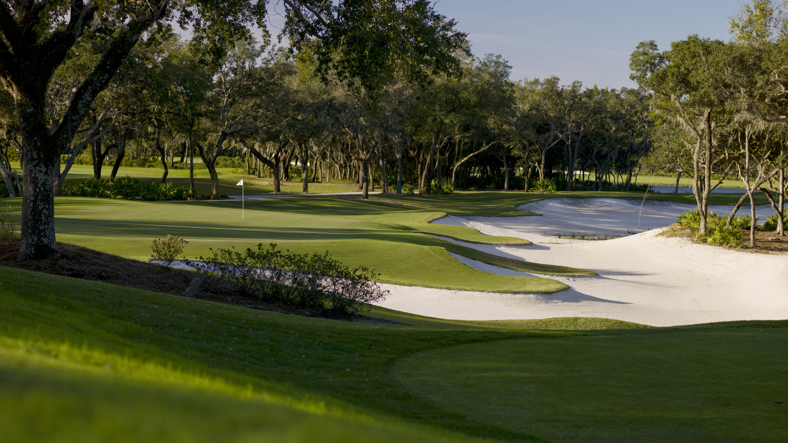 | 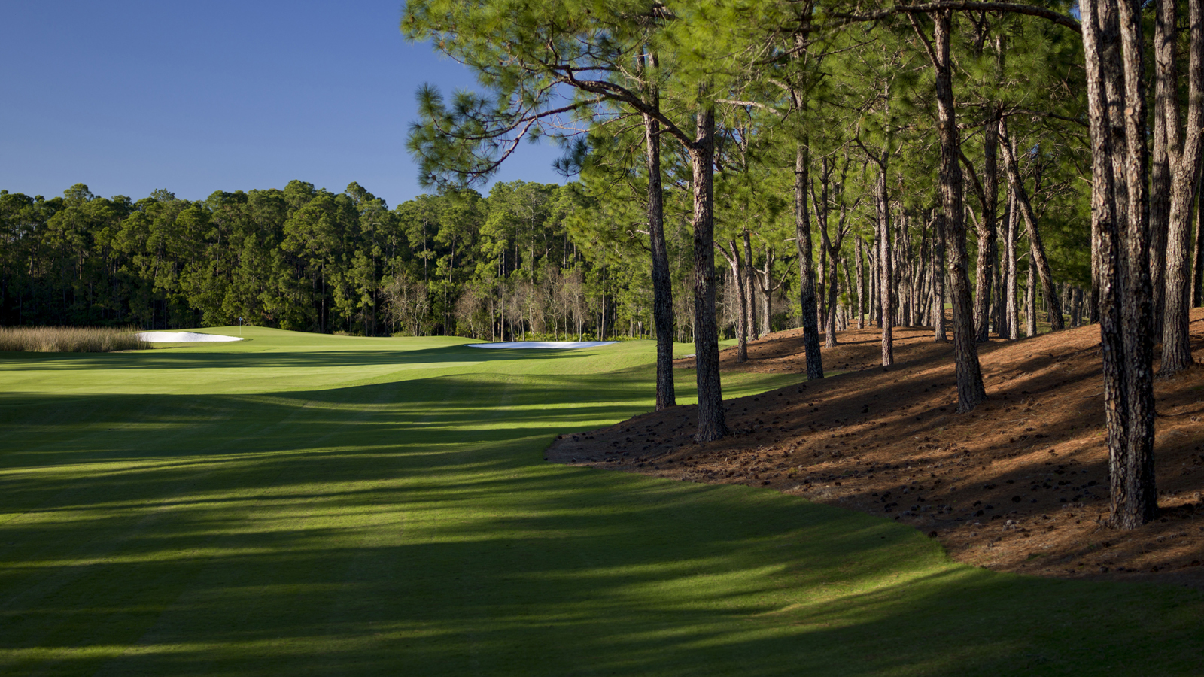 | 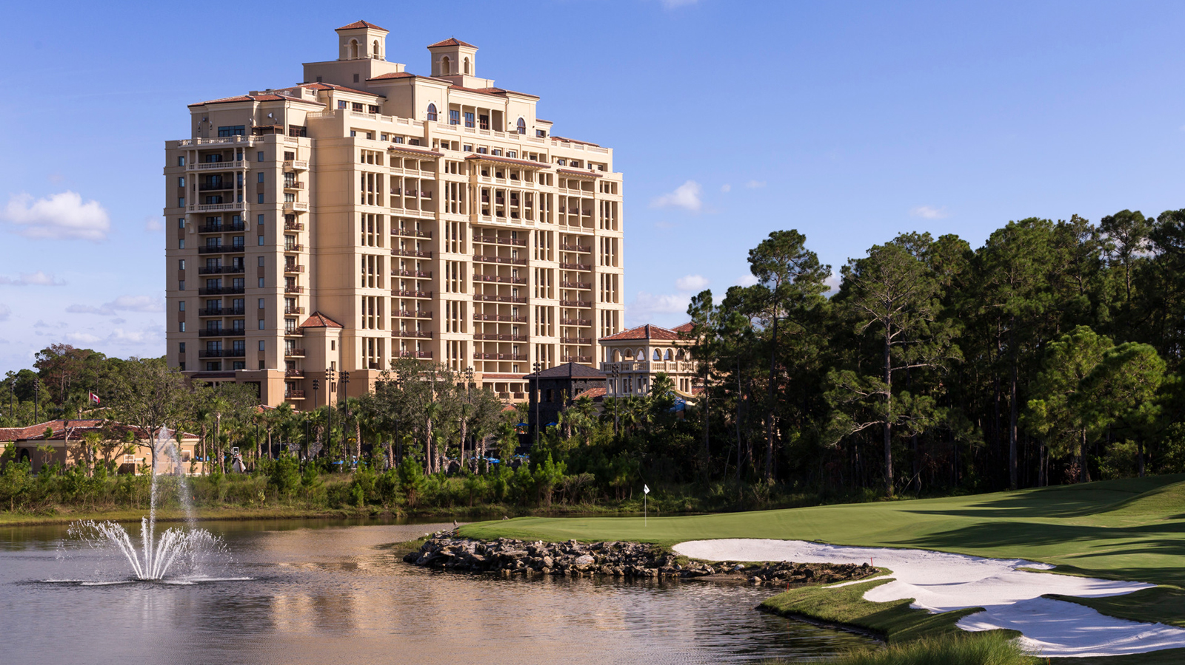
Tranquilo Golf Club, located at
Four Seasons
Resort Orlando at Walt Disney World Resort, is pleased to be the host venue for the 2nd annual Diamond Resorts Invitational benefitting Florida Hospital for Children and taking place January 13-15, 2017. The three-day tournament will be nationally televised on Golf Channel.
The event brings together up to 27 PGA TOUR Champions players, three LPGA players, and 50 celebrities from the sports and entertainment industry to compete side-by-side for purses totaling USD 1.25 million. PGA TOUR Champions players will compete for USD 750,000 over the 54-hole tournament, while celebrities will play for a USD 500,000 purse. The tournament will utilise a Modified Stableford scoring format, which awards points as opposed to strokes, encouraging players to make the most out of every hole and creating a heightened sense of anticipation for fans.
“We are thrilled to have the opportunity to host the Diamond Resorts Invitational and to welcome this world-class tournament to Tranquilo Golf Club,” said Thomas Steinhauer, Regional Vice President and General Manager of
Four Seasons
Resort Orlando. “It is a distinct honour to take part in an event that will benefit Florida Hospital for Children and leave a lasting charitable impact in our community.”
Proceeds from the event’s live and silent auction will directly benefit Florida Hospital for Children, one of the nation’s premier children’s hospitals, setting standards for innovation, quality and comprehensive care. The child-centric healing environment designed to keep kids comfortable is complemented by a staff of world-class doctors, specialists, nurses and healthcare professionals utilising advanced technologies, therapies and treatments.
Tranquilo Golf Club
Tranquilo Golf Club at
Four Seasons
Resort Orlando is named to reflect the Spanish revival style of the Resort and pay homage to the Florida landscape, such as the southern live oak trees that are found throughout the course. Originally built in 1992 and designed by Tom Fazio, the golf course was enhanced by Fazio for its October 2014 reopening. Enhancements included creating a completely new hole and renovated bunkers, plus improved visibility and airflow by enhancing the landscape design, in addition to a fully renovated clubhouse. The course is a par 71 and plays to 6,901 yards. Home to abundant wildlife, the course is certified by the Audubon Cooperative Sanctuary program for golf by the National Audubon Society.
“It's very exciting for Tranquilo Golf Club to host this special tournament in its second year and to be put in the national spotlight on the Golf Channel," said Charlie Kent, Director of Golf at
Four Seasons
Resort Orlando. "Our team has been working hard over the past few months to ensure the course is in impeccable condition for this main event. We could not be more thrilled to work with Diamond Resorts International and their team on this amazing tournament."
"This combination of PGA TOUR Champions and celebrities is the only format of its kind,” said Michael Flaskey, Chief Operating Officer for Diamond Resorts International. “With the calibre of well-known golf professionals and sports and entertainment stars, plus the incredible venue of Tranquilo Golf Club, we hope to capture the public’s imagination.”
The Bobby Jones Golf and Spa Experience Package
For those who wish to enjoy all that
Four Seasons
Resort Orlando has to offer, the Bobby Jones Golf and Spa experience package includes a daily USD 100 Resort credit toward either a golf lesson, round of 18 holes of golf at Tranquilo Golf Club, or a treatment at The Spa; a USD 100 one-time credit toward a Bobby Jones purchase from the Golf Shop, plus a deluxe coffee table book, The Legend of Bobby Jones: The Greatest of Them All. To learn more about the package, click here.
Continuing the support for the hospital, for the month of January 2017, each of the Resort’s restaurants will donate a portion of dining proceeds to the hospital when patrons mention Florida Hospital for Children. A portion of revenue will also be donated for treatments experienced at The Spa, tennis lessons, golf lessons or rounds of golf, as well as retail purchases at the Resort’s boutiques, simply when the patron references “Florida Hospital” upon booking or purchase. For reservations or tee times, call 4073138090.
One-day and three-day grounds passes for the Diamond Resorts Invitational are on sale now through January 15, 2017 and can be purchased online.

RELATED

March 27, 2017, Orlando at Walt Disney World Resort, U.S.A.
Experience the Ultimate Summer Vacation at Four Seasons Resort Orlando
http://publish.url/orlando/hotel-news/2017/summer-vacation.html

March 27, 2017, Orlando at Walt Disney World Resort, U.S.A.
Férias com ofertas especiais no Four Seasons Resort Orlando
http://publish.url/br/orlando/hotel-news/2017/summer-vacation-2.html

PRESS CONTACTS

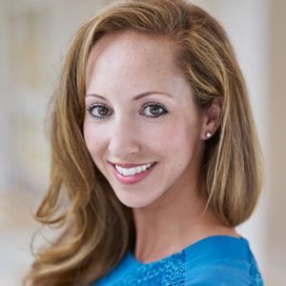 | Dana Berry  Director of Public Relations  10100 Dream Tree Boulevard  Orlando  U.S.A.  dana.berry@fourseasons.com  1 (407) 313-7777

