Four Seasons Resort Lanai Named Five-Star Hotel by Forbes Travel Guide in 2021 Ratings Announcement

Luxurious Hawaiian resort earns prestigious award
February 16, 2021, Hawaii, Lanai, U.S.A.

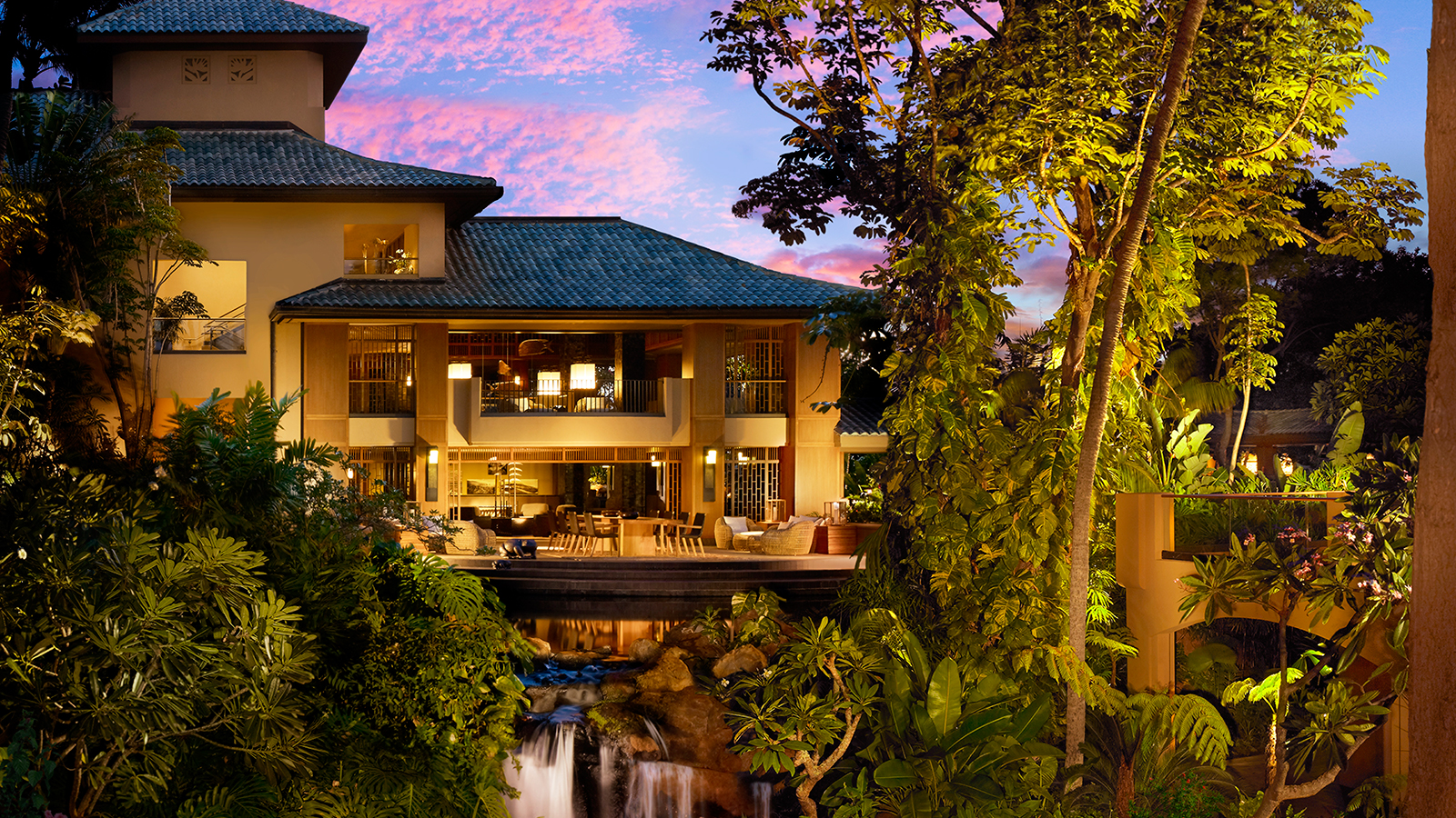
Forbes Travel Guide unveiled its annual Star Rating list, recognising Four Seasons Resort Lanai as a Forbes Travel Guide Five Star hotel, the Guide’s highest rating. The luxury resort offers a sophisticated sanctuary on a secluded Hawaiian island paradise.
“On behalf of all our colleagues, it is with great pleasure to receive this award and be recognised within this exclusive group of luxury hotels and resorts. While this is a challenging and uncertain time in our industry, we know that our guests will always experience the warm service and aloha spirit each and every one our colleagues shares with all our guests here on Lanai,” says Alastair McAlpine, Resort General Manager.
The Resort features 213 guest rooms in a series of low-rise buildings spread along the Pacific coastline, providing a private residential experience. Numerous restaurants, including NOBU LANAI - awarded Four Stars by Forbes; a spa and wellness program; beach and pool with spacious seating areas nestled among tropical gardens; a variety of complimentary activities and cultural programming; luxury retail boutique; Jack Nicklaus Signature Manele Golf Course; tennis; and land, sea and air small group and private experiences ensure an exclusive island adventure for guests.

RELATED

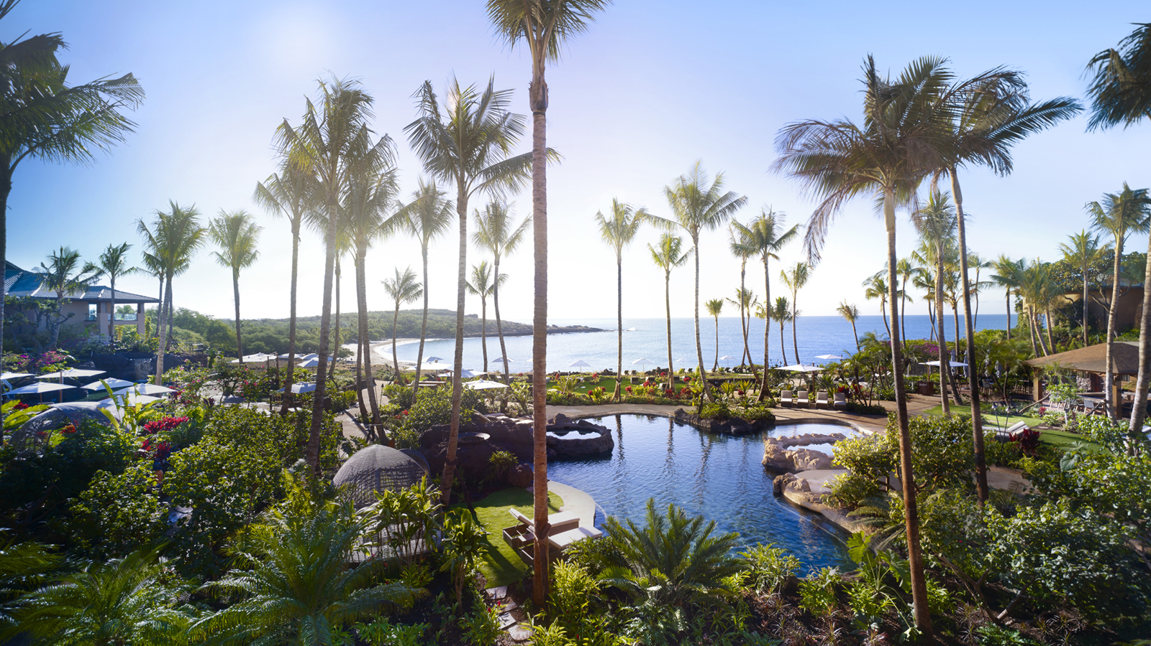 | February 2, 2021, Hawaii, Lanai, U.S.A.  Four Seasons Resort Lanai Recognised as #1 Hotel in the United States  https://publish.url/lanai/hotel-news/2021/best-hotel-in-usa.html
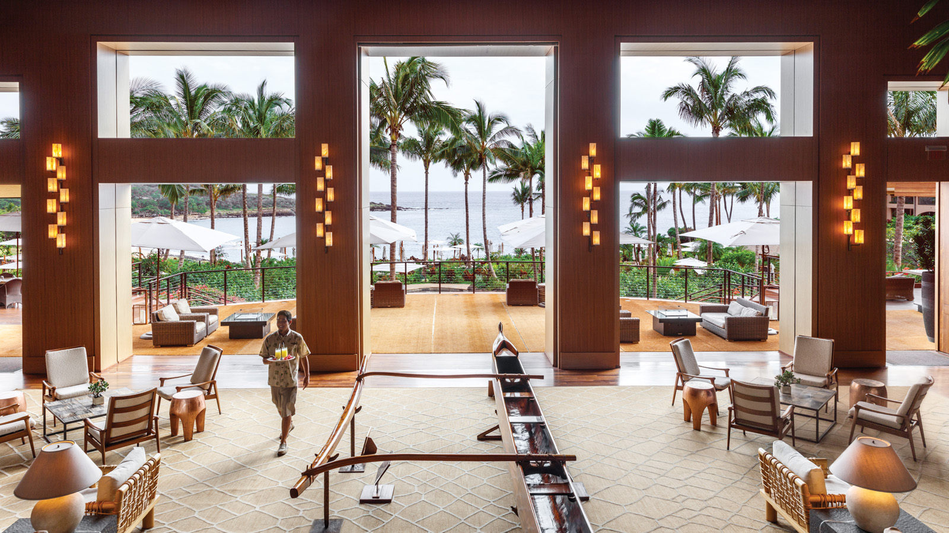 | January 25, 2021, Hawaii, Lanai, U.S.A.  Luxury Charter Flights to Four Seasons Resorts Lanai from Honolulu Included for the Perfect Island Escape  https://publish.url/lanai/hotel-news/2021/honolulu-lanai-air-transfers-included.html

PRESS CONTACTS

Lori Holland
Director of Public Relations
6100 Center Drive, Suite 1250
Los Angeles
U.S.A.
lori.holland@fourseasons.com

+1 (201) 294-7810

Olivia Kragen
Digital Marketing Manager
6100 Center Drive, Suite 1250
Los Angeles
U.S.A.
olivia.kragen@fourseasons.com

+1 (310) 695-3385

