For the Coffee Connoisseur

October 13, 2015, Orlando at Walt Disney World Resort, U.S.A.

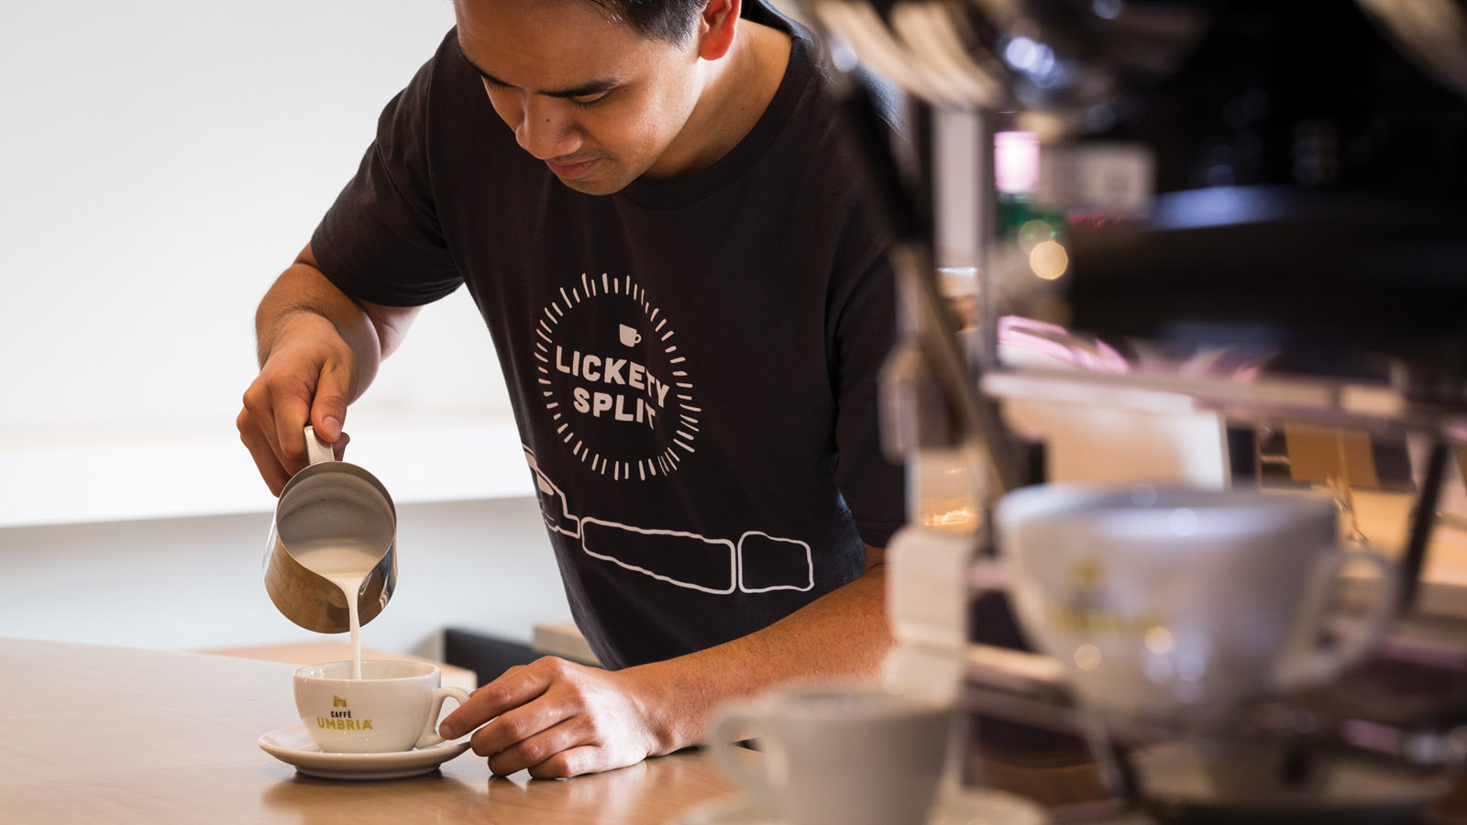
Guests rave about the coffee options offered at Lickety Split, the lobby level coffee shop at
Four Seasons
Resort Orlando.
Truly an innovator among Central Florida coffee shops, Lickety Split features techniques and equipment unique to Orlando. Serving Caffe Umbria coffee, a third generation Italian coffee roaster based out of Seattle, Washington, and offering six different blends and four different brew styles, Lickety Split baristas are able to customise the coffee experience.
Ask about the custom 8-hour cold brew coffee, with a slow-drip over ice that changes the flavour profile of an iced coffee -- making it richer and more complex-- than is typically made by pouring hot coffee over ice.

RELATED

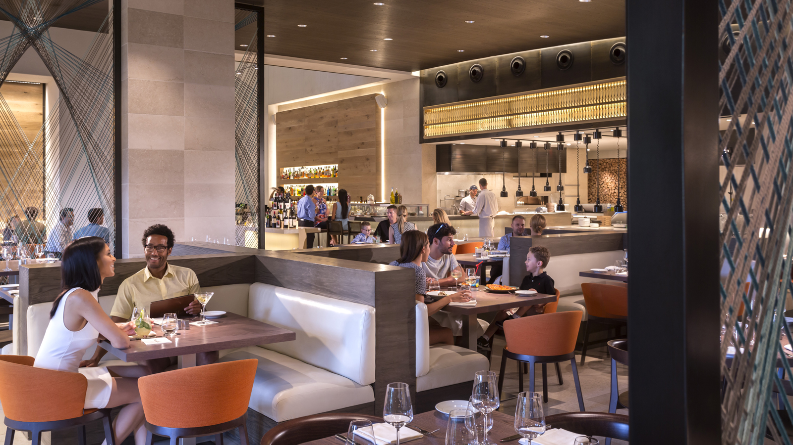 | July 20, 2017, Orlando at Walt Disney World Resort, U.S.A.  Ravello at Four Seasons Resort Orlando Announces Magical Dining Menu  http://publish.url/orlando/hotel-news/2017/magical-dining-menu.html
June 29, 2017, Orlando at Walt Disney World Resort, U.S.A.
Escape for the Day with the new “Daycation Experience” at Four Seasons Resort Orlando
http://publish.url/orlando/hotel-news/2017/daycation-experience.html

PRESS CONTACTS

Dana Berry
Director of Public Relations
10100 Dream Tree Boulevard
Orlando
U.S.A.
dana.berry@fourseasons.com

1 (407) 313-7777

