Four Seasons Hotel Hong Kong Celebrates 2020 Mid-Autumn Festival with New and Classic Mooncake Flavours

Special offers available on Eshop
June 24, 2020, Hong Kong, China

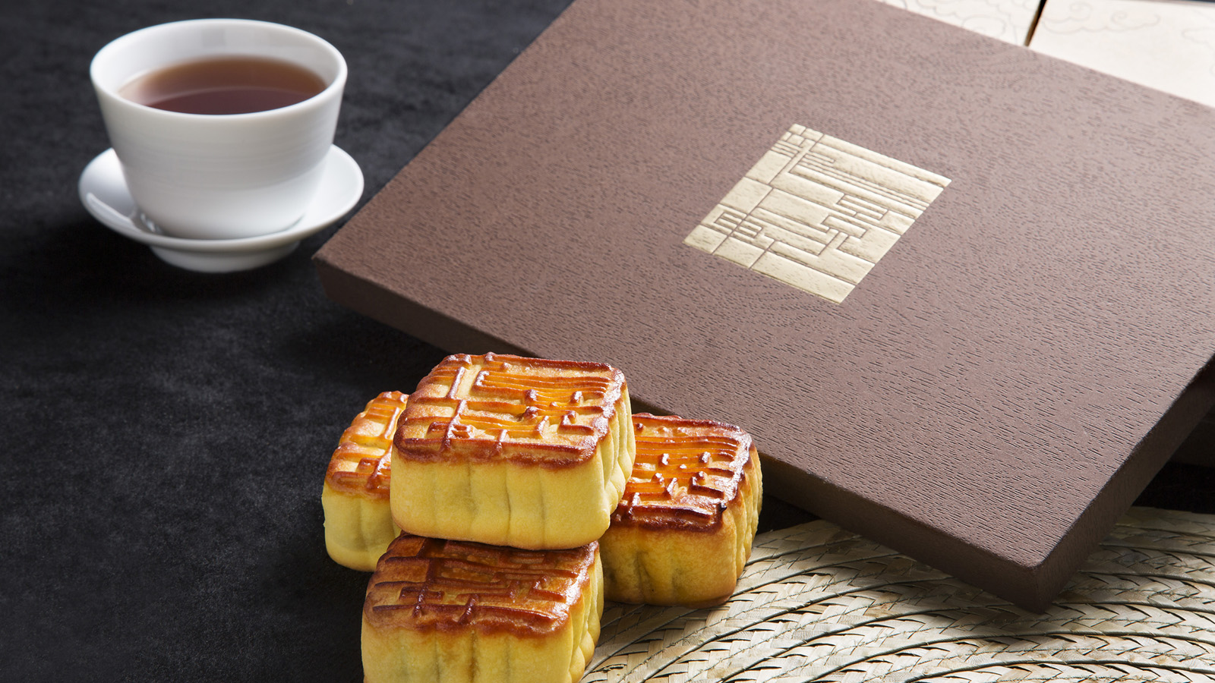
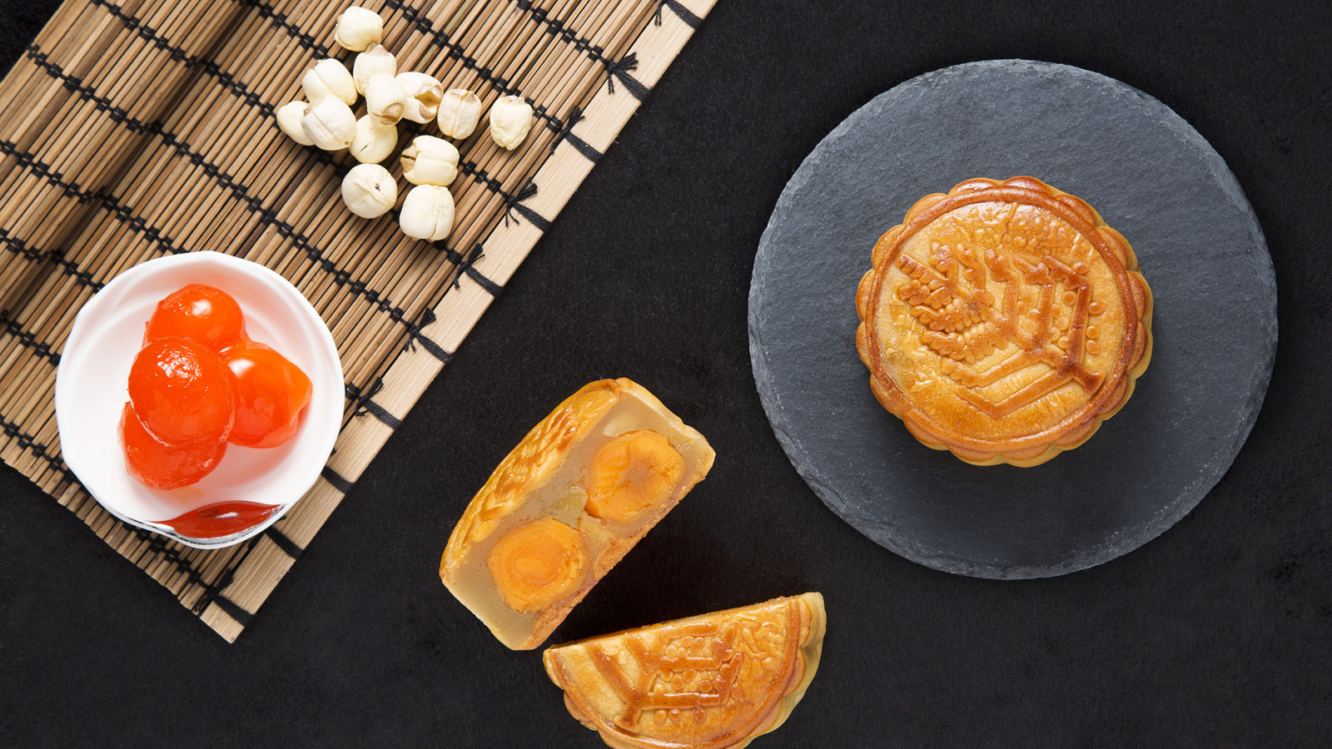 | 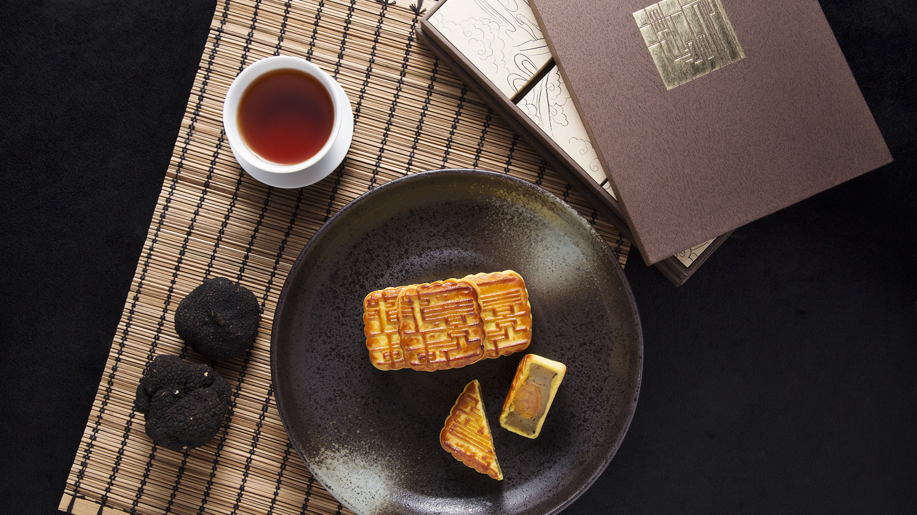 | 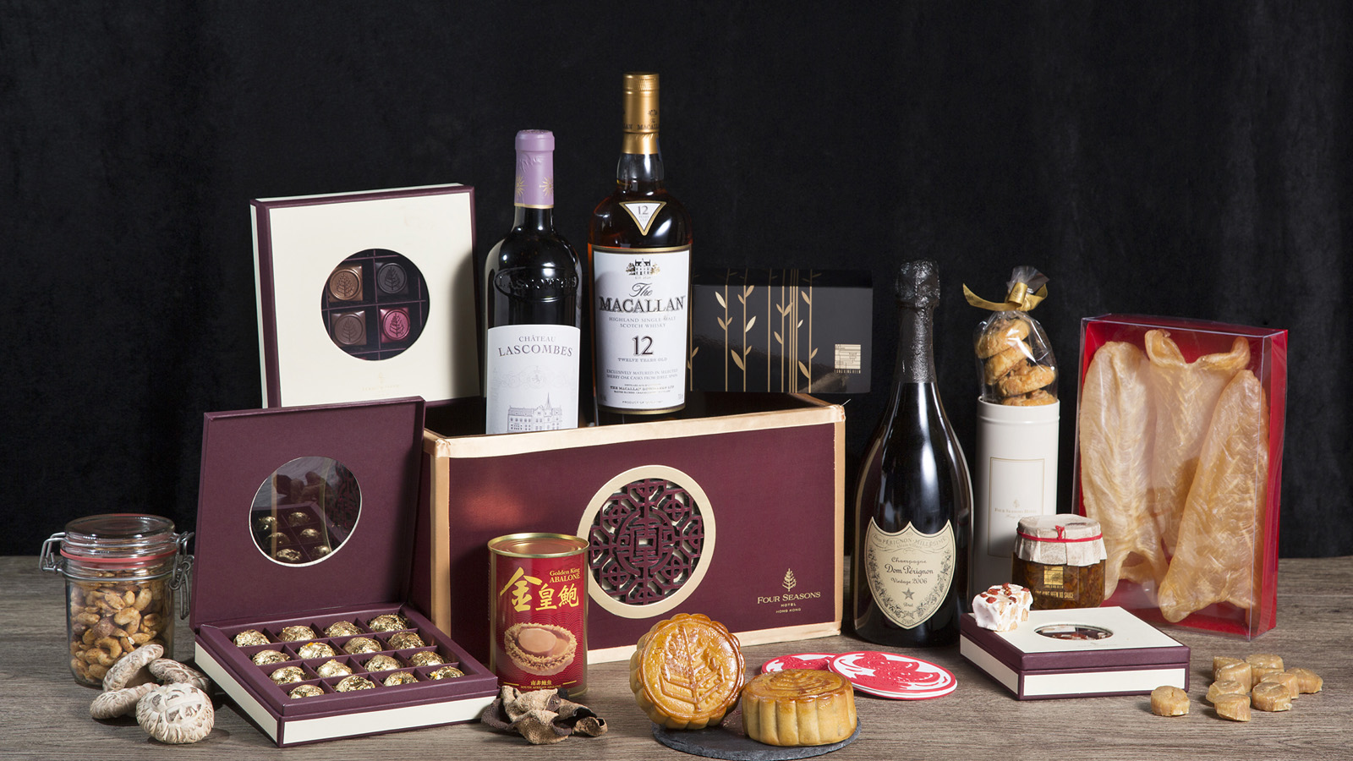
Celebrate the annual Mid-Autumn Festival tradition with Four Seasons Hotel Hong Kong mooncakes and hampers, featuring handcrafted mooncakes from three Michelin starred Chinese restaurant Lung King Heen as well as Four Seasons traditional flavours. Enjoyed every year, these festive favourites make thoughtful gifts for family, loved ones and business associates. Purchase on Eshop to enjoy bulk order savings and early bird offers - guests who purchase Lung King Heen mooncakes digitally will receive a special gift.
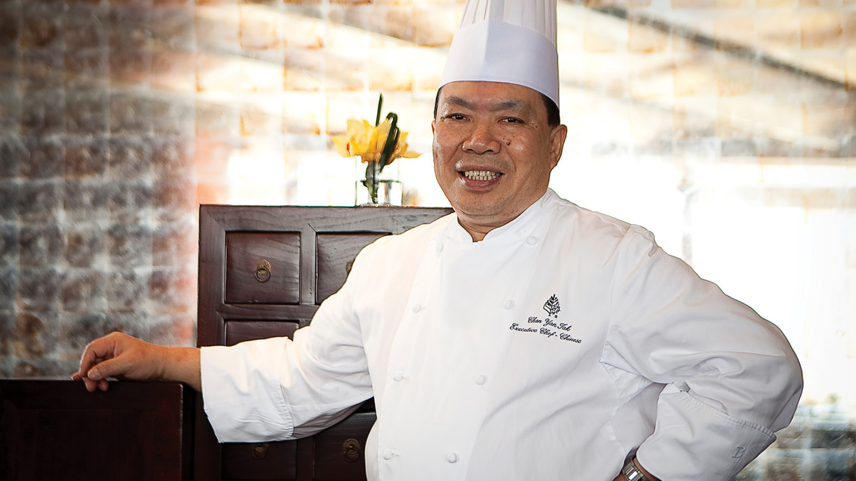 | 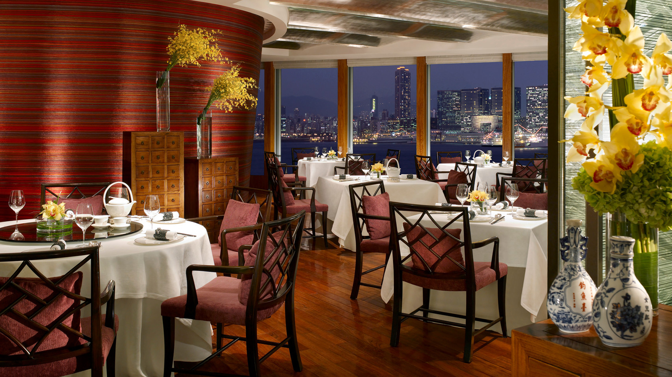
Exquisite Lung King Heen Mooncakes
Chef Chan Yan Tak, Chinese Executive Chef of the Hotel, introduces a new mooncake flavour this year: Chinese Date Mooncakes with Walnuts.
Chef Tak and his team incorporates Chinese dates for their healing and nourishing qualities - they contain multiple essential nutrients and are known for anti-inflammatory and anti-haemorrhagic properties. Chinese dates enhance the mooncake with a chewy texture; they are sweet on the palate with a hint of tartness, yet carries a low caloric load. Walnuts add crunch to the mooncake with its bitterness perfectly balanced out by the sweet and the sour flavours from the dates. This novel flavour is also suitable for lacto-ovo vegetarians.
Purchase the Assorted Signature Mooncake box and enjoy both novel and classic flavours. The gift box includes six mooncakes and three flavours, a perfect treat for those who want the complete experience:
- Lung King Heen Preserved Eggs and Pickled Ginger
- Lung King Heen Chinese Date Mooncakes with Walnuts
- Lung King Heen Lotus Seed Paste Mooncakes with Salted Egg Yolk and Black Truffle
Not to be missed is the Cream Custard with Toasted Pine Nuts mooncake, a sought-after delicacy created by Chef Tak since the Hotel opened.
Lung King Heen mooncakes are handmade by the restaurant chefs and contain no preservatives. The cakes are elegantly presented in a gift box crafted by locally renowned designer Alan Chan.
Lung King Heen Mooncakes Selection (mini sized/6 pieces)
- Lung King Heen Chinese Date Mooncakes with Walnuts – HKD 530
- Lung King Heen Cream Custard Mooncakes with Toasted Pine Nuts - HKD 530
- Lung King Heen Preserved Eggs and Pickled Ginger - HKD 530
- Lung King Heen Lotus Seed Paste Mooncakes with Salted Egg Yolk and Black Truffle - HKD 560
- Lung King Heen Assorted Signature Mooncakes (Pickled Ginger/Chinese Date/ Black Truffle) - HKD 560
Lung King Heen mooncakes are available for sale on Eshop from now until October 1, 2020, while stock lasts. Mooncakes are best enjoyed with a cup of Chinese tea to aid digestion, and guests who purchase online will receive complimentary premier tea leaves from Yú teahouse.
Traditional Favourites
For those who prefer traditional mooncake flavours, the Four Seasons White Lotus Seed Paste Mooncakes with Double Salted Egg Yolk makes the perfect choice.
This year, early bird and bulk purchase benefits are available, making Four Seasons mooncakes a great giveaway for corporate clients.
- Four Seasons White Lotus Seed Paste with Double Salted Egg Yolk (4 pieces) - HKD 518
Early Bird Bulk Purchase Offer (from now to August 16, 2020)
- 20-49 boxes - 25% savings - HKD 388.50 per box
- 50-99 boxes - 30% savings - HKD 362.60 per box
- 100 boxes or above - 35% savings - HKD 336.70 per box
Early Bird Individual Box Offer
- Now until August 16, 2020 - 20% savings
Both offers are exclusive to Four Seasons mooncakes only.
Four Seasons mooncakes are also available to order via Eshop from now until October 1, 2020 until stock lasts.
Mid-Autumn Hampers
As families gather for this celebratory occasion, festive hampers are a great way to express gratitude and love. Four Seasons Hotel Hong Kong offers three hampers that include a variety of Lung King Heen handmade delicacies and all-time favourites from the boutique.
- Lung King Heen Gourmet Hamper - HKD 2,688
- Lung King Heen Deluxe Hamper - HKD 3,688
- Lung King Heen Ultimate Hamper - HKD 10,888
Mooncakes and hampers are now available to order. Four Seasons mooncakes and hampers are available for collection from August 17 to October 1, 2020 and Lung King Heen mooncakes are available for collection from September 17 to October 1, 2020. Pick up and collection will be at the Festive Desk located at The Lobby and it will open from August 17 to October 1, 2020 from 10:00 am to 8:00 pm on Monday to Friday and 10:00 am to 6:00 pm on weekends. For further details, call (852) 3196 8708 or email shop.hkg@fourseasons.com.

RELATED

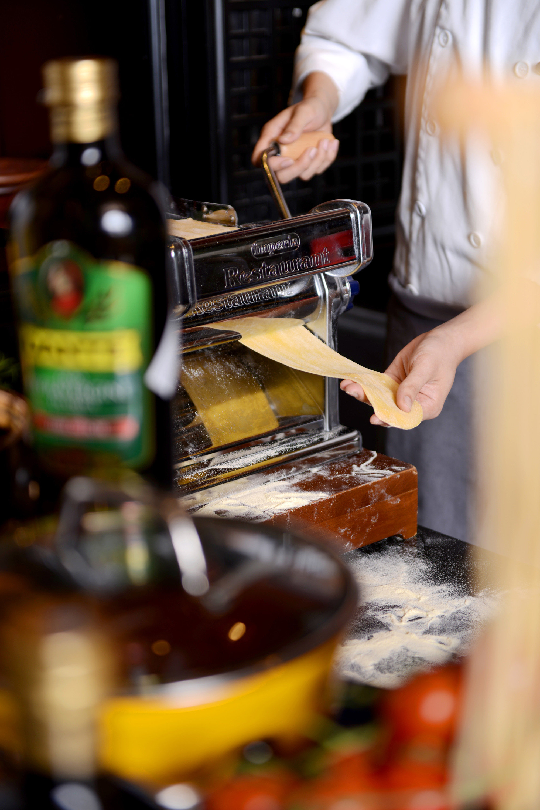 | June 19, 2020, Hangzhou at West Lake, China  杭州西子湖四季酒店西湖餐厅打造耳目一新的意式风味菜单  https://publish.url/zh/hangzhou/hotel-news/2020/new-menu-at-wl-bistro.html
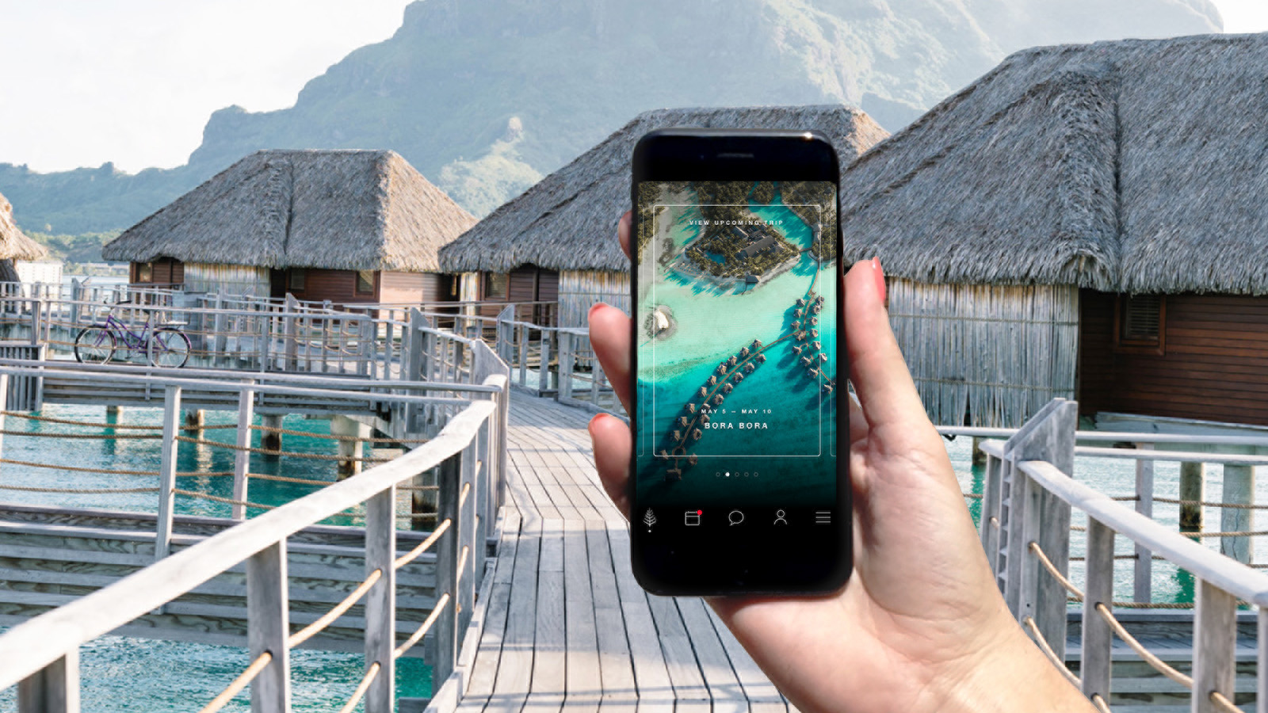 | June 18, 2020, Toronto, Canada  Four Seasons Hotels and Resorts Announces Enhanced Health and Safety Program at Properties Worldwide  https://publish.url/news-releases/2020/lead-with-care-program.html

PRESS CONTACTS

Chu Wong
Director of Public Relations
8 Finance Street, Central
Hong Kong
China
chu.wong@fourseasons.com

(852) 3196 8306

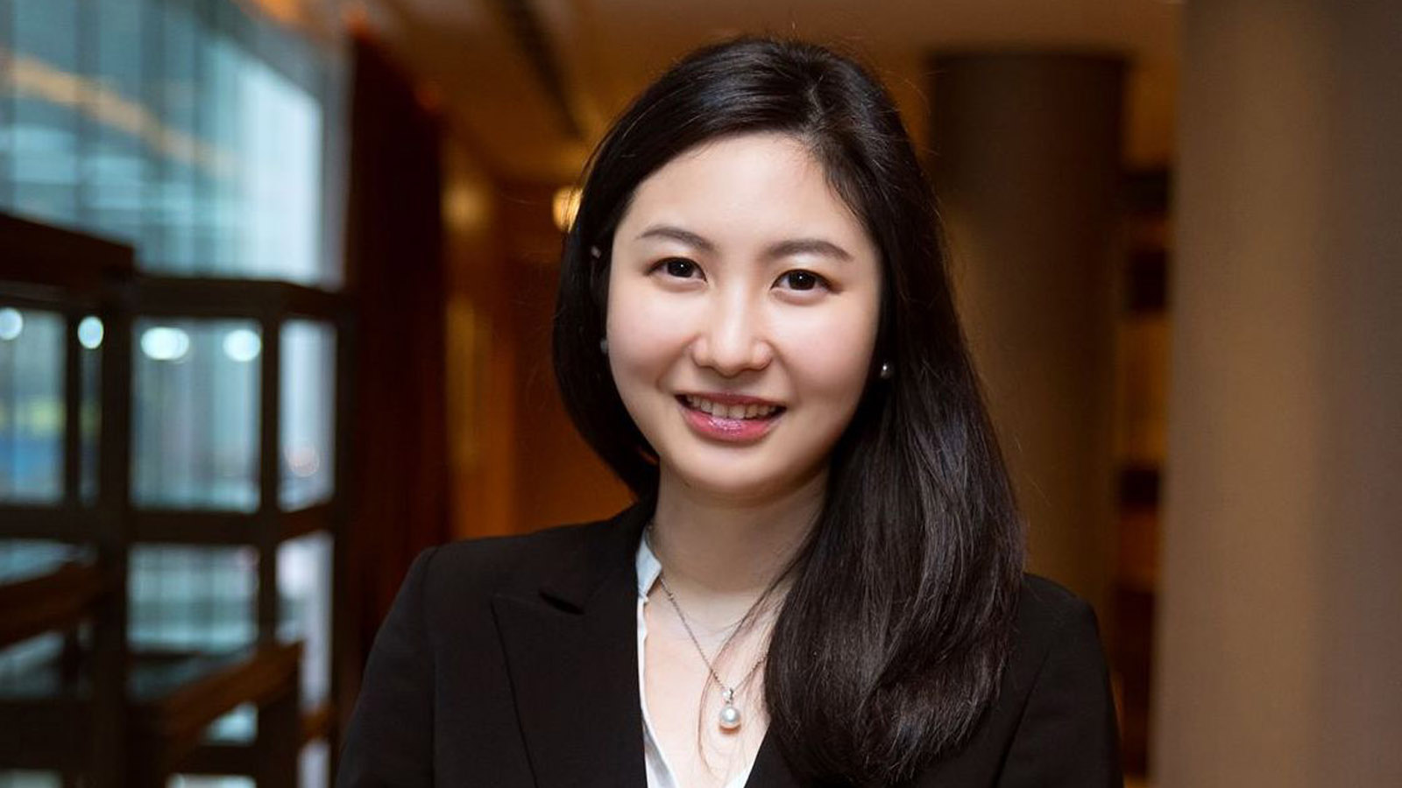 | Priscilla Chan  Assistant Public Relations Director  8 Finance Street, Central,  Hong Kong  China  priscilla.chan@fourseasons.com  (852) 3196 8307

