Mercury Lounge at Four Seasons Resort Dubai at Jumeirah Beach Returns with a Sizzling New Sicilian Look and Flavour

The Dubai rooftop lounge breezes into the new season atop Four Seasons
September 6, 2021, Dubai, U.A.E.

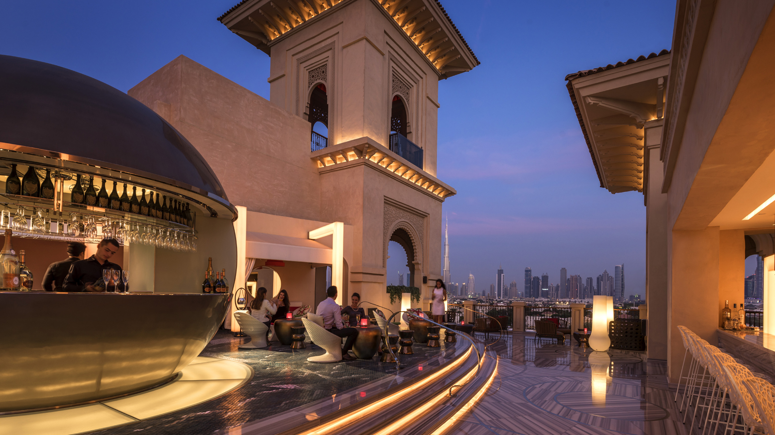
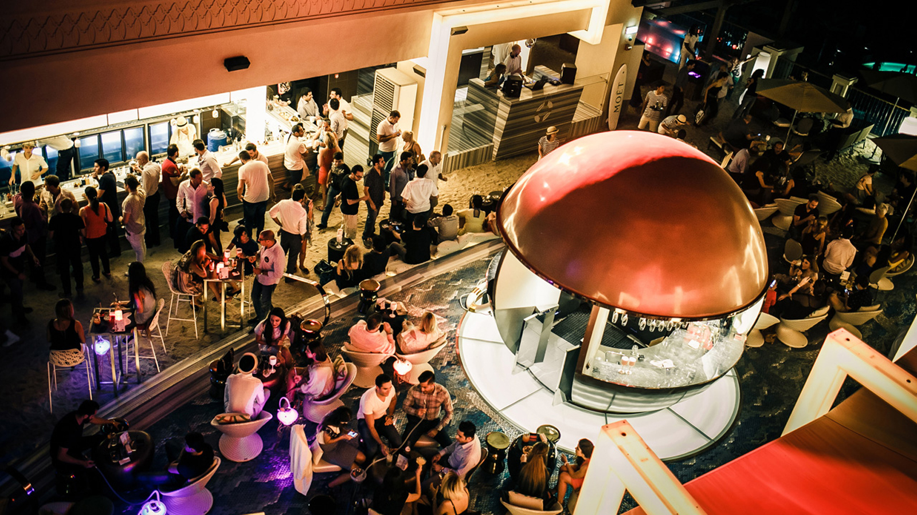 | 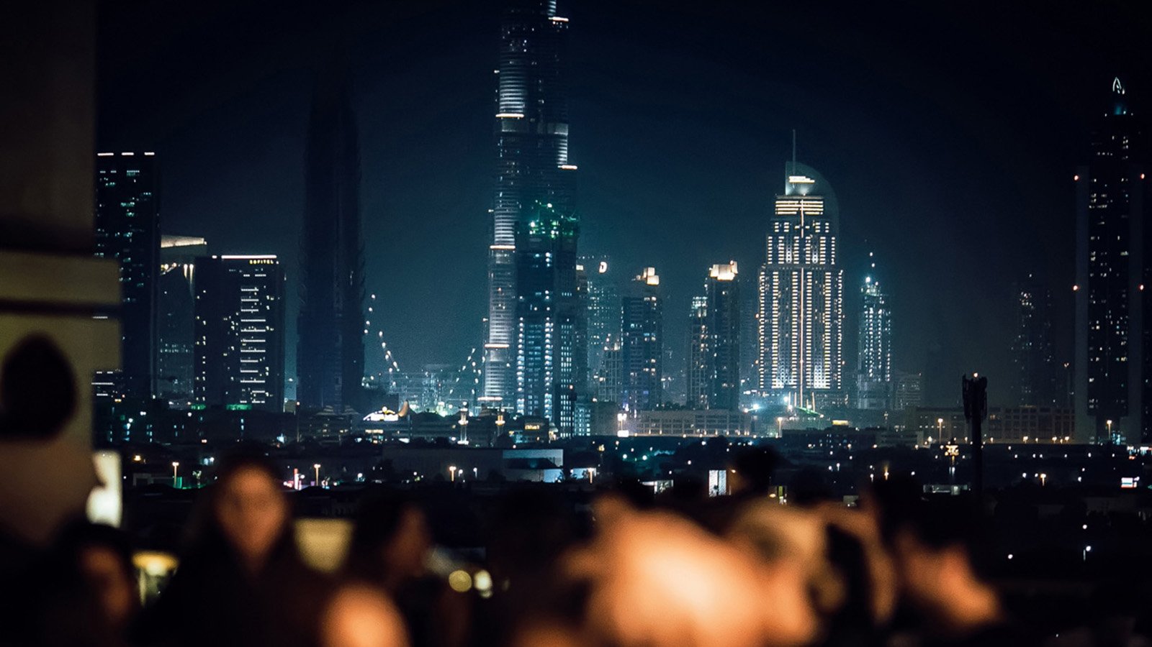 | 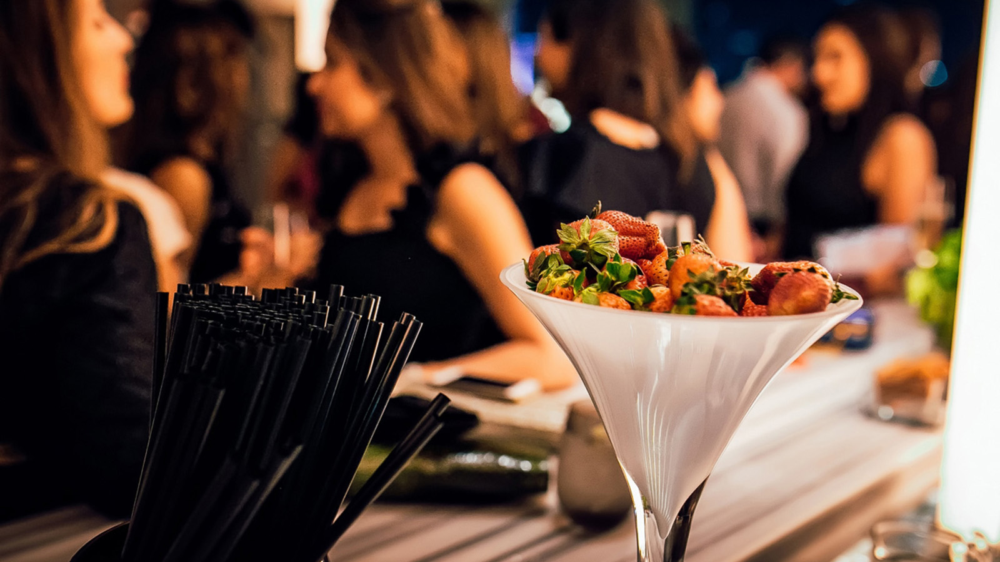
Inspired by an island where 100 buongiornos a day is customary, Mercury Lounge is ready to re-open its doors on September 16, 2021 and offer guests a taste of charming Sicily. The rooftop venue that Dubai socialites have come to love continues its tradition of an evolving menu and theme, this time transporting guests to the valleys of Mount Etna and the bays of old Syracuse.
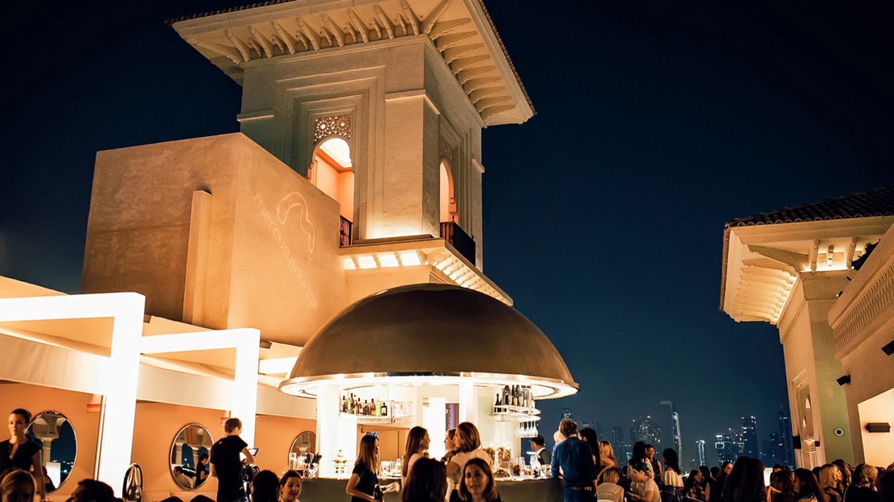 | 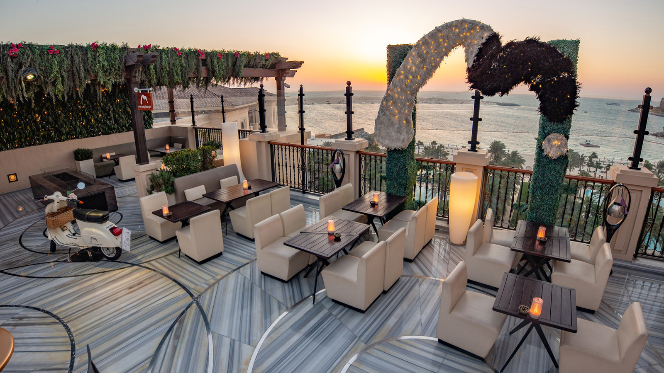
“Energy, connection, excitement, novelty and culinary excellence are what we strive to serve at all of our venues,” says Vincent Chasseignaux, Director of Food and Beverage, Four Seasons Resort Dubai at Jumeirah Beach. “Mercury Lounge has embodied this year after year, and we are very excited to wear our new Sicilian colours for the season.”
Draped and painted in Sicilian colour, Mercury Lounge’s patrons can expect stunning Insta-moments from the minute they arrive. Few things scream Sicily as much as a ciao bella! greeting, and a Vespa is one of them. A candy-red moto greets revellers at the entrance, footsteps away from a vibrant winged mural. Mercury Lounge’s signature floral arch frames Burj Khalifa and the skyline, making for a glittering Dubai flick.
All the elements that make up a memorable night fall into place at Mercury Lounge. Energy, hypnotic rhythm, tempting flavour and a select crowd set the scene. Upwards is the only direction at the glittering rooftop venue. Glasses are raised, spirits are lifted, standards are elevated and anticipation is high for a magical night, every night. Orchestrating the flow of the evening, the suave service team are well versed in making guests feel both looked after and entertained in colourful Sicilian manner. Everyone is made to feel like a superstar, which may be why the venue has been known to attract celebrities from around the world.
The menu, true to Sicilian philosophy, presents simple creations that focus on ingenious combinations of truly great produce. The machheroni ala Norma, which combines fried eggplant, smoked ricotta and basil leaves, is aptly named after the famous opera Norma, comparing the dish to a theatrical masterpiece. Another standout, the seabass in crust of bread dough, is a delicate Sicilian seafood classic. Of course, a trip to Sicily without a traditional cannoli would be incomplete, and guests can only expect to be wowed by Mercury’s rendition of this classic.
With sips to match the culinary flair, the mixologists at Mercury Lounge have crafted a selection of beverages inspired by the Sicilian way. The Dolce Segreto, decorated with a sweet secret message is bound to capture hearts. Ciao Bella, an ode to Sicilian lemons and oranges, offers a citrusy finish and is aptly named with its beautiful presentation. The night-crowd can also look forward to DJ spun sounds that fit the Sicilian theme, with a dash of current trend and rhythm.
Mercury Lounge opening timings:
- Saturday to Tuesday: 6:00 pm to 2:00 am
- Wednesday to Friday: 6:00 pm to 3:00 am
Guests who would like to make a reservation can book online by visiting mercurydubai.com or follow @Mercurydubai on Instagram to stay in tune.

RELATED

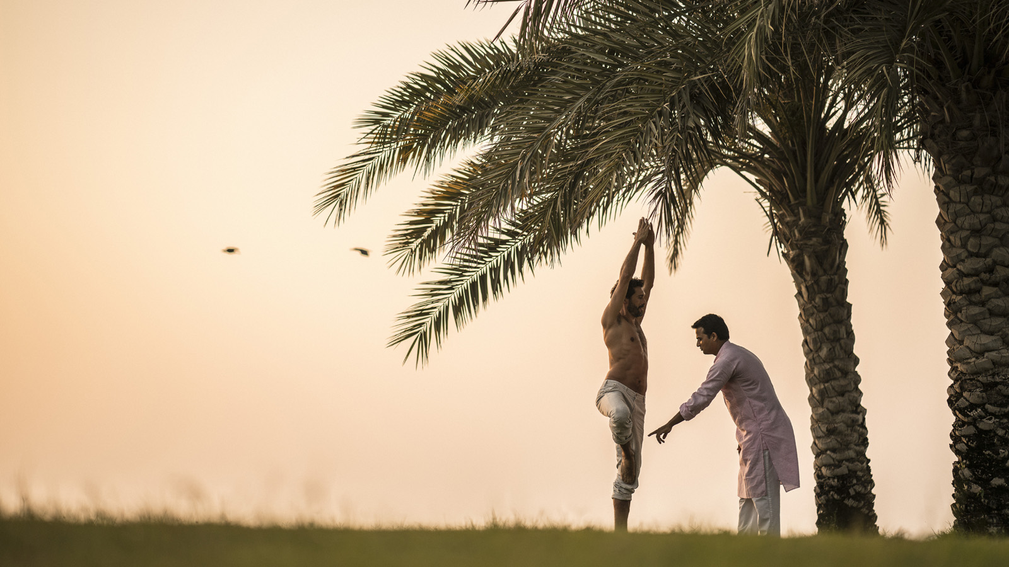 | September 14, 2021, Dubai, U.A.E.  The Pearl Spa and Wellness UAE Celebrates World Wellness Weekend with a Host of Activities at Four Seasons  https://publish.url/dubaidifc/hotel-news/2021/world-wellness-weekend.html
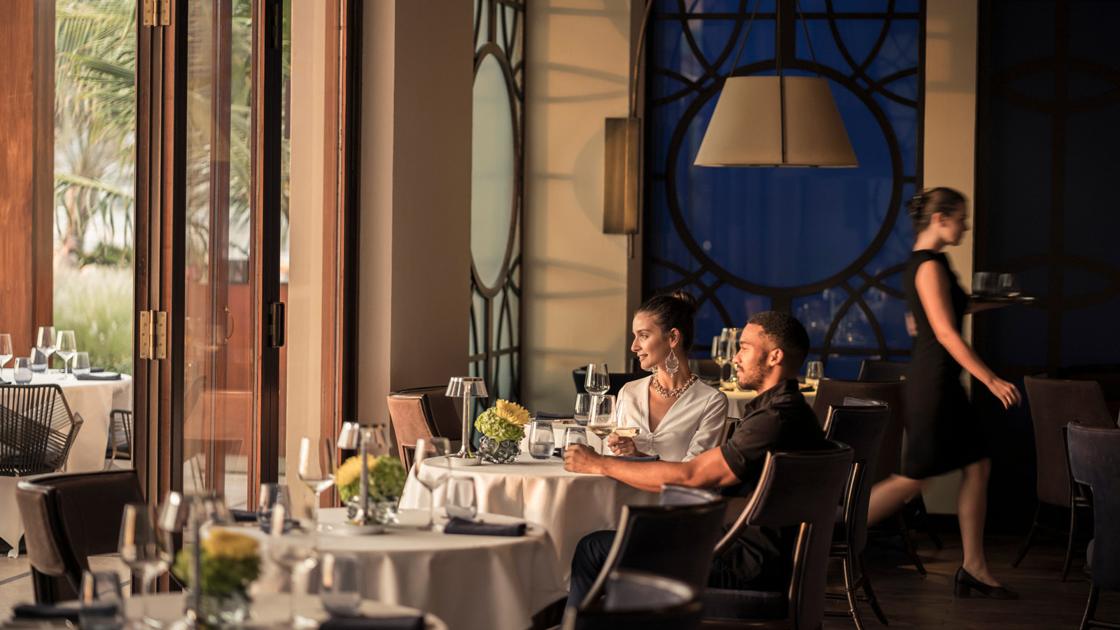 | September 1, 2021, Dubai, U.A.E.  Sea Fu Restaurant Reopens at Four Seasons Resort Dubai at Jumeirah Beach  https://publish.url/dubai/hotel-news/2021/sea-fu-restaurant-reopening.html

PRESS CONTACTS

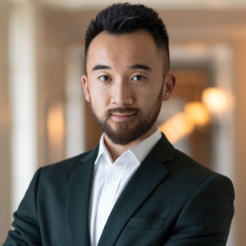 | Mazhit Ismailov  Senior Director of PR and Communications  Jumeirah Road  Dubai  United Arab Emirates  mazhit.ismailov@fourseasons.com  + 971 4 270 7723
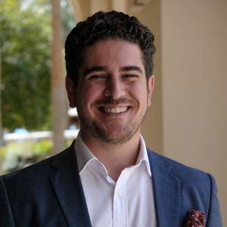 | Ghaith Adnan  Public Relations and Marketing Manager  Jumeirah Road  Dubai  United Arab Emirates  ghaith.adnan@fourseasons.com  + 971 4 270 7884

