Four Seasons Hotel Baltimore Named Best Hotel in Maryland in 2021 U.S. News & World Report Best Hotels Rankings

U.S. News & World Report recognises Four Seasons as 2021 Gold Hotel
February 2, 2021, Baltimore, U.S.A.

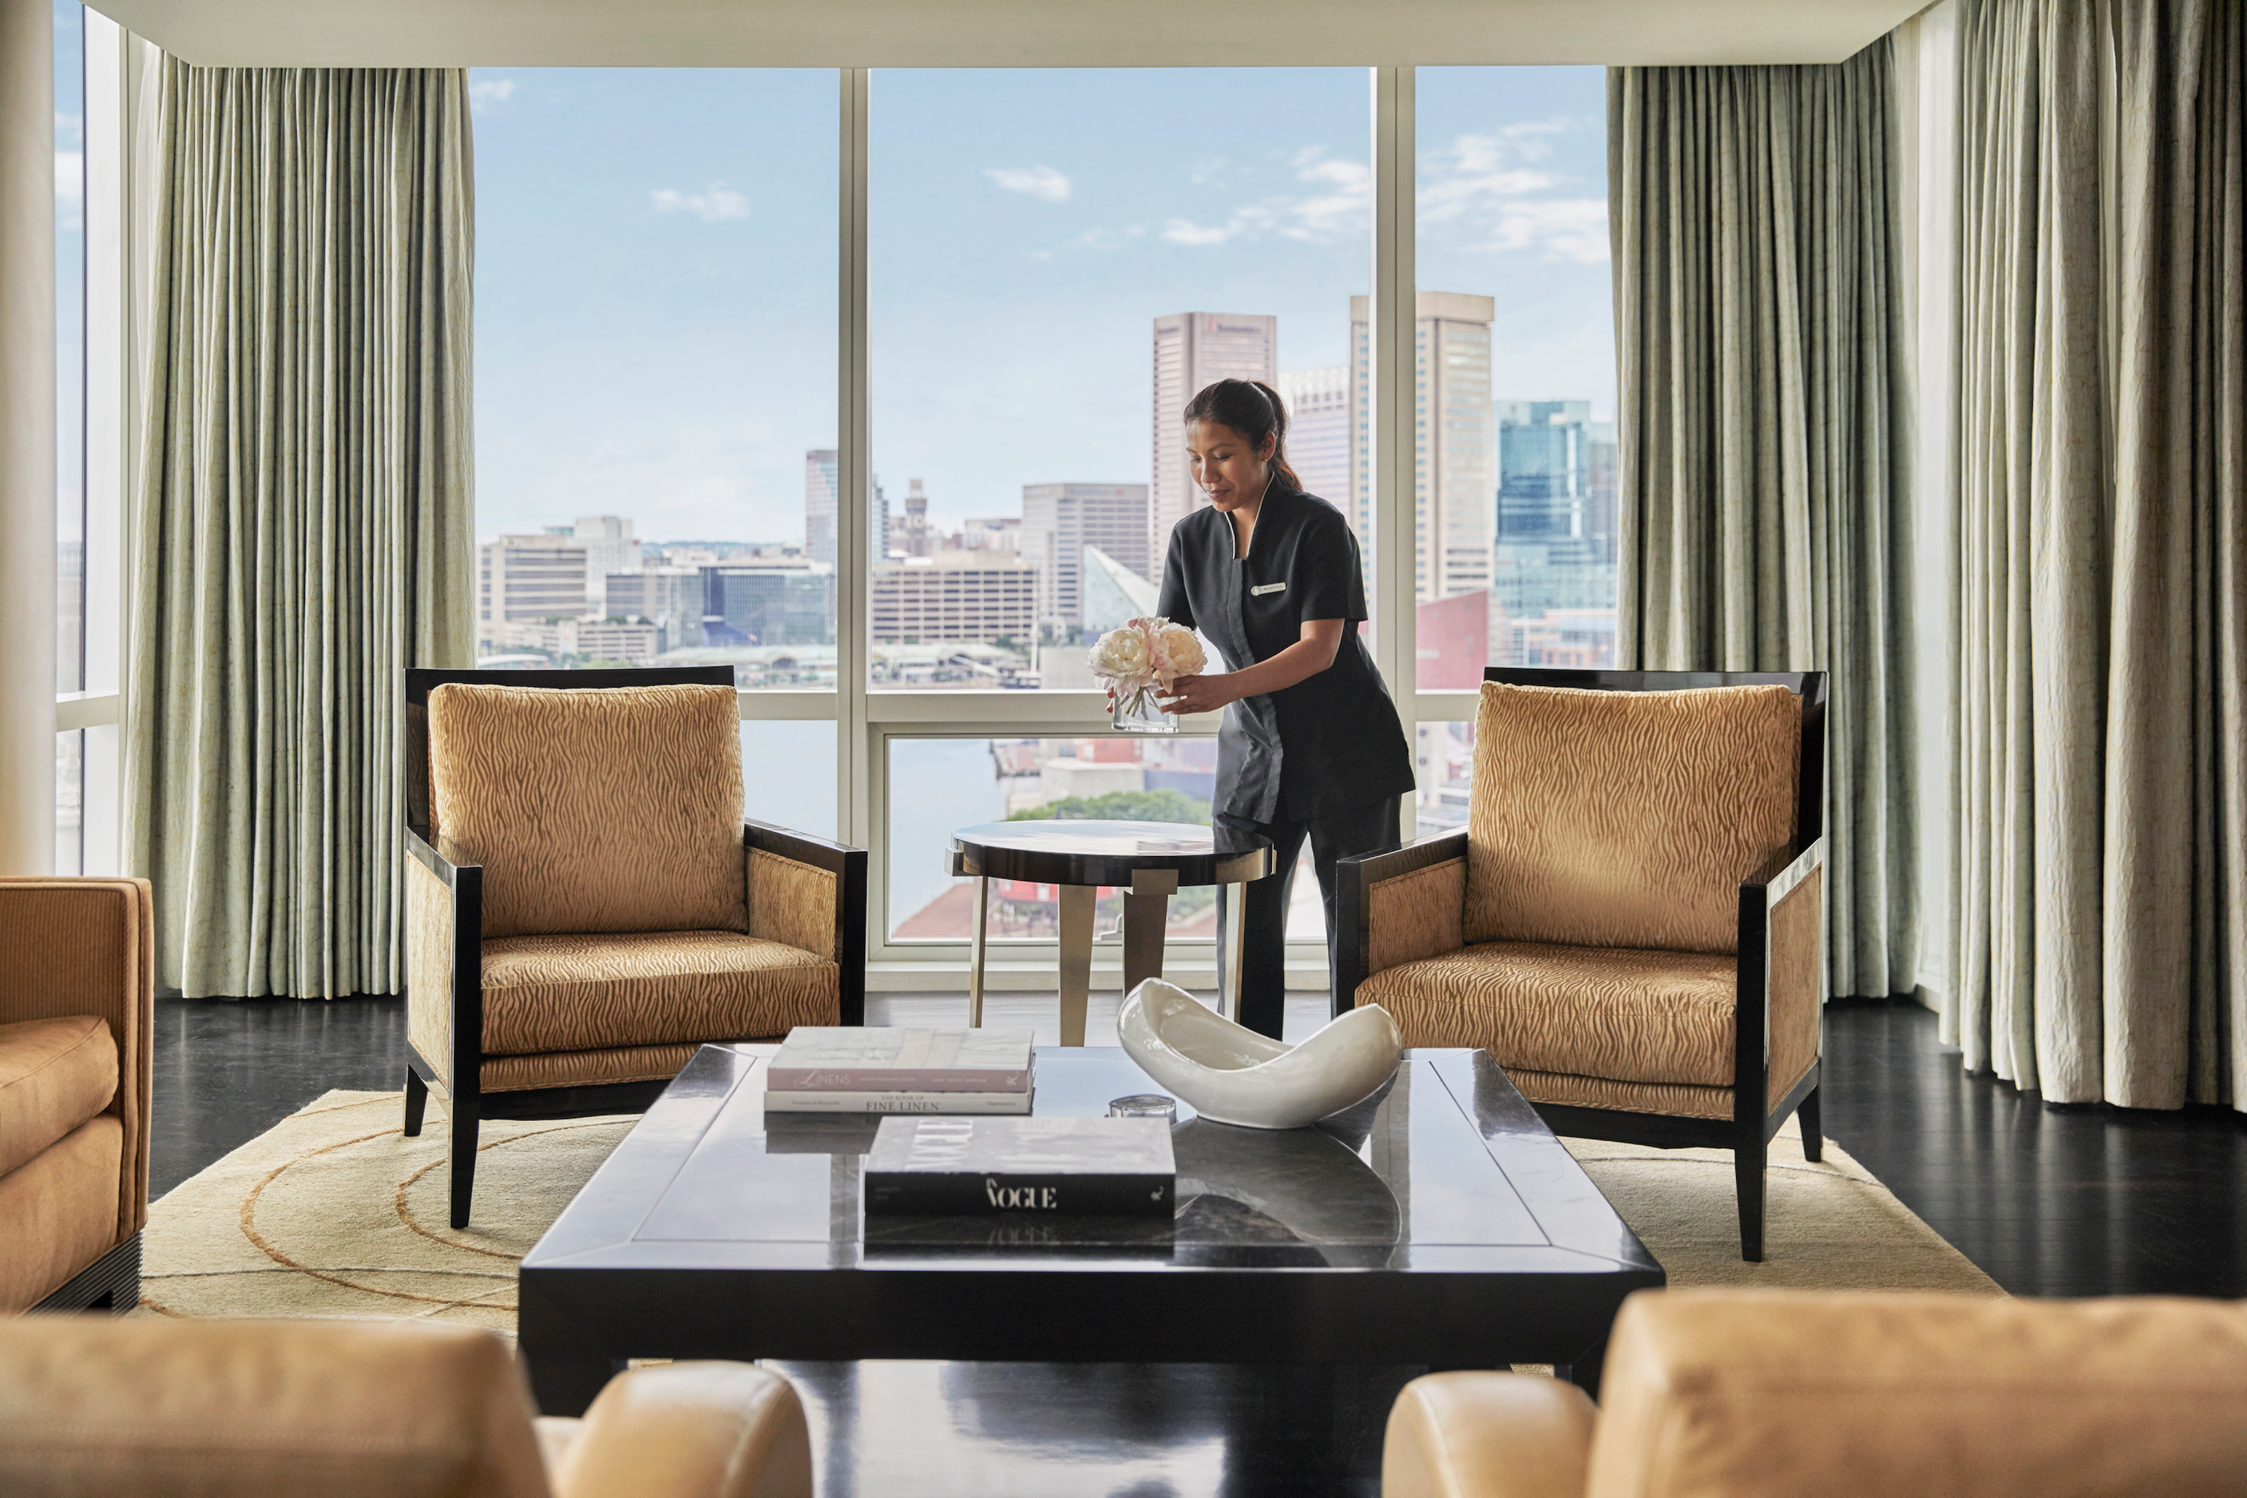
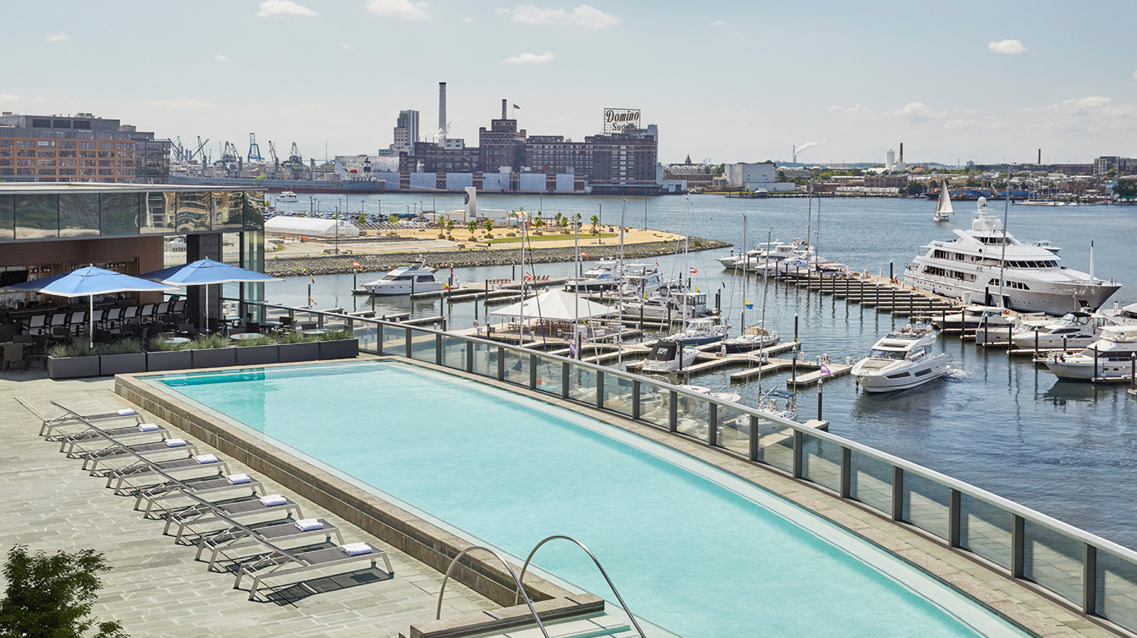 | 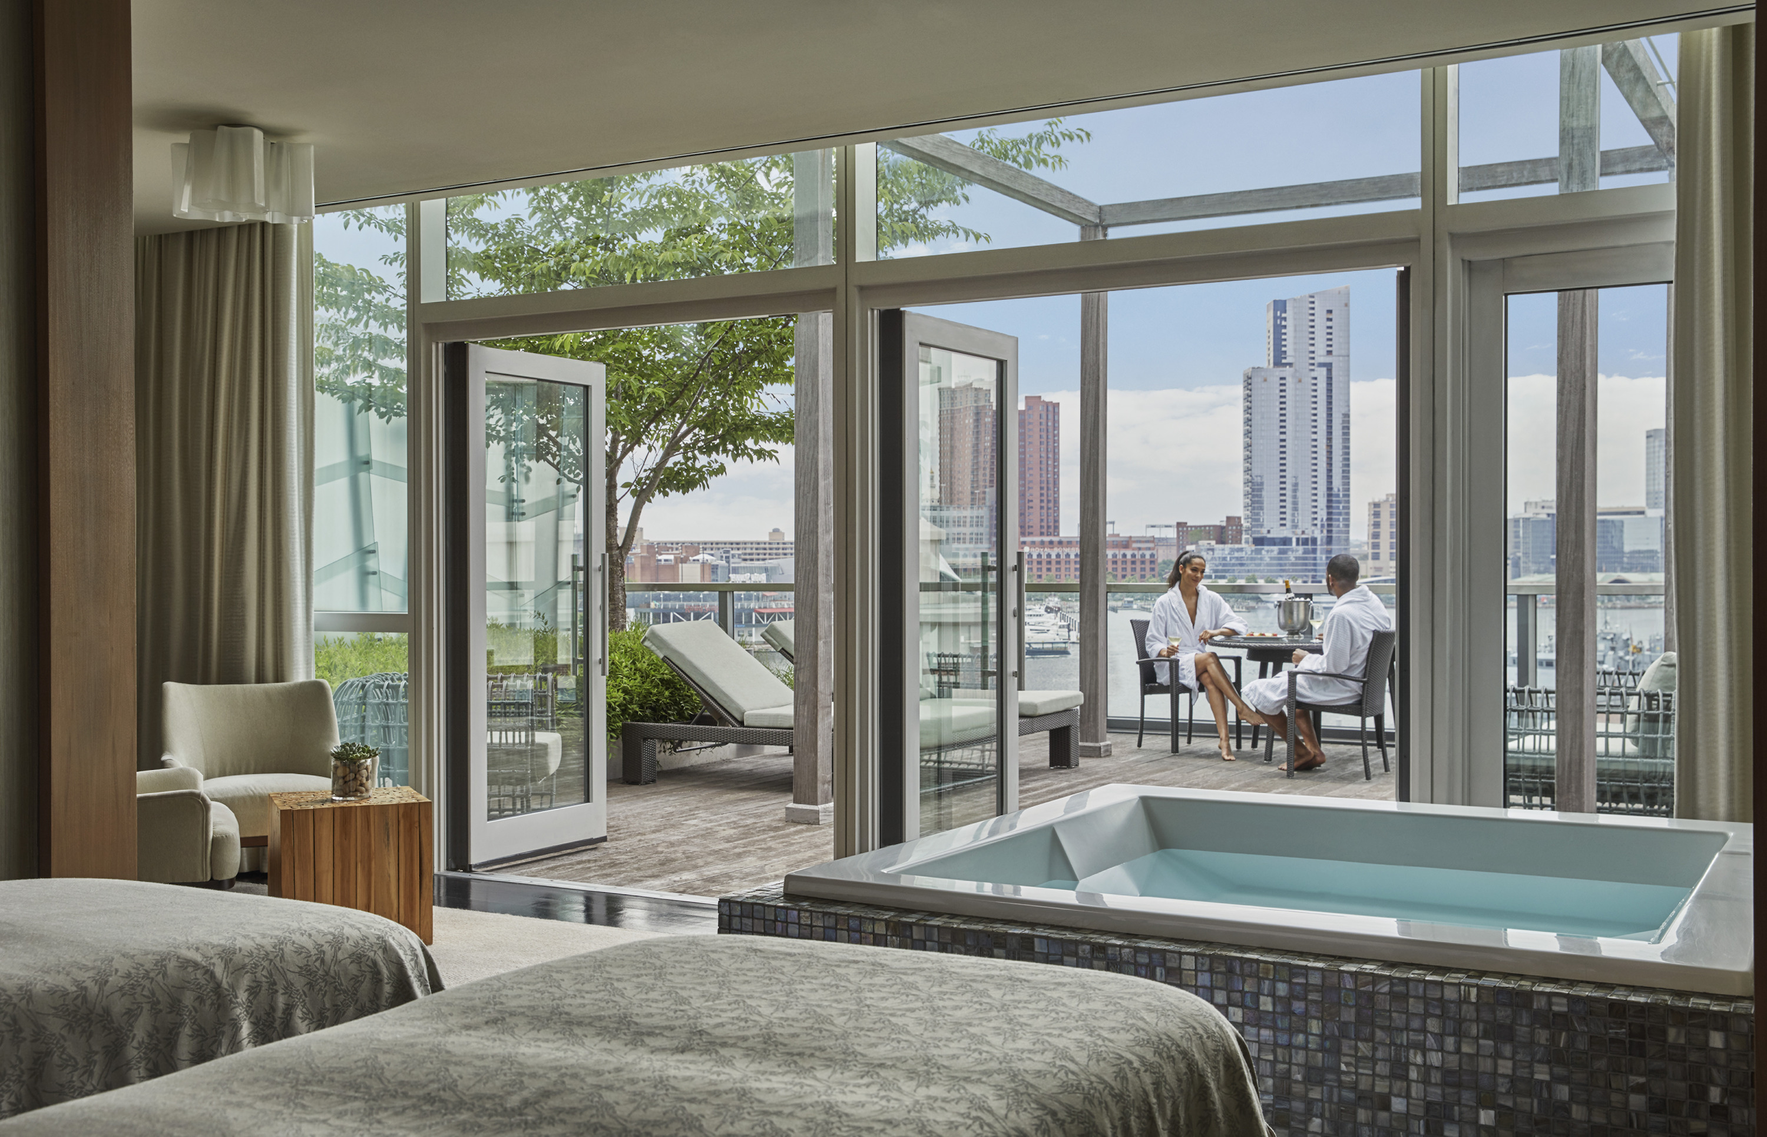 | 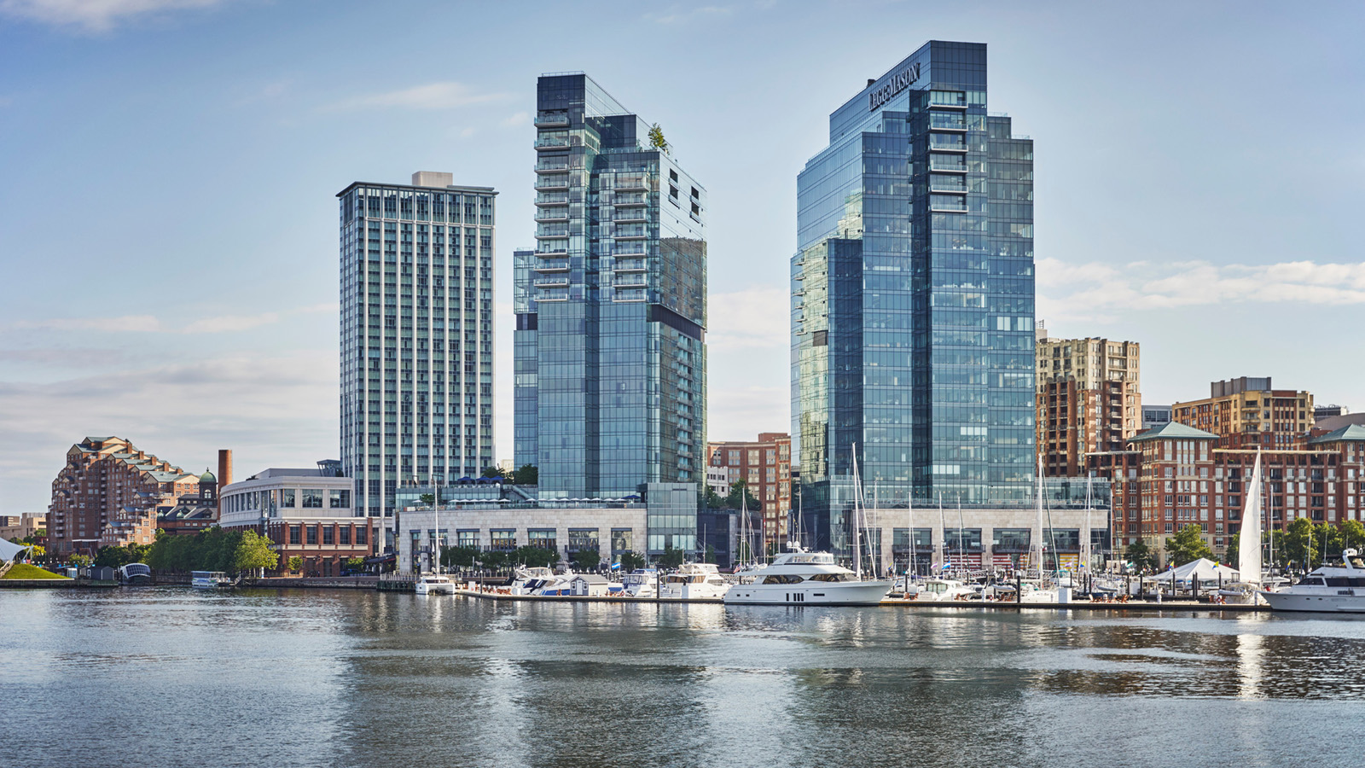
The eleventh U.S. News & World Report “Best Hotels” award recognised Four Seasons Hotel Baltimore as the #1 hotel in the categories of Best Hotels in Maryland and Best Hotels in Baltimore in its annual evaluation of hotels that offer high-quality amenities and exceptional experiences. This is the ninth year Four Seasons Hotel Baltimore has received both top rankings.
The online site is the global authority in rankings and consumer advice and the “Gold Hotel” badge represents the top 10 percent of all ranked luxury hotels in the United States.
“We are honoured to be named the #1 hotel in Baltimore and the state,” says Beverly Magee, General Manager of Four Seasons Hotel Baltimore. “This recognition is a testament to the passion and dedication of our team of hospitality professionals who go above and beyond every day to provide the highest level of care and personalised five-star guest service that truly sets our Hotel apart.”
In addition to being ranked Best Hotel in Maryland and Baltimore by U.S. News & World Report, Four Seasons Hotel Baltimore was also named as the #1 Best Wedding Hotel and #1 Best Business Hotel in both Maryland and Baltimore. The Spa was also recognised as the #2 Best Spa Hotel in Maryland.
The annual Best Hotels rankings evaluate more than 30,000 luxury hotels and resorts across the United States, Europe, Canada, Mexico, Bermuda, and the Caribbean. The methodology accounts for each hotel’s industry awards with expert and guest sentiment, the combination of which helps determine each hotel's rank.

RELATED

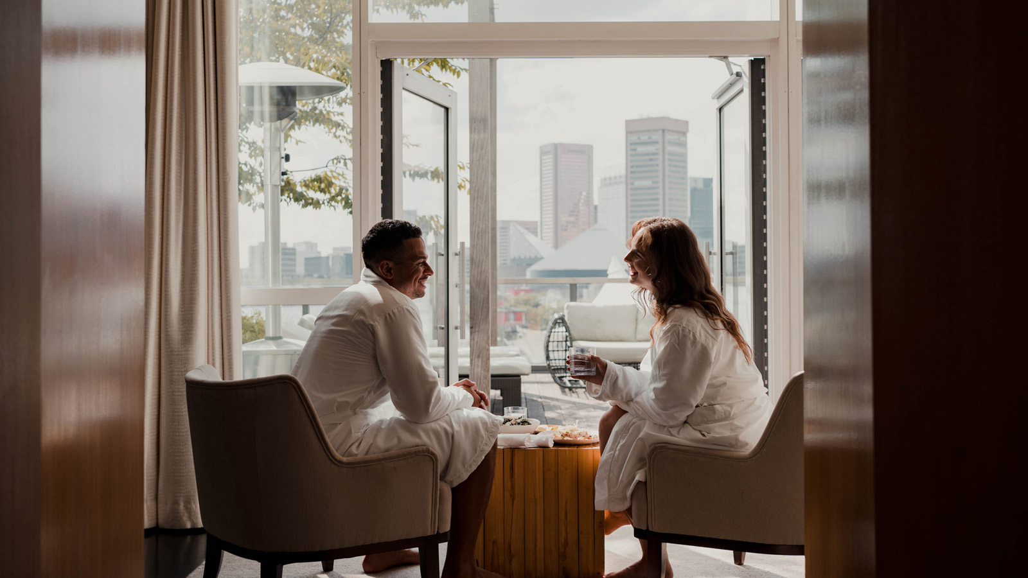 | January 27, 2021, Baltimore, U.S.A.  Celebrate the Month of Love in Balt-Amour with Four Seasons Hotel Baltimore  https://publish.url/baltimore/hotel-news/2021/valentines-day.html
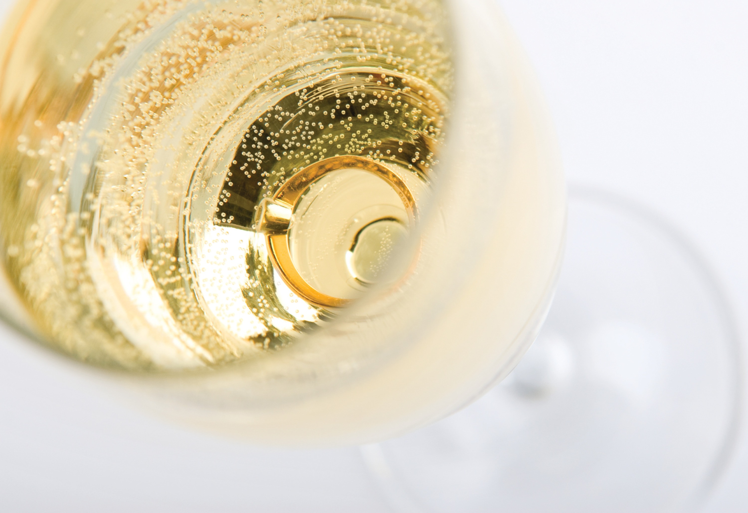 | December 15, 2020, Baltimore, U.S.A.  Celebrate New Year’s Eve in Style at Four Seasons Hotel Baltimore  https://publish.url/baltimore/hotel-news/2020/new-years-eve.html

PRESS CONTACTS

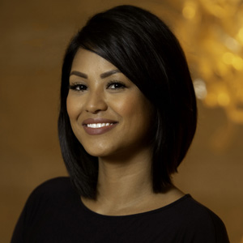 | Christina Criss  Director of Public Relations  200 International Drive  Baltimore  USA  christina.criss@fourseasons.com  +1 410 223 1343

