Four Seasons Resort Mauritius at Anahita Announces a Resort Culinary Transformation Through Multi-Million Dollar Restaurant and Bar Renovations

Forbes Five-star pool villa resort to bring new level of luxury to island dining, debuting this fall
July 8, 2021, Mauritius

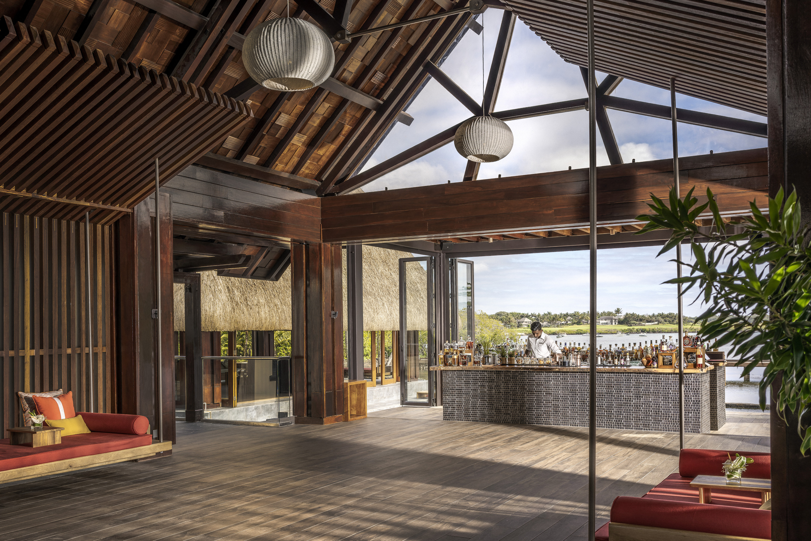
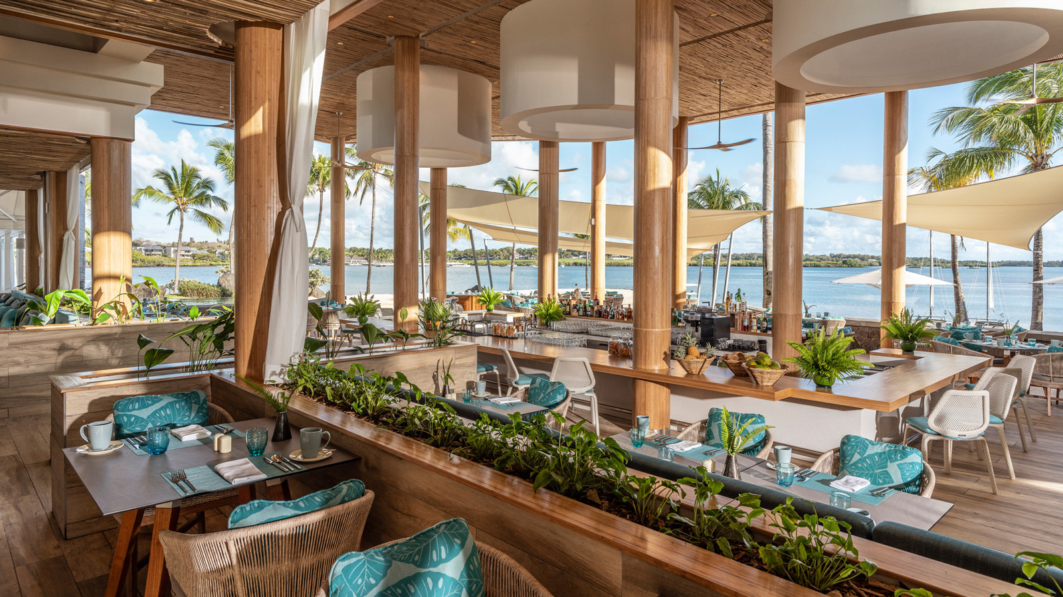 | 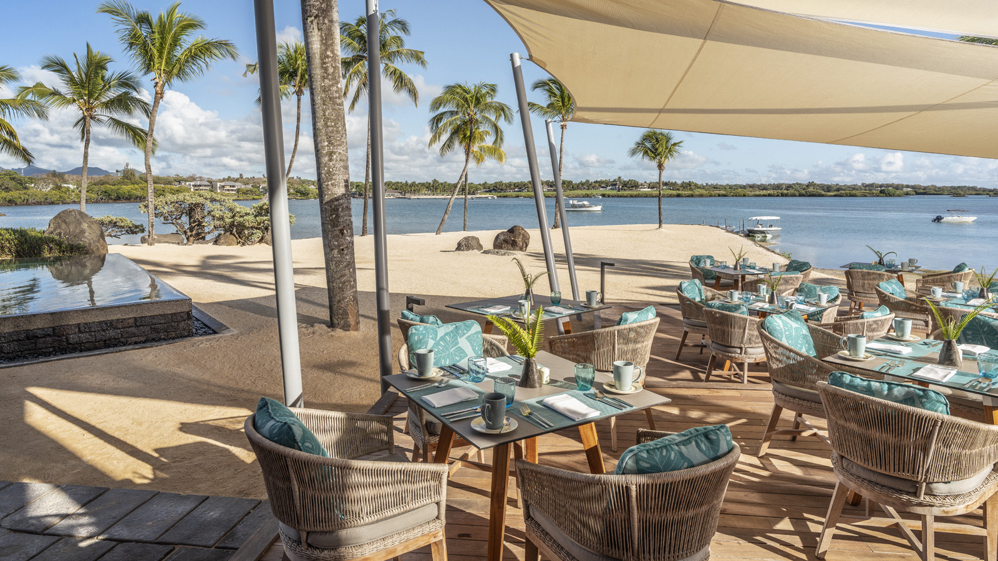 | 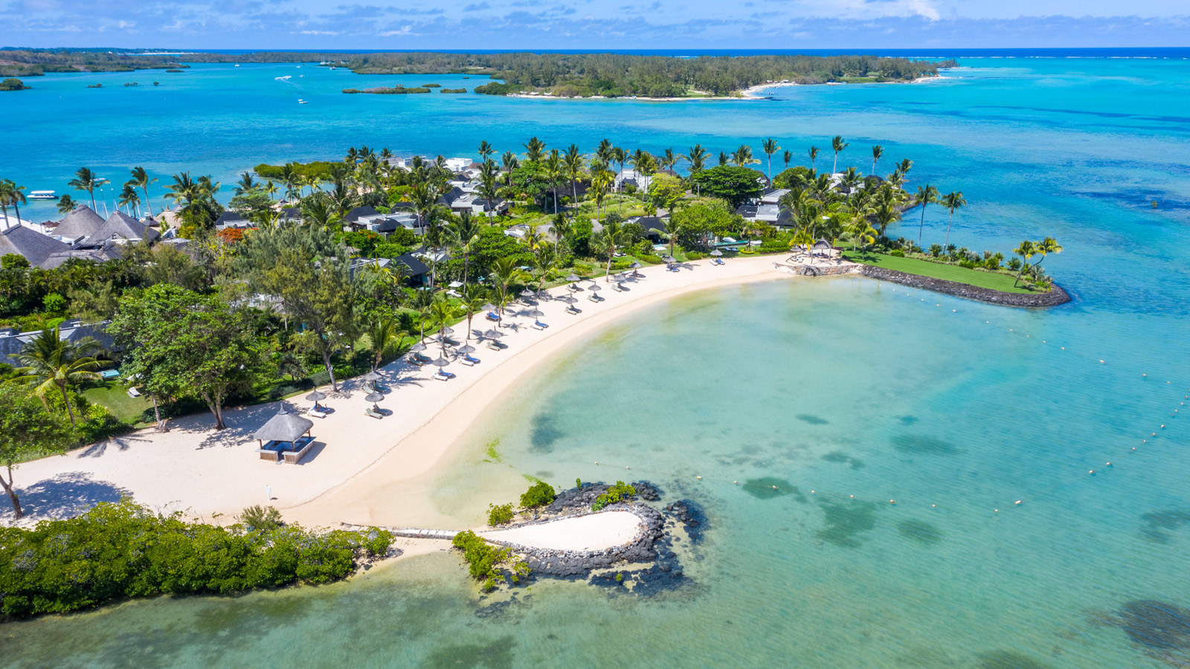
Edging turquoise Indian Ocean waters and with tropical gardens beautifully woven throughout the property, Four Seasons Resort Mauritius at Anahita is set to further elevate its exotic sanctuary with the announcement of a significant restaurant and bar renovation, to be unv­eiled in October 2021.
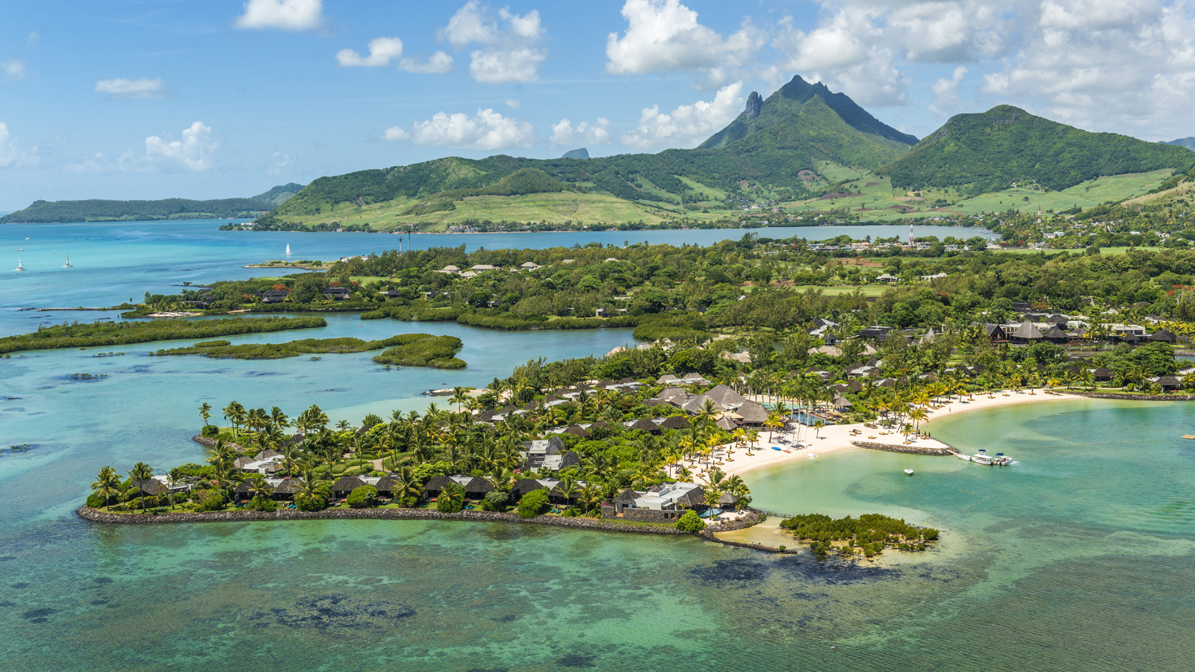
Boasting a current total of four restaurants, including the acclaimed La Plaz Beach Grill on the Four Seasons exclusive beach on Ile aux Cerfs, plus a lounge bar, Cotomili Herb Garden with dedicated cooking class area, 24-hour in-villa dining and a variety of private dining experiences, the Resort’s already extensive culinary offerings are set to be raised to the next level through the planned enhancements.
The four-month long renovation at the Forbes Five-star rated Resort will introduce a brand new Lobby Bar and see the complete transformation of the beachfront Bambou Restaurant and Bar through a structural re-build and fresh design concept, led by Macbeth Architects & Designers and EDG Design.
“We are delighted to be unveiling the plans for this renovation,” says Lindley Thomen, Resort Manager at Four Seasons Resort Mauritius at Anahita. “The Mauritius government has just announced a partial reopening of the borders ahead of a full reopening in October, perfectly coinciding with our Resort’s reopening. This renovation will bring to life a true essence of the island culture through our restaurants and bars – both in the beauty of the physical design and the locally-sourced materials used, as well as the culinary offerings to be served. After a closure of more than a year due to the pandemic, we simply cannot wait to once again have chance to welcome back our guests and to showcase the Resort at its finest.”
Al Fresco Oceanfront Bars and Restaurants
With its poolside location and adjacent views over the tranquil lagoon, Bambou Restaurant and Bar will be transformed through significant re-construction that will provide a more expansive area for covered seating, as well as a new beach dining location. Set to become the new home of the Resort’s breakfast offering, the Restaurant will offer all day dining variety, with a Mediterranean-themed lunch menu being complemented by the best of local Creole cuisine each evening.
The new Lobby Bar will offer a revived welcome experience, while also taking advantage of the picturesque setting overlooking the tiered barachois. Centred around an open bar counter, the Lobby Bar will seat up to 32 guests and will serve a drinks menu inspired by infused cocktails, sugar cane based drinks and Mauritian-infused rums.
Throughout the day, the Lobby Bar will evolve in its offerings, with a selection of teas and coffees served from early morning, ahead of a light tapas selection for lunch from late morning until late afternoon, prior to catering to aperitifs and digestifs in the evening.
An Island Journey Through Design
In its iconic location at the heart of the Resort, Bambou Restaurant will be re-imagined through a design artfully created to reflect its ocean-front setting. Marine blue upholstery will be complemented by elegantly patterned furnishings to depict the gentle waves of the surrounding lagoon, while soft, draping fabrics will provide subtle separation and privacy, referencing to the sails of local pirogues that are often seen in the nearby lagoon. The island’s rich, verdant nature on land will also be brought to life by trellises of greenery and locally-sourced bamboo that will partition seating areas.
The Lobby Bar design draws on the concept of al fresco island living, with both bar stool and lounge seating available with views over the barachois. A warm terracotta upholstery will be punctuated by soft neutral tones to invite relaxation for enjoying lagoon-front views. Adjacent to the bar area, a new outdoor walkway will connect to the previous Welcome Lounge, where extended seating will be available.
Be Among the First to Experience the Revitalised Four Seasons Resort Mauritius at Anahita
To make reservations now for stays beginning in October 2021, click here.

RELATED

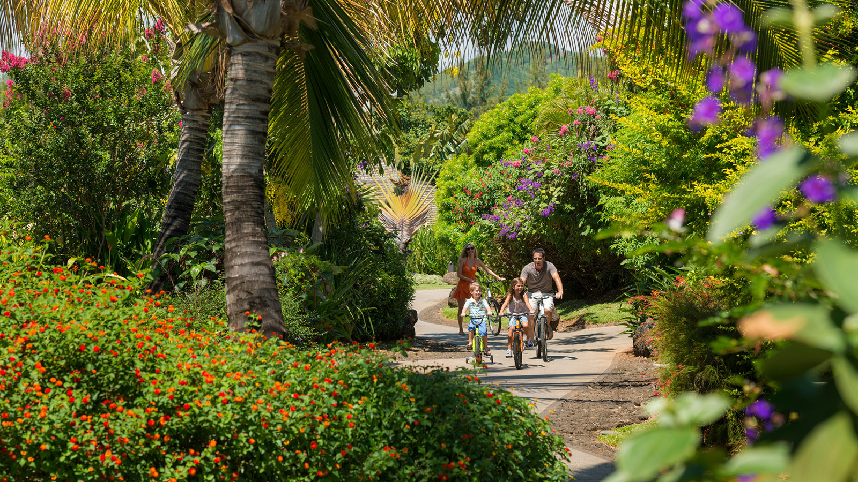 | November 25, 2021, Mauritius  The Shine of Festive Season Awaits at Four Seasons Resort Mauritius at Anahita  https://publish.url/mauritius/hotel-news/2021/festive-season.html
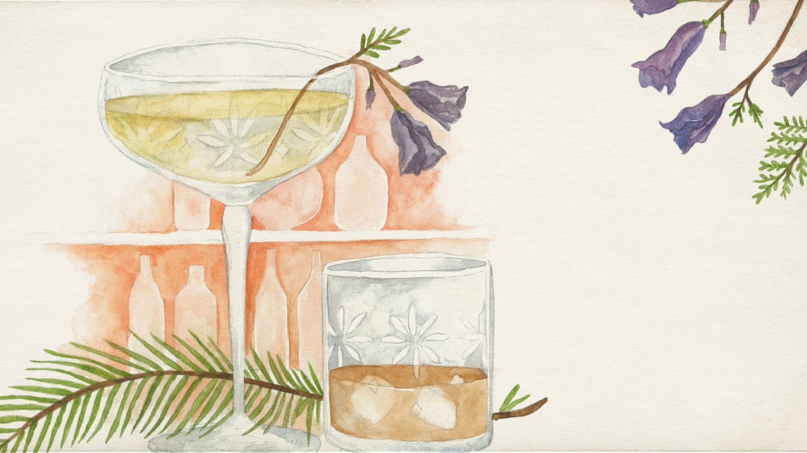 | November 24, 2021, Johannesburg, South Africa  The Festive Season is All Wrapped Up at Four Seasons Hotel The Westcliff Johannesburg  https://publish.url/johannesburg/hotel-news/2021/festive-season.html

PRESS CONTACTS

Debbie Duval
Senior Director of Public Relations and Communications

Beau Champ
Mauritius
debbie.duval@fourseasons.com

(230) 402 3100

Beatrice Tsang
Public Relations Coordinator

Beau Champ
Mauritius
beatrice.tsang@fourseasons.com

+230 4023100

