Chef Alon Shaya Partners with Four Seasons Hotel New Orleans for Exciting New Restaurant Concept

James Beard Foundation Award-winner to unveil a signature restaurant and bar on the New Orleans riverfront in 2021
October 21, 2020, New Orleans, U.S.A.

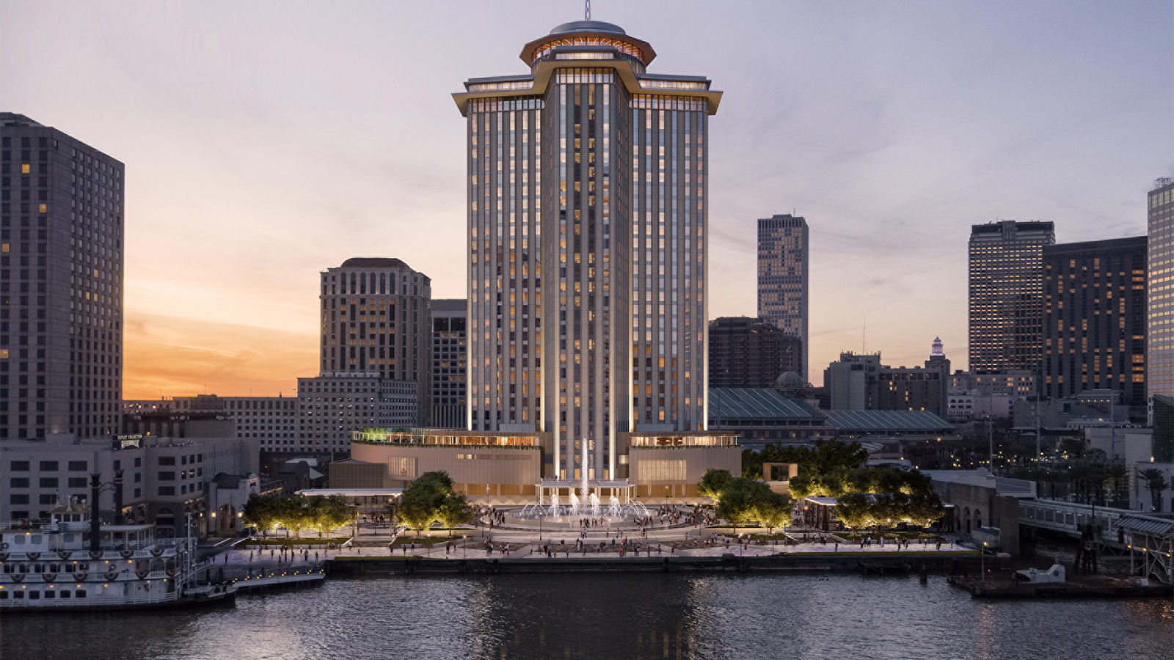
In a city renowned for its dynamic dining scene, award-winning Chef Alon Shaya is set to debut a new restaurant and bar in Four Seasons Hotel and Private Residences New Orleans. Scheduled to open in early 2021, the restaurant will offer a fresh perspective on a classic Louisiana dining experience in a festive and inviting atmosphere at the Hotel’s street level.
“There’s no question that New Orleans has long held an influential place in America’s culinary evolution,” notes the property’s General Manager Mali Carow. “Now, in partnership with Chef Alon Shaya, our aim at Four Seasons Hotel and Private Residence New Orleans is to continue that tradition, while forging an imaginative new path into the future.”
About Alon Shaya
Alon Shaya, who has earned numerous accolades including Esquire magazine’s Chef to Watch, Eater New Orleans Chef of the Year and several James Beard Foundation awards and nominations, has traced a winding path to his newest venture with Four Seasons Hotel New Orleans. Born in Israel and raised in Philadelphia, Alon grew up cooking alongside his mother and grandmother, which inspired studies at the Culinary Institute of America before interning in Las Vegas.
A NOLA resident for nearly two decades, Alon and his wife Emily created Pomegranate Hospitality, where cultural differences are celebrated while creating delicious cuisine. In 2018, Pomegranate Hospitality opened the city’s popular Saba restaurant, where Alon, Emily and team present a culinary journey through the Middle East, Europe and North Africa with a Louisiana twist. Alon is also the author of Shaya: An Odyssey of Food, My Journey Back to Israel.
Guests at the new restaurant in Four Seasons Hotel New Orleans can expect a spirited take on beloved New Orleans dishes, and an emphasis on the abundance of Gulf seafood, vegetables and other ingredients thoughtfully sourced from Shaya’s extensive network of fishermen, farmers and other purveyors. The menus at the as-yet-to-be-named restaurant and hotel lobby bar will be enhanced by an extensive beverage program, including a curated selection of well-crafted cocktails.
“We are very happy to work with Four Seasons, a company that shares the love of great food and gracious hospitality with a team-first approach,” says Chef Shaya. “We are honoured to be part of this project that will help reenergise New Orleans’ riverfront. Together, we will create a grand dining experience that celebrates Louisiana’s diverse culture and cuisine.”
About Four Seasons Hotel and Private Residences New Orleans
The partnership with Chef Alon Shaya is the first of several exciting announcements about the food and beverage program at Four Seasons Hotel and Residences New Orleans. In addition to this signature restaurant and bar, a second restaurant is planned, along with a poolside venue and in-room dining.
Set to open in the summer of 2021, the new Four Seasons is housed in a 34-storey tower in the iconic riverfront World Trade Center and will also include 341 rooms and suites; wellness facilities including a full-service spa, fitness centre and outdoor pool deck; state-of-the-art event spaces and private gardens for hosting meetings, conferences, weddings and other celebrations; signature restaurants by Alon Shaya and Donald Link; and 92 Four Seasons Private Residences.

RELATED

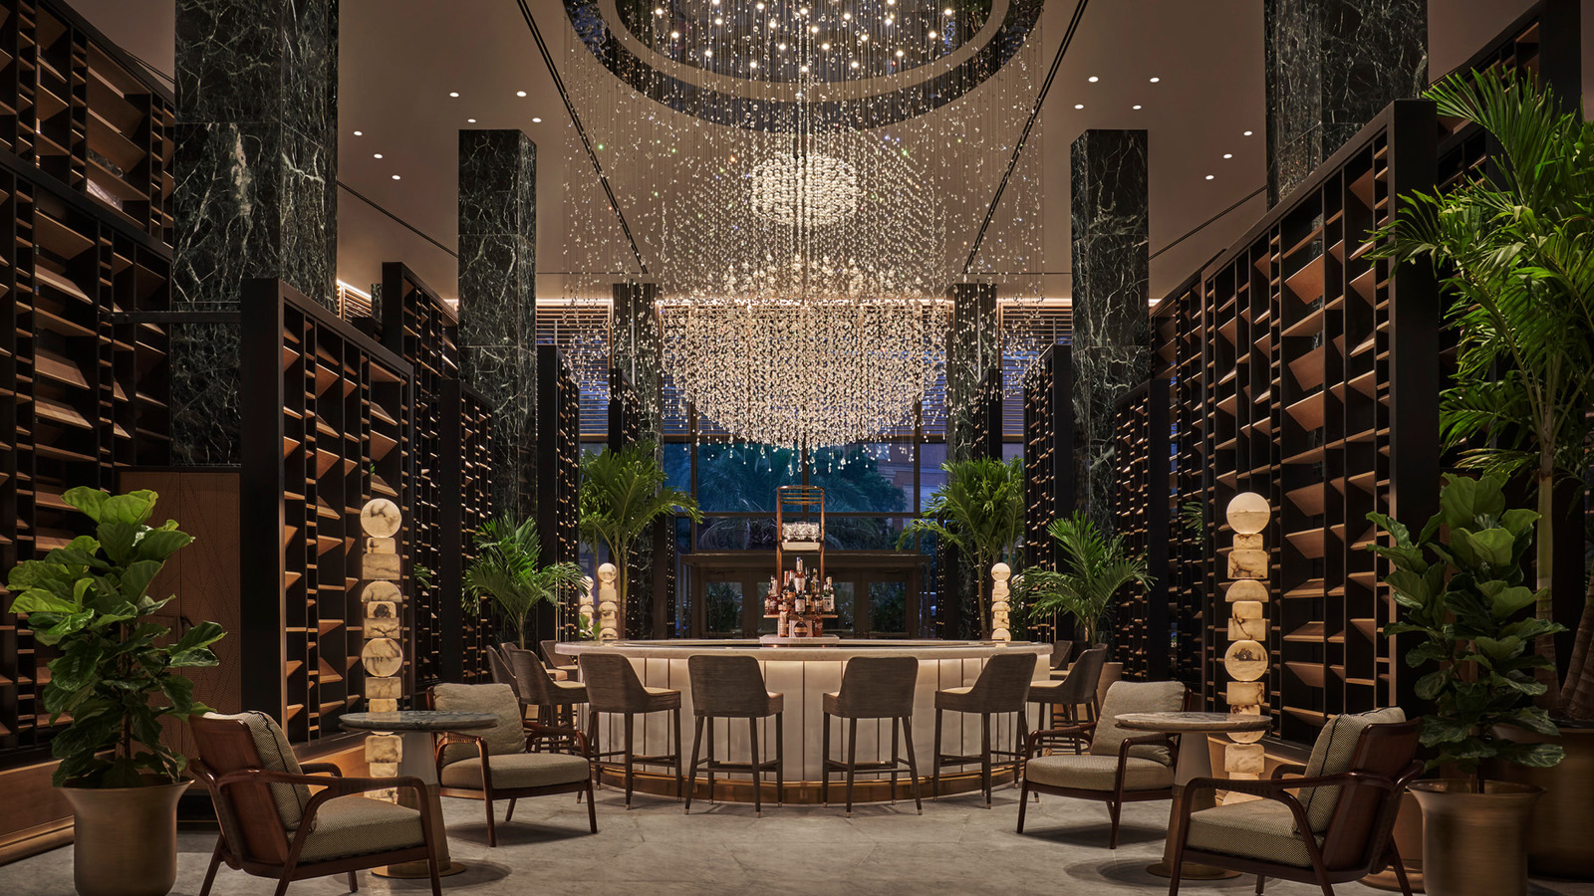 | August 17, 2021, New Orleans, U.S.A.  新奥尔良四季酒店与私人住宅瞩目开业，邀请宾客尽赏新月城之美  https://publish.url/zh/neworleans/hotel-news/2021/now-open-4.html
August 17, 2021, New Orleans, U.S.A.
تم الافتتاح: فندق وبرايفت ريزيدنسز فورسيزونز نيو أورلينز يرحب بضيوفه ليعيشوا أجمل اللحظات في مدينة الهلال
https://publish.url/ar/neworleans/hotel-news/2021/now-open-5.html

PRESS CONTACTS

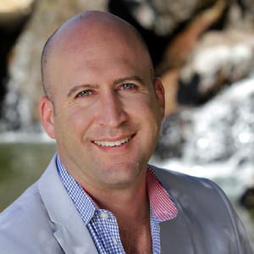 | Brad Packer  Director of Public Relations  350 South Beverly Drive, Suite 100  Beverly Hills  USA  brad.packer@fourseasons.com  +1 310 712 1493
Vicki Bristol
Director of Public Relations and Communications
2 Canal Street
New Orleans
USA
vicki.bristol@fourseasons.com

+1 504 434 7012

