Anguilla Plus Miami: Luxury Layover Package Gives Long-Distance Travellers a Chance to Experience Two Four Seasons for the Price of One

Enjoy a complimentary night in Miami with four nights paid in Anguilla
February 12, 2018, Anguilla, West Indies

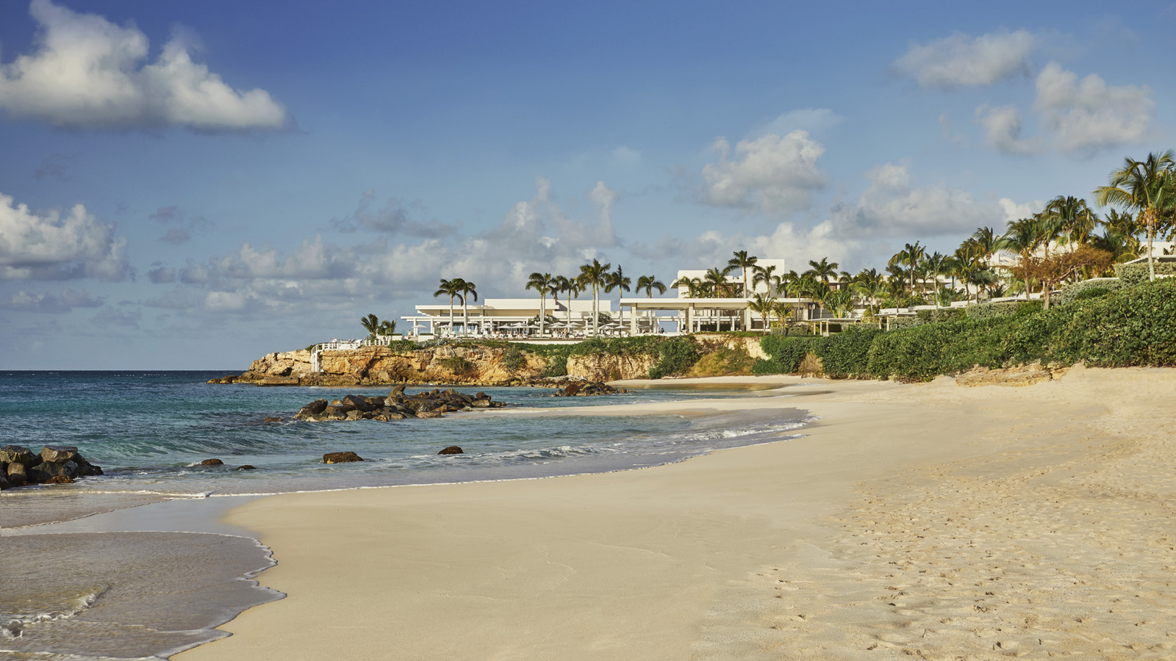
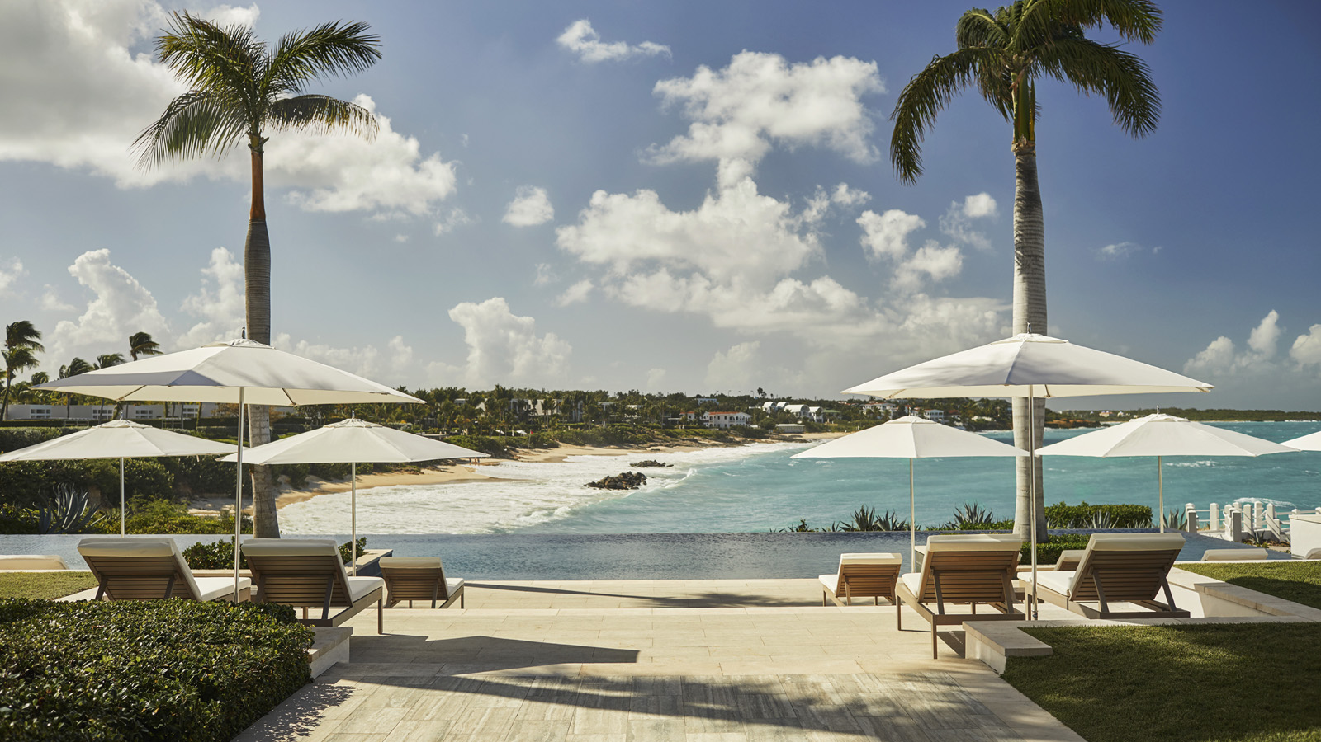 | 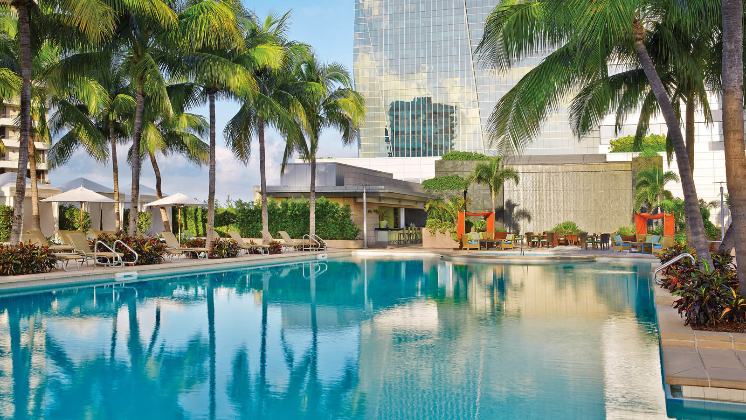
Those travelling to the tropical island of Anguilla may want to consider an overnight stop in Miami. The Miami Layover Package provides a complimentary overnight stay at the luxurious
Four Seasons
Hotel Miami with the purchase of four nights at
Four Seasons
Resort and Residences Anguilla.
Located on Brickell Avenue, and conveniently located within easy driving distance from the Miami International Airport,
Four Seasons
Hotel Miami provides an exceptional overnight stay in the bustling city prior to, or after, a vacation on the beautiful island of Anguilla.
At
Four Seasons
Resort and Residences Anguilla, guests select their preferred accommodation from a resort view guest room to a five-bedroom villa, and when they stay four nights or more, they’ll receive a complimentary night at
Four Seasons
Hotel Miami.
The Miami Layover Package includes:
- One complimentary night in a Bay-View Room at
Four Seasons
Hotel Miami when staying four consecutive paid nights in any room type at
Four Seasons
Resort and Residences Anguilla
- Daily buffet breakfast for two adults per bedroom at both
Four Seasons
Anguilla and
Four Seasons
Miami
The package is available through December 15, 2018. Rates start at USD 600 per night. For reservations, call 800 201 9580.

Advance reservations are required. Blackout dates apply. All offers are subject to availability at time of reservation. Offers are not valid in conjunction with any other offer or contract and do not apply to groups. Rates are per room, per night, vary by arrival date and/or length of stay, and do not include applicable taxes, service charges, levies, resort fees or surcharges, unless otherwise noted. Rates are subject to change. Early departure fees may apply.

RELATED

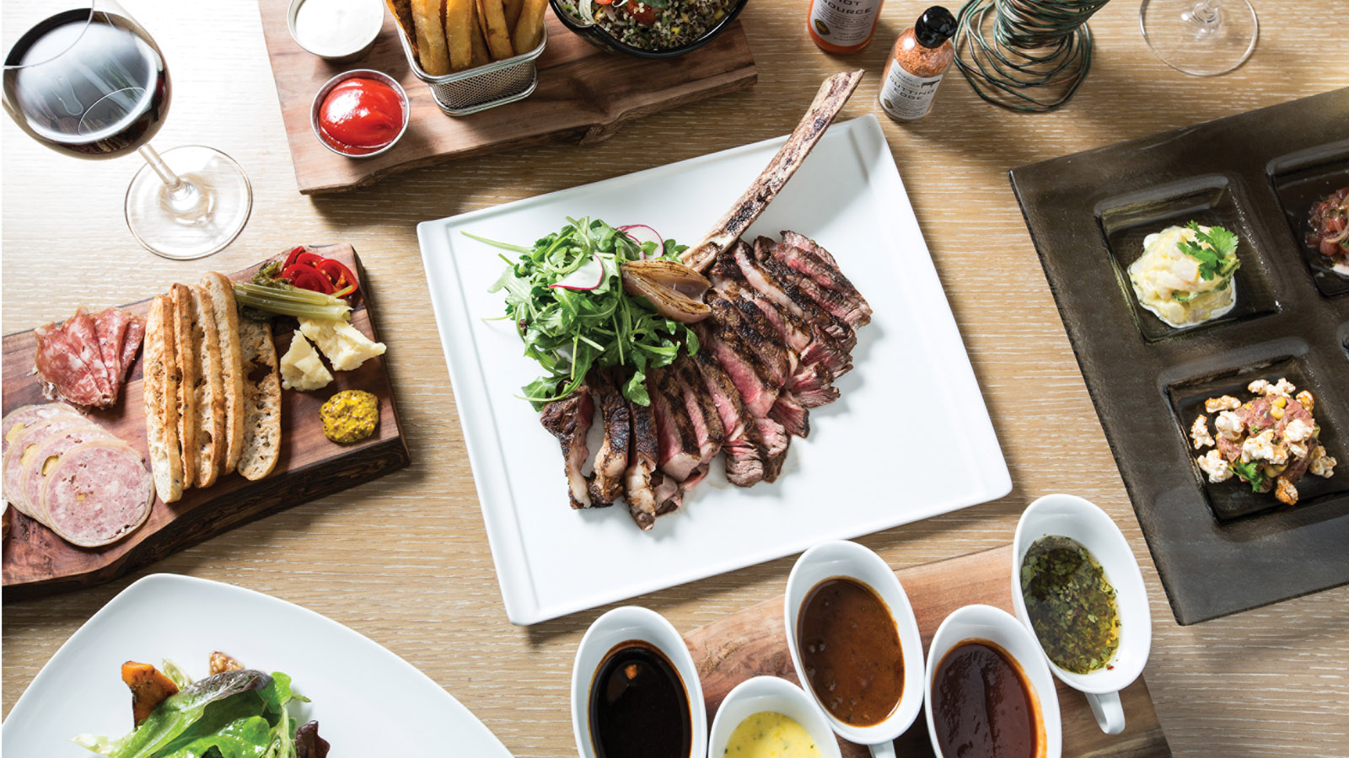 | February 7, 2018, Miami, U.S.A.  A Suite and Savoury Valentine Week at Four Seasons Hotel Miami  https://publish.url/miami/hotel-news/2018/valentines-day.html
January 16, 2018, Miami, U.S.A.
Australia Day Festivities are Back at Four Seasons Hotel Miami
https://publish.url/miami/hotel-news/2018/australia-day.html

PRESS CONTACTS

Suzanne Willis
Director of Public Relations and Communications
Barnes Bay, P.O. Box 8028
West End
Anguilla
suzanne.willis@fourseasons.com

+1 (239) 287-7070

Stephanie Cardelle
Director of Public Relations and Communications
1435 Brickell Avenue
Miami
U.S.A.
stephanie.cardelle@fourseasons.com

1 (305) 381-3037

