Bali’s Newest Wellness Destination: The Healing Village Spa at Four Seasons Resort Jimbaran Bay

October 15, 2020, Bali at Jimbaran Bay, Indonesia

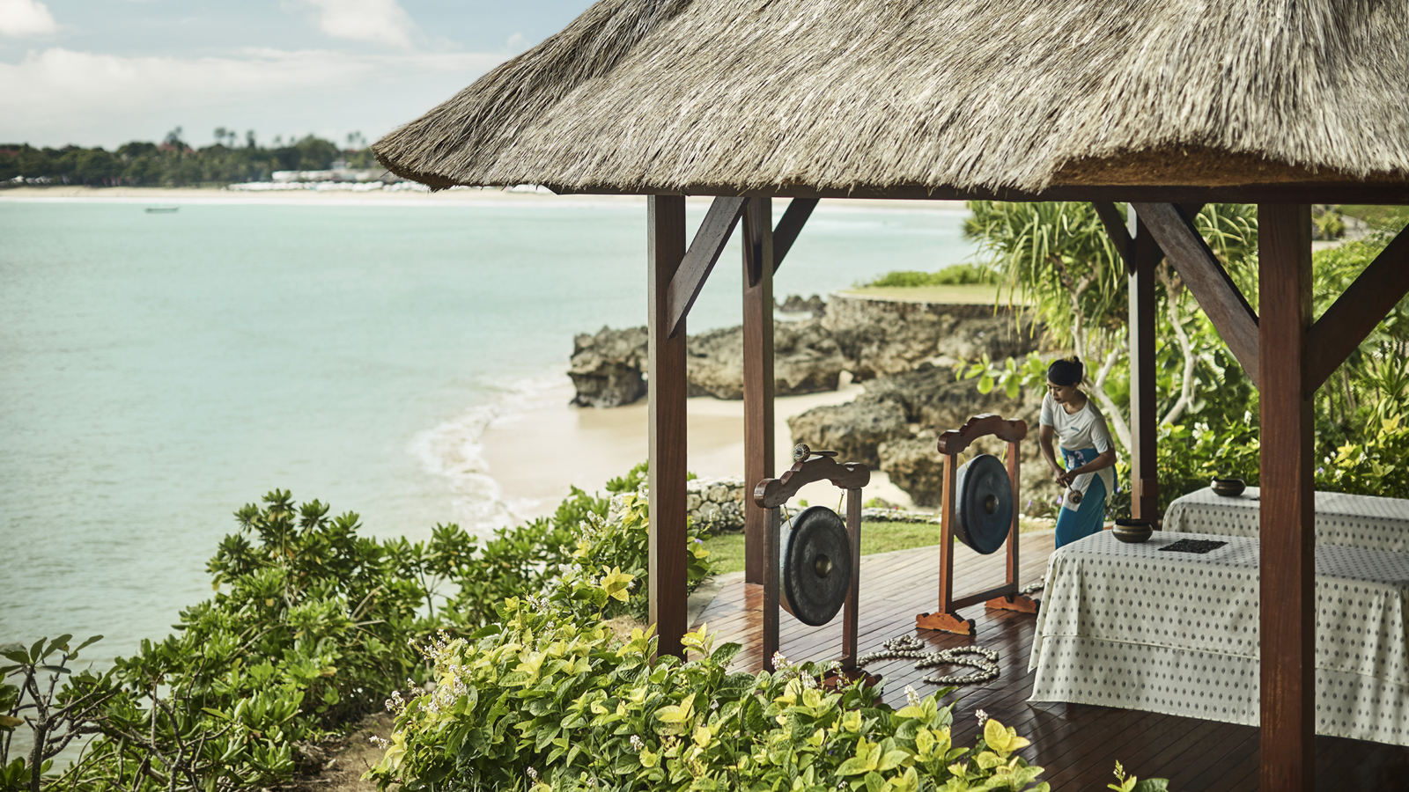
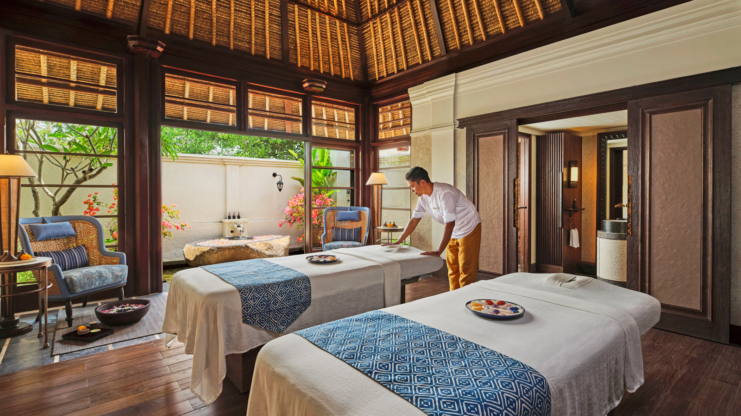 | 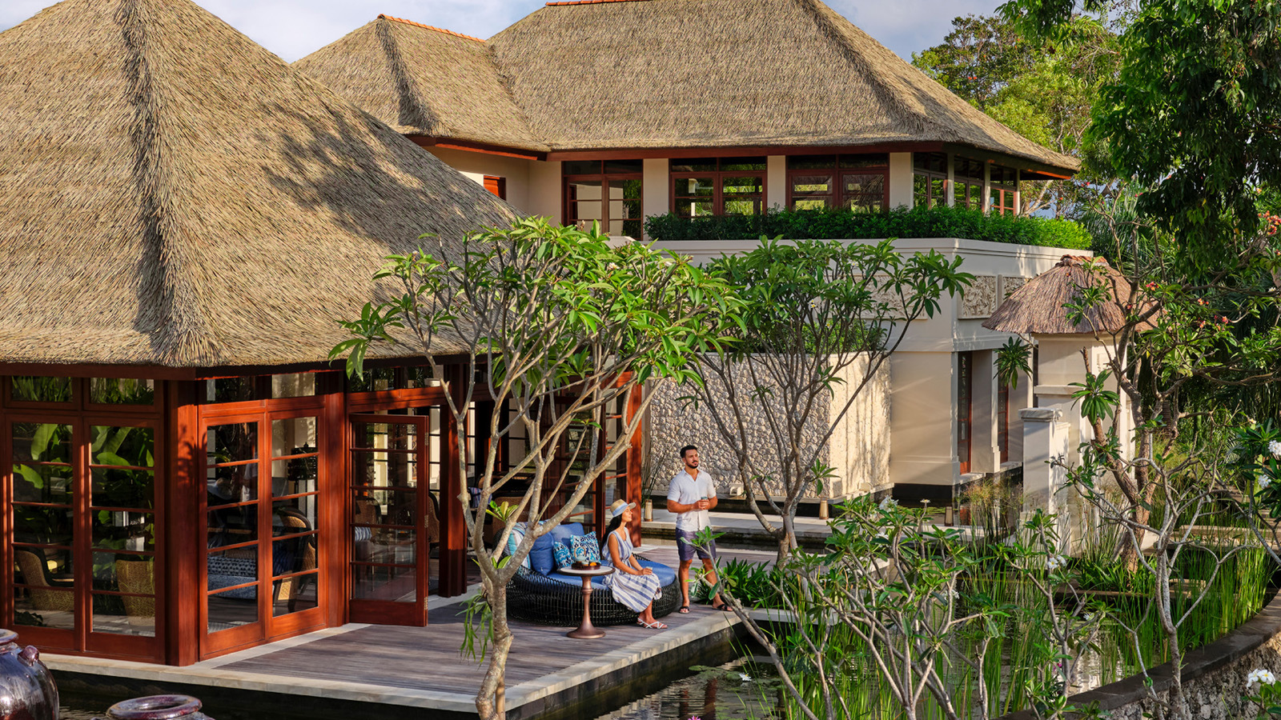 | 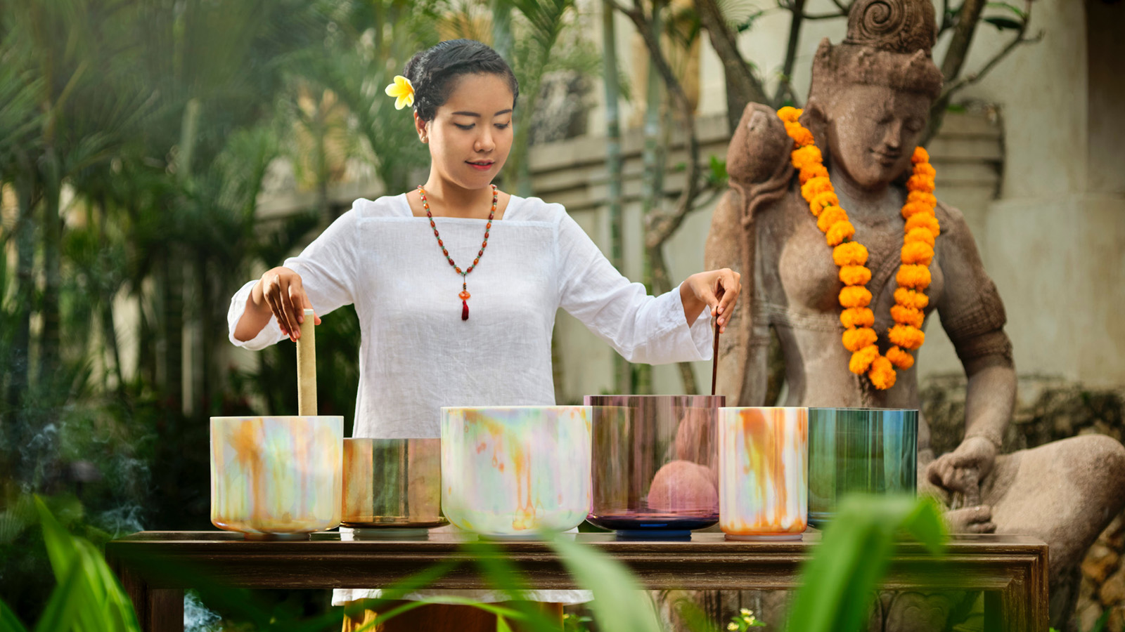
At a time when our collective wellbeing is more important than ever, Bali is ready for those seeking a fresh start and renewed energy, with the opening of the new Healing Village Spa at Four Seasons Resort Bali at Jimbaran Bay.
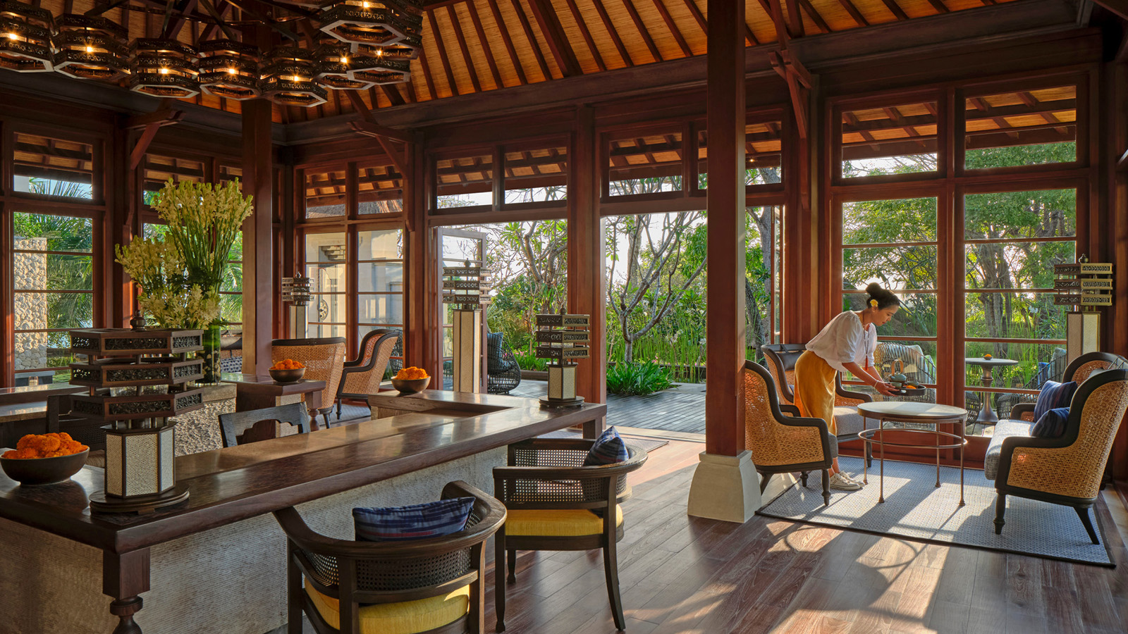
Emerging from an 18-month-long renovation with a contemporary Balinese design by Australian architect Nick Juniper and soothing interiors by Japan’s Yasuhiro Koichi, The Healing Village Spa fuses ancient wisdom with modern science. Revolutionary treatments combine light and sound, thermal and colour therapy, plants and gemstones to complement the traditional healing for which Bali is so renowned.
The two-storey building – seemingly suspended over water and 70 per cent bigger than before at 2,000 square metres (21,500 square feet) – has 10 all-suite spa rooms including the Illume Room for a fully immersive experience. It features heated quartz-sand bed for inversion therapy and undulating massage, coloured light therapy, gemstones and crystal singing bowls, and surround sound original music. The Spa’s soundtrack was created by former rocker-turned-wellness music producer Gus Till who stayed up all night to record the sounds of the waves and wildlife at the Resort.
Another Bali first, the Longevity Garden is a private DIY treatment space in a lush "secret" garden. Couples can take their time to enjoy self-directed healing and nourish each other with local organic products including Indonesian volcanic mud wraps and coconut soap. To maximise mineral absorption, there’s a private steam room and double sun loungers equipped with infra-red gemstone therapy mats. A cleanse under the powerful two-metre-high (6.5 feet) waterfall shower is followed by ice bath immersion – recommended for three minutes at sub-10 degrees Celsius to release endorphins, tighten pores, speed up muscular recovery, and invigorate from head to toe.
“I am thrilled to announce the opening of The Healing Village Spa and grateful for the support of our owners in continuing to invest in our two Bali Resorts. This has enabled us to not only maintain the quality of our facilities and services, but enhance them to ensure an even better experience for our guests in future,” says Uday Rao, General Manager of Four Seasons Resorts Bali.
Regional Director of Spa Luisa Anderson says the Balinese therapists draw on their culture’s ancient wisdom and healing rituals to deliver transformative experiences, supported by innovations in product and equipment. “The seven healing attributes of water, community, gemstones, light, sound, plants, and love are woven into the tapestry of the new Healing Village Spa, and unite cultural elements with the latest in emerging science."
Products from ISUN – a dynamic skincare brand committed to a "quantum healing effect" – draw on wild-crafted, organic ingredients infused with the power of gemstones. The Spa also features the only Rossano Ferretti Hair Spa in Southeast Asia – an exciting opening by the world’s leading hair care expert, whose luxury salons extend from Milan and Mumbai to New York, London and Dubai. The Italian celebrity stylist will cater for both local residents as well as visitors to Bali, offering unique access to the Ferretti Method: a highly personalised approach that works with the natural fall of a client’s hair and facial contours.
On The Healing Village Spa’s upper level, beautiful ocean views and state-of-the-art equipment inspire a work-out at the Fitness Centre with the Resort’s personal trainers. Fully-certified yoga masters offer sessions at the studio or the ocean’s edge, including AntiGravity, Yin and Restorative Hot Stone Yoga, as well as Balinese Sekala Yoga, which ends with a blessing and energy cleansing by the Resort’s Balinese-Hindu priest.
The rejuvenation of The Healing Village Spa complements the renowned wellness program at Sacred River Spa at Four Seasons Resort Bali at Sayan in the foothills of Ubud. Reaffirming their reputation as the island’s leading wellness destination, the two Resorts offer combination stays for guests to take a wellness journey from the ocean to the rice fields, to discover Bali – and themselves – on a deeper level.
To mark the opening of The Healing Village Spa, Four Seasons Resort Bali at Jimbaran Bay has launched new “Waves of Wellness” packages including accommodation in a private pool villa, daily breakfast, and a daily program of spa treatments and experiences. Guests can choose from the 3-Day Reset or 5-Day Refocus valid until March 31, 2022, with the reassurance of Four Seasons flexible booking policy globally.

RELATED

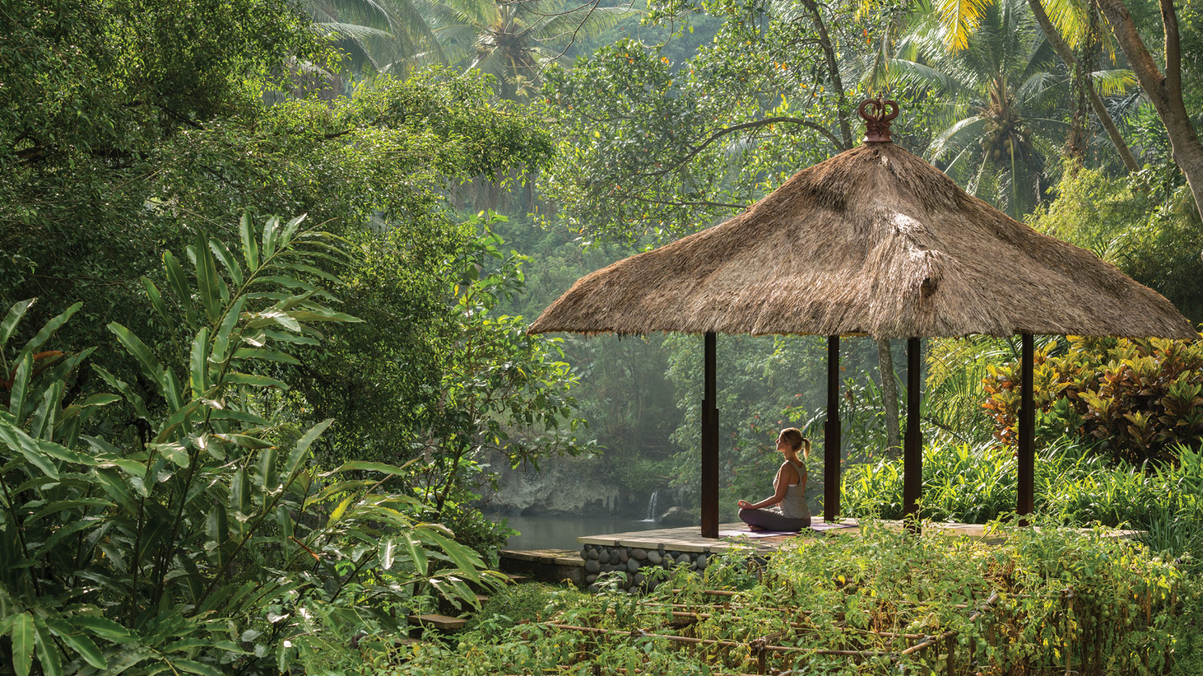 | July 3, 2020, Bali, Indonesia  Four Seasons Resorts Bali Welcome Guests with Exclusive Private Experiences  https://publish.url/jimbaranbay/hotel-news/2020/reopening.html
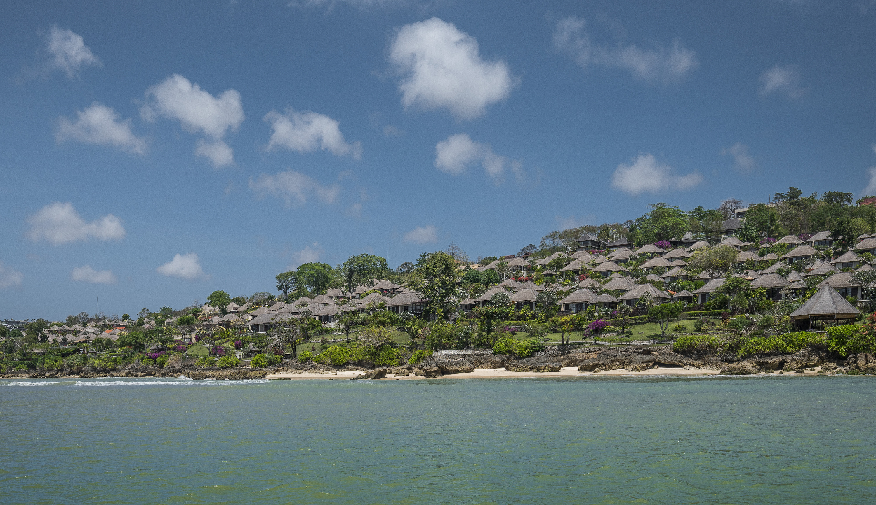 | May 11, 2020, Bali at Jimbaran Bay, Indonesia  Energy Balancing and Teamwork at Four Seasons Resort Bali at Jimbaran Bay  https://publish.url/jimbaranbay/hotel-news/2020/behind-the-scenes-resort-maintenance.html

PRESS CONTACTS

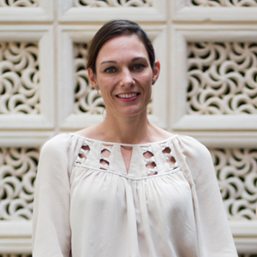 | Marian Carroll  Senior Director of Public Relations  Jimbaran  Indonesia  marian.carroll@fourseasons.com  +62 (361) 701010

