Four Seasons Hotel Doha Introduces Summer Staycation Offer

Now is the time to experience Qatar’s newly designed urban sanctuary
June 29, 2020, Doha, Qatar

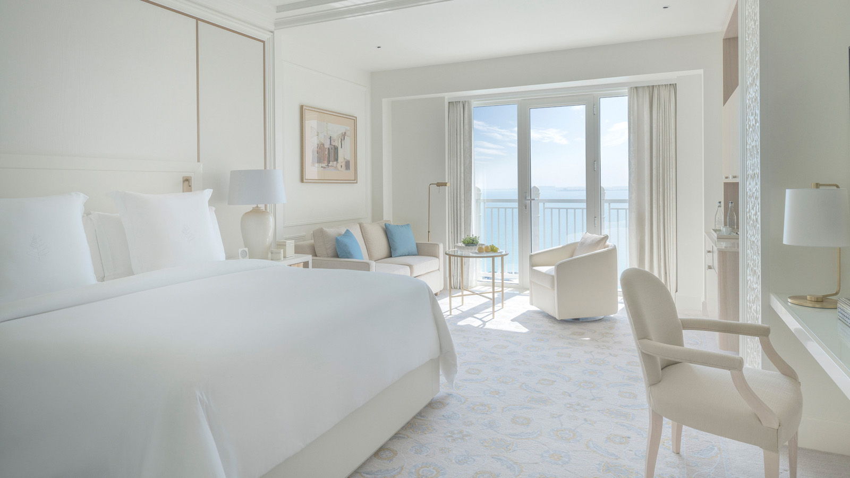
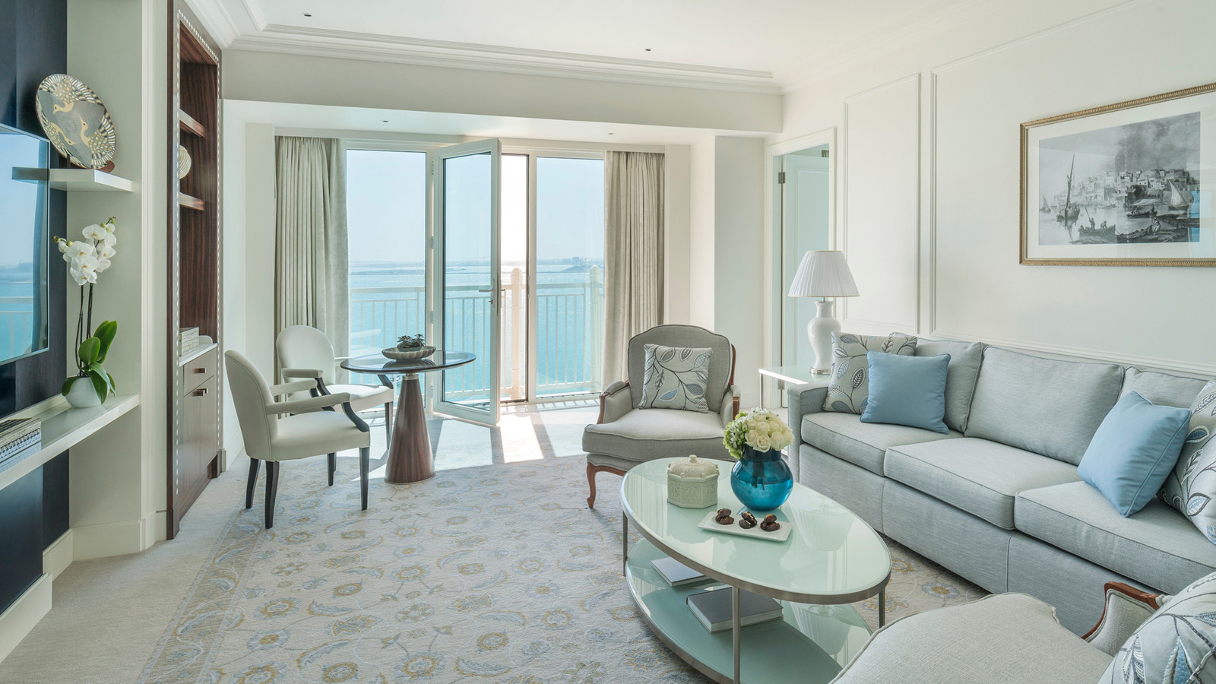 | 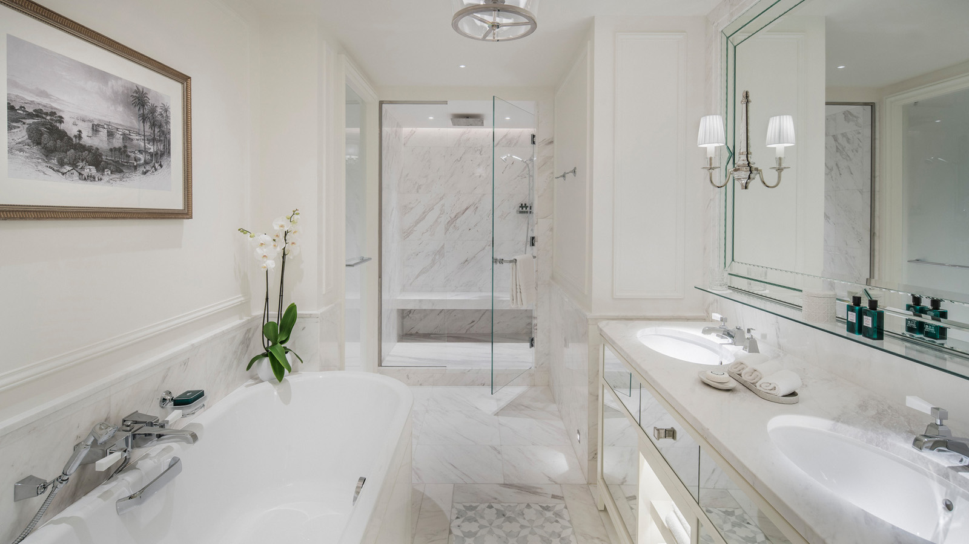 | 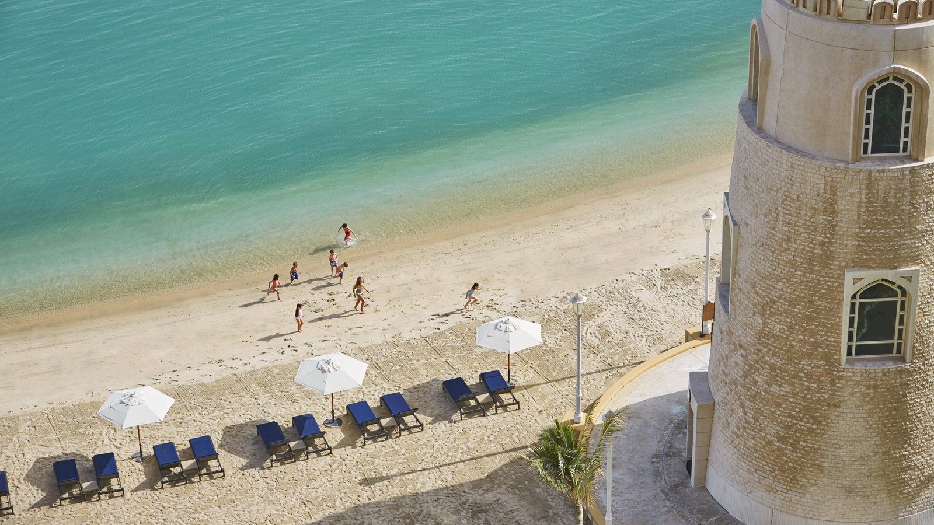
Following an extensive refurbishment project and the lifting of Qatar government restrictions, Four Seasons Hotel Doha launches a special offer designed for guests looking to stay closer to home this summer. The Experience More promotion provides local residents the opportunity to be among the first to enjoy the re-imagined hotel and an elevated guest experience - all guided by the new Four Seasons global health and safety program, Lead With Care.
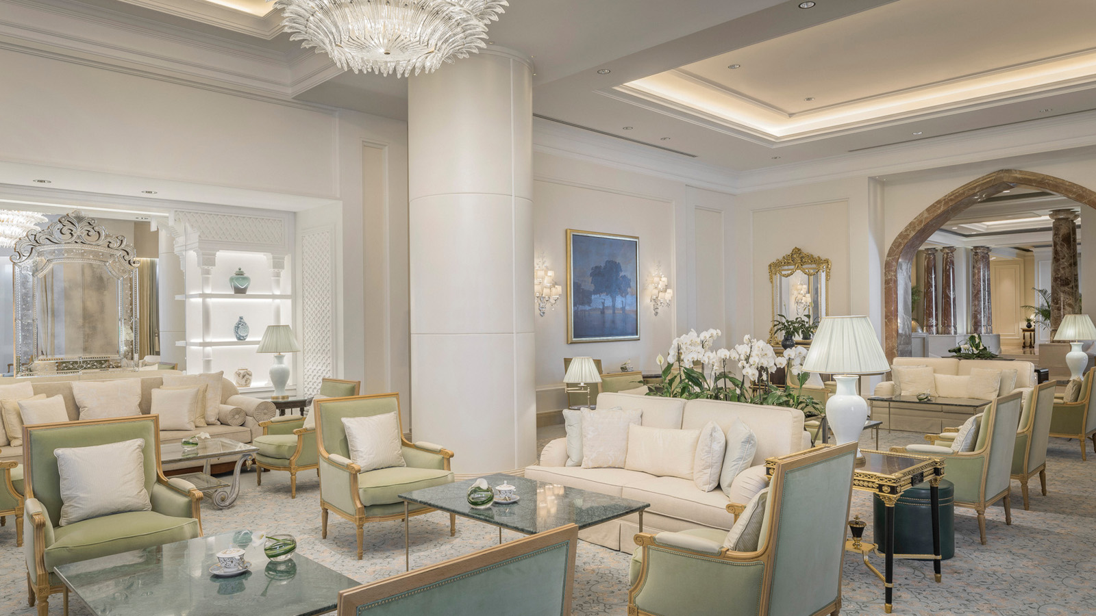 | 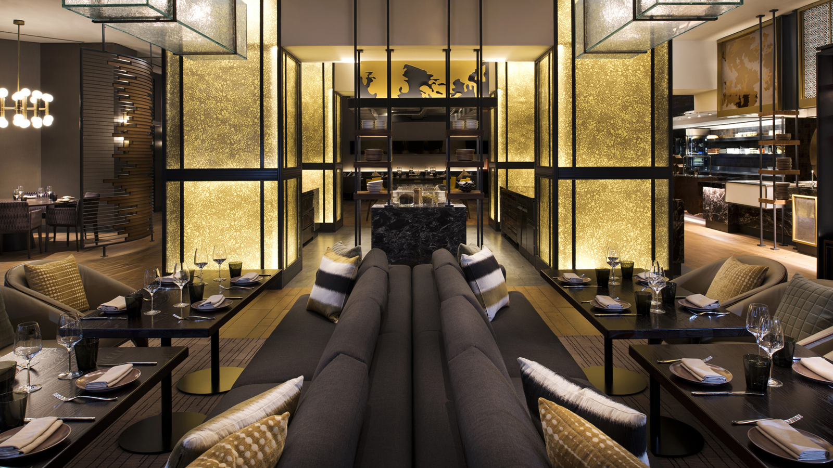
“Now more than ever, our guests - especially our local community - are seeking a well-deserved respite,” says Jeff Rednour, General Manager at Four Seasons Hotel Doha. “We’re eager to welcome them to a new guest experience that puts the health and safety of our employees and guests at the forefront without compromising genuine Four Seasons care and signature service.”
A New Four Seasons Hotel Doha
Led by award winning and world-renowned interior designer Pierre-Yves Rochon, the Hotel recently completed an extensive renovation of its guest rooms, suites, floors, lobby and select dining outlets. Guests will appreciate the thoughtful and intentional balance between traditional and modern features. From Qatari artwork to mother of pearl inserts in the bookcases, the redesign pays homage to Middle Eastern influences while guest rooms and suites boast the latest energy efficient technologies including automated curtains and lighting systems as well as windows with temperature management preservation.
A strong sense of place and nod to nature continue throughout the Lobby and the Hotel’s refreshed dining and lounge outlets such as Nobu, Elements, Seasons Tea Lounge, Arabica, Library and Cigar Lounge, and Pool Grill. Notably, the Seasons Tea Lounge, reminiscent of a Parisian café, is enhanced with marbled floor inspired by Islamic mosaic tilework. Guests can enjoy bespoke coffee brewed from single-origin beans at Arabica, complete with a new contemporary coffee and dessert bar.
Experience More Staycation Offer
Guests can make the most of their stay with a credit toward Hotel dining and drinks, early check-in, and late check-out until 4:00 pm starting from QAR 1,400 per night with minimum stay of two nights. With diverse dining and lounge concepts, there is no shortage of options to enjoy food and beverage credits as follows:
- Deluxe or Premier Rooms: USD 100 (approximately QAR 360) per stay
- Executive or Seaview Suites: USD 150 (approximately QAR 545) per stay
- Ambassador One Bedroom Suite: USD 200 (approximately QAR 725) per stay
Offered only this summer, the Experience More promotion is available for online booking now.
Lead With Care
Anticipating that the COVID-19 global pandemic will continue to evolve, Four Seasons properties across the world, including Four Seasons Hotel Doha, have launched Lead With Care. A health and safety program provides ongoing, real-time guidance and clear measures to enhance cleanliness, guest comfort and safety, and employee training.
While face-to-face interactions may be more limited, Four Seasons staff will remain as connected as ever. Through the Four Seasons App and Chat, guests will have direct access to property teams in 100+ different languages, providing a contactless experience that allows guests to manage their itinerary, request amenities, discover personalised recommendations, and more.
For more information on Lead With Care, click here.

RELATED

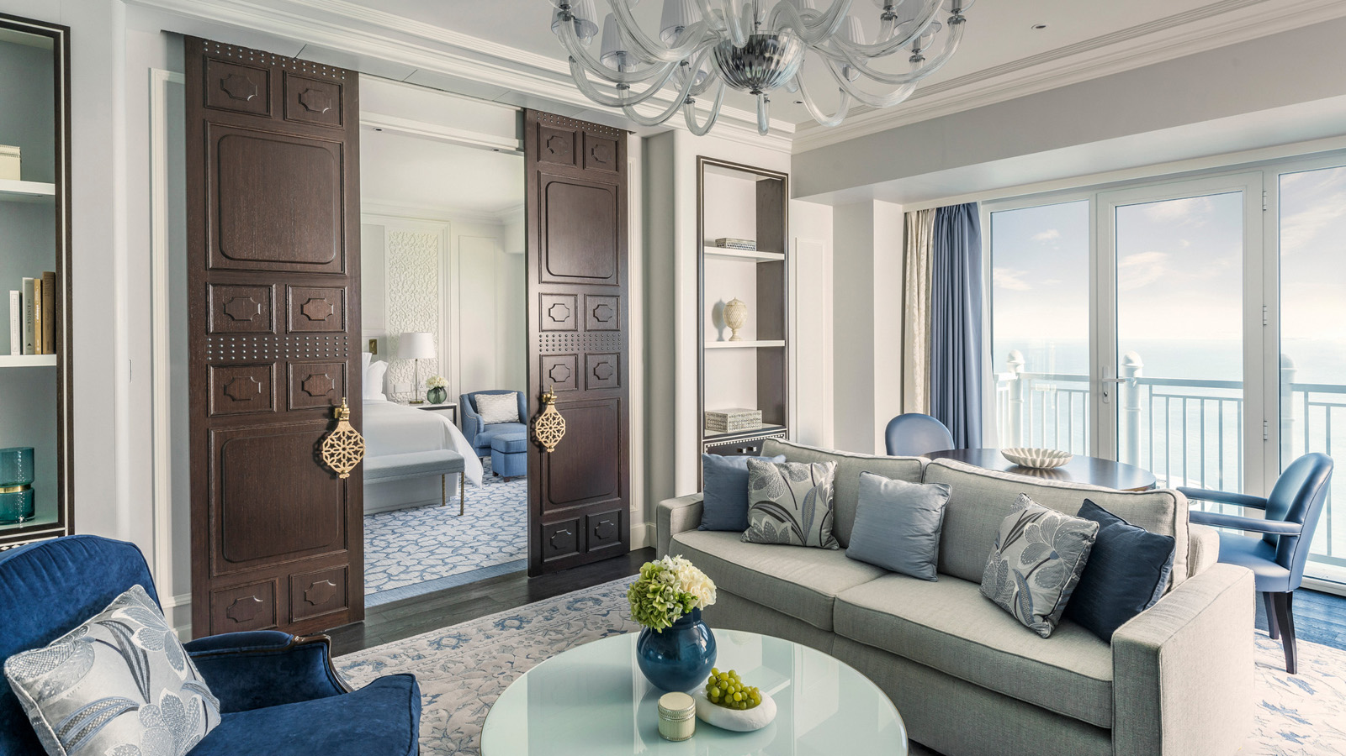 | April 28, 2020, Doha, Qatar  Four Seasons Hotel Doha Unveils Complete Redesign by Pierre-Yves Rochon  https://publish.url/doha/hotel-news/2020/design-details.html
April 28, 2020, Doha, Qatar
Four Seasons Hotel Doha представляет полностью переосмысленный дизайн от Пьера-Ива Рошона
https://publish.url/ru/doha/hotel-news/2020/design-details-2.html

PRESS CONTACTS

Endamia Decour
Director of Public Relations and Communications
The Corniche, PO Box 24665
Doha
Qatar
endamia.decour@fourseasons.com

(974) 4494 8888

