Love is in the Air at Four Seasons Hotel Toronto

With a full suite of programming, Four Seasons Hotel Toronto prepares to pamper guests in a celebration of love
February 8, 2019, Toronto, Canada

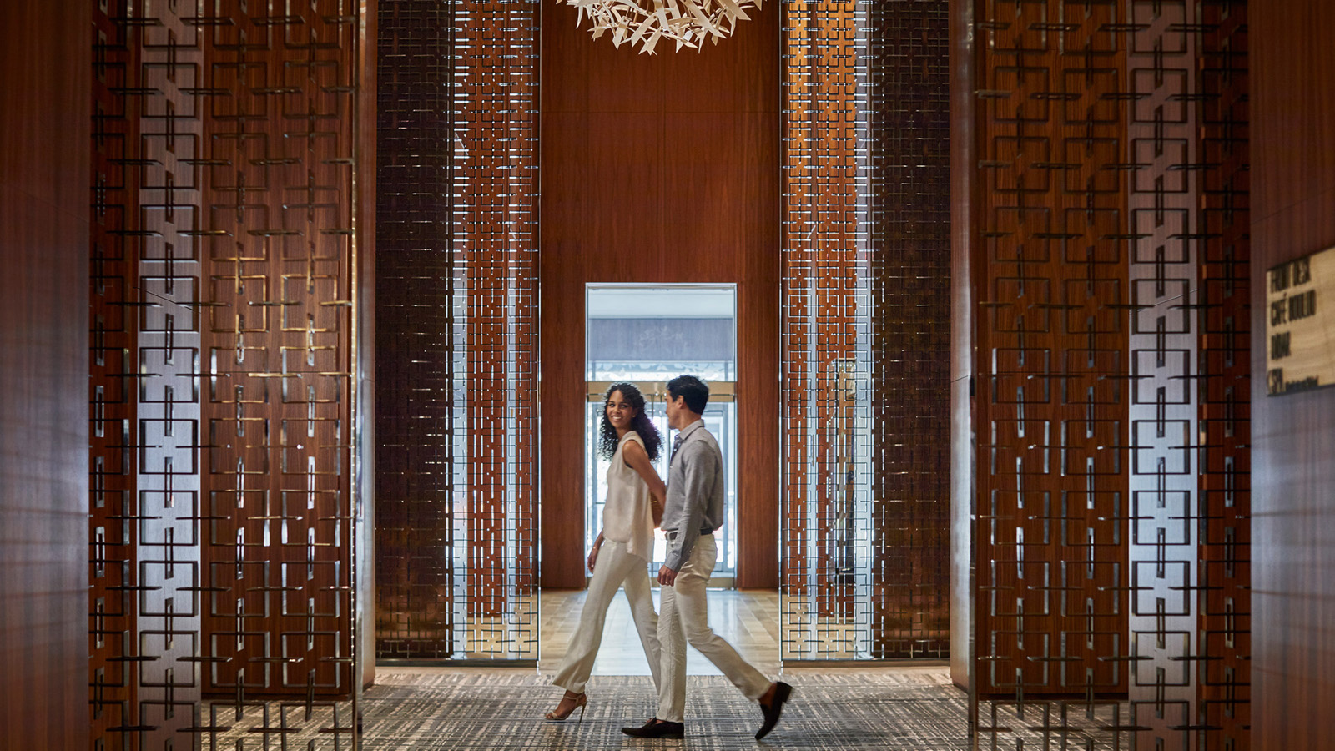
The team at Four Seasons Hotel Toronto invites guests to join them in embracing the spirit of love this February. From blissful moments of self-care to romantic experiences shared with loved ones, this month offers something special for everyone.
The culinary team of Café Boulud Toronto has put together a Valentine’s Day dinner that will transport guests to the city of love itself. On Thursday, February 14, 2019 between 5:00 and 10:00 pm, Chef Nicholas Trosien presents a swoon-worthy four-course menu featuring artichoke and truffle salad, grass-fed NY steak, cherry and chocolate mousse and more at CAD 135 per person.
For those that prefer to celebrate over the weekend, Café Boulud is extending an exclusive three-course prix fixe menu on Friday, February 15 and Saturday, February 16, 2019 for CAD 80 per person, with additional offerings of shaved truffle, oysters and lobster available.
Downstairs, rose-tinted d|bar is stirring up feelings of love for the entire month of February with a new feature cocktail, For the Love of Punch: a fruity, sparkling creation perfect for date night. Seafood specialty items will also be added to the menu for patrons to enjoy between Thursday, February 14 and Saturday, February 16, 2019.
As there is no gift more romantic than the gift of memories created together, the Hotel will be reopening its popular Gift Card Desk for one week only from February 7 to 15, 2019, just in time for Valentine’s Day. Purchase gift cards for a world-class couples massage at the Spa at Four Seasons Toronto, an unforgettable meal at Café Boulud Toronto or a romantic staycation with a Four Seasons Hotel Toronto gift card. Add a sweet note with limited edition macaron boxes specially crafted by Executive Pastry Chef Steven Tran.
The Hotel is also celebrating the importance of self-love with signature treatments at the Spa at Four Seasons Toronto. Ascend to Cloud 9 on the 9th floor and enjoy an indulgent experience the entire month of February 2019 with the following offers while sipping on healthy, healing and energising refreshments from Greenhouse Juice.
- Any 60-minute massage for CAD 165 (regular CAD 200)
- Any 90-minute massage for CAD 265 (regular CAD 300)
- 3-in-1 Super Facial for CAD 195 (regular CAD 245)
- 30 percent off Kjaer Weis Certificated Organic Makeup Line
To book a Spa escape, call 416 964 0411 or reserve a treatment online.
For reservations at Café Boulud, call 416 963 6000 or book online.

*Meal prices do not include tax or gratuity. All spa offers are valid until February 28, 2019. Treatment offers valid Monday to Thursday only, excluding Valentine's Day and Family Day. Treatment prices do not include taxes or gratuity.

RELATED

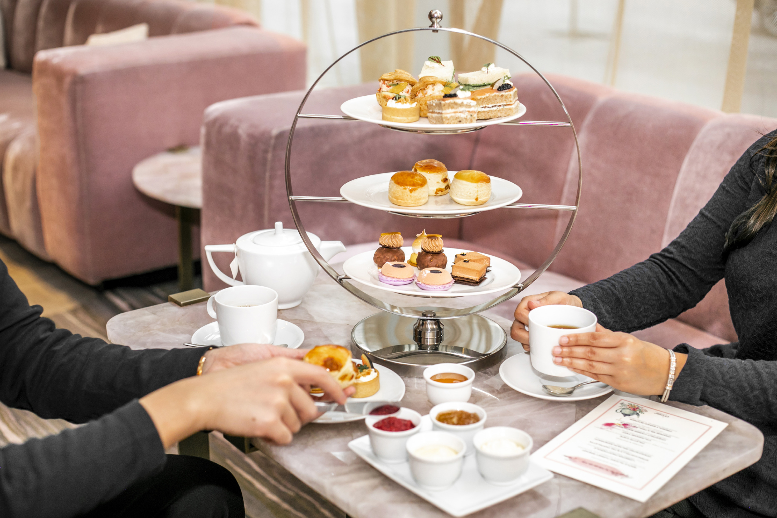 | February 26, 2020, Toronto, Canada  “Thé Quelqu'un?” Four Seasons Hotel Toronto Presents Afternoon Tea with a Boulud Twist  https://publish.url/toronto/hotel-news/2020/french-afternoon-tea-at-dbar.html
February 24, 2020, Toronto, Canada
There’s Always Time to “Take Your Time” with Four Seasons Hotel Toronto
https://publish.url/toronto/hotel-news/2020/take-your-time.html

PRESS CONTACTS

Halla Rafati
Public Relations Director
60 Yorkville Avenue
Toronto
Canada
halla@haloandco.co

+1 416 364 0404

