Fall Experiences from Four Seasons Hotel Chicago

From a Warhol-themed stay package to a special maple menu at Allium, iconic hotel is the city's downtown destination this season
October 9, 2019, Chicago, U.S.A.

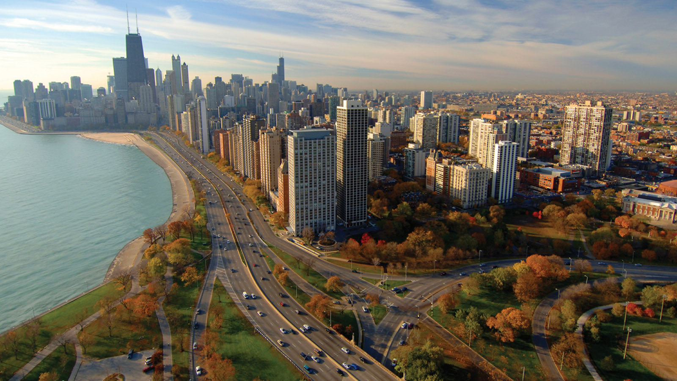
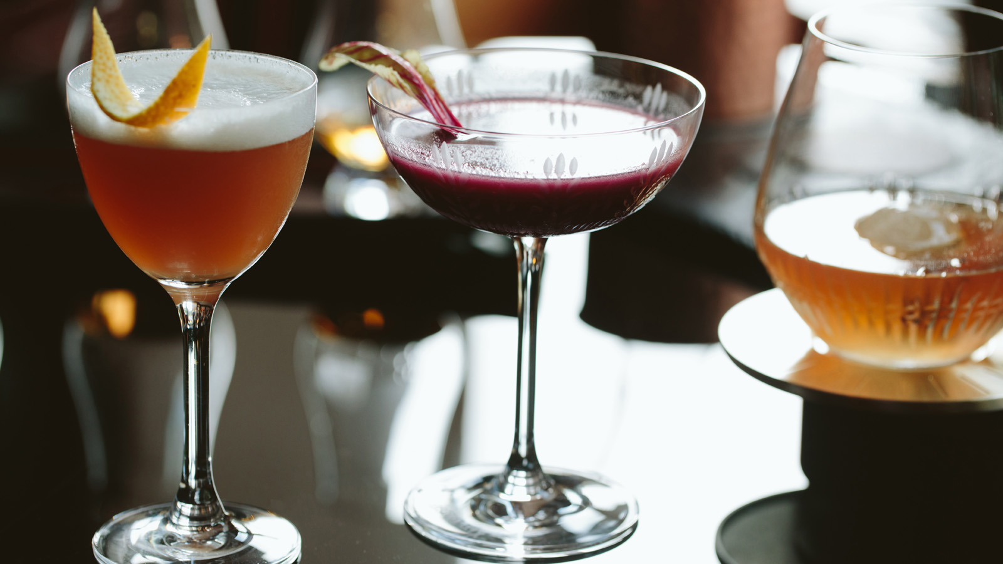 | 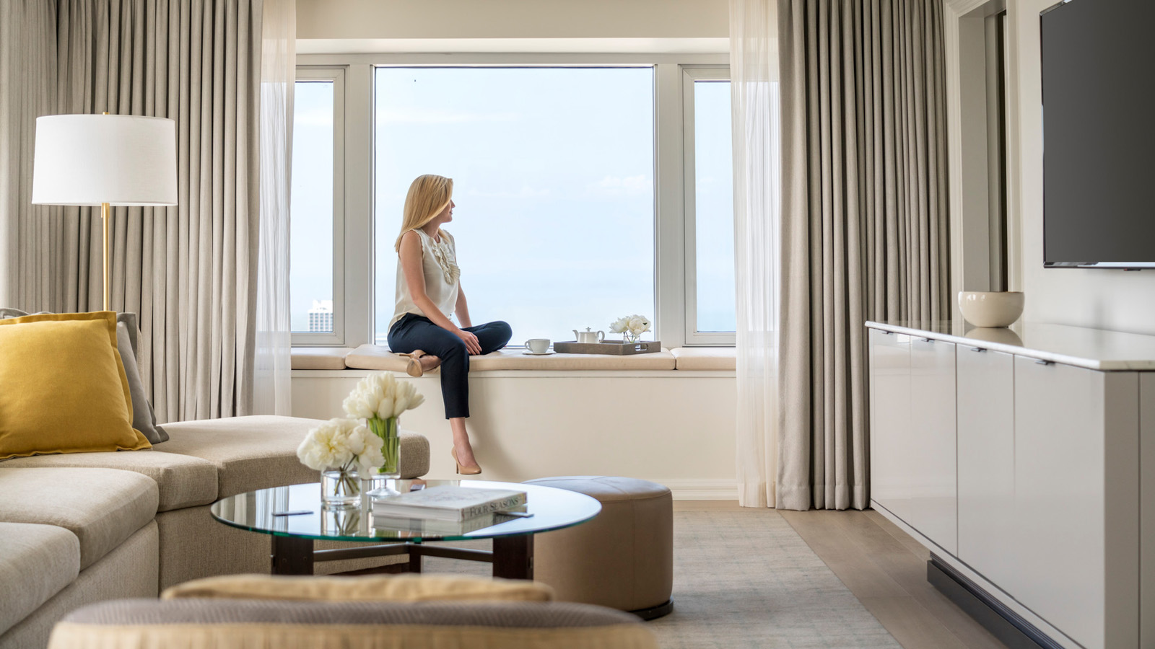
Four Seasons Hotel Chicago invites guests to explore the city this fall, including the brilliant fall colours and lushly landscaped gardens along the Lakefront Trail this season, as well as visiting one of the many festivals - from Fall Fest at Lincoln Park Zoo to Lincoln Square Ravenswood Apple Fest.
Maple Menu at Allium
Allium Restaurant's Executive Cheg Michael Zachman has partnered with Craig Dunek of Dunek Acres, a local purveyor of maple products, located in Hillsboro, Wisconsin. Craig Dunek, learning the maple syrup production process from his father in his teens, first tapped neighbours' trees and boiled it on his parent's stove. Today, the company taps 3,000 trees (as it takes 40 gallons of sap to make one gallon of syrup). Chicagoans can see Dunek and family at Green City Market in Lincoln Park each first Saturday of the month. The maple-inspired menu items are as follows:
- Applewood and maple smoked "millionaire's bacon" for breakfast
- Baby spinach salad with butternut squash, spiced pecans, smoked chicken breast and maple chili vinaigrette for lunch
- Maple brined duck leg with butternut squash, sage croissant pudding and maple blackberry gastrique for dinner
- Maple bacon macaron, maple bourbon milkshake and the contemporary twist on baked Alaska, maple Alaska for dessert
- Smoked maple Old Fashioned cocktail from Allium Bar
Fall Treatments at The Spa
An urban oasis, the 8,000 square-foot (743 square-metre) Spa has introduced three new treatments for fall:
- Pumpkin Spice Facial - With anti-ageing effects, this facial delivers a combination of natural pumpkin enzymes and alpha hydroxyl acids that penetrate deep into the skin to gently exfoliate. Next, a powerful combination of 100 vitamins and phyto-nutrients are infused to nourish and replenish the skin to reveal a radiant glow.
- Vanilla Chai Manicure and Pedicure - Fall notes of cinnamon and cardamom compliment the natural exfoliation of this milk infused soak from the nail salon. A sugar scrub rich in antioxidants and humectants replenishes the skin, followed by a relaxing hand and foot massage.
- Warm Citrus Body Treatment - In this aromatic body ritual, experienced therapists gently exfoliate the back with a refreshing citrus body polish. The treatment culminates in a signature hot stone massage as warm notes of ginger, orange and cinnamon awaken the senses.
The Hotel, with its 345 rooms and suites, presents the Warhol Experience stay package - a special offer for the major retrospective of the American pop artist at the Art Institute of Chicago. Guests taking advantage of this offer will enjoy a stay in a newly renovated Executive Suite, two glasses of Champagne at Allium Restaurant, a special Warhol welcome amenity, two fast passes to the Art Institute and tickets to the exhibit. Running October 20, 2019 to January 26, 2020, the exhibit showcases more than 350 works from his entire career.

RELATED

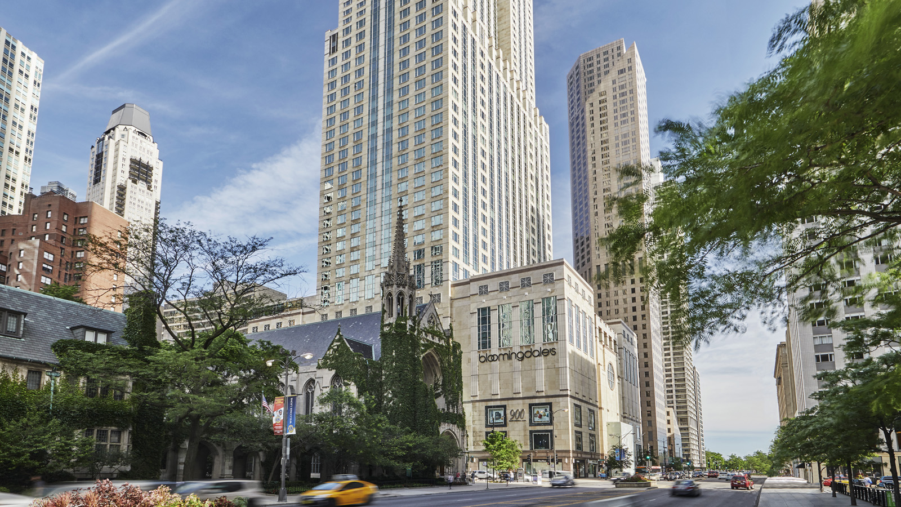 | September 24, 2019, Chicago, U.S.A.  Stephen Wancha Named General Manager of Four Seasons Hotel Chicago  https://publish.url/chicago/hotel-news/2019/new-gm-stephen-wancha.html
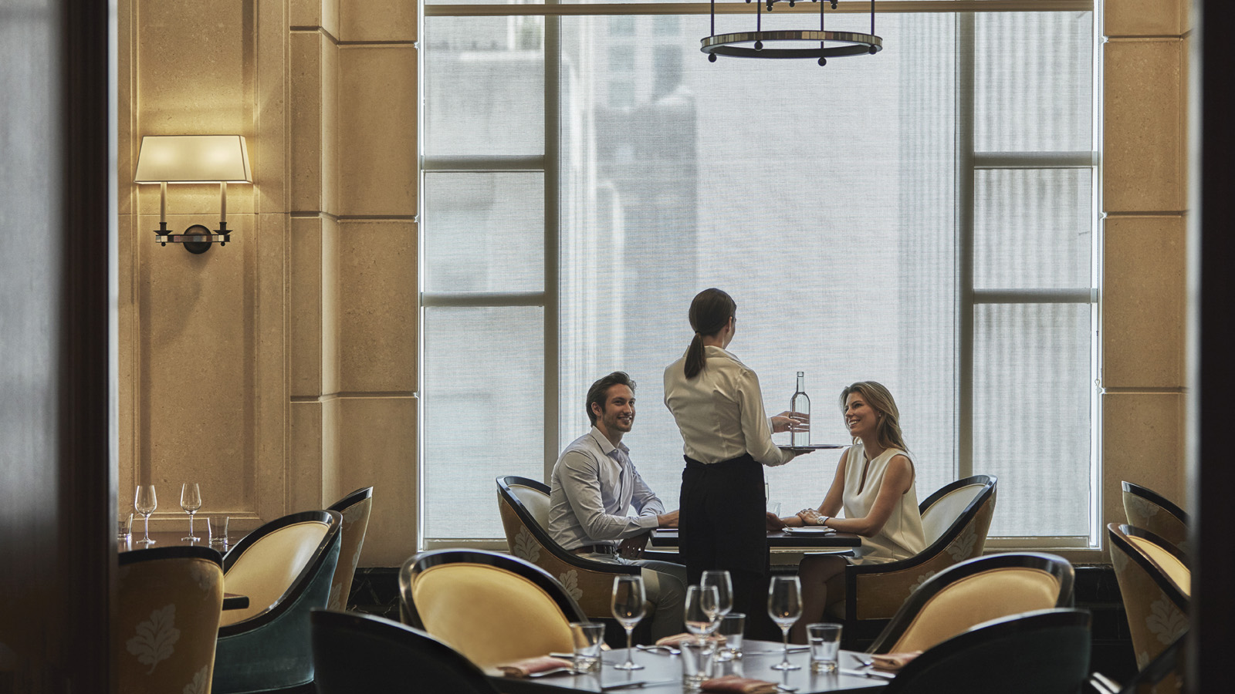 | September 10, 2019, Chicago, U.S.A.  Fleurs de Villes Floral Couture Exhibit Descends Upon Four Seasons Hotel Chicago and 900 Shops  https://publish.url/chicago/hotel-news/2019/fleurs-de-villes-event.html

PRESS CONTACTS

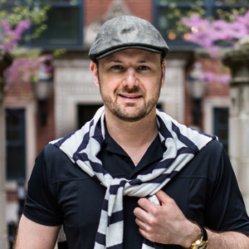 | Jim Guttau  Director of Public Relations  120 East Delaware Place  Chicago  U.S.A.  jim.guttau@fourseasons.com  +1 312 280 8800

