Announcing Shadi Suleman as Senior General Manager of Four Seasons Hotel Doha and Four Seasons Resort and Residences at The Pearl-Qatar

March 21, 2023, Doha, Qatar

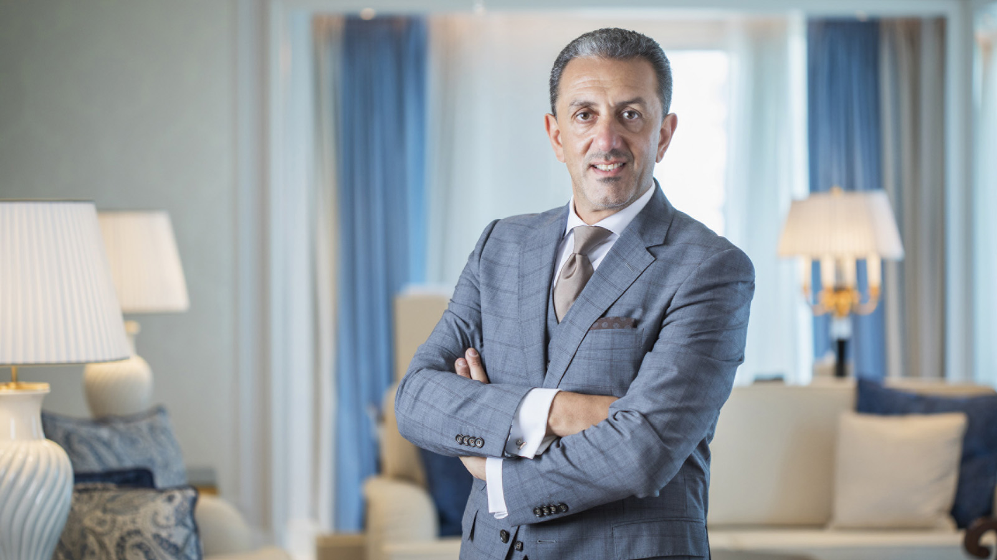
Four Seasons Hotel Doha announces the promotion of Shadi Suleman to Senior General Manager. In his new role, he will continue to oversee Four Seasons Hotel Doha and have additional oversight of the upcoming Four Seasons Resort and Residences at The Pearl-Qatar.
“It is with great pride that we share the news of Shadi’s promotion to Senior General Manager” says Simon Casson, President, Hotel Operations - Europe, Middle East and Africa for Four Seasons. “Beyond striving for perfection, Shadi’s exposure to numerous operations in the GCC and the Middle East, along with his pre-opening experience, will undoubtedly contribute to the further success of Four Seasons Hotel Doha and the highly anticipated debut of Four Seasons Resort and Residences at The Pearl–Qatar.”
A veteran of more than 20 years with Four Seasons Hotel and Resorts, Shadi has worked his way up in the company. He started his career in August 2002 at Four Seasons Hotel Riyadh at Kingdom Centre as Front Office Manager. In the years since, he has risen through the ranks with increasing responsibilities and challenging new assignments. In 2005, he joined the pre-opening team at Four Seasons Hotel Damascus. In 2007, he joined another pre-opening mission for Four Seasons Hotel Istanbul at the Bosphorus. In 2008, he made the move to Four Seasons Hotel Doha as Director of Rooms where he advanced to Hotel Manager in 2013. His first General Manager position was at Four Seasons Hotel Alexandria, where he honed his leadership skills and oversaw the expansion and the renovation projects of the property.
After achieving tremendous success on the Mediterranean, a move to Doha followed in 2021, where he was appointed to General Manager of Four Seasons Hotel Doha. Since his return, Shadi has led many successful projects, including FIFA World Cup 2022 activations, the refurbishment of Library Lounge, as well as the opening of Curiosa by Jean-Georges, Makani Beach Club and Le Deli Robuchon coming soon. Moreover, his commitment to exceptional service and quality in employee and guest experience, reflected in the Hotel’s #1 Best Hotel in the Middle East and #5 in the World accolade by Conde Nast Traveler award in 2022.
Moving forward, Shadi is dedicated to use his experience to overseeing the debut of Four Seasons Resort and Residences at The Pearl–Qatar and flourishing the identities of both Doha properties. “Four Seasons has been at the forefront of luxury hotel brands in Qatar and a market leader in the capital,” says Shadi. “With our growing portfolio in Doha, I look forward to working alongside General Manager Mehdi Zaanoun and our large family of professionals at The Pearl to position ourselves as the leader for resort guests and private residence owners.”

RELATED

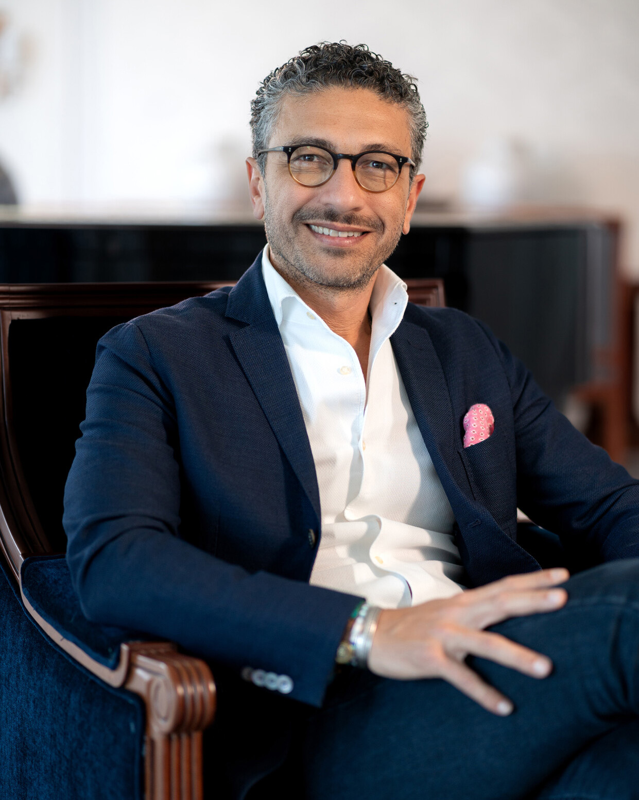 | July 24, 2023, Doha, Qatar  Mohamed Abou Doh Heads East to Qatar with Appointment as Director of Marketing for Four Seasons Hotel Doha  https://publish.url/doha/hotel-news/2023/new-director-of-marketing-mohamed-abou-doh.html
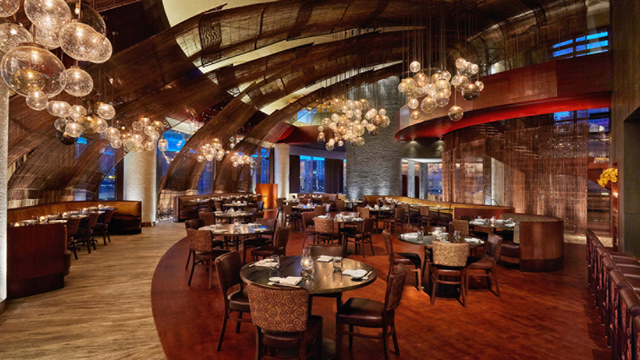 | May 17, 2023, Doha, Qatar  Nobu Doha Meets Malibu: Sushi Chef Toshiyuki Shiramizu to Present a Special Culinary Experience at Four Seasons Hotel Doha  https://publish.url/doha/hotel-news/2023/nobu-doha-meets-malibu-dining-event.html

PRESS CONTACTS

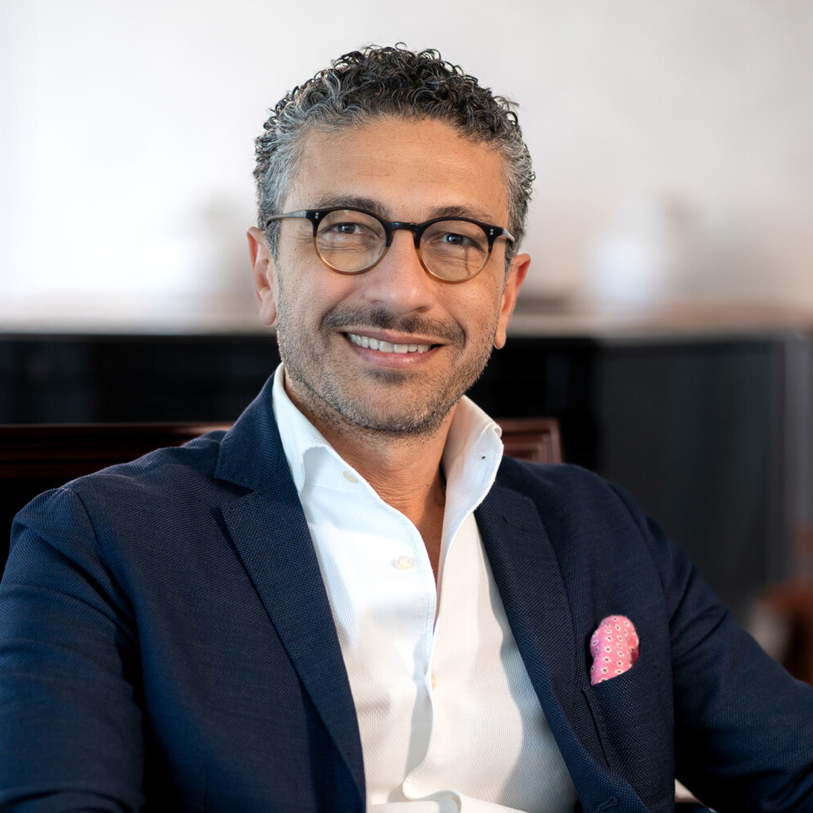 | Mohamed Abou Doh  Director of Marketing  The Corniche, PO Box 24665  Doha  Qatar  mohamed.aboudoh@fourseasons.com  +974 4494 8888

